PBL Lab Assignment 4
Batch: G1
Project Members:
- Ibrahim Ansari (1032233145)
- Chayan Raj Bharati (1032233134)
- Omkar Darekar (1032232336)
- Mohammed Jasim (1032232360)
Title: Designing a Flight Price Analysis Solution
Problem Statement: To design an analytical workflow and dashboard wireframe for analyzing flight pricing data to identify cost-saving opportunities and market trends.

Objectives
- To design a structured analytical workflow for flight data processing.
- To select and implement appropriate visualization tools (Tableau/Power BI) for travel insights.
- To create a wireframe layout for the Flight Price Analysis Dashboard.

Aim: To develop an interactive data exploration platform that analyzes and visualizes flight price trends, airline competitiveness, and the impact of travel factors to provide actionable insights for optimized travel planning.
Objectives:
- To analyze and visualize flight price trends between different destinations to help users understand pricing patterns over time.
- To compare ticket prices across different airlines and identify which airlines offer more economical options for similar routes.
- To study the impact of factors such as delays, booking time, and travel dates on flight prices and provide useful insights for better travel planning.

Dashboard Wireframe Design

1️⃣ KPI Cards (Top Summary Section)
Critical metrics displayed at a glance:
- Cheapest Route: Identification of the route with the lowest current average fare.
- Price Gap Index: Percentage difference between Economy and Business class fares across all sectors.
- Average Market Fare: The mean ticket price across all integrated airlines.

2️⃣ Average Ticket Price (Class Comparison)
- Visualization: Side-by-Side Bar Chart.
- Purpose: To quantify the price premium of Business Class over Economy across different carriers.

3️⃣ Route vs. Price Analysis
- Visualization: Heatmap or Ranked Bar Chart.
- Purpose: To identify high-demand, high-cost corridors versus budget-friendly travel routes.

4️⃣ Destination Popularity vs. Pricing
- Visualization: Dual-Axis Combo Chart (Bar + Line).
- Insight: Correlating the volume of bookings (Popularity) with the average ticket cost to see if high demand leads to price surges.

5️⃣ Price Over Time (Trend Analysis)
- Visualization: Line Chart with Time-Series Forecasting.
- Purpose: Tracking seasonal fluctuations and identifying "Golden Windows" for booking (e.g., 30 days vs. 60 days before departure).

6️⃣ User-Driven Interactive Filters
- Sidebar elements: Source City, Destination, Airline Selector, and Travel Date Range.
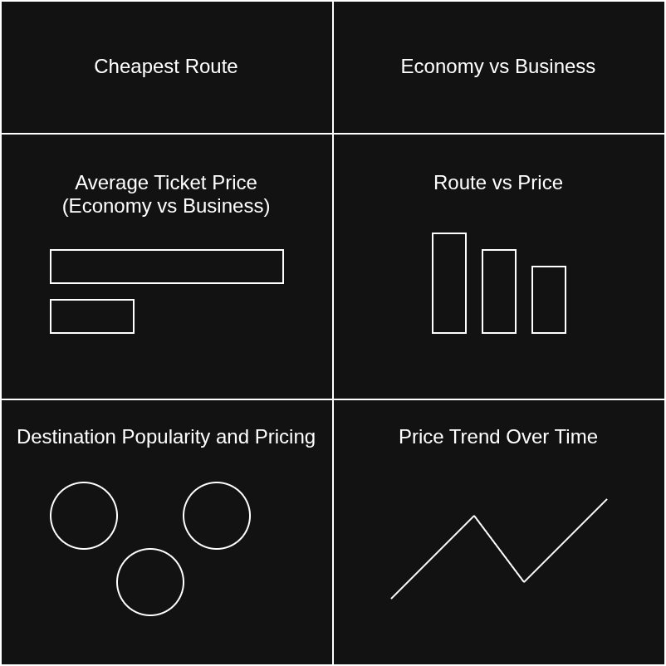
Conclusion: Thus, successfully developed wireframe for dashboard design with constructive metrics to provide users useful and meaningful insights.

