PBL Lab Assignment 5
Batch: G1
Project Members:
- Ibrahim Ansari (1032233145)
- Chayan Raj Bharati (1032233134)
- Omkar Darekar (1032232336)
- Mohammed Jasim (1032232360)
Title: Implementation of Dashboard
Problem Statement: Implementing a dashboard-based solution to gain actionable insights into flight pricing trends, class-based fare differences, and destination popularity using a real-world dataset.

Objectives:
- To design and develop an interactive dashboard using a flight industry dataset.
- To apply data visualization principles (color theory, hierarchy, and clarity) for business insights.
- To facilitate KPI-based decision-making for cost-effective travel planning.

Implementation Details

Key Performance Indicators (KPIs)
KPI Name | Logic / Formula | Business Value
Cheapest Route | MIN(Average_Price) group by Route | Identifies the most budget-friendly destination for the current selection.
Economy vs. Business Gap | (Avg_Business_Price - Avg_Economy_Price) | Helps users decide if the upgrade cost is justified by current market margins.

Visualizations Implemented
- Average Ticket Price (Economy vs. Business):
A Grouped Bar Chart comparing the two classes. This highlights the pricing multiplier (e.g., Business is typically 3x–5x the price of Economy).
- Route vs. Price:
A Tree Map or Horizontal Bar Chart showing which flight paths are the most expensive, allowing for "source-destination" cost benchmarking.
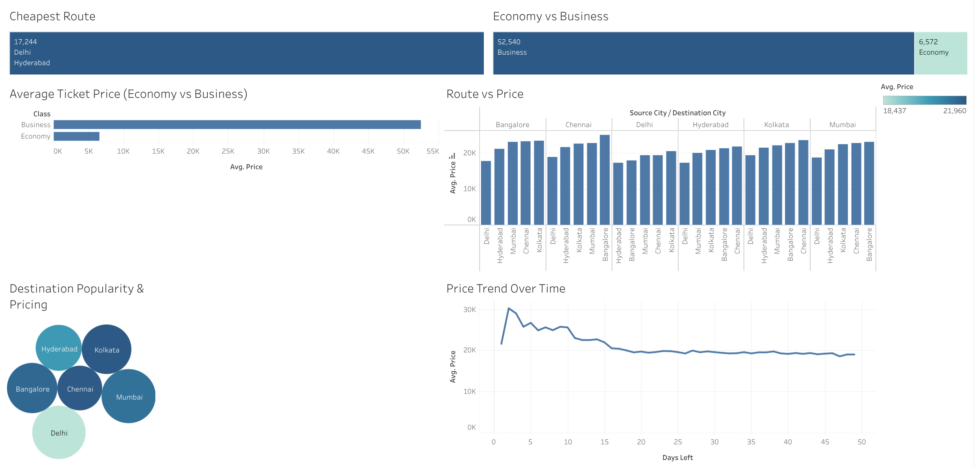
- Destination Popularity vs. Pricing:
A Scatter Plot. The X-axis represents the volume of flights (Popularity) and the Y-axis represents the Average Price. This reveals if high-demand routes are being "surged" or discounted due to competition.
- Price Over Time:
A Line Chart with a trend line. This tracks daily or monthly price movements, essential for spotting seasonal peaks (holidays) and troughs.

Conclusion: Thus, successfully translated wireframe design with key performance indicators and charts for business insights to an actual dashboard implemented with Tableau.

