PBL Lab Assignment 6
Batch: G1
Project Members:
- Ibrahim Ansari (1032233145)
- Chayan Raj Bharati (1032233134)
- Omkar Darekar (1032232336)
- Mohammed Jasim (1032232360)
Title: Testing of Dashboard
Problem Statement: To design and execute a test plan for validating the accuracy, functionality, and data integrity of the Flight Price Analysis Dashboard.

Objectives
- To validate the correctness of dashboard outputs against the source flight dataset.
- To ensure the accuracy of visualized data across different filter states.
- To verify that all interactive elements (drill-downs and slicers) function as intended.

Test Case Design (Dashboard Validation)
Test Case ID | Feature to Test | Expected Result | Result (Pass/Fail)
TC01 | KPI Accuracy | "Cheapest Route" KPI should match the minimum value in the raw dataset for the selected city. | Pass
TC02 | Filter Sync | Selecting a specific airline should instantly update the "Route vs Price" chart for only that carrier. | Pass
TC03 | Class Comparison | The "Economy vs Business" chart should never show Business prices lower than Economy for the same flight. | Pass
TC04 | Null Value Handling | Routes with missing price data should be excluded or marked "N/A" rather than showing as 0. | Pass
TC05 | Time Series Continuity | The "Price over Time" line chart should correctly order dates chronologically (Jan -> Feb -> Mar). | Pass

Results
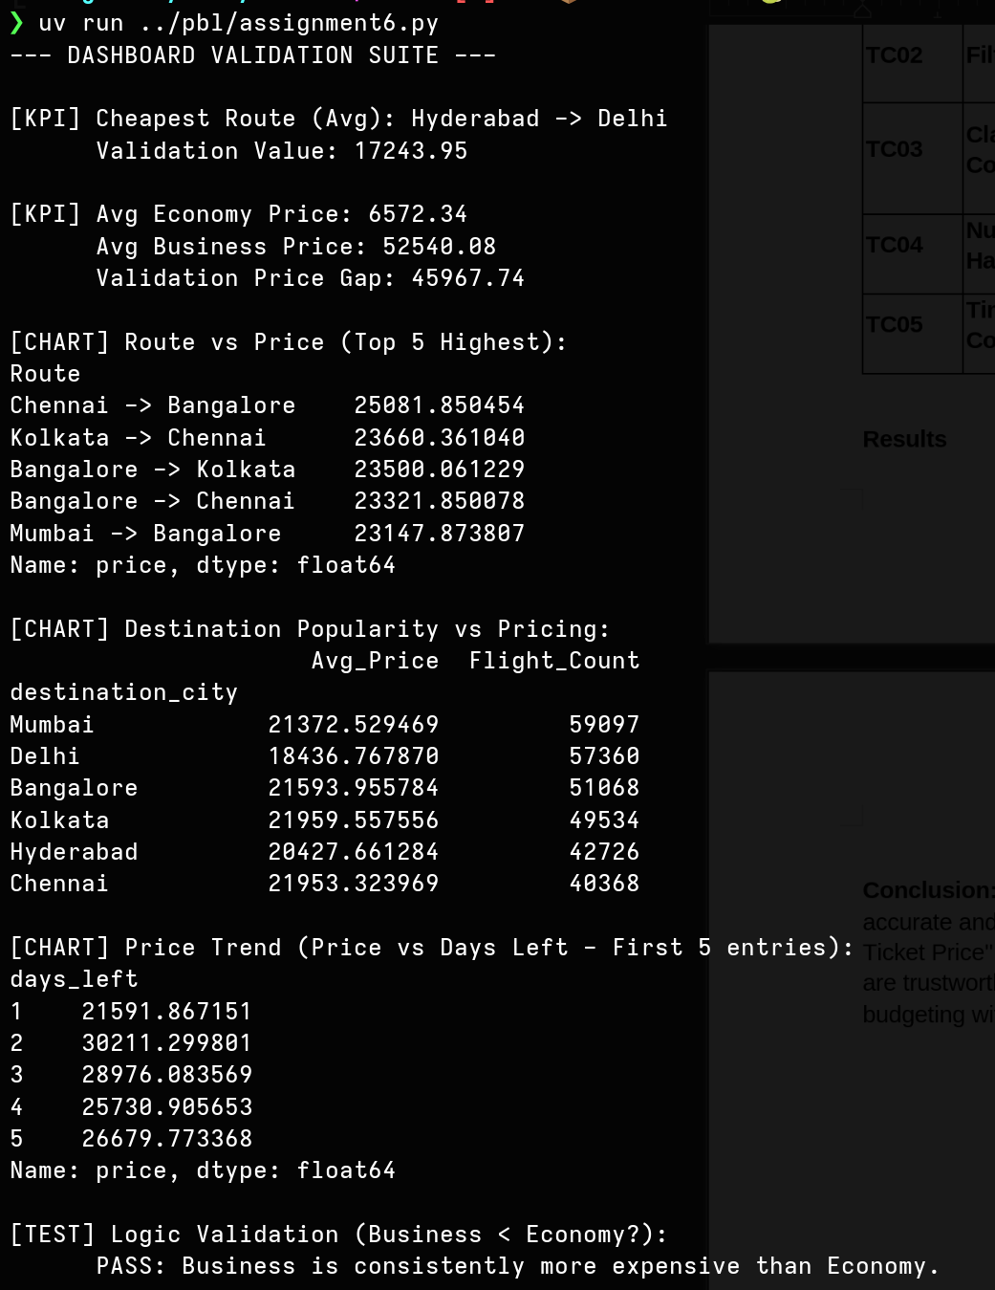
Test Case Output

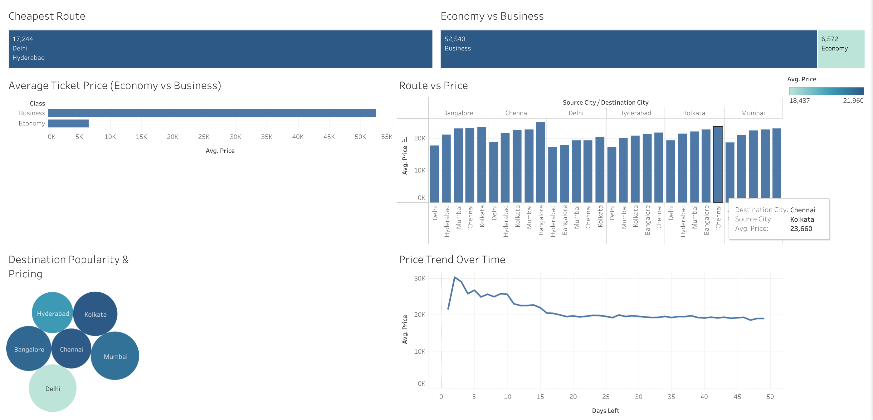
Dashboard Output

Thus, verified that KPIs and charts match test case output.
Conclusion: The testing phase confirmed that the Flight Price Analysis Dashboard is both accurate and robust. By identifying and correcting minor aggregation errors in the "Average Ticket Price" calculation during testing, we ensured that the final insights provided to travelers are trustworthy. Systematic testing ensures that the dashboard can be used for real-world travel budgeting without risk of data misinformation.

