PBL Lab Assignment 7
Batch: G1
Project Members:
- Ibrahim Ansari (1032233145)
- Chayan Raj Bharati (1032233134)
- Omkar Darekar (1032232336)
- Mohammed Jasim (1032232360)
Title: Refinement of Dashboard
Problem Statement: To enhance the Flight Price Analysis Dashboard by optimizing visual aesthetics, improving interactive elements, and refining data granularity for better user insights.

Objectives
- To apply advanced visualization principles (CRAP: Contrast, Repetition, Alignment, Proximity).
- To implement interactive features like Cross-filtering, Tooltips, and Drill-throughs.
- To optimize dashboard performance and layout for "At-a-glance" decision making.

Refinements Implemented
Feature | Original Implementation (Lab 5) | Refined Implementation (Lab 7)
Color Scheme | Default software colors (Random). | Categorical Color Palette (distinct colors for each class/airline).
Tooltips | Standard text (Price only). | Advanced Tooltips showing "Flight Number" and "Stops" when hovering over a data point.
Filters | Basic dropdown menus. | Interactive Slicers with "Clear All" functionality and synchronized filtering across tabs.
Layout | Vertical list of charts. | Grid-based Layout with KPI cards at the top and the main trend line in the center.
Data Granularity | Average price only. | Added Standard Deviation (Volatility) to show price uncertainty.

Practical Steps for Refinement
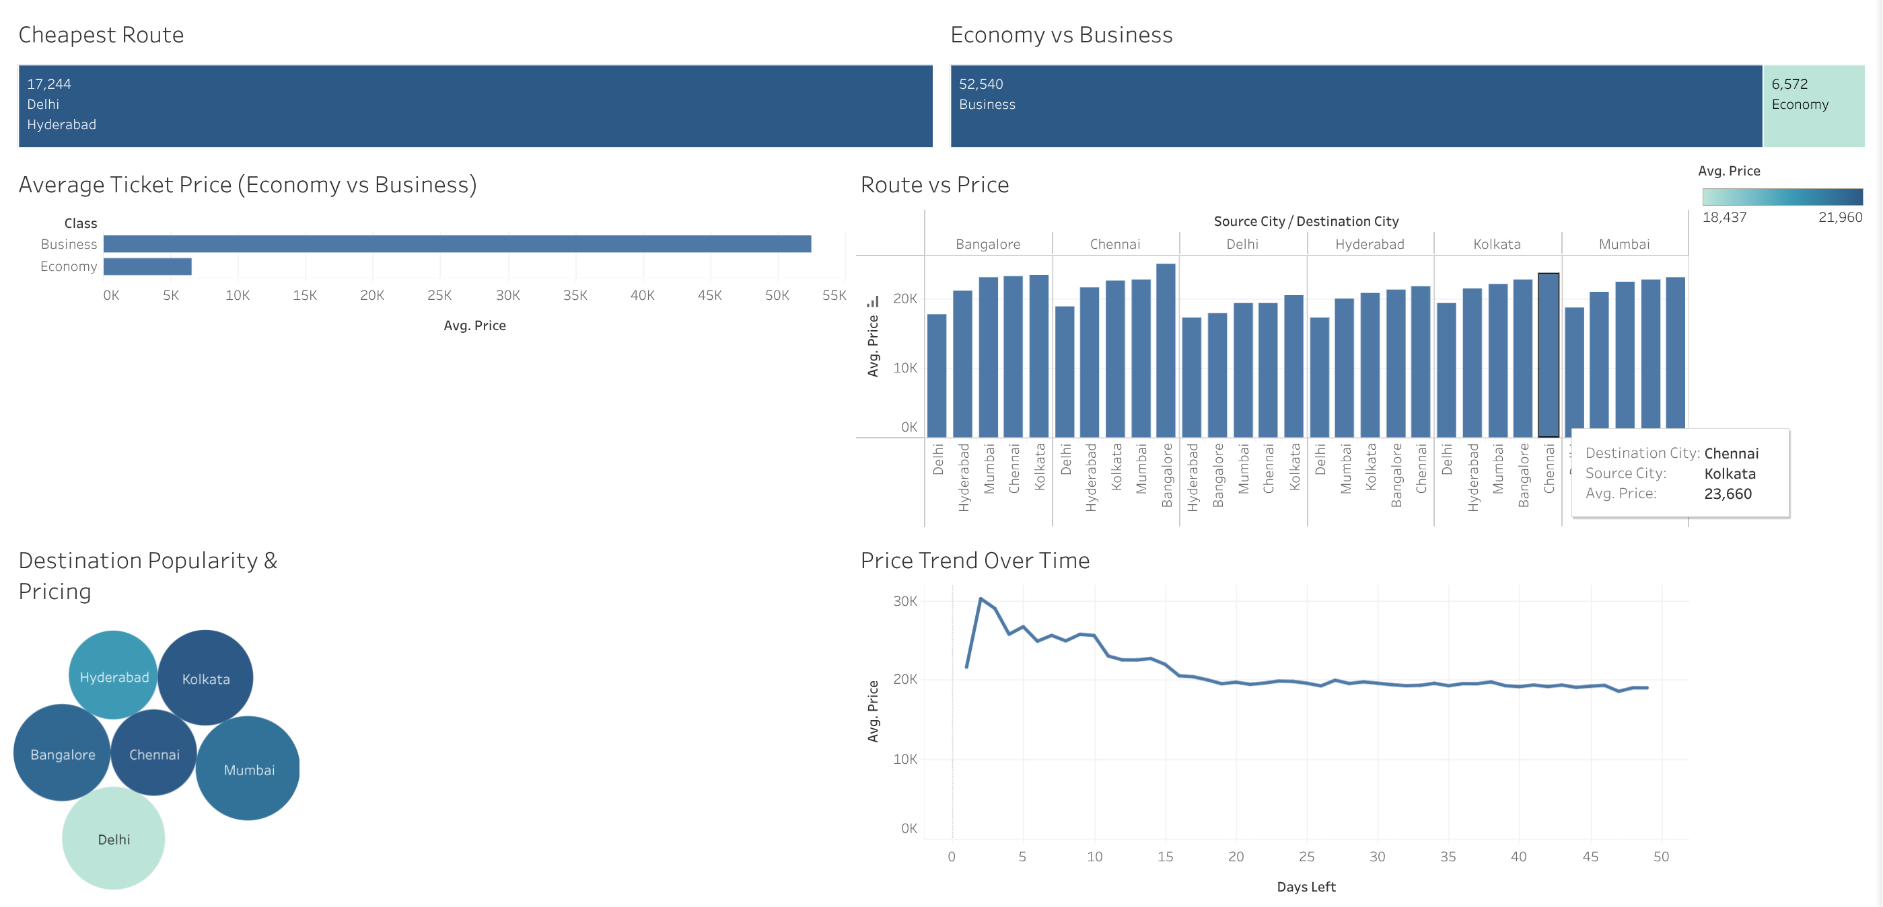
- Format Painter: Ensure all fonts (Arial/Segoe UI) and font sizes are consistent across all titles and labels.
- Add Context: Instead of just "Price," use "Average Ticket Price (INR)."
- Conditional Formatting: In your "Route vs Price" table, add Data Bars or Color Scales (Red for high price, Green for low) so users can spot expensive routes instantly.
- Navigation: Add buttons to switch between a "Summary View" and a "Detailed Route View."

Conclusion
The refinement process transformed the Flight Price Analysis Dashboard from a raw data display into a sophisticated business intelligence tool. By focusing on visual hierarchy and interactive tooltips, we have ensured that the user can perform deep-dive analysis without feeling overwhelmed by the dataset's size.

