PBL Lab Assignment 2
Batch: G1
Project Members:
- Ibrahim Ansari (1032233145)
- Chayan Raj Bharati (1032233134)
- Omkar Darekar (1032232336)
- Mohammed Jasim (1032232360)
Title: Exploration of Data and problem analysis
Objectives:
- To examine how flight prices fluctuate over various time dimensions—such as seasons, months, and days of the week—enabling users to identify the "cheapest" periods to fly.
- To perform a comparative analysis of pricing structures across different carriers on identical routes to determine value-for-money trends and airline-specific pricing strategies.
- To quantify the relationship between external variables (e.g., booking lead time, flight duration, and number of stops) and the final ticket cost.
- To transform complex, multi-dimensional datasets into intuitive, interactive visual dashboards that allow users to drill down by route, airline, and date.
Scope:
- Multi-Dimensional Data Filtering and Retrieval
- Comprehensive Visual Trend Analysis
- Comparative Airline and Route Bench-marking
- Analytical Reporting without Transactional Features
Tools Used:
- Jupyter
- Numpy
- MatPlotLib
- Python

Tasks to be performed:
- Download dataset
- Import the necessary files
- Read the dataset
- Display the dataset (head, tail)
- Identify the missing values
- Display the feature names in your dataset
- Data cleaning and handling missing values
  - Zero imputation
  - Mean imputation
  - Median imputation
- Identifying the outliers
- Data visualization
  - Display at least 5-7 visualization graphs
  - Histogram, Bar graph, Pie chart, Scatter plot, Box-whisker plot, KDE plot, Heat-map
Screenshots: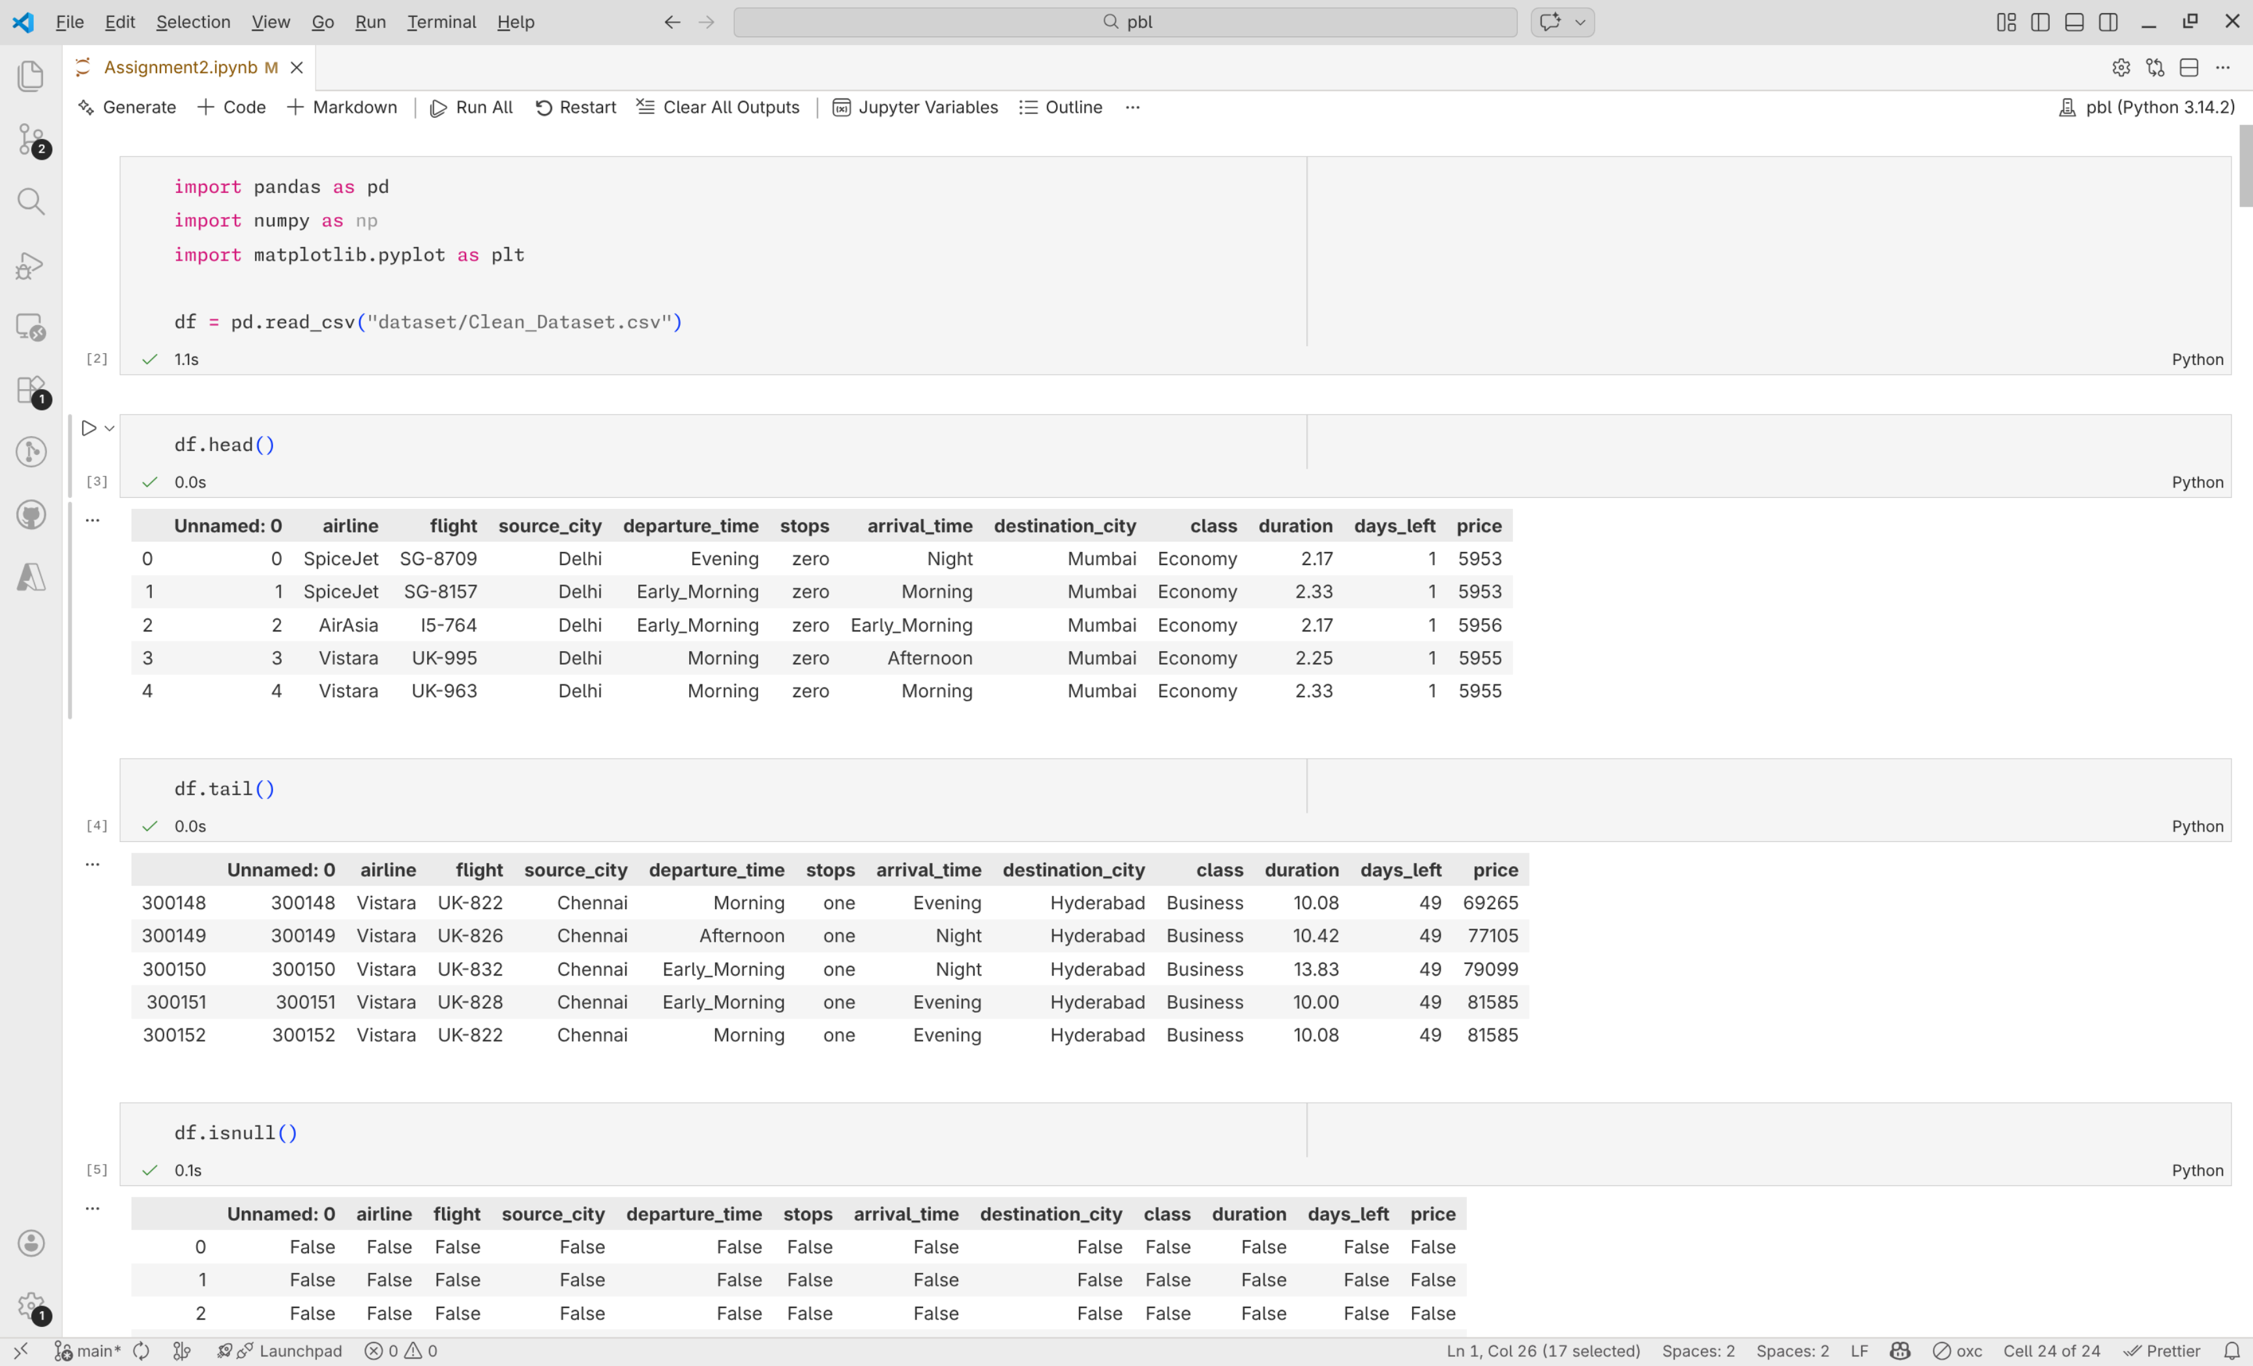
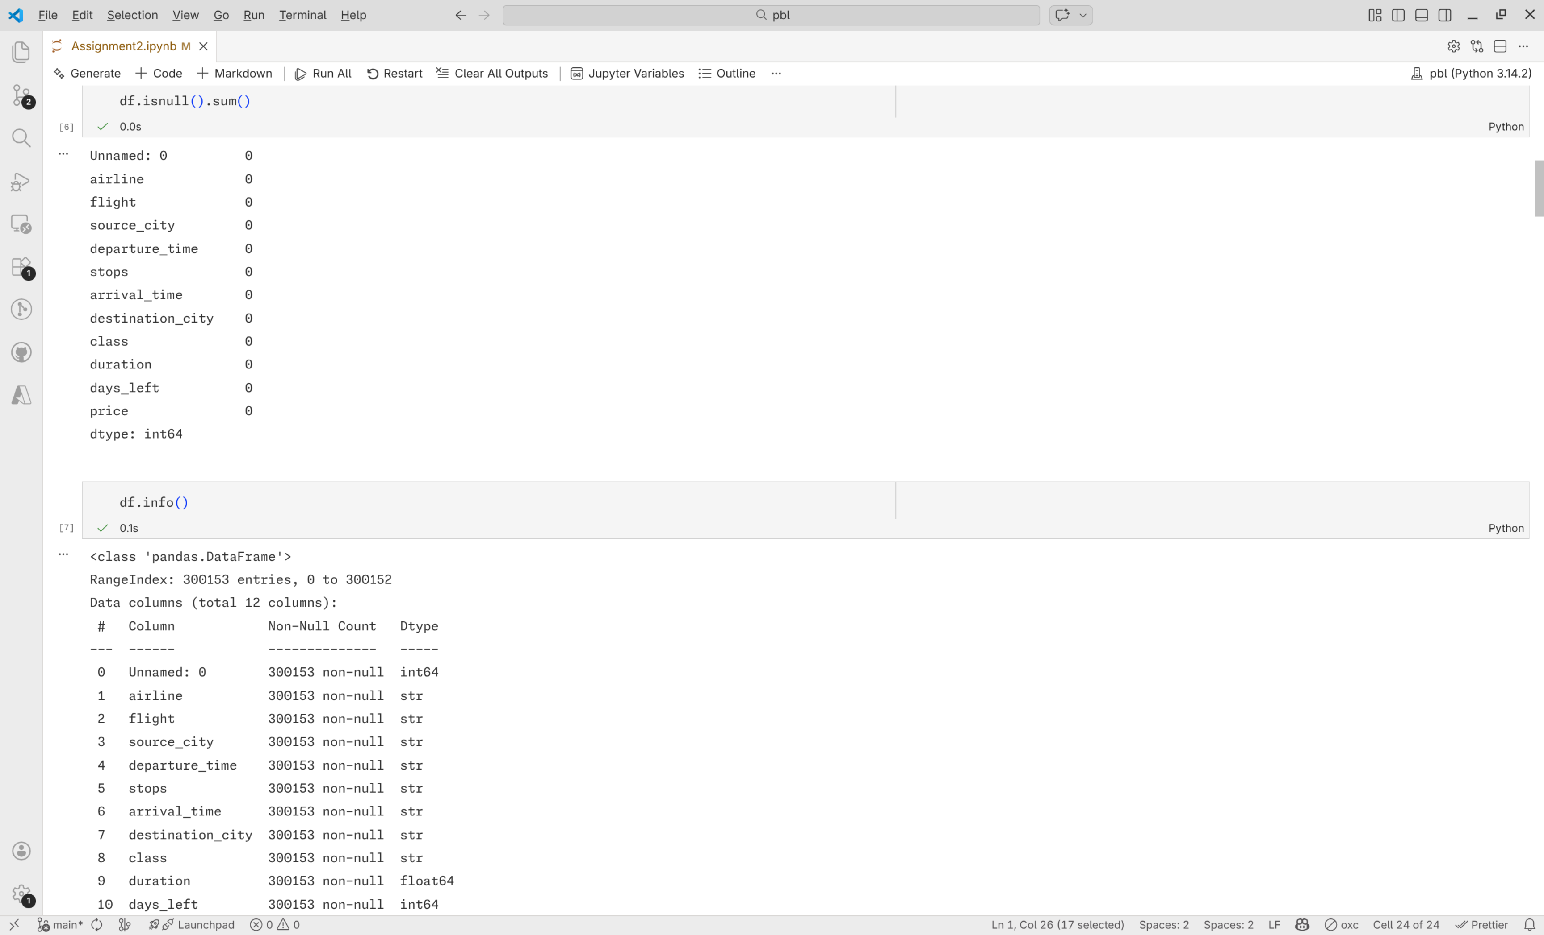
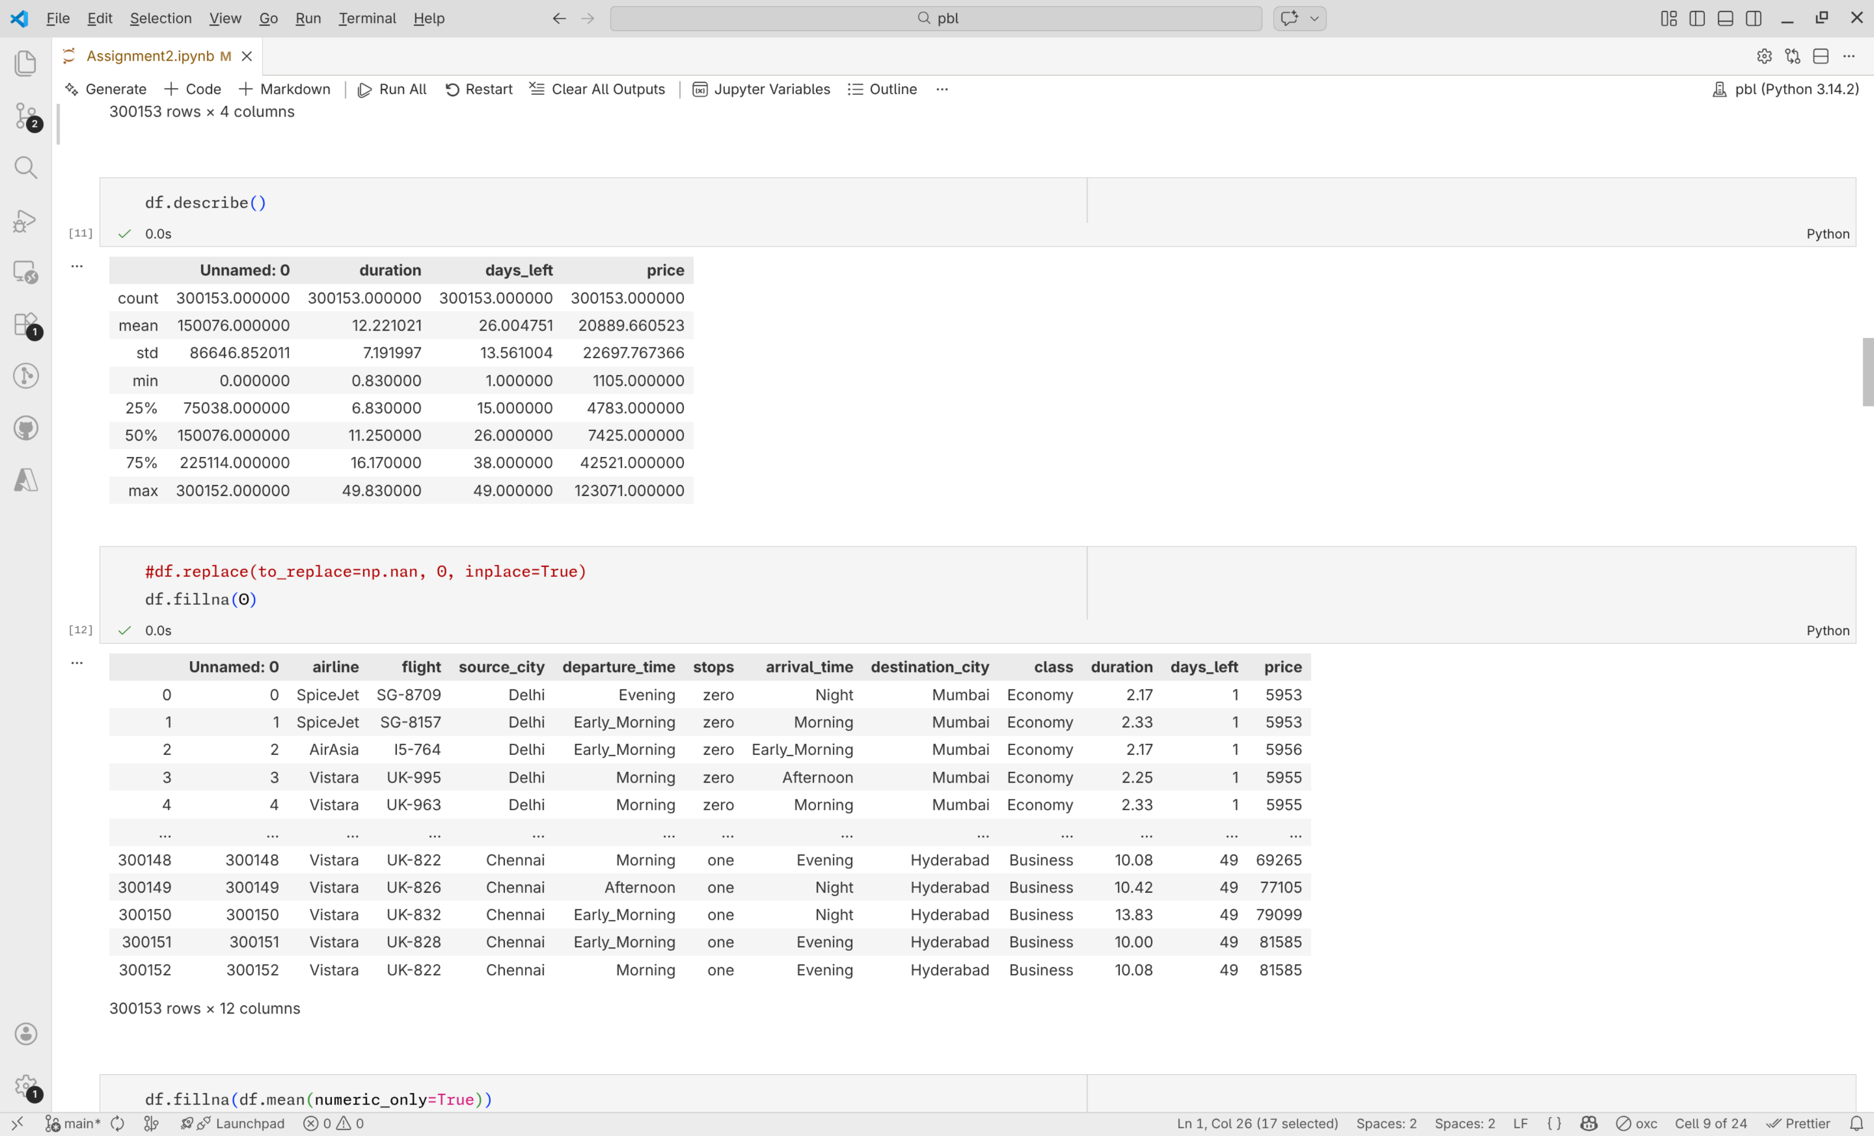
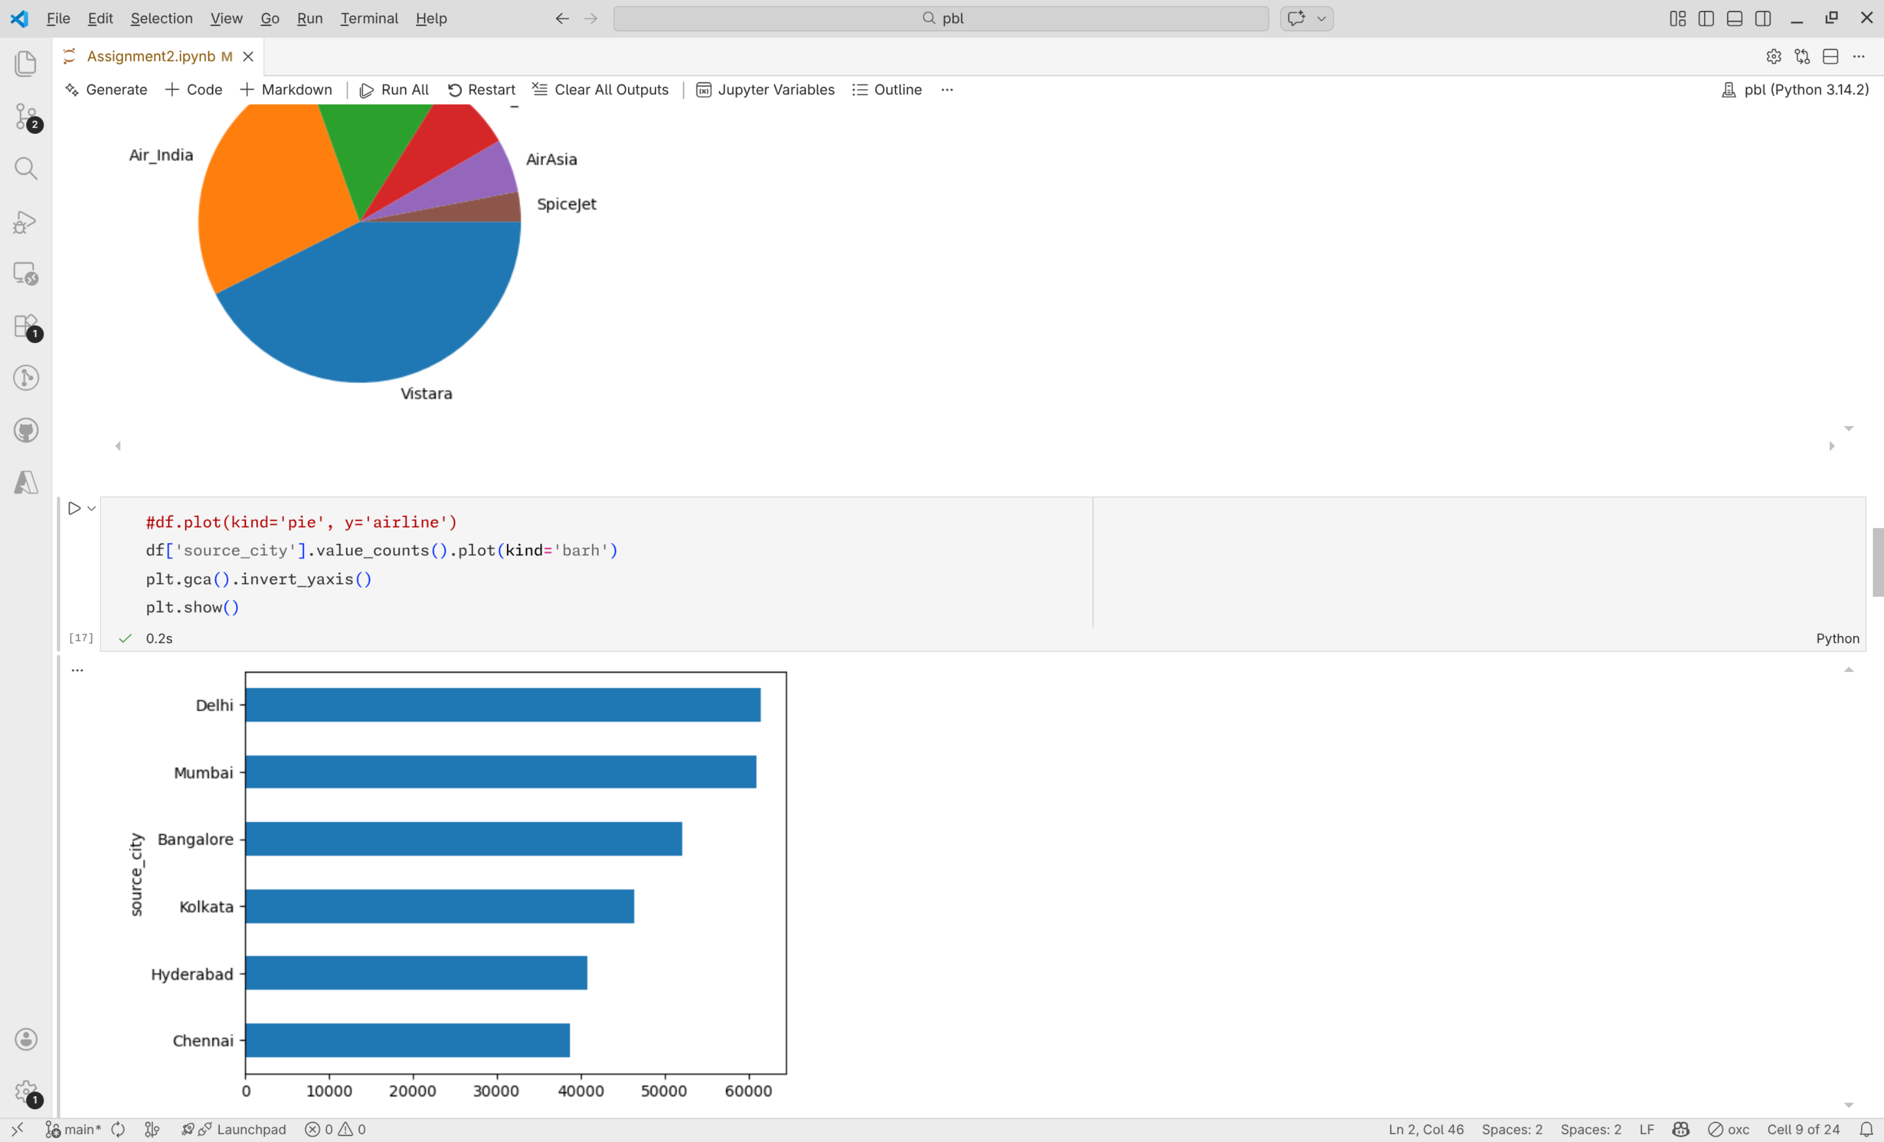
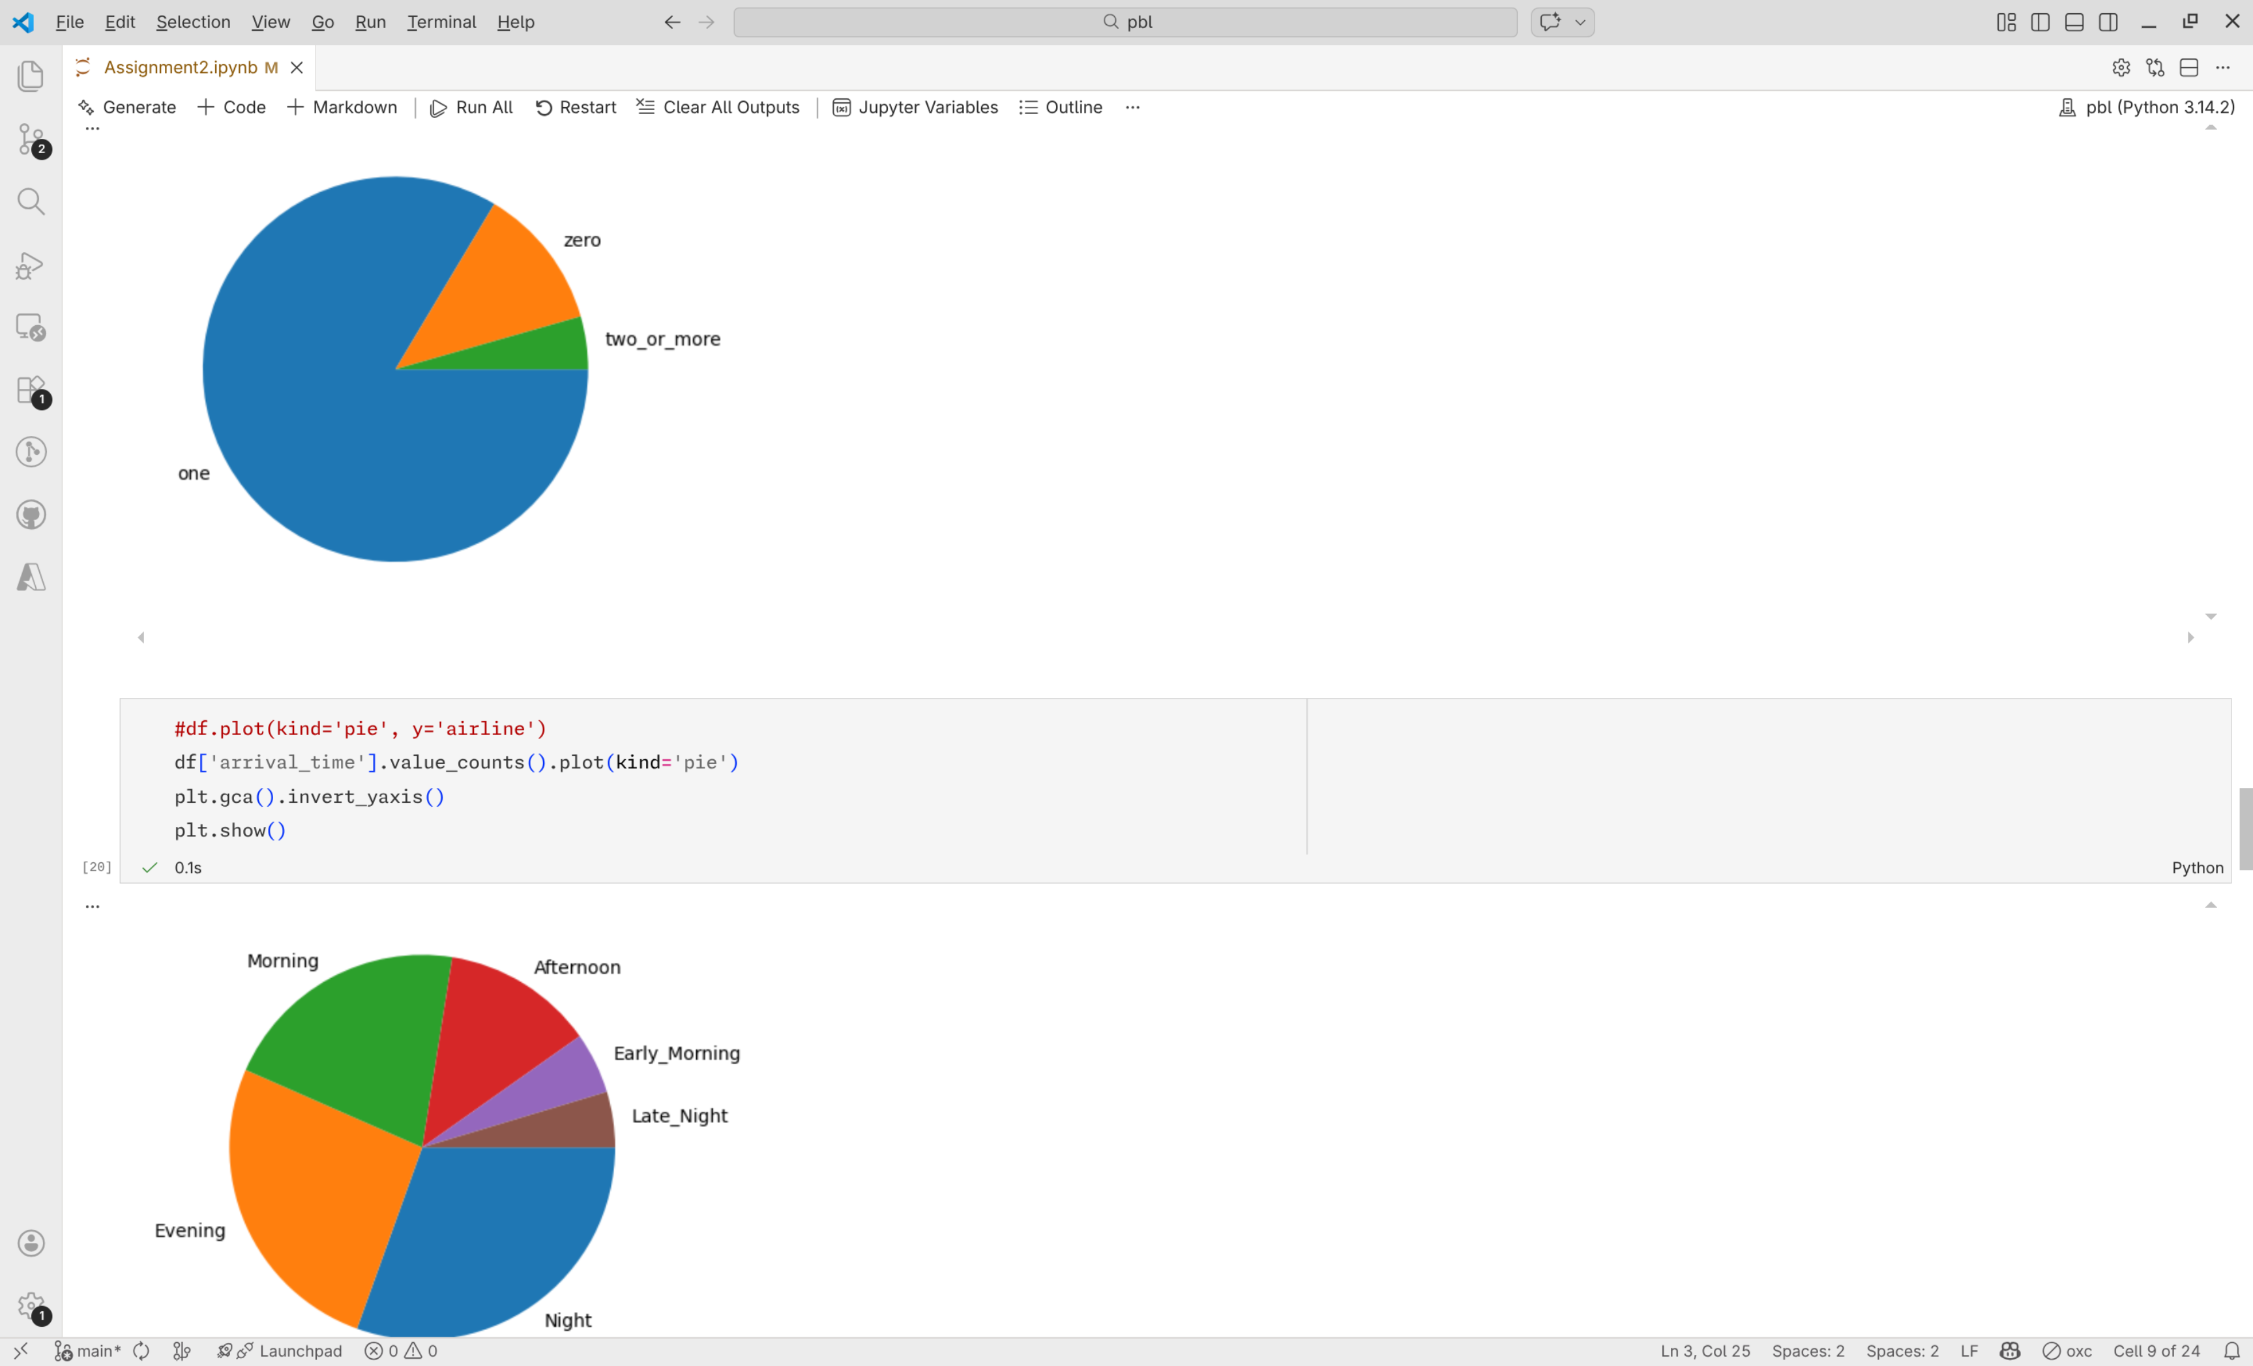

Conclusion: Thus, successfully explored data, visualized it and analyzed the dataset in the problem statement

