ASSIGNMENT NO: 04
Title: Named Entity Recognition (English and Hindi)

Problem Statement
To demonstrate Named Entity Recognition in NLP: build an NER pipeline, take different inputs (a corpus paragraph, a benchmark-dataset sentence and a live URL) in English and Hindi, and demonstrate the various named entities visually.

Objectives
- To learn the concepts of NER in NLP.
- To apply a pretrained English NER model (spaCy) and a pretrained multilingual NER model (mBERT) to text in two languages and scripts.
- To scrape a live news article, clean it, and visualise the entities it contains.
- To measure the Hindi model's span-level precision, recall and F1 against gold labels.

Algorithm / Implementation

Section 1 — English NER on the NLTK Brown corpus (spaCy)
- Download the Brown corpus with nltk.download('brown') and the spaCy pipeline en_core_web_sm.
- Select the first document of the "news" category and join its first 250 words into one string.
- Run doc = nlp_en(document); each span in doc.ents gives text, label, start and end character offsets.
- Tabulate the entities in a pandas DataFrame.
- Visualise: seaborn count plot of labels; a word cloud of the entity strings (multi-word entities joined with underscores so they stay together); displacy.render(doc, style="ent") for in-context highlighting.

Section 2 — Hindi NER on the PAN-X benchmark (mBERT)
- Load the Hindi split of PAN-X (WikiANN) from the google/xtreme dataset: 5 000 train, 1 000 validation, 1 000 test sentences, token-level IOB2 tags for PER, LOC, ORG.
- Select the first training sentence that contains at least one entity tag and join its tokens.
- Load the transformers pipeline("ner") with Davlan/bert-base-multilingual-cased-ner-hrl (mBERT fine-tuned on 10 high-resource languages including Hindi) and aggregation_strategy="simple" so word pieces are merged back into whole entities.
- Tabulate entity, type, offsets and confidence score.
- Draw a horizontal bar chart of confidence per entity with a Devanagari font (Noto Sans Devanagari) and the entity type annotated at the end of each bar.

Section 3 — Live Hindi news scraping and NER (BBC Hindi)
- Fetch the BBC Hindi home page with requests and parse it with BeautifulSoup; pick the first link containing /hindi/articles/.
- Fetch that article; take the <h1> as the headline and join all <p> blocks longer than five words as the body.
- Clean: collapse line breaks and repeated spaces, remove zero-width spaces (\u200b) and non-breaking spaces (\xa0); keep the first 1 500 characters to stay within the model's 512-token limit.
- Run the same mBERT pipeline; drop any 'O' groups; tabulate entity, type and confidence.
- Render with displaCy in manual mode by passing {text, ents:[{start, end, label}]} built from the pipeline output.
- A fallback paragraph is used if the site is unreachable, so the cell always runs.

Section 4 — Performance metrics (Hindi model vs PAN-X gold labels)
- Take the first 300 sentences of the PAN-X Hindi test split; each carries gold token-level tags (O, B-PER, I-PER, B-ORG, I-ORG, B-LOC, I-LOC).
- Join each sentence's tokens with spaces, run the mBERT pipeline, and map every returned entity's character span back onto the tokens it overlaps, emitting B-type for the first token and I-type for the rest; all other tokens are O.
- Score at span level (CoNLL rule, implemented inline): a predicted span is a true positive only if its boundaries and type both match a gold span; an unmatched prediction is a false positive; an unmatched gold span is a false negative.
- Precision = TP / (TP + FP); Recall = TP / (TP + FN); F1 = 2PR / (P + R). Report micro-averaged overall scores and per-type scores with support, and plot per-type P/R/F1.
- Sections 1 and 3 (Brown paragraph, BBC article) have no gold annotations, so they are demonstrations only; only Section 2's data source allows measurement.

Core code
doc_en = nlp_en(document_en)
df = pd.DataFrame([{"Entity": e.text, "Label": e.label_, "Start": e.start_char, "End": e.end_char} for e in doc_en.ents])
displacy.render(doc_en, style="ent", jupyter=True)

ner_hi = pipeline("ner", model="Davlan/bert-base-multilingual-cased-ner-hrl", aggregation_strategy="simple")
ents = ner_hi(text) # [{'entity_group','score','word','start','end'}, ...]

displacy.render({"text": text, "ents": [{"start": e["start"], "end": e["end"], "label": e["entity_group"]} for e in ents]},
style="ent", manual=True, jupyter=True)

gold, pred = get_spans(true_tags), get_spans(pred_tags) # sets of (type, start, end)
y_true = [[tag_names[t] for t in ex["ner_tags"]] for ex in test]
y_pred = [predict_bio_tags(ex["tokens"]) for ex in test] # char offsets -> per-token BIO
TP = len(gold & pred); FP = len(pred - gold); FN = len(gold - pred)

Platform
64-bit open-source Linux; Python 3, Google Colab; spaCy 3 with en_core_web_sm; NLTK (Brown corpus); transformers + torch with Davlan/bert-base-multilingual-cased-ner-hrl; datasets (google/xtreme PAN-X.hi); requests, BeautifulSoup; pandas, matplotlib, seaborn, wordcloud; Noto Sans Devanagari font.

Input
# | Language | Input | Source | Size
1 | English | News paragraph | NLTK Brown corpus, category "news", first document, first 250 words | ≈1 450 characters
2 | Hindi | Benchmark sentence | PAN-X (WikiANN) Hindi train split, first sentence with an entity tag | 2 sentences, 3 entities
4 | Hindi | Evaluation set | PAN-X Hindi test split, first 300 sentences with gold BIO tags | 300 sentences
3 | Hindi | Live news article | BBC Hindi, first article link on the home page at run time (Indian stock-market fall story) | first 1 500 characters
Table 1 — Inputs used in the three sections and the evaluation set.

Output

Section 1 — English (Brown corpus, spaCy)
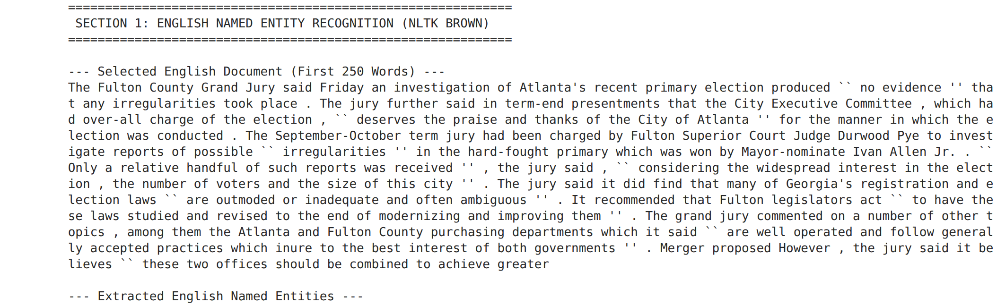
Figure 1 — The selected Brown-corpus news document (first 250 words). Inference: The text is 1960s newspaper prose with many proper names, dates and place names — well suited to the OntoNotes-trained model.
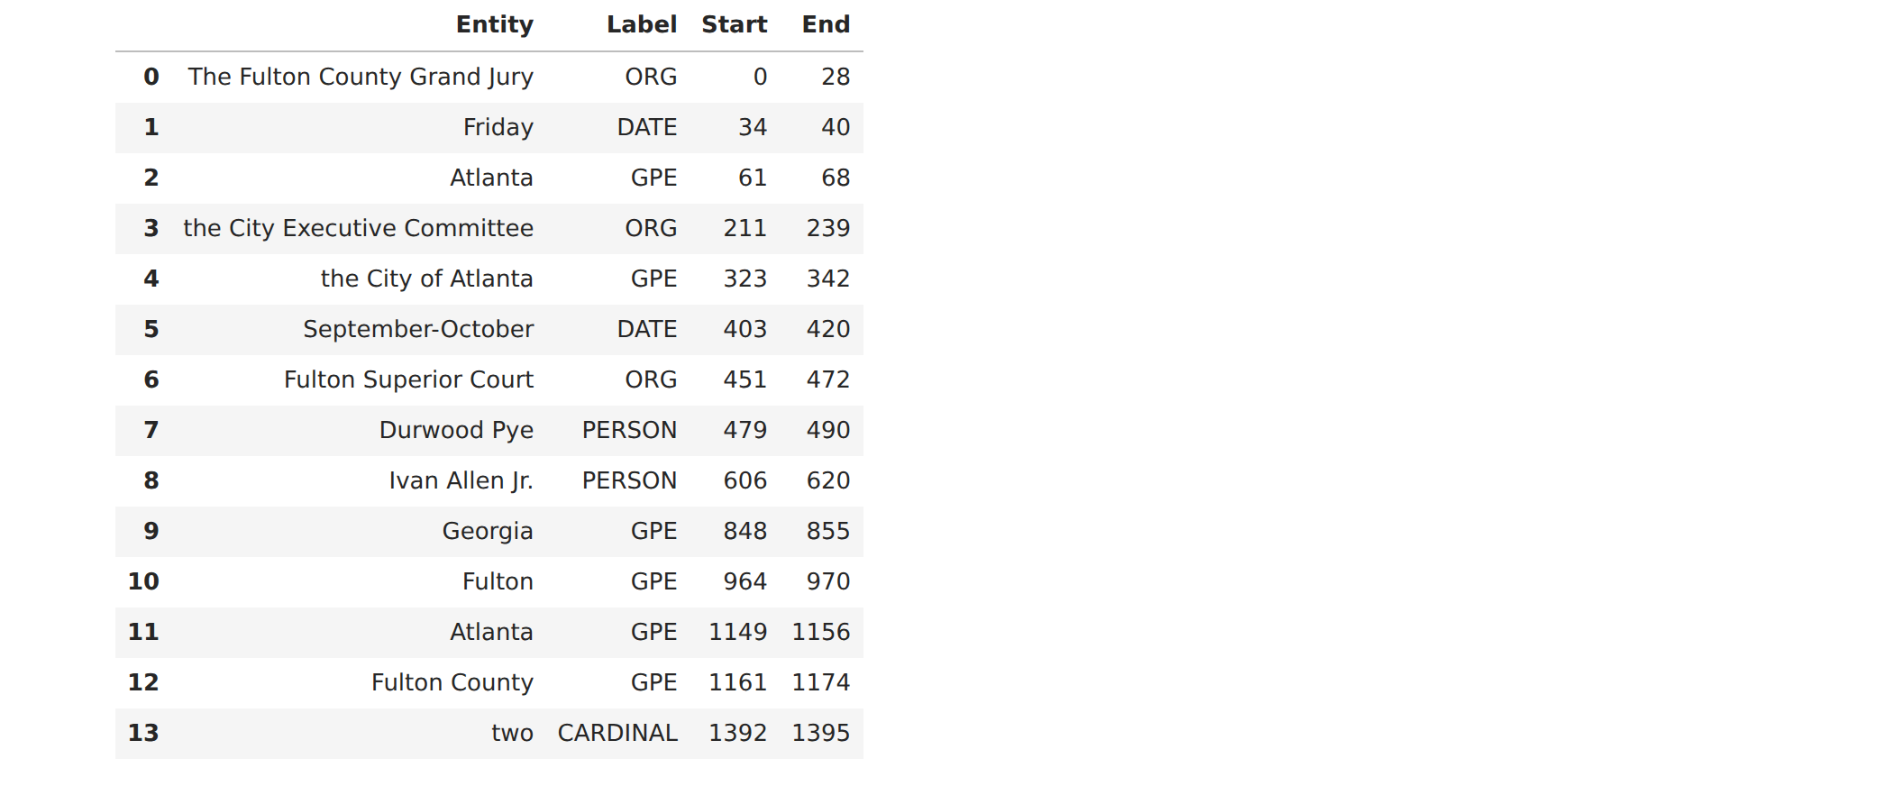
Table 2 — English entities extracted by spaCy with character offsets. Inference: 14 entities of five types; the model captured leading articles in spans such as "The Fulton County Grand Jury", a boundary error that exact-match scoring would penalise.
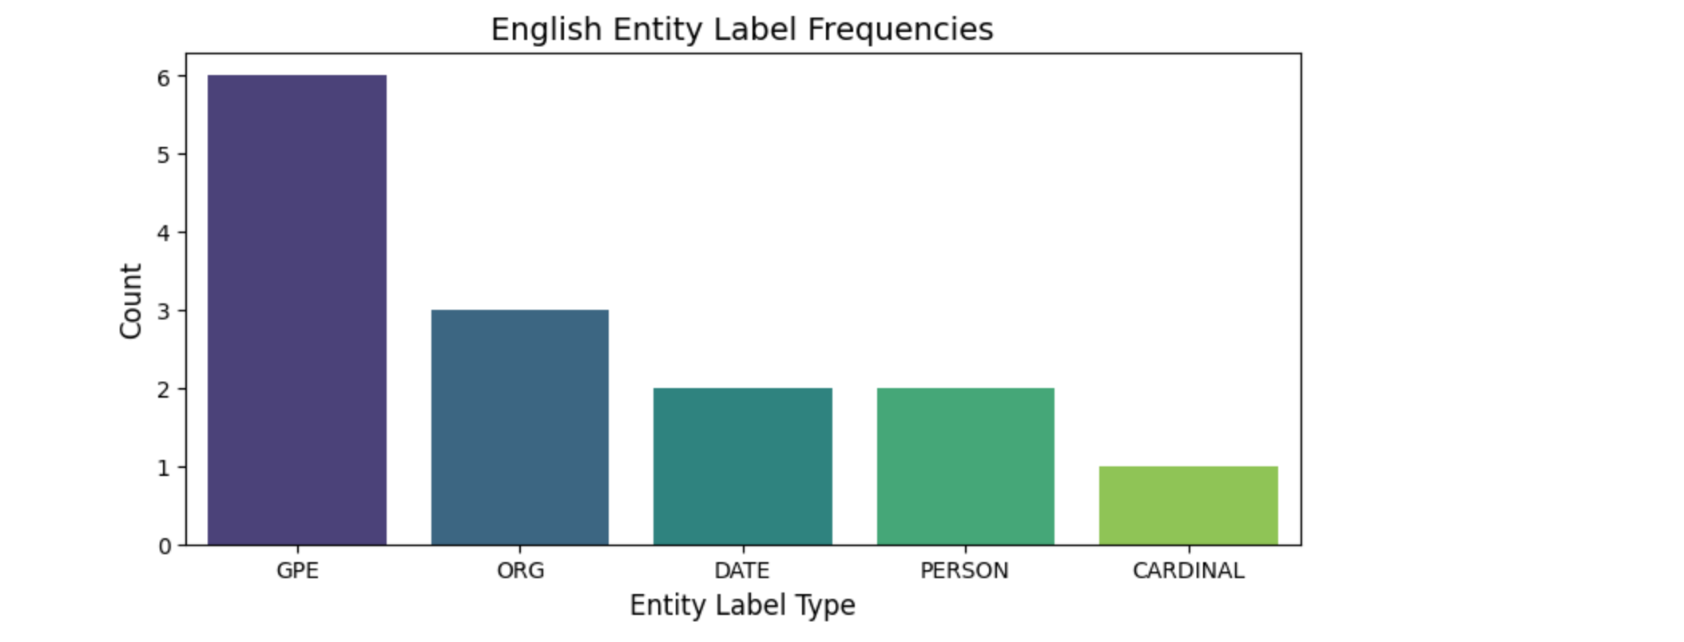
Figure 2 — English entity-label frequencies. Inference: GPE (6) and ORG (3) dominate, as expected for a local-government news story; only five of spaCy's 18 label types occur, so the label variety depends on the text, not the model.
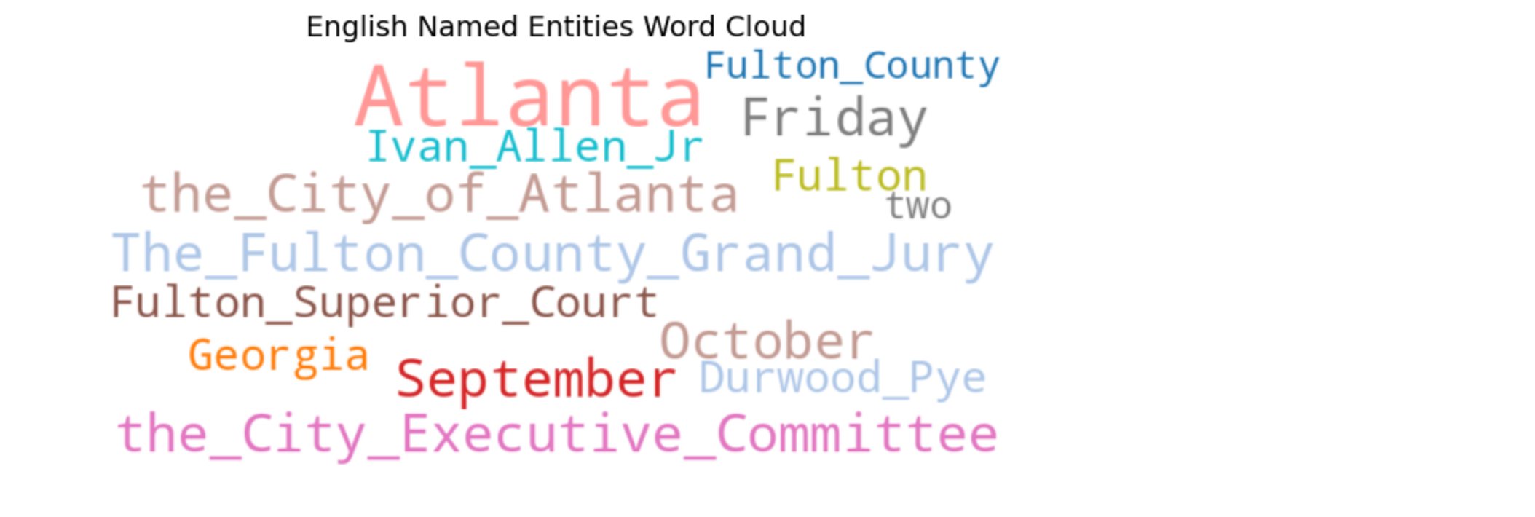
Figure 3 — Word cloud of English named entities. Inference: Atlanta, Fulton and the City of Atlanta are the most repeated entities, confirming that the story is about one city's administration.
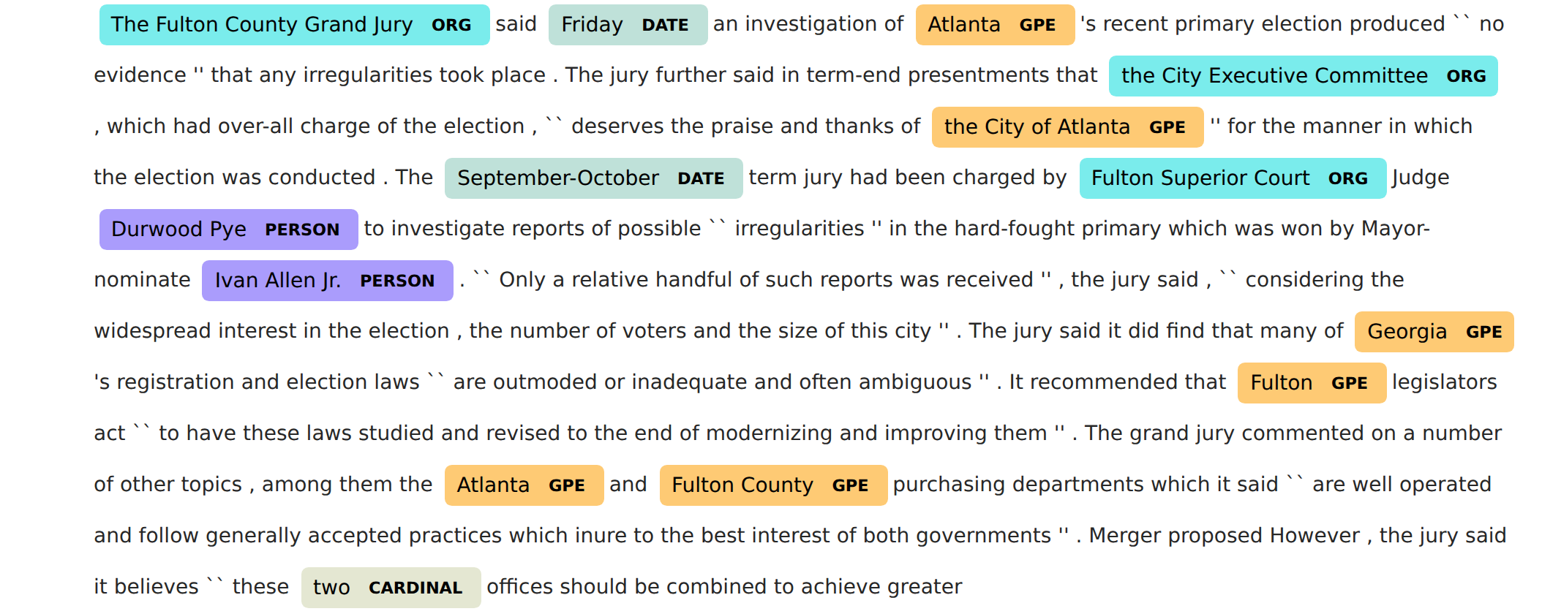
Figure 4 — displaCy view of the English document. Inference: Colour-coding makes errors visible at a glance: entities are correct in context except "Ivan Allen Jr." being split from the surrounding title.

Section 2 — Hindi (PAN-X benchmark, mBERT)
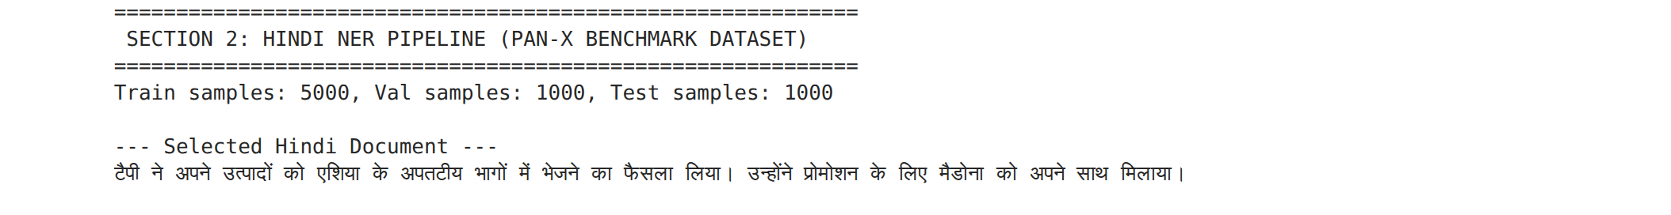
Figure 5 — PAN-X Hindi split sizes and the selected training sentence. Inference: The benchmark provides 5 000 / 1 000 / 1 000 sentences; the chosen sentence contains three entities, enough to demonstrate all three PER/LOC/ORG classes.
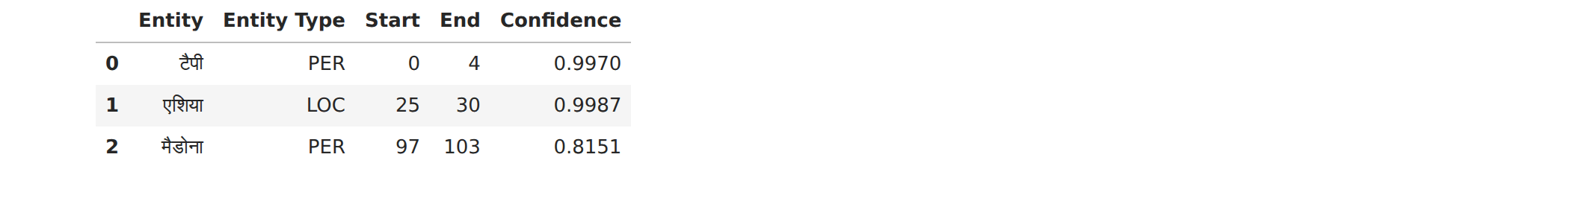
Table 3 — Hindi entities from the PAN-X sentence with confidence scores. Inference: All three entities were found with the right type; मैडोना (Madonna) scored lowest (0.82) because a transliterated foreign name is rare in Hindi text.
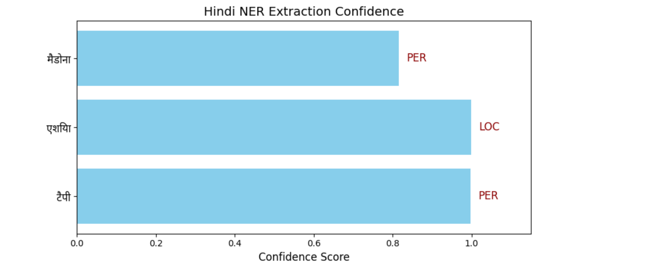
Figure 6 — Confidence per entity with Devanagari labels and the type annotated in red. Inference: Confidence is above 0.8 for every entity, but confidence is the model's own certainty and not a measure of correctness — see Section 4.

Section 3 — Live Hindi news (BBC Hindi, mBERT)
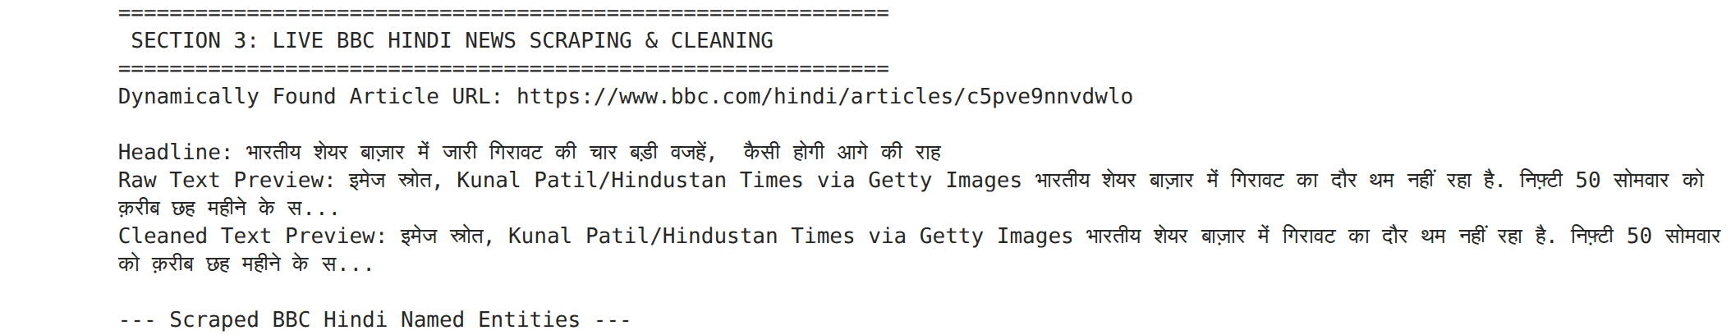
Figure 7 — Article URL discovered at run time, headline, and raw versus cleaned text previews. Inference: The scraper found a live article without a hard-coded URL; the cleaned preview shows that stray whitespace and invisible characters were removed before tagging.
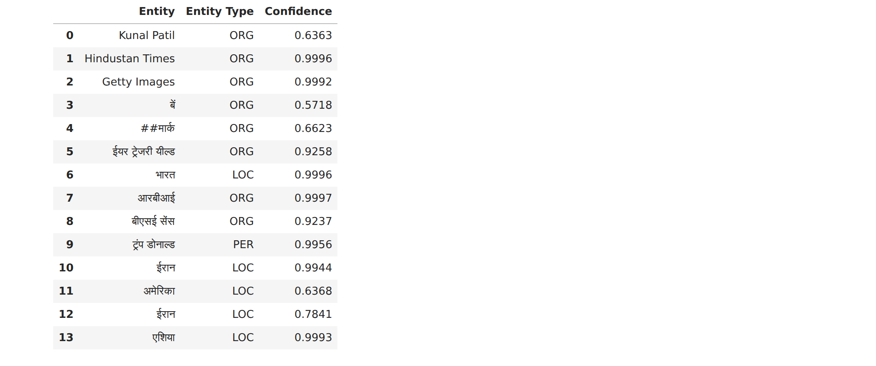
Table 4 — Entities extracted from the BBC Hindi article. Inference: 14 entities across ORG, LOC and PER; Latin-script names (Hindustan Times, Getty Images) and Devanagari names (आरबीआई, भारत) were tagged in one pass, but बें / ##मार्क are word-piece fragments the aggregation did not merge.
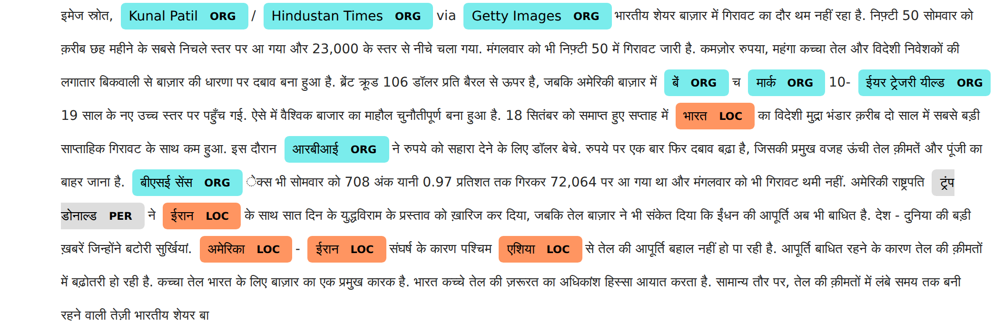
Figure 8 — displaCy rendering (manual mode) of the Hindi article. Inference: Countries appear as LOC rather than GPE because the WikiANN scheme has no GPE class; no dates or numbers are tagged because the scheme has no such classes.

Section 4 — Performance metrics (PAN-X Hindi test, 300 sentences)
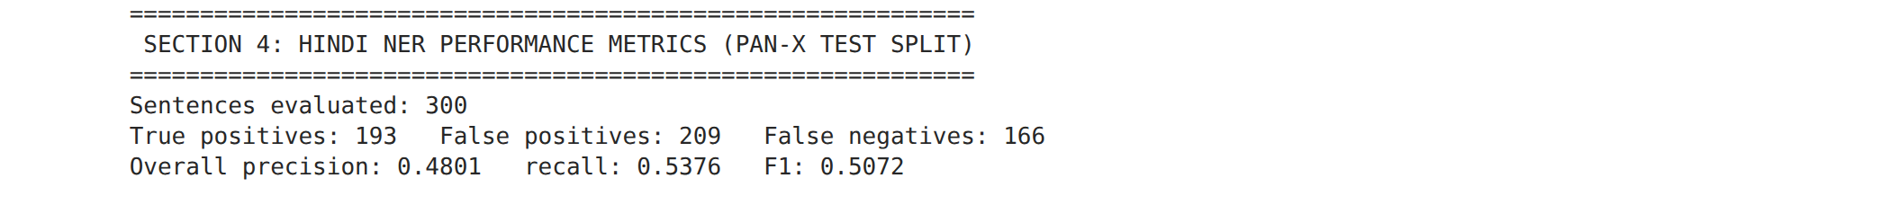
Figure 9 — Overall counts and scores on 300 PAN-X test sentences. Inference: 193 true positives against 209 false positives and 166 false negatives give precision 0.480, recall 0.538, F1 0.507 — the model over-generates spans more than it misses them.
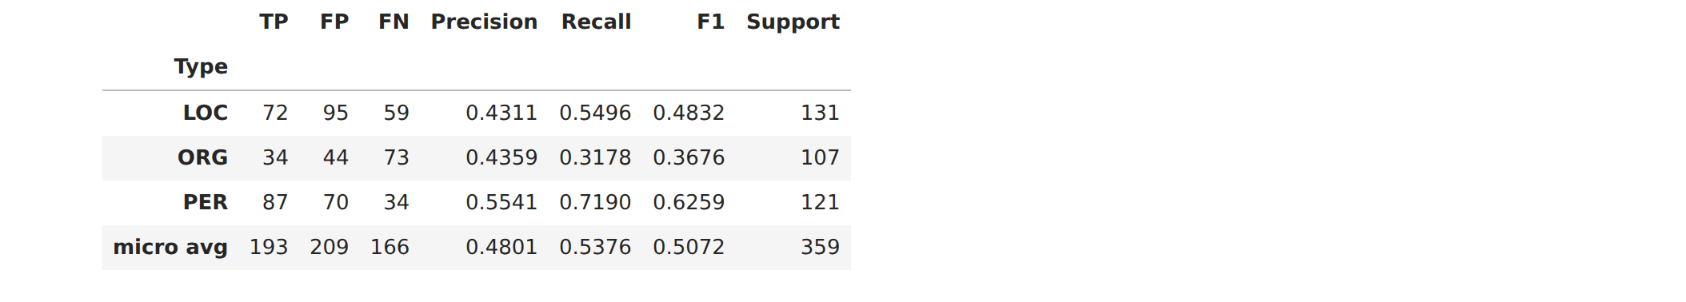
Table 5 — Per-type span-level precision, recall and F1 with support. Inference: PER is easiest (F1 0.63), ORG hardest (F1 0.37, recall 0.32): organisation names in Hindi are long and often transliterated, so exact span matches are rare.
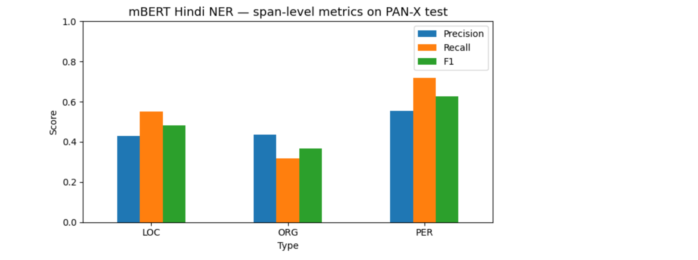
Figure 10 — Precision, recall and F1 by entity type. Inference: Recall exceeds precision for PER and LOC but not ORG, confirming that the model finds most person and place names but fragments or mislabels organisations.

Results summary
Input | Model | Entities | Types found | Notes
Brown paragraph (EN) | spaCy en_core_web_sm | 14 | ORG 3, GPE 6, DATE 2, PERSON 2, CARDINAL 1 | 18-label OntoNotes scheme
PAN-X sentence (HI) | mBERT ner-hrl | 3 | PER 2, LOC 1 | Confidence 0.82–0.999
BBC Hindi article | mBERT ner-hrl | 14 | ORG 8, LOC 5, PER 1 | 3-type PER/LOC/ORG scheme
Table 6 — Entity counts and types found per input.

Type | TP | FP | FN | Precision | Recall | F1 | Support
PER | 87 | 70 | 34 | 0.554 | 0.719 | 0.626 | 121
LOC | 72 | 95 | 59 | 0.431 | 0.550 | 0.483 | 131
ORG | 34 | 44 | 73 | 0.436 | 0.318 | 0.368 | 107
Micro average | 193 | 209 | 166 | 0.480 | 0.538 | 0.507 | 359
Table 7 — Span-level metrics of the Hindi model on 300 PAN-X test sentences.

Observations
- spaCy's English model has 18 entity types; the mBERT model has only PER, LOC and ORG. So the Hindi outputs show fewer types, and countries appear as LOC instead of GPE.
- The same mBERT model handled English and Hindi text in one pass with high confidence.
- A few Hindi entities are broken word pieces (बें / ##मार्क). A stricter aggregation strategy or a confidence filter would remove them.
- Confidence is not accuracy. Against gold labels the Hindi model scored F1 0.507 (precision 0.480, recall 0.538). PER was easiest (F1 0.63), ORG hardest (F1 0.37).
- The score is moderate because the model was not fine-tuned on Hindi, and scoring requires exact span and type match.

Conclusion
Hence, learned the concepts of NER. A pretrained spaCy pipeline was applied to an English Brown-corpus paragraph, and a pretrained multilingual BERT NER model was applied to a Hindi PAN-X benchmark sentence and to a live BBC Hindi news article scraped and cleaned at run time. Entities were demonstrated visually with tables, a label-frequency chart, a word cloud, confidence bar charts with Devanagari labels, and displaCy highlighting for both languages. The English model recognised five of its eighteen entity types; the multilingual model recognised PER, LOC and ORG across both Latin and Devanagari script with high confidence, with a few sub-word fragments that a stricter aggregation strategy would remove. Scored against PAN-X gold labels on 300 test sentences, the Hindi model reached precision 0.480, recall 0.538 and F1 0.507.

