ASSIGNMENT NO: 05
Title: Text Summarization using NLTK

Problem Statement
To build and compare four types of text summarization — extractive, abstractive, generic and query-based — on an English news article (CNN/DailyMail) and a Hindi news article (XL-Sum), with three tunable parameters (summary ratio, number of sentences, frequency weight), and to evaluate the summaries against journalist-written reference summaries with ROUGE-1, ROUGE-2, ROUGE-L, compression ratio and content coverage.

Objectives
- To learn the concepts of extractive and abstractive text summarization in NLP.
- To implement generic and query-based summarizers with NLTK and scikit-learn, and abstractive summarizers with pretrained T5 and mT5 models.
- To evaluate summaries with ROUGE on standard public corpora and study the effect of the three tunable parameters.
- To repeat the comparison on Hindi and note what changes for an Indic language.

Algorithm / Implementation

Corpora
- CNN/DailyMail (Hermann et al. 2015; See et al. 2017) — ~300 000 English news articles, each paired with the journalist's 3–4 sentence "highlights". The standard English summarization benchmark. One article is taken from the test split (11 490 articles).
- XL-Sum (Hasan et al. 2021) — BBC news articles with a one-sentence journalist summary in 45 languages. One article is taken from the Hindi test split (8 847 articles).

Common preprocessing (NLTK)
- Split the article into sentences with sent_tokenize() and into words with word_tokenize().
- Lower-case, keep alphabetic tokens, remove English stopwords, lemmatize with WordNetLemmatizer.
- Count word frequencies over the cleaned tokens and normalise by the maximum frequency.
- Target number of sentences = min(round(number_of_sentences × summary_ratio), num_sentences).

Summarizer 1 — Extractive (frequency scoring)
- Score every sentence as the mean normalised frequency of its cleaned words.
- Rank sentences, keep the top target sentences, output them in original order.

Summarizer 2 — Abstractive (T5-small for English, mT5 XL-Sum for Hindi)
- Split the article into chunks of 250 (English) or 200 (Hindi) words.
- Prefix each chunk with "summarize: " (T5) and generate with beam search (4 beams, no repeated n-grams).
- Concatenate the chunk summaries; if longer than the word target (article words × summary ratio, clamped to 40–130), summarize once more.

Summarizer 3 — Generic (frequency + position + length)
- frequency_score = mean normalised word frequency; position_score = (N − index) / N; length_score = min(words / 20, 1).
- final = frequency_weight × frequency_score + (1 − frequency_weight) × position_score + 0.1 × length_score; keep the top target sentences.

Summarizer 4 — Query-based (TF-IDF similarity)
- Fit a TfidfVectorizer on [query] + sentences and compute cosine similarity between the query and every sentence.
- final = 0.8 × similarity + 0.2 × frequency_score; keep the top target sentences.
- English query: built from the article's six most frequent content words. Hindi query: the BBC headline.

Hindi-specific changes
- Sentence splitting by regex on । ? ! and "." — NLTK's punkt does not recognise the Devanagari full stop.
- Devanagari-only word regex and a small Hindi stopword list; no lemmatiser (NLTK has none for Hindi).
- Abstractive model csebuetnlp/mT5_multilingual_XLSum, because T5-small has no Hindi in its vocabulary.
- A Devanagari-aware tokenizer passed to RougeScorer — the default keeps only [a-z0-9] and would score every Hindi summary as 0.

Evaluation
- ROUGE-1, ROUGE-2, ROUGE-L precision, recall and F1 against the journalist reference (rouge-score package).
- Compression ratio = summary words / article words. Content coverage = fraction of reference sentences whose best TF-IDF cosine similarity to a summary sentence exceeds 0.15.
- Overall score = mean of the three ROUGE F1 values.

Parameter tuning
Grid: summary ratio ∈ {0.1, 0.2, 0.3}, number of sentences ∈ {3, 5, 8}, frequency weight ∈ {0.3, 0.5, 0.7} (Generic only). Each summarizer is run over the grid and scored; the best configuration and the average ROUGE per parameter value are reported.

Core code
cnndm = load_dataset("abisee/cnn_dailymail", "3.0.0", split="test"); document, reference = cnndm[0]["article"], cnndm[0]["highlights"]
xlsum_hi = load_dataset("csebuetnlp/xlsum", "hindi", split="test"); document_hi, reference_hi = xlsum_hi[0]["text"], xlsum_hi[0]["summary"]
target = min(max(1, round(len(sentences) * summary_ratio)), num_sentences)
final = fw * freq_score + (1 - fw) * (N - i) / N + 0.10 * min(len(words) / 20, 1) # generic
sims = cosine_similarity(tfidf[0], tfidf[1:]).flatten(); final = 0.8 * sims[i] + 0.2 * freq_score # query-based
out = model.generate(**tokenizer("summarize: " + chunk, return_tensors="pt", max_length=512, truncation=True), num_beams=4)
scorer = rouge_scorer.RougeScorer(["rouge1", "rouge2", "rougeL"], use_stemmer=True)

Platform
64-bit open-source Linux; Python 3, Google Colab; NLTK 3.9 (punkt, stopwords, wordnet); scikit-learn; rouge-score; transformers with t5-small and mT5 XL-Sum, sentencepiece; datasets (CNN/DailyMail 3.0.0, XL-Sum); pandas, numpy, matplotlib, seaborn.

Input
Item | Description | Size
English article | CNN/DailyMail test article 0: the Palestinian Authority joining the International Criminal Court. | 664 words
English reference | Journalist highlights for that article. | 37 words
English query | "What does the article say about icc, said, palestinian, court, state, palestine?" (built from top content words) | —
Hindi article | XL-Sum Hindi test article 0: साध्वी का ब्रेन मैपिंग और नॉर्को टेस्ट (court-ordered tests in the Malegaon case). | 220 words, 11 sentences
Hindi reference | BBC one-sentence summary. | 31 words
Hindi query | The BBC headline. | —
Default parameters | summary_ratio = 0.2, num_sentences = 5, frequency_weight = 0.7 | —
Table 1 — Inputs: articles, references, queries and default parameters.

Output

1. English article (CNN/DailyMail)
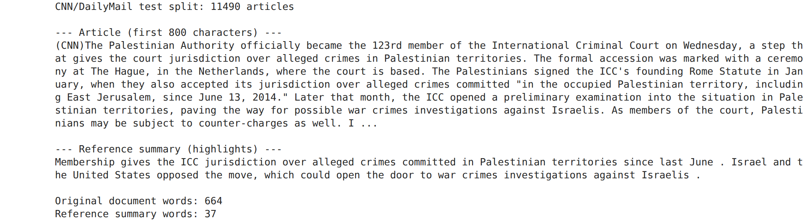
Figure 1 — The CNN/DailyMail article (Palestinian Authority joins the ICC) and its journalist highlights. Inference: The reference is two sentences (37 words) for a 664-word article, so every summarizer produces more text than the reference and precision will be low by construction.
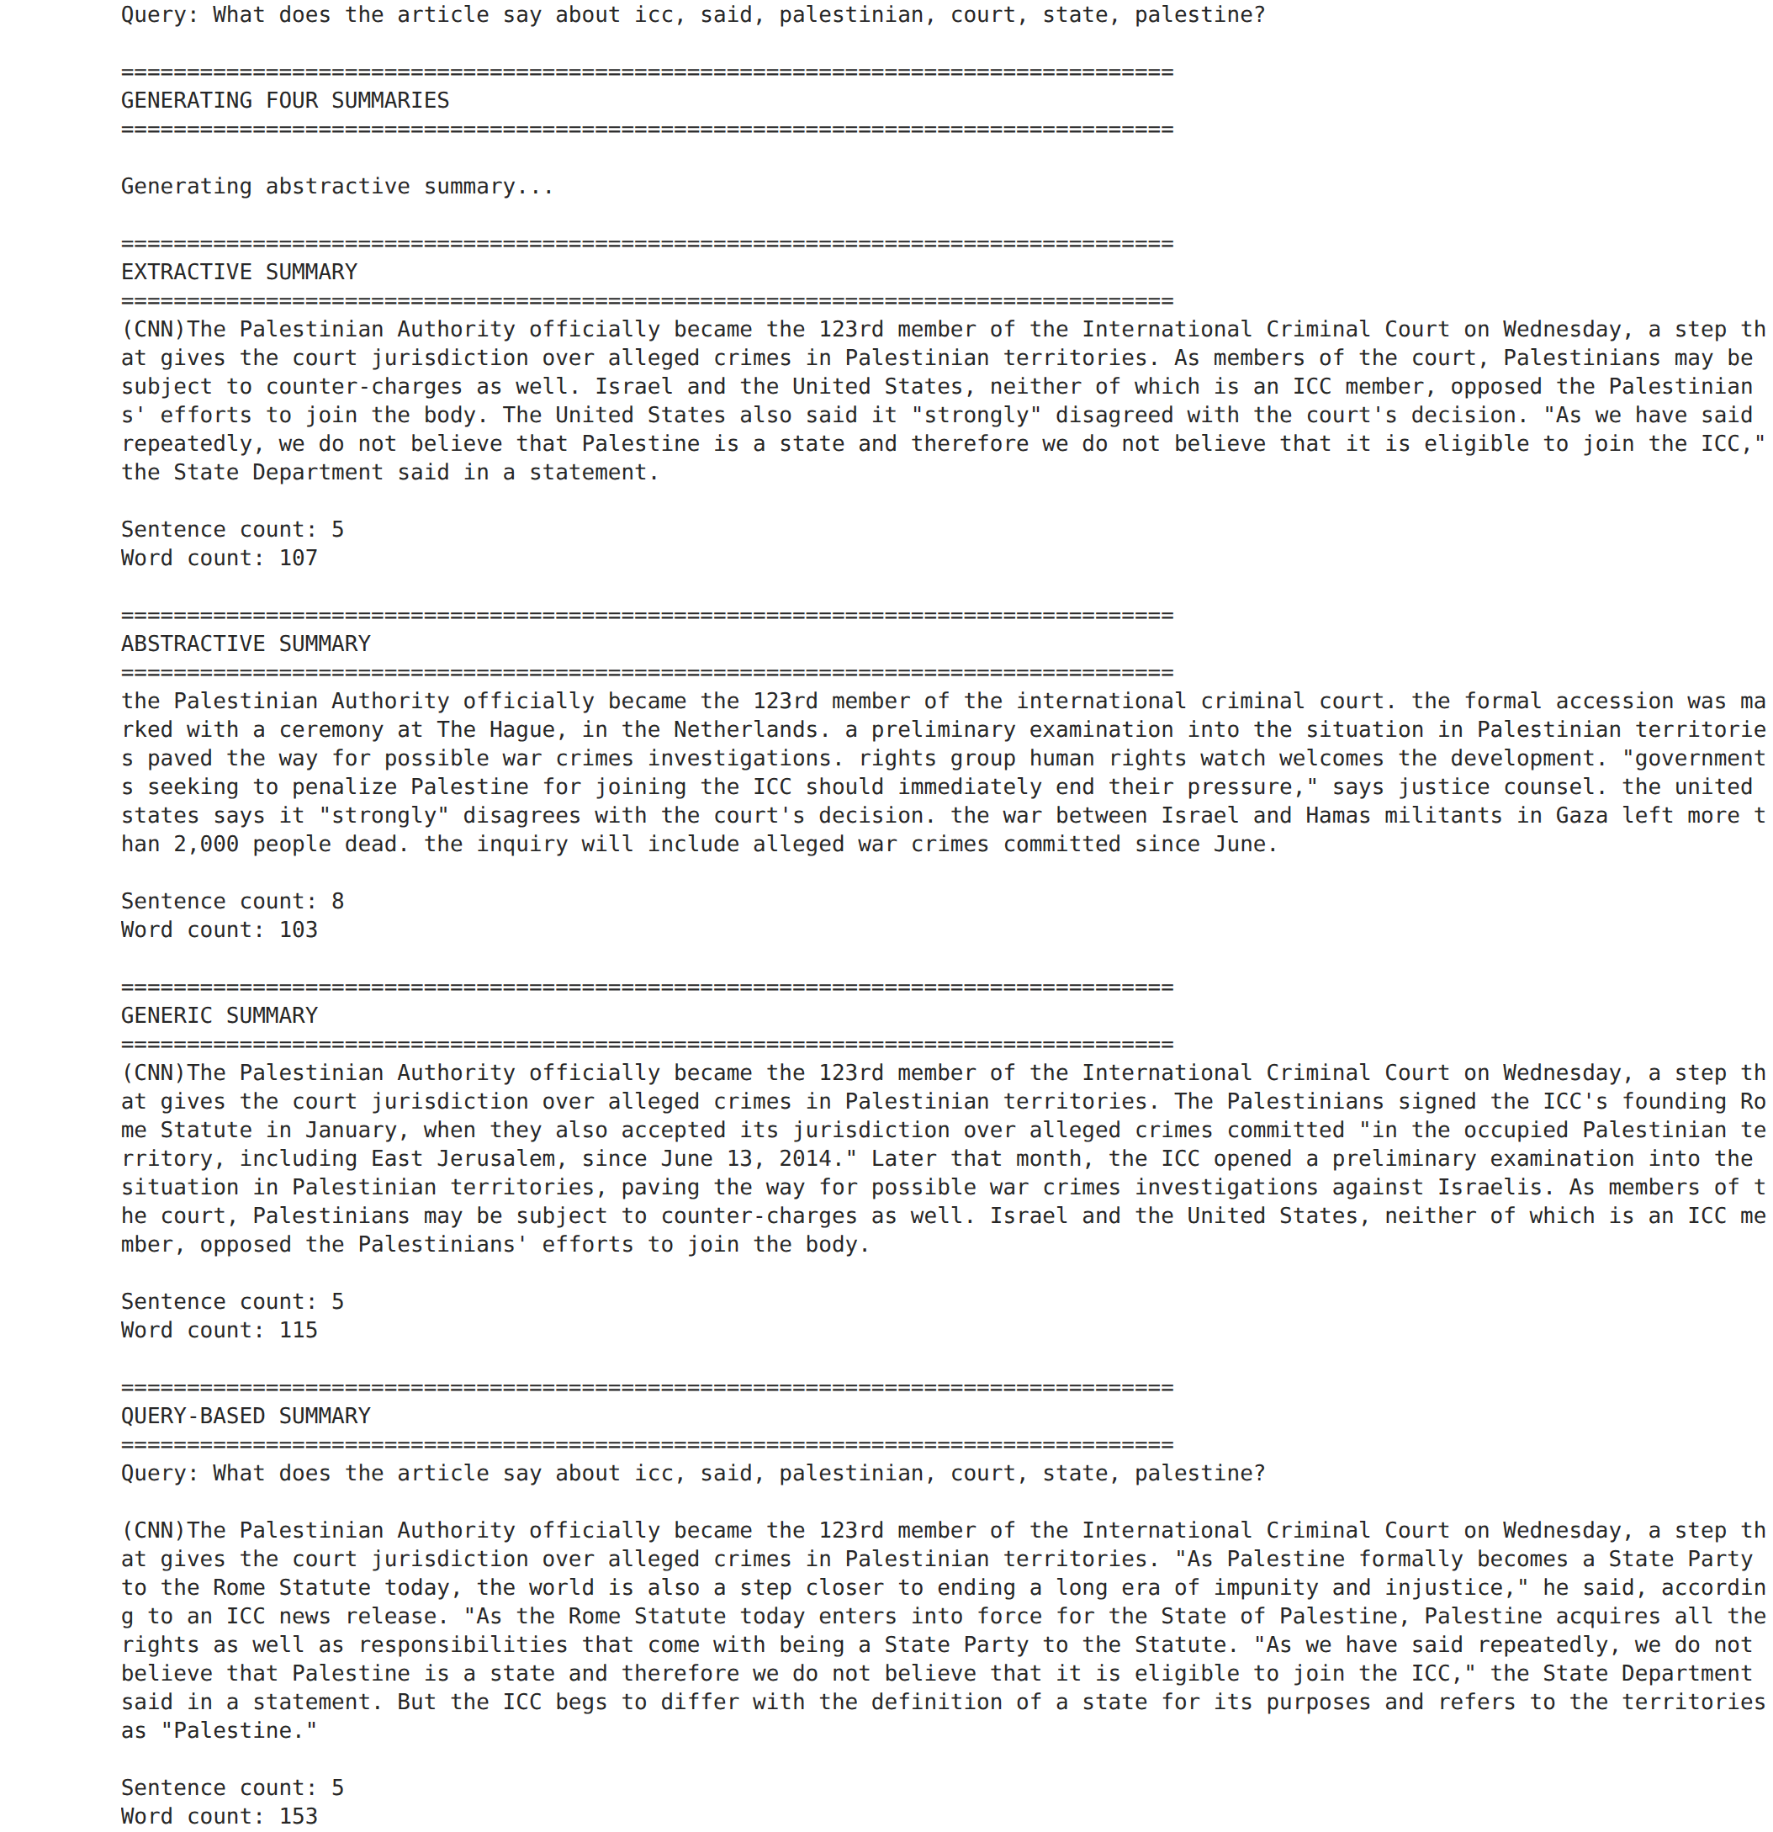
Figure 2 — Automatically built query and the four generated English summaries. Inference: Extractive and Generic copy the lead sentences; T5 rewrites in lower case and adds one detail (Human Rights Watch) that the highlights omit; the query pulled in quotation sentences.
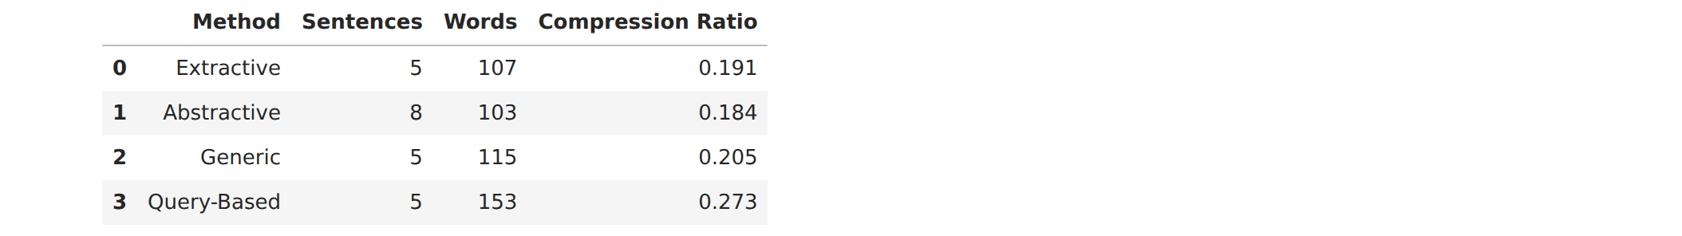
Table 2 — Summary statistics: sentences, words and compression ratio. Inference: All summaries are 100–150 words, three to four times the reference length; Query-based is longest (153 words) because its sentences are long quotations.
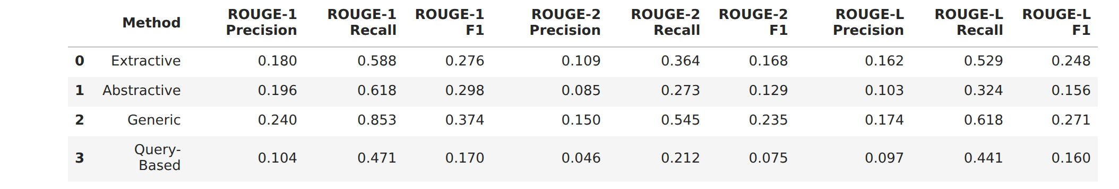
Table 3 — ROUGE-1/2/L precision, recall and F1 for the four English methods. Inference: Recall is high (Generic ROUGE-1 recall 0.85) and precision low for every method — the summaries contain the reference but also much more; Generic leads on all three F1 scores.
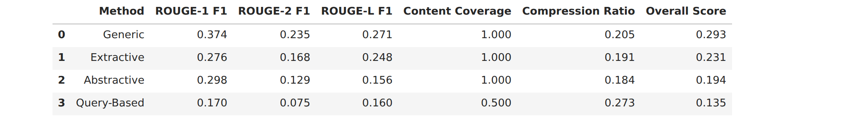
Table 4 — Final consolidated results sorted by overall score. Inference: Generic (0.293) > Extractive (0.231) > Abstractive (0.194) > Query-based (0.135); the lead-position term is what separates Generic from plain Extractive.

2. Parameter tuning (English)
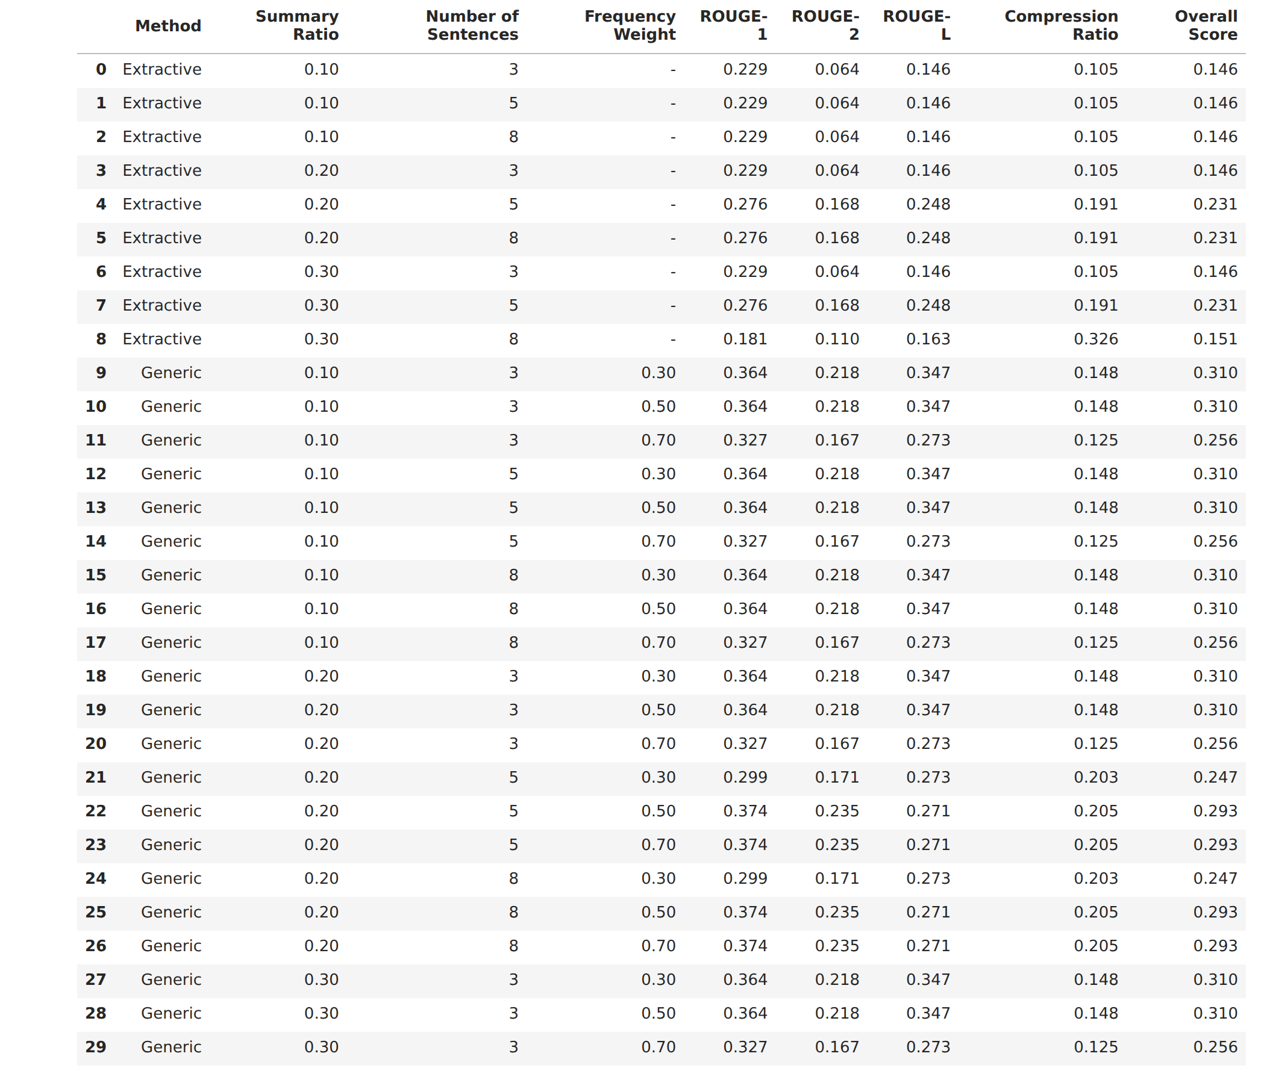
Table 5 — Tuning results over the 3 × 3 × 3 grid. Inference: Rows repeat in blocks because the sentence cap and ratio interact: for this article ratio 0.1 always yields 3 sentences and ratio 0.2 about 6, so the sentence cap and the ratio are not independent.
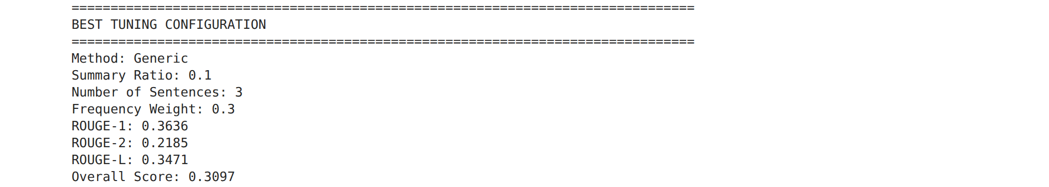
Figure 3 — Best tuning configuration. Inference: Generic with ratio 0.1, 3 sentences and weight 0.3 scores 0.310 — shorter summaries and more weight on position match a two-sentence reference best.

3. Visualisations (English)
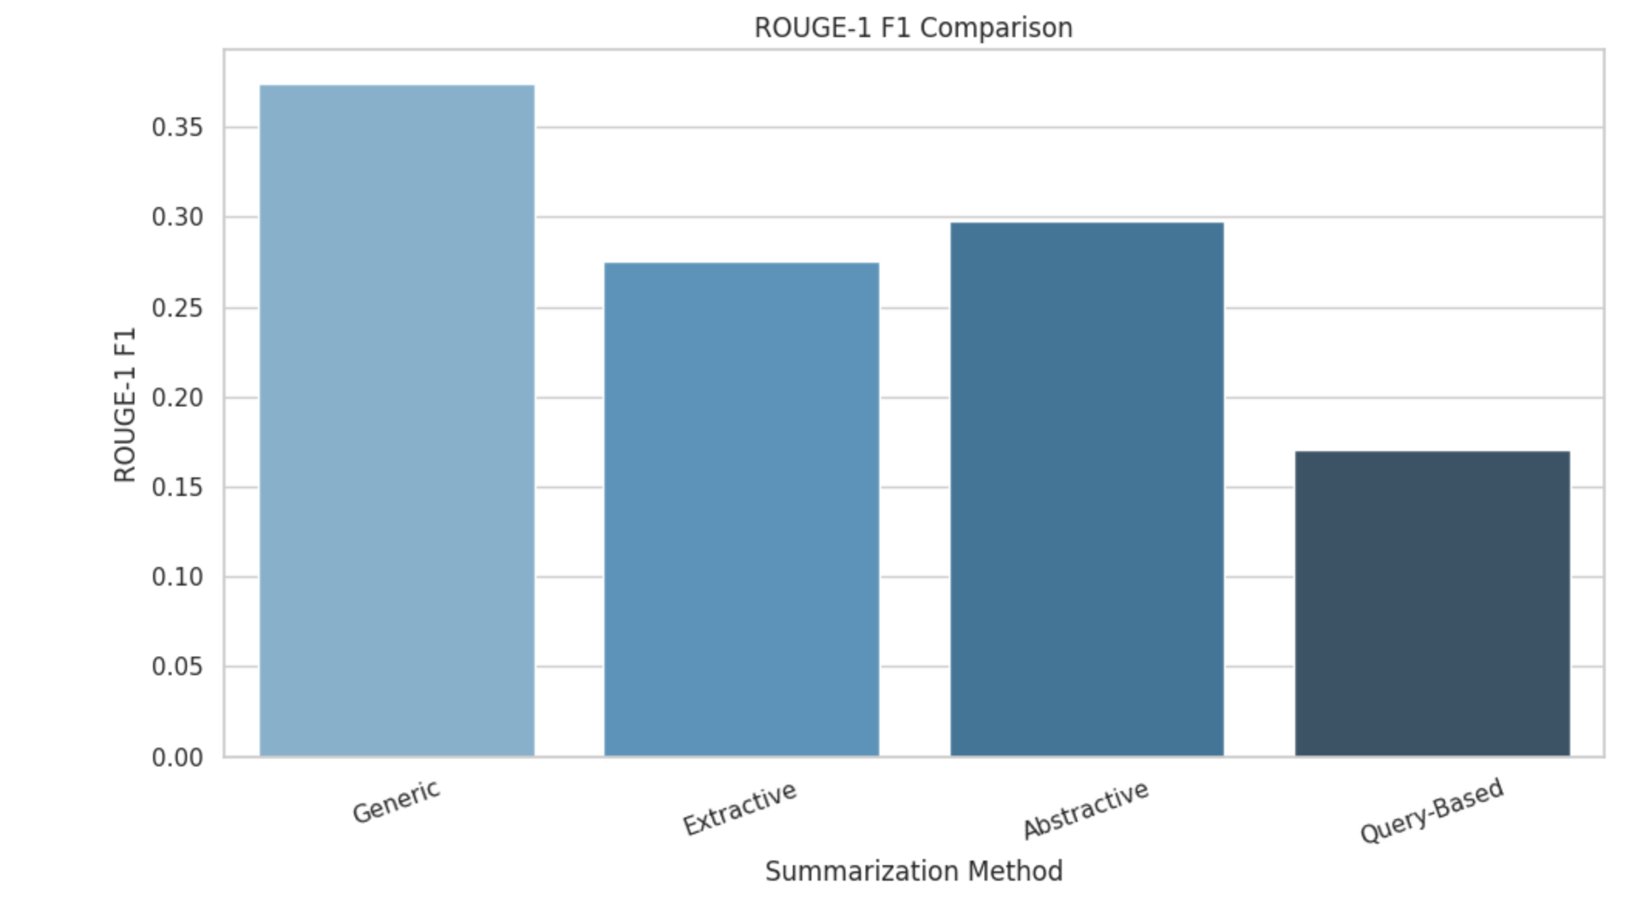
Figure 4 — ROUGE-1 F1 by method. Inference: Generic leads at 0.374; Query-based trails at 0.170, showing that an automatic keyword query is a poor proxy for the journalist's focus.
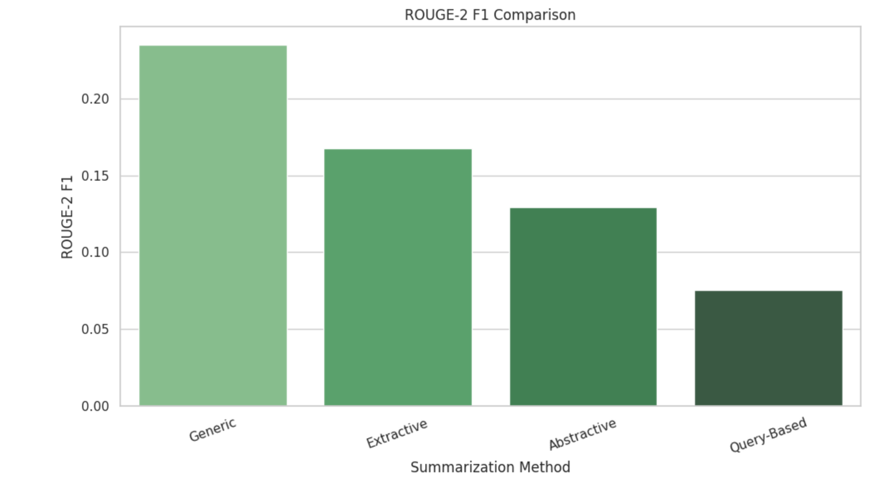
Figure 5 — ROUGE-2 F1 by method. Inference: Generic keeps a clear lead on bigrams (0.235), meaning it reproduces the reference's phrasing, not just its vocabulary.
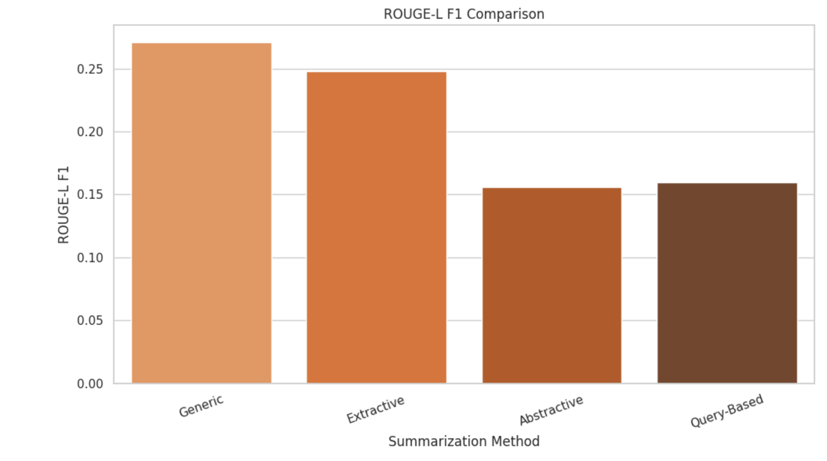
Figure 6 — ROUGE-L F1 by method. Inference: Extractive (0.248) is close to Generic (0.271) here because both copy whole sentences and so preserve word order; T5's rewriting costs it on ROUGE-L.
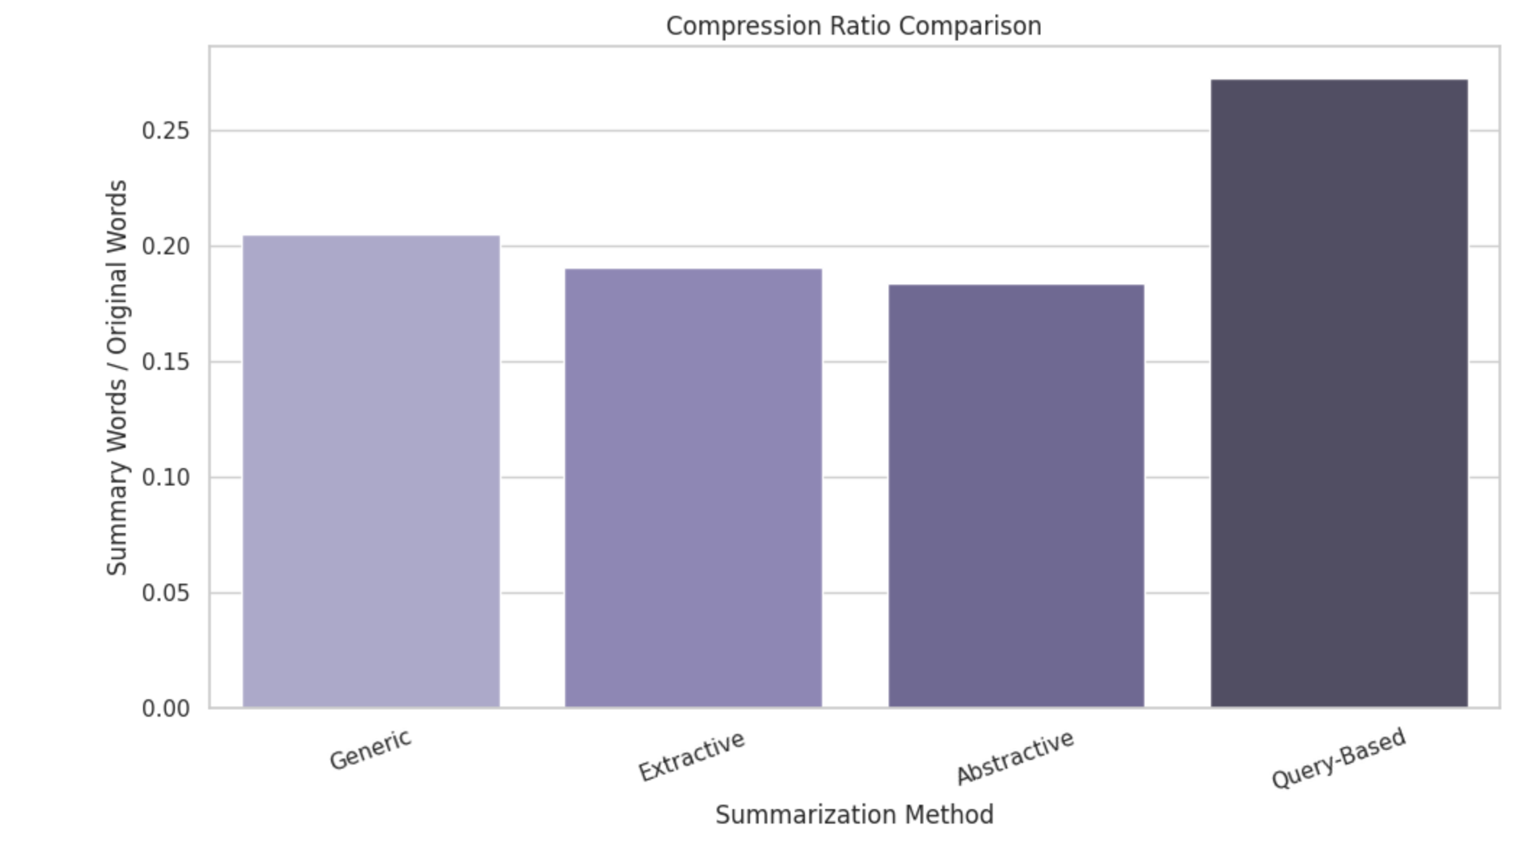
Figure 7 — Compression ratio by method. Inference: All methods keep about 20 % of the article; Query-based keeps the most (27 %), which lowers its precision.
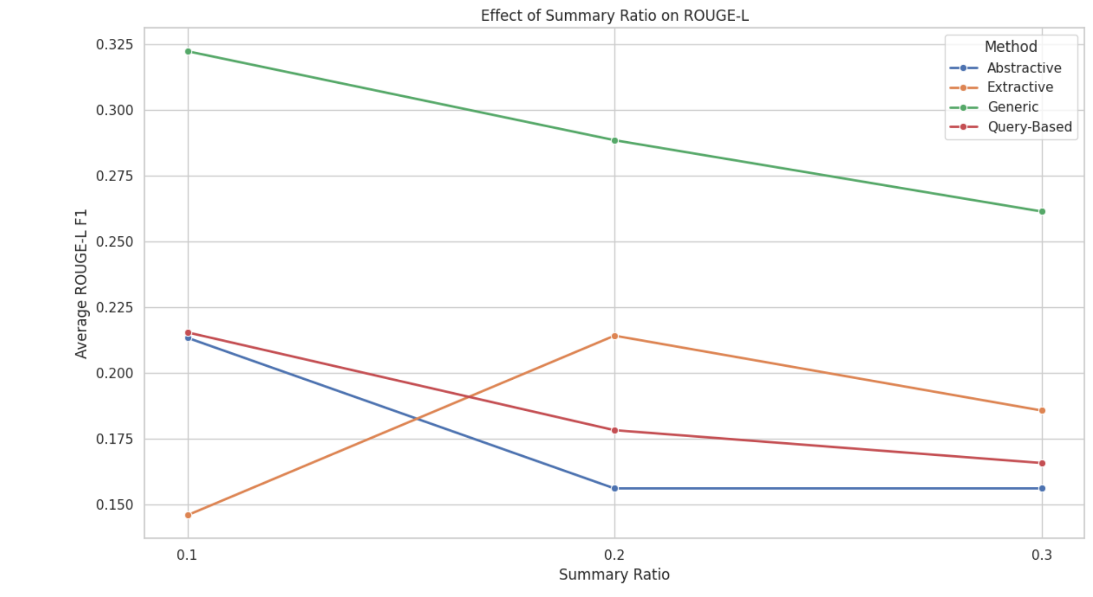
Figure 8 — Effect of summary ratio on ROUGE-L. Inference: Ratio 0.2 is best for the extractive methods; 0.1 gives too few sentences and 0.3 adds sentences the reference does not cover. Abstractive is flat because ratio only changes its target length.
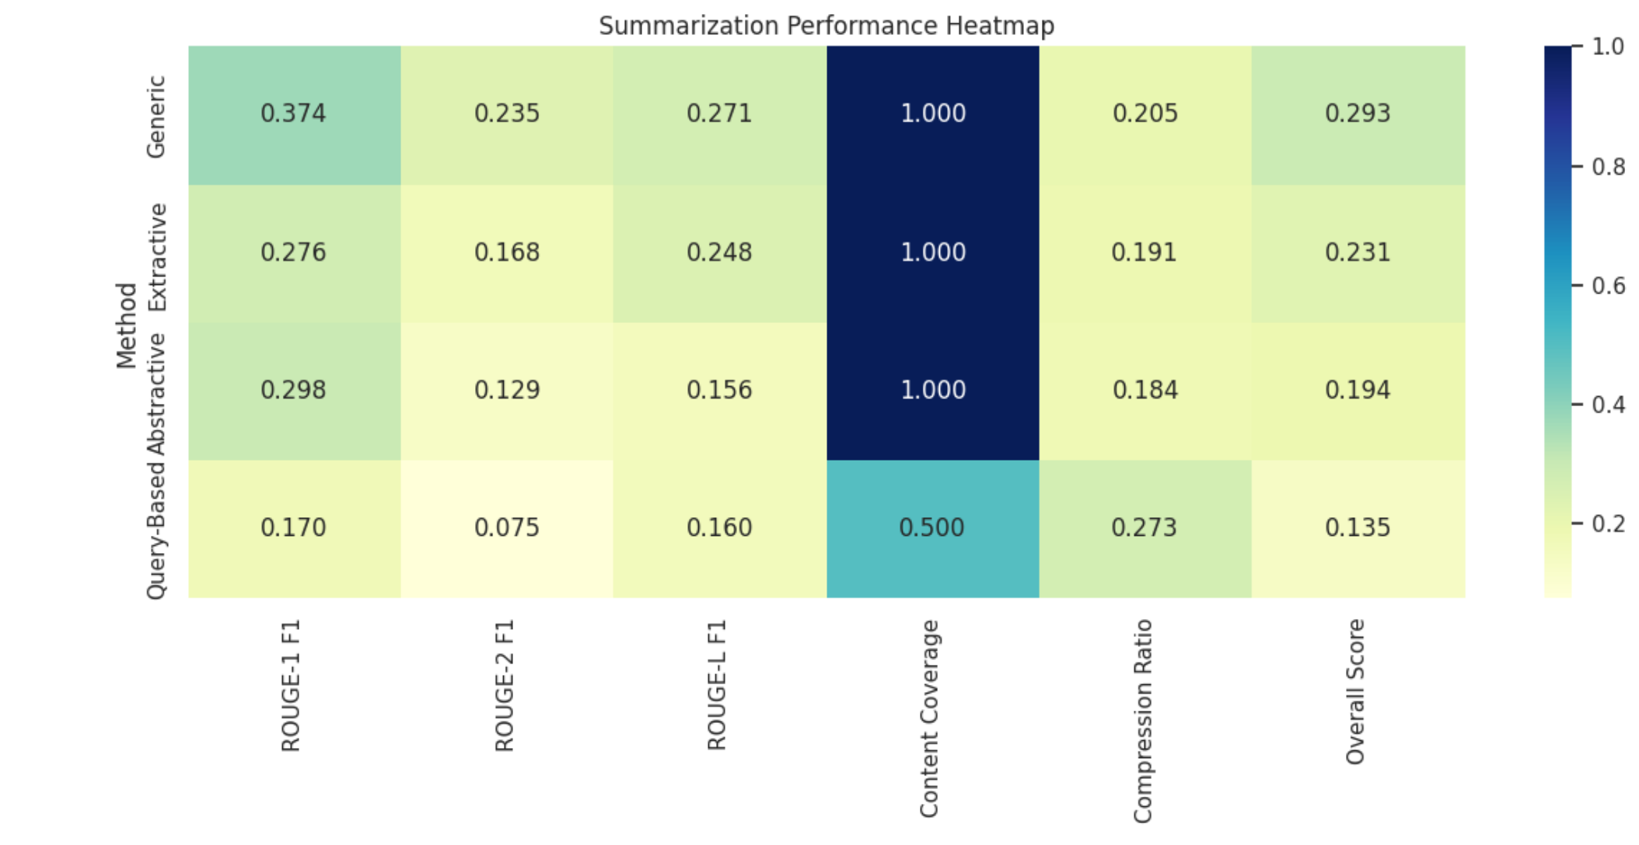
Figure 9 — Performance heatmap over all metrics. Inference: One row (Generic) is uniformly darkest; no method wins one metric while losing another, so the ranking is stable across metrics.
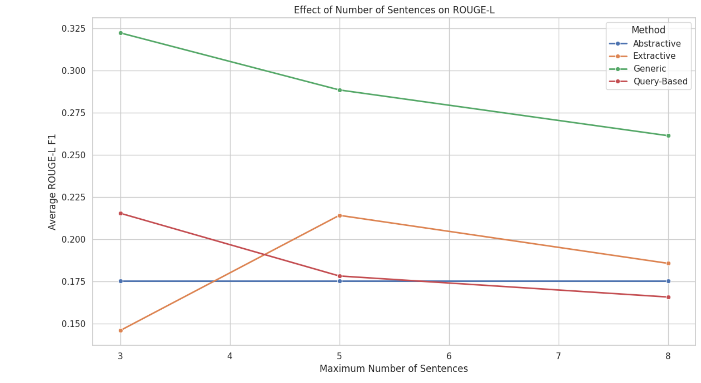
Figure 10 — Effect of number of sentences on ROUGE-L. Inference: Scores rise from 3 to 5 sentences and flatten after, because the ratio target (7 sentences at 0.2) caps the count before the 8-sentence limit does.
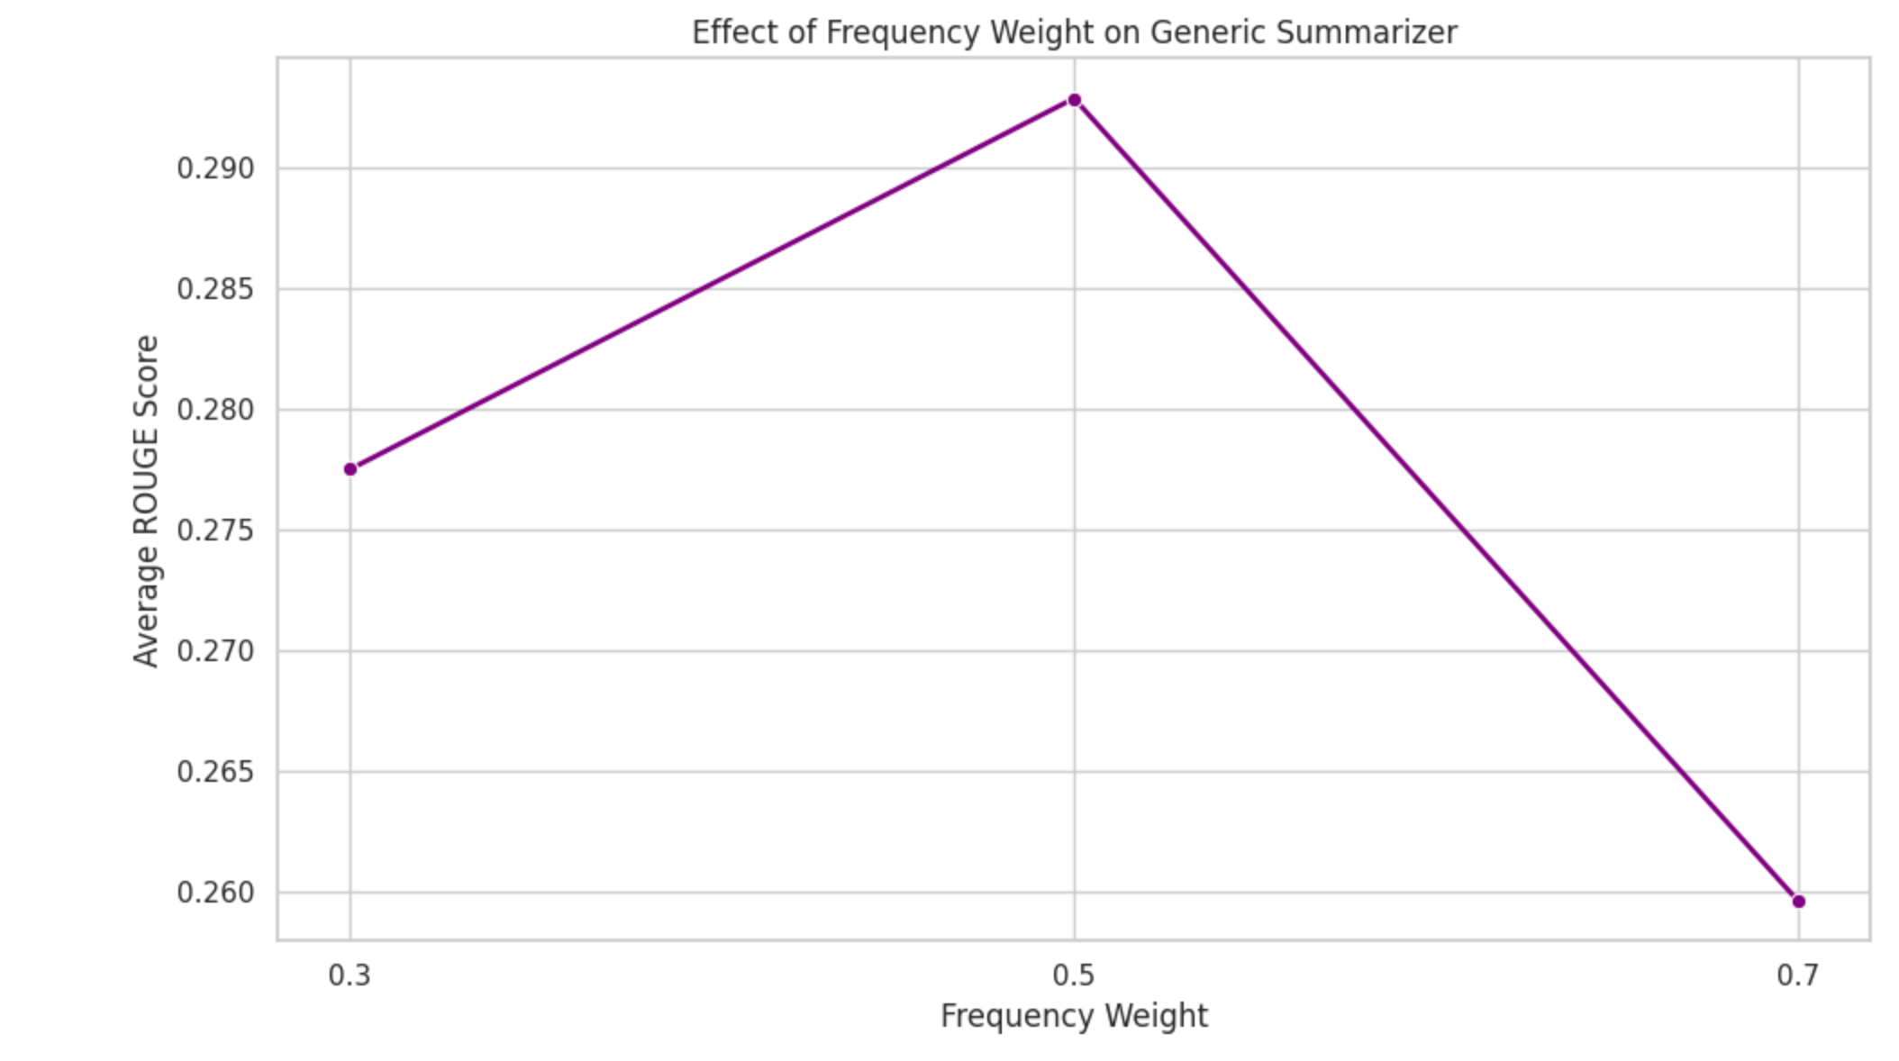
Figure 11 — Effect of frequency weight on the Generic summarizer. Inference: Lower frequency weight (more weight on position) scores higher: in news, the first sentences carry the summary, so position is a stronger signal than word frequency.

4. Best summarizer and parameter effects (English)
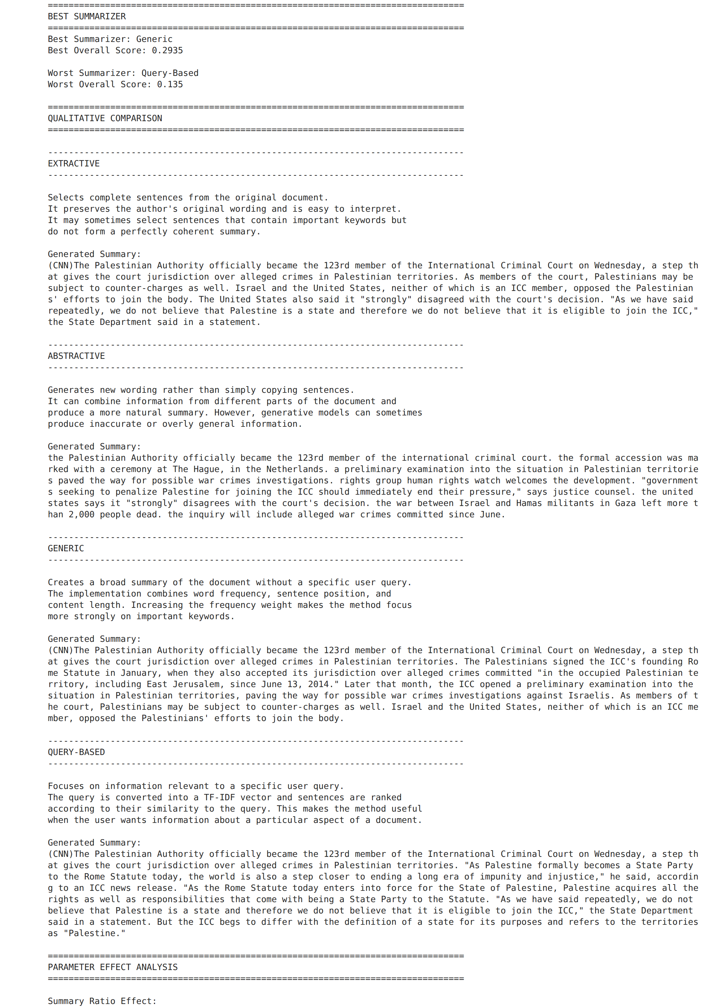
Figure 12 — Best/worst summarizer and sentence-level qualitative comparison. Inference: Reading the summaries confirms the numbers: the Generic and Extractive outputs read as a coherent lead; the T5 output is fluent but lower-cased; the Query-based output is a list of quotations.
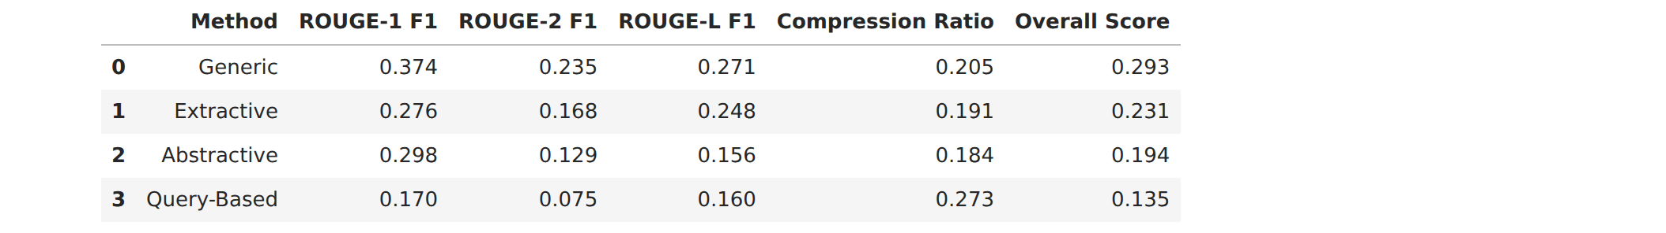
Table 6 — Final English results table. Inference: Same ranking as Table 4; the table is repeated at the end of the notebook as the deliverable.

5. Hindi article (XL-Sum)
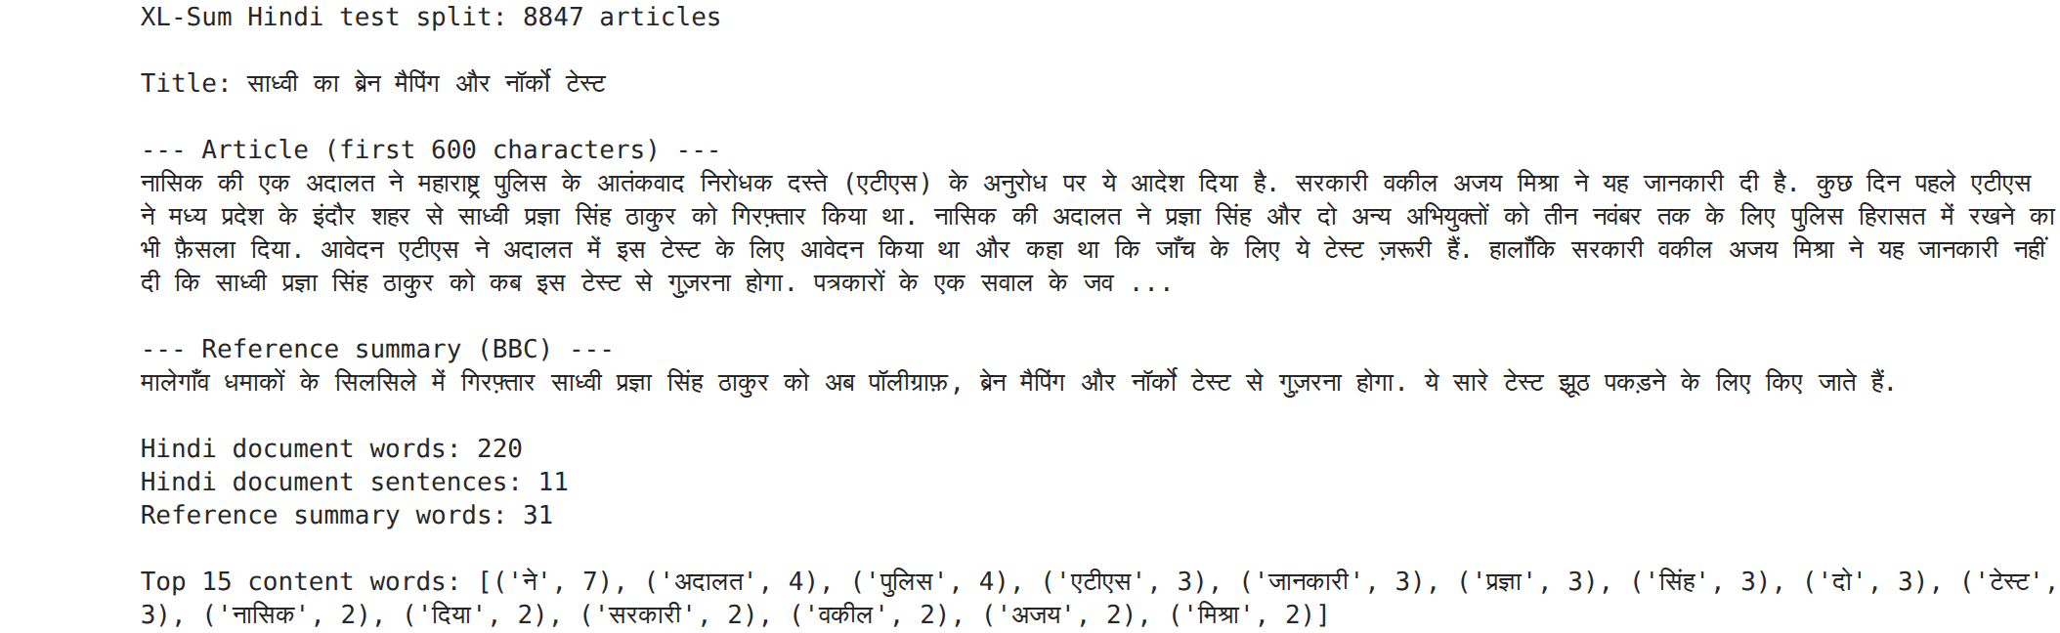
Figure 13 — The XL-Sum Hindi article, BBC one-sentence summary and statistics. Inference: The reference is a single 31-word sentence for a 220-word, 11-sentence article; the top content words (अदालत, पुलिस, टेस्ट) match the headline topic.
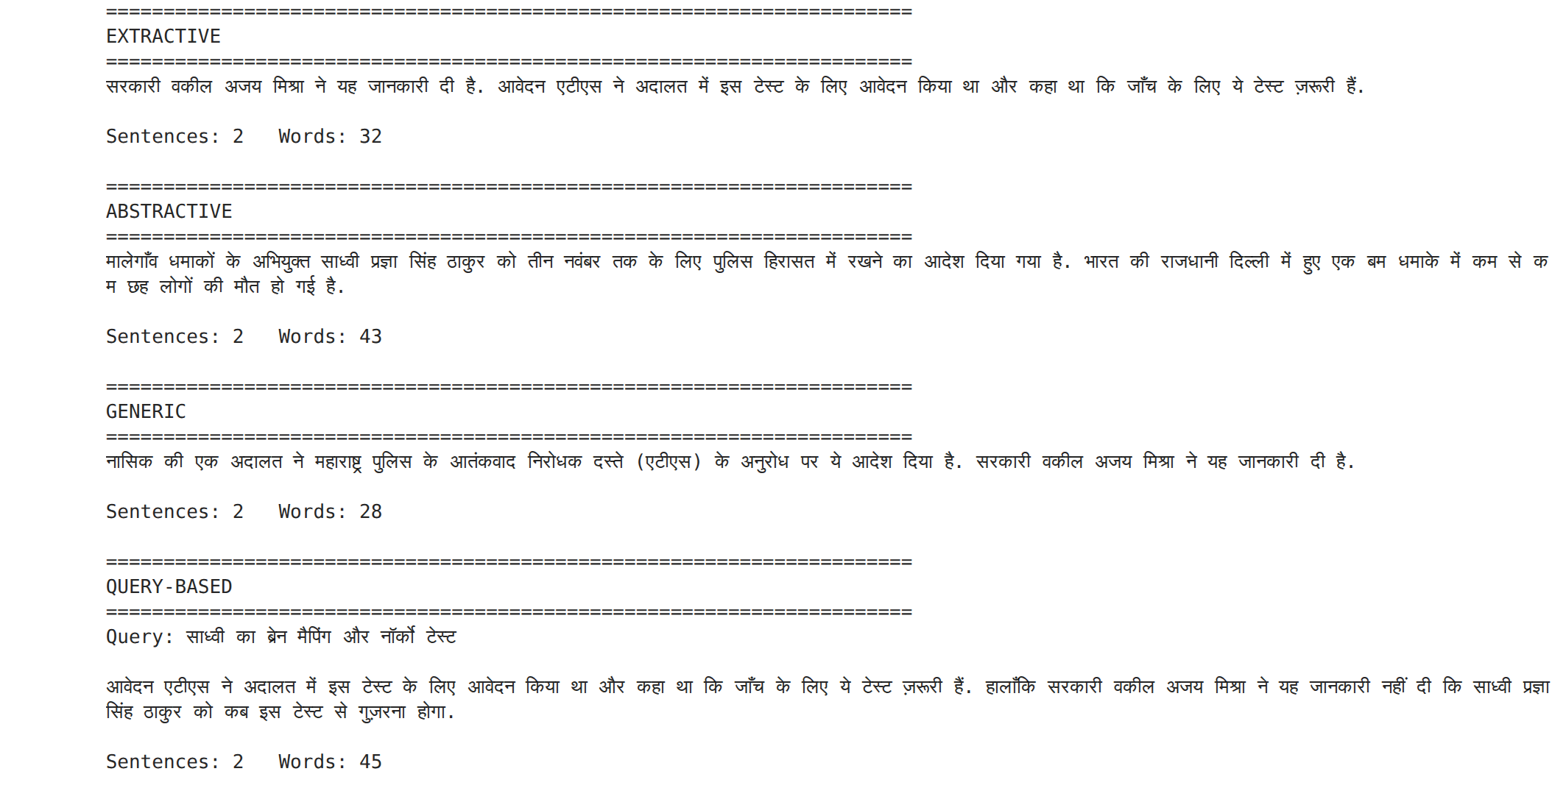
Figure 14 — The four Hindi summaries. Inference: The extractive methods each pick two sentences; mT5 writes new sentences, one of which (a Delhi bomb blast) is not in the article — a hallucination.
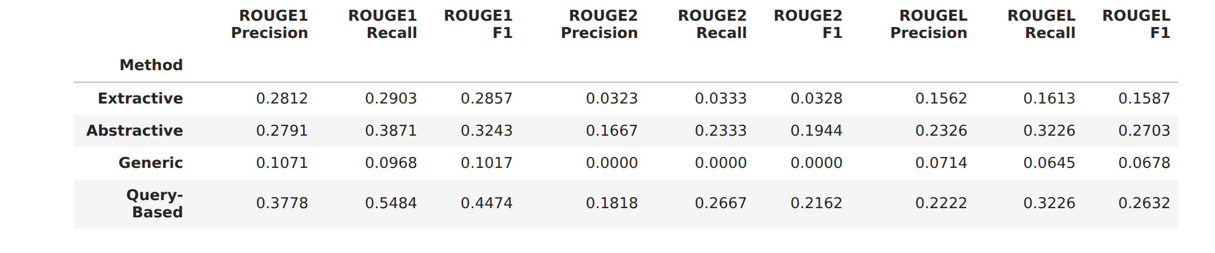
Table 7 — Hindi ROUGE-1/2/L precision, recall and F1. Inference: Query-based has the highest recall (0.55) and ROUGE-1 F1 (0.45); Generic scores near zero because its position bias selected procedural opening sentences the BBC summary ignores.
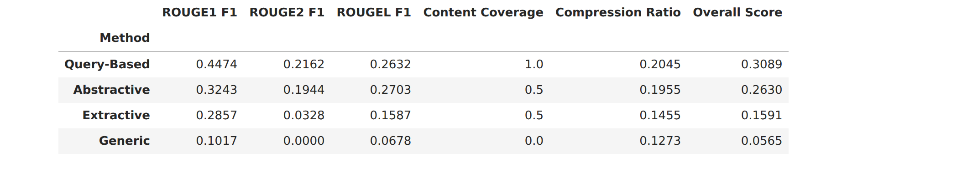
Table 8 — Hindi final table sorted by overall score. Inference: Query-based (0.309) > Abstractive (0.263) > Extractive (0.159) > Generic (0.057) — the reverse of the English order for Generic, showing that lead bias is not universal.
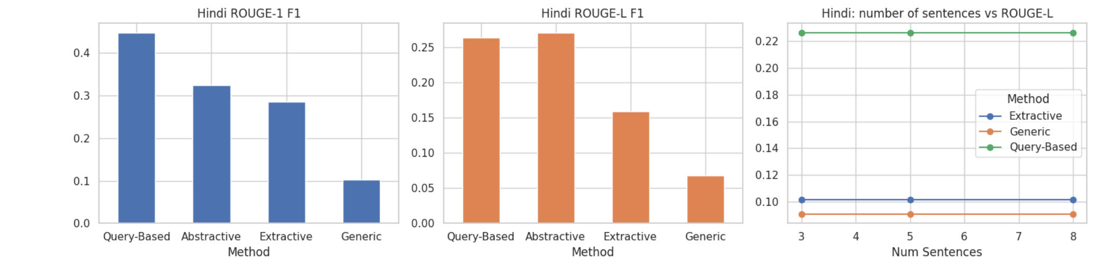
Figure 15 — Hindi ROUGE-1, ROUGE-L and the number-of-sentences effect. Inference: Three sentences is the best setting for all methods; adding sentences only lowers precision against a one-sentence reference.
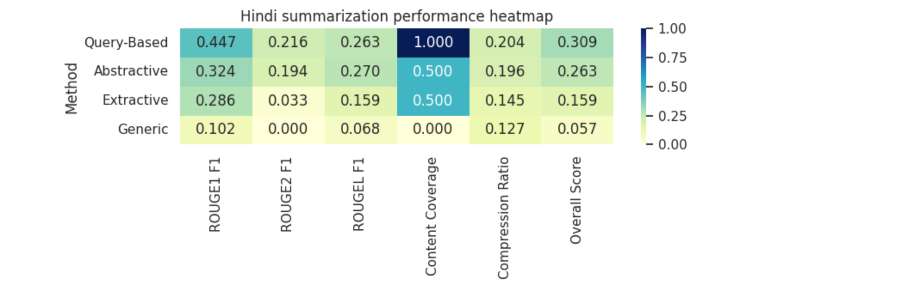
Figure 16 — Hindi performance heatmap. Inference: Query-based and Abstractive share the dark cells; Generic is light everywhere, so its failure is consistent rather than metric-specific.
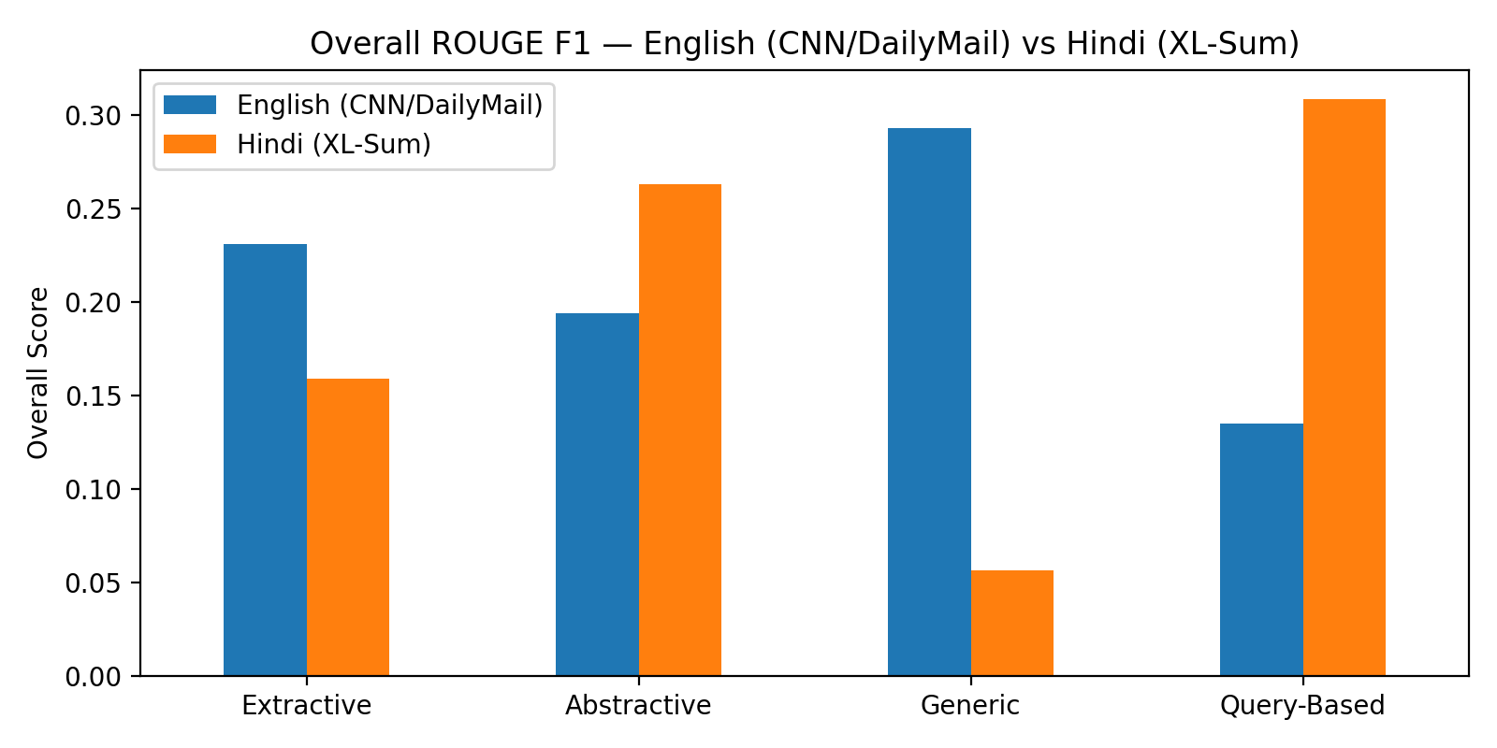
Figure 17 — Overall ROUGE F1, English (CNN/DailyMail) versus Hindi (XL-Sum). Inference: No method wins in both languages: Generic is best in English and worst in Hindi; Query-based is worst in English and best in Hindi. The right method depends on the reference style and the quality of the query.

Results summary
English — CNN/DailyMail
Method | ROUGE-1 F1 | ROUGE-2 F1 | ROUGE-L F1 | Coverage | Compression | Overall
Generic | 0.374 | 0.235 | 0.271 | 1.0 | 0.205 | 0.293
Extractive | 0.276 | 0.168 | 0.248 | 1.0 | 0.191 | 0.231
Abstractive (T5) | 0.298 | 0.129 | 0.156 | 1.0 | 0.184 | 0.194
Query-based | 0.170 | 0.075 | 0.160 | 0.5 | 0.273 | 0.135
Table 9 — English results on the CNN/DailyMail article.

Hindi — XL-Sum
Method | ROUGE-1 F1 | ROUGE-2 F1 | ROUGE-L F1 | Coverage | Compression | Overall
Query-based | 0.447 | 0.216 | 0.263 | 1.0 | 0.205 | 0.309
Abstractive (mT5) | 0.324 | 0.194 | 0.270 | 0.5 | 0.196 | 0.263
Extractive | 0.286 | 0.033 | 0.159 | 0.5 | 0.146 | 0.159
Generic | 0.102 | 0.000 | 0.068 | 0.0 | 0.127 | 0.057
Table 10 — Hindi results on the XL-Sum article.

Observations
- English: Generic scored highest (0.293) because news articles put the key facts first and the position term rewards early sentences. Query-based scored lowest (0.135); its automatic query pulled in quotation-heavy sentences.
- Hindi: Query-based scored highest (0.309) because the query was the BBC headline, which names the same facts as the BBC summary. Abstractive (mT5) was second and produced a fluent rewritten summary; its second sentence is not from the article, an example of hallucination.
- Generic scored lowest in Hindi (0.057): the article opens with procedural detail, so the position bias picked sentences the one-line summary does not mention.
- Both references are short (37 and 31 words), so recall is high and precision low for every method; the tuning found smaller summaries (3 sentences) score best.
- Results are from one article per language and one reference each, so the ranking is indicative only.

Conclusion
Hence, learned the concepts of text summarization. Four summarizers — extractive, abstractive, generic and query-based — were built with NLTK, scikit-learn and transformers and evaluated with ROUGE-1/2/L, compression ratio and content coverage on one CNN/DailyMail article and one XL-Sum Hindi article, using the journalists' own summaries as references. On the English article the generic frequency + position summarizer performed best (overall 0.293); on the Hindi article the query-based summarizer performed best (0.309) with mT5 abstractive second (0.263). Hindi required its own sentence splitter, stopword list, a Devanagari-aware ROUGE tokenizer and a multilingual abstractive model.

