ASSIGNMENT NO: 06
Title: Machine Translation — Concepts, Models and Metrics

Problem Statement
To demonstrate machine translation in NLP: implement six translation-related concepts (neural machine translation, image OCR translation, transliteration, language identification, back-translation, pivot translation), compare two open pretrained translation models against a commercial reference, and evaluate the outputs with six performance metrics (BLEU, chrF, METEOR, TER, WER, BERTScore). Language pair: English ↔ Hindi.

Objectives
- To learn the concepts of neural machine translation and the auxiliary tasks around it.
- To use pretrained MarianMT and mBART-50 models for English→Hindi translation.
- To evaluate translation quality with standard automatic metrics and compare models on quality and speed.

Algorithm / Implementation

Part 1 — Six concepts
# | Concept | Method used | Steps
1 | Neural machine translation | Helsinki-NLP/opus-mt-en-hi (MarianMT) | Tokenise with MarianTokenizer → model.generate() → decode; translate three sample sentences EN→HI.
2 | Image OCR translation | Tesseract OCR (pytesseract) + MarianMT | Fetch image by URL → pytesseract.image_to_string() → pass extracted text to the NMT model.
3 | Transliteration | indic-transliteration (sanscript) | Devanagari → Latin (IAST) and Latin (ITRANS) → Devanagari; script changes, language does not.
4 | Language identification | langdetect | detect() and detect_langs() on English, Hindi, French and Spanish sentences.
5 | Back-translation | opus-mt-en-hi + opus-mt-hi-en | EN→HI, then HI→EN; compare round-trip output with the original as a reference-free quality check.
6 | Pivot translation | opus-mt-hi-en + opus-mt-en-fr | Hindi → English (pivot) → French, for a pair with no direct model.
Table 1 — The six machine-translation concepts and how each was implemented.

Part 2 — Model comparison
- Model A: Helsinki-NLP/opus-mt-en-hi — a bilingual MarianMT transformer trained only on English→Hindi; small (≈300 MB) and fast.
- Model B: facebook/mbart-large-50-many-to-many-mmt — a multilingual seq2seq transformer covering 50 languages (≈2.4 GB); source language set to en_XX, target forced to hi_IN with forced_bos_token_id.
- Reference system: Google Translate via deep-translator, with retry and a fallback to the MyMemory engine if Google refuses the request.
- Test set: five English sentences with human-written Hindi reference translations.
- Translate the test set with all three systems and print outputs side by side with the reference.

Part 3 — Metrics
Metric | Library | Measures | Range / direction
BLEU | sacrebleu.corpus_bleu | Modified n-gram precision with brevity penalty | 0–100, higher better
chrF | sacrebleu.corpus_chrf | Character n-gram F-score; robust for morphologically rich languages | 0–100, higher better
METEOR | nltk meteor_score | Unigram precision/recall with stem and synonym matching, fragmentation penalty | 0–1, higher better
TER | sacrebleu.corpus_ter | Translation edit rate: edits needed to reach the reference / reference length | 0+, lower better
WER | jiwer.wer | Word error rate: word-level Levenshtein distance / reference length | 0+, lower better
BERTScore | bert_score (bert-base-multilingual-cased) | Cosine similarity of contextual token embeddings, F1 | 0–1, higher better
Table 2 — The six performance metrics.

Each metric is computed for the three systems against the five references and tabulated in a pandas DataFrame; BLEU/chrF and METEOR/BERTScore are plotted as grouped bar charts.

Extras
- Inference speed — each system translates the test batch three times; average seconds per batch is plotted.
- Qualitative inspection — a table with source, all three outputs and the reference for sentence-level error analysis.

Core code
tok = MarianTokenizer.from_pretrained("Helsinki-NLP/opus-mt-en-hi")
model = MarianMTModel.from_pretrained("Helsinki-NLP/opus-mt-en-hi")
out = model.generate(**tok(texts, return_tensors="pt", padding=True))
hyps = [tok.decode(t, skip_special_tokens=True) for t in out]

# mBART-50: force the target language
out = model_b.generate(**batch, forced_bos_token_id=tokenizer_b.lang_code_to_id["hi_IN"])

# metrics
sacrebleu.corpus_bleu(hyps, [refs]).score; sacrebleu.corpus_chrf(hyps, [refs]).score
sacrebleu.corpus_ter(hyps, [refs]).score; jiwer.wer(refs, hyps)
meteor_score([word_tokenize(ref)], word_tokenize(hyp))
bert_score(hyps, refs, lang="hi")

Platform
64-bit open-source Linux; Python 3, Google Colab; transformers, sentencepiece, sacremoses (MarianMT, mBART-50); pytesseract + tesseract-ocr (English and Hindi); indic-transliteration; langdetect; deep-translator; sacrebleu, nltk, jiwer, bert-score; pandas, matplotlib.

Input
Input | Content
Sample sentences (Concept 1) | "The weather is nice today.", "I am learning machine translation.", "Please send me the report by tomorrow."
Image (Concept 2) | A generated 700×120 PNG reading "Machine translation is useful", fetched by URL.
Transliteration text (Concept 3) | "नमस्ते, आप कैसे हैं?" and "namaste, aap kaise hain?"
Language-ID texts (Concept 4) | One sentence each in English, Hindi, French, Spanish.
Back-translation / pivot (Concepts 5–6) | "Please send me the report by tomorrow."; "कृपया मुझे कल तक रिपोर्ट भेजें।"
Test set (models and metrics) | Five English sentences with Hindi reference translations: weather, learning MT, sending a report, city history, asking for help.
Table 3 — Inputs used in the notebook.

Output

Part 1 — Six concepts
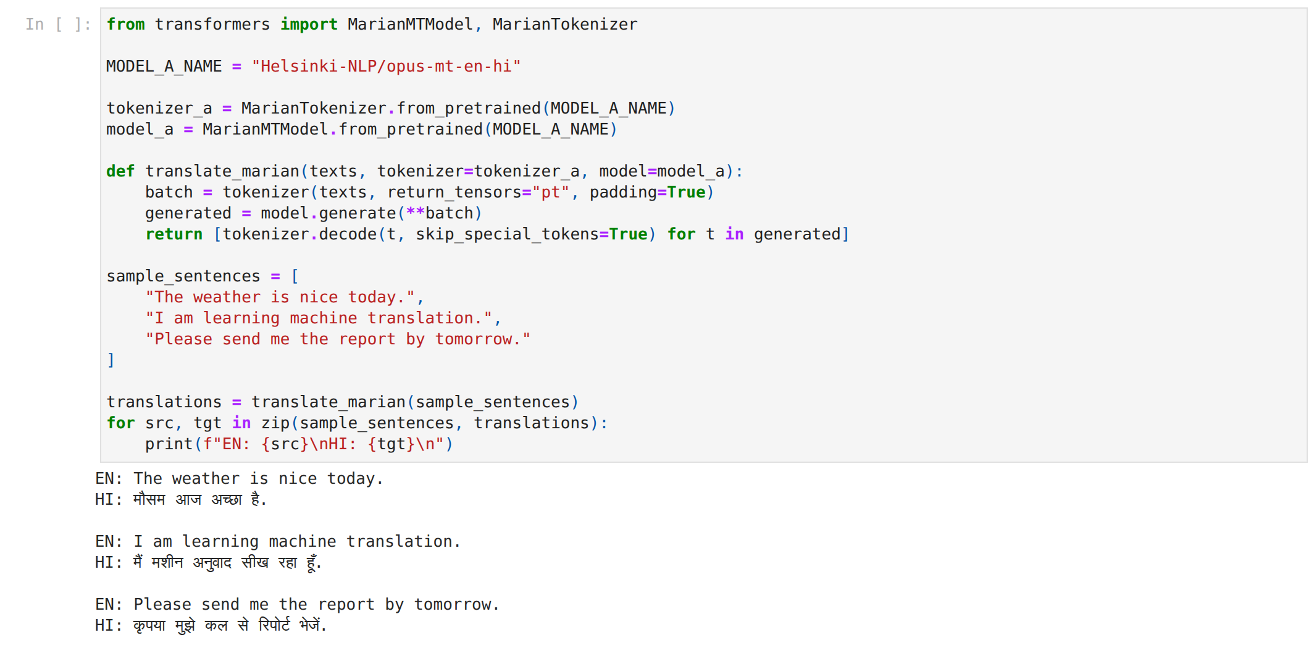
Figure 1 — Concept 1 — neural machine translation EN→HI with MarianMT. Inference: Three simple sentences are translated correctly; the third uses कल से (from tomorrow) for "by tomorrow", the one word-choice error that recurs throughout the evaluation.
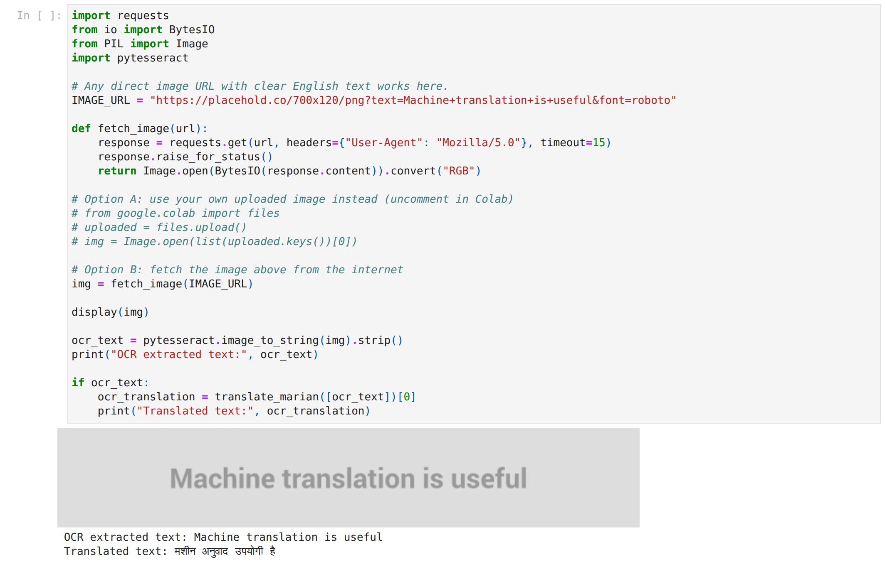
Figure 2 — Concept 2 — image → OCR text → Hindi translation. Inference: Tesseract read the generated image exactly and the translation is correct; OCR errors, not translation errors, would be the main risk with real photographs.
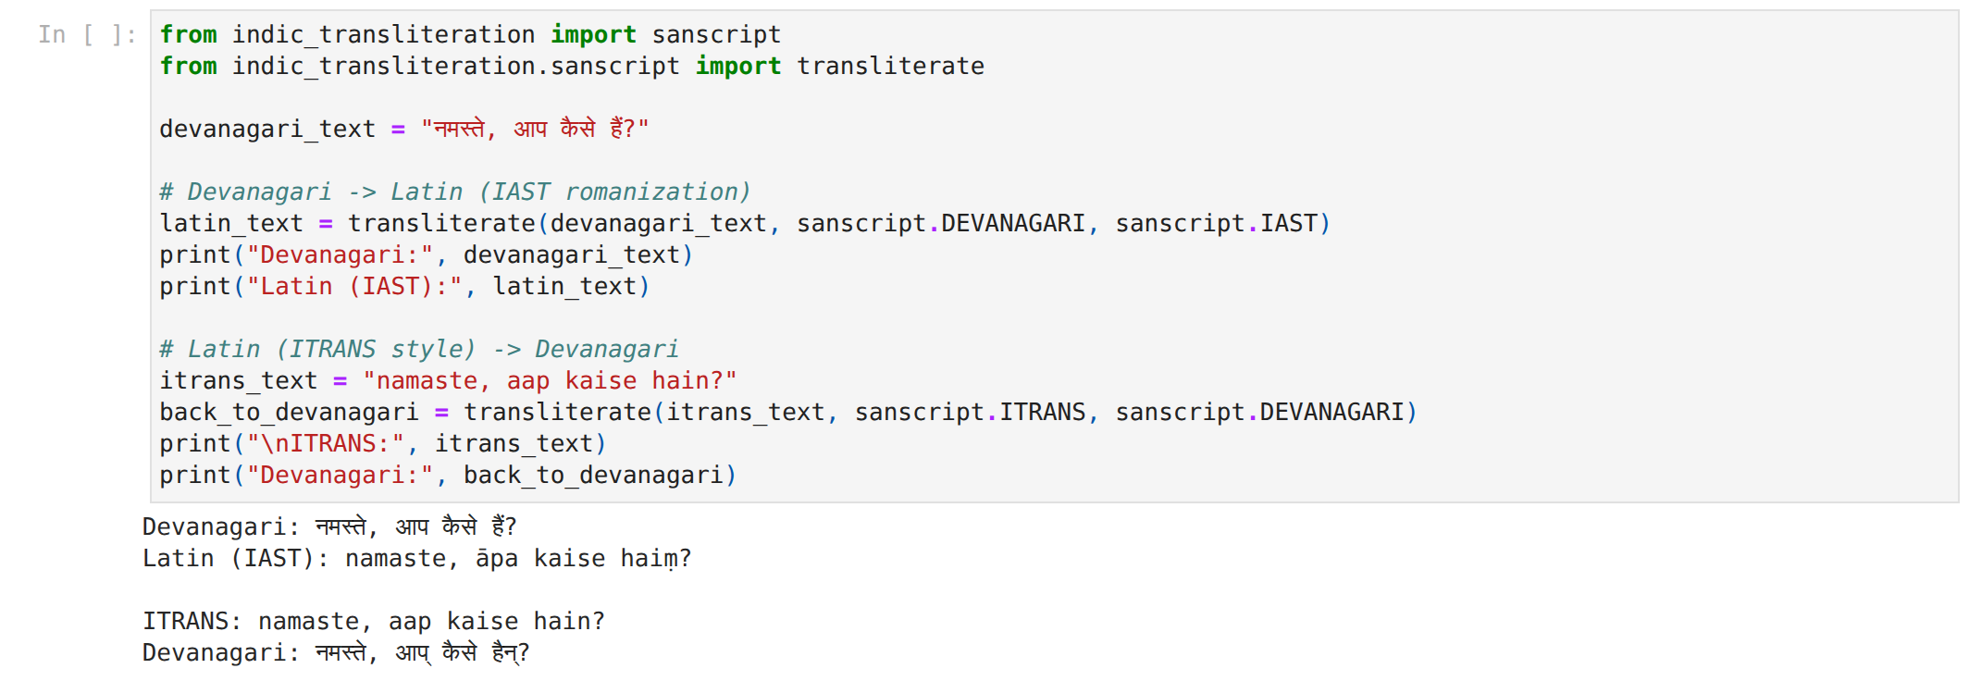
Figure 3 — Concept 3 — Devanagari ↔ Latin transliteration. Inference: Devanagari→IAST is exact; the ITRANS→Devanagari return trip inserted halants (आप्, हैन्) because ITRANS spells final vowels and anusvāra differently — transliteration is rule-based and only as good as the input scheme.
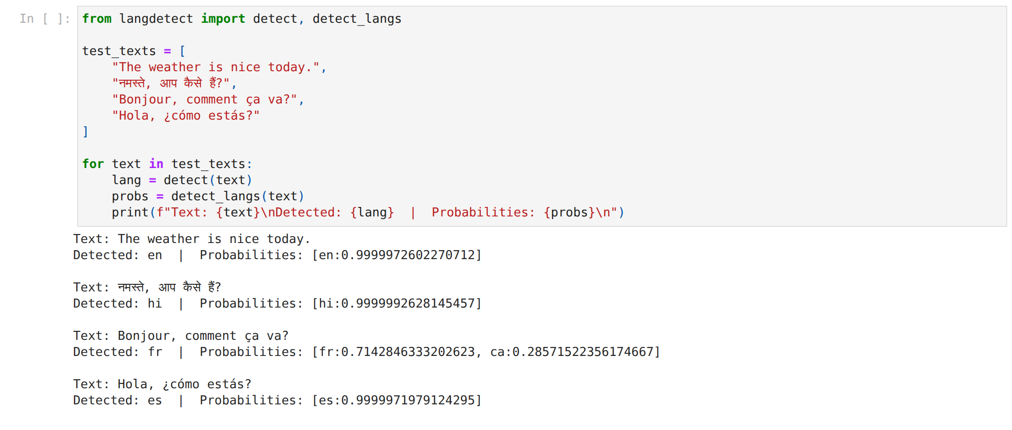
Figure 4 — Concept 4 — language identification with probabilities. Inference: English, Hindi and Spanish are identified at ≈1.0; French is 0.71 with Catalan 0.29, showing that short texts in closely related languages are hard for a character-n-gram detector.
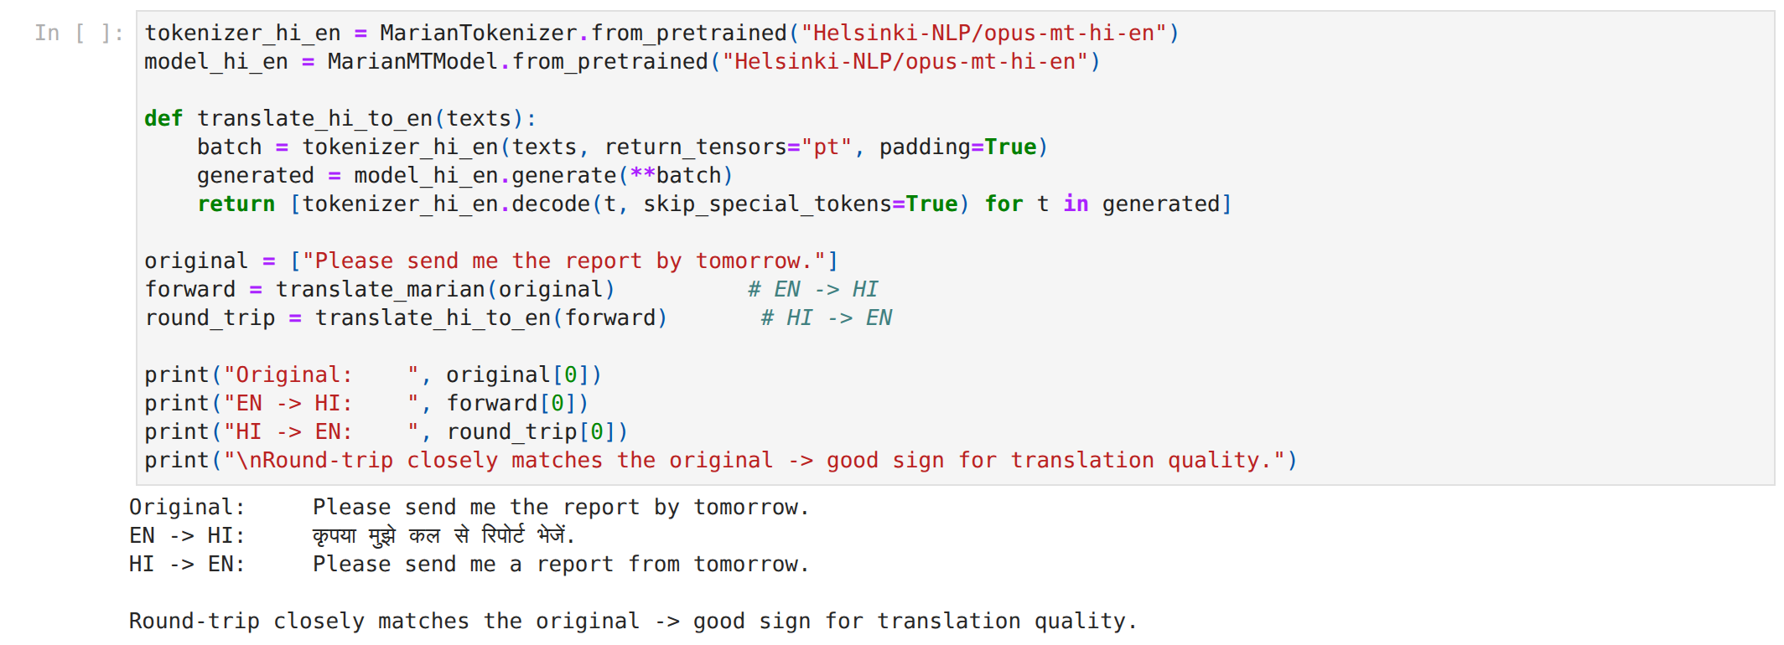
Figure 5 — Concept 5 — back-translation round trip EN→HI→EN. Inference: The round trip returns "from tomorrow" for "by tomorrow", exposing the same MarianMT error without needing a reference translation.
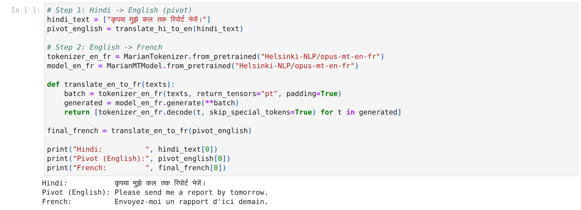
Figure 6 — Concept 6 — pivot translation Hindi → English → French. Inference: The French output is correct, so the pivot preserved meaning here; any error in the first hop would have propagated into the second.

Part 2 — Model comparison
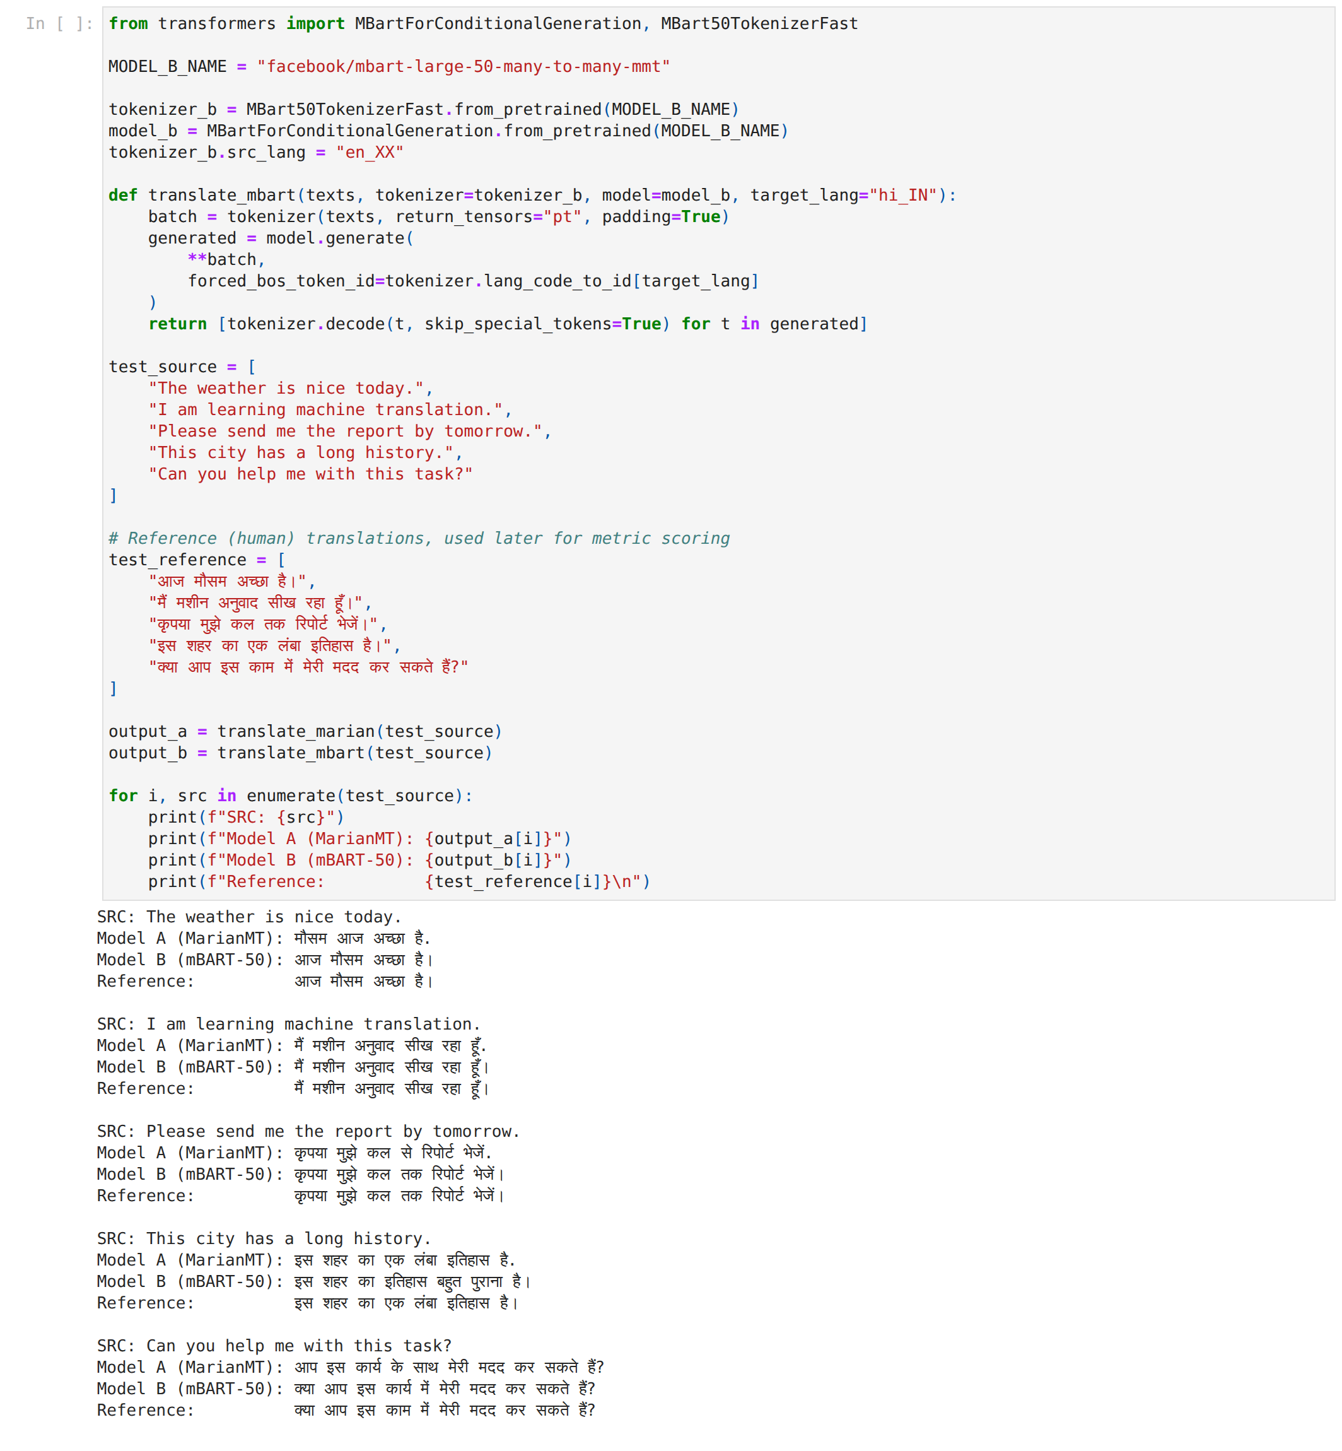
Figure 7 — MarianMT versus mBART-50 outputs on the five-sentence test set, with references. Inference: mBART-50 matches the reference exactly on three of five sentences and uses the Hindi full stop (।); MarianMT ends with "." and makes two word-choice errors, which the word-level metrics will penalise.
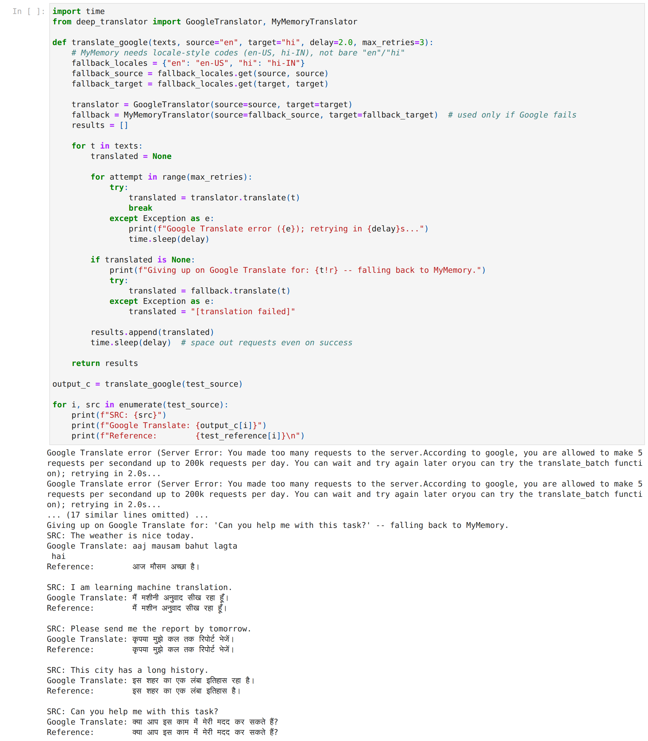
Figure 8 — Google Translate call log (truncated) and outputs. Inference: Every request was rate-limited and all five outputs came from the MyMemory fallback; its first output is romanised Hindi, so this column must be read as a third-party free engine, not Google.

Part 3 — Metrics
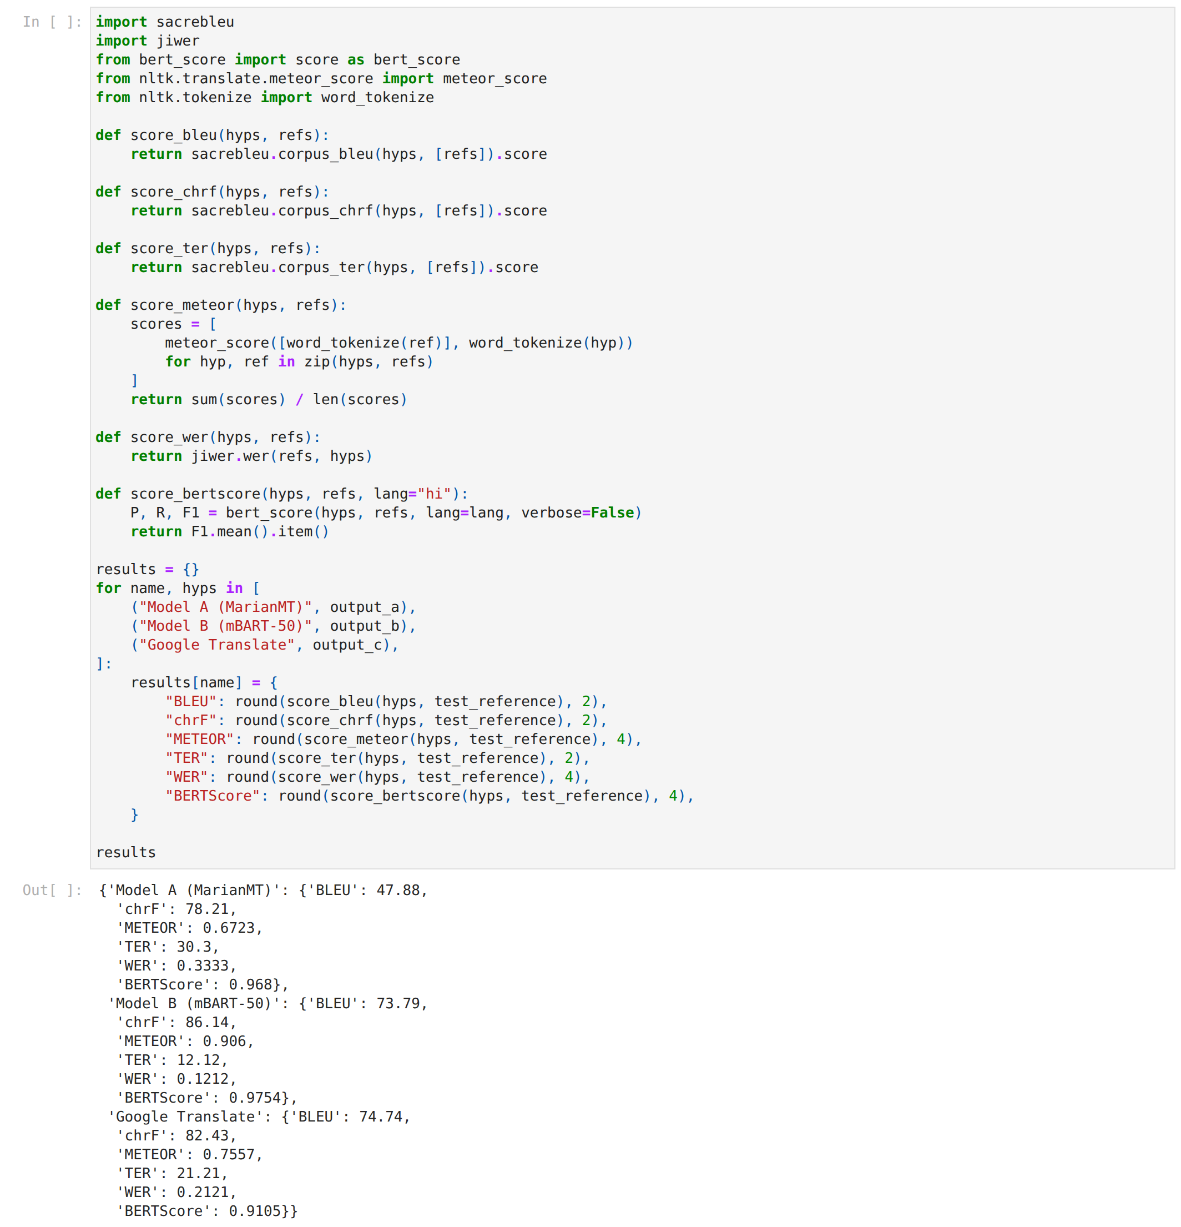
Figure 9 — Metric functions and the raw results dictionary. Inference: Six metrics are computed with three libraries (sacrebleu, nltk, jiwer, bert-score) from the same hypotheses and references, so the systems are compared on identical inputs.
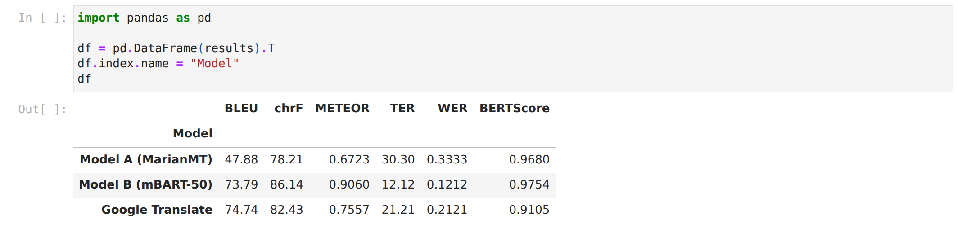
Table 4 — Metric table for the three systems. Inference: mBART-50 leads on every metric; MarianMT's BLEU deficit (26 points) shrinks to 0.007 on BERTScore, showing that its errors are mostly surface-level.
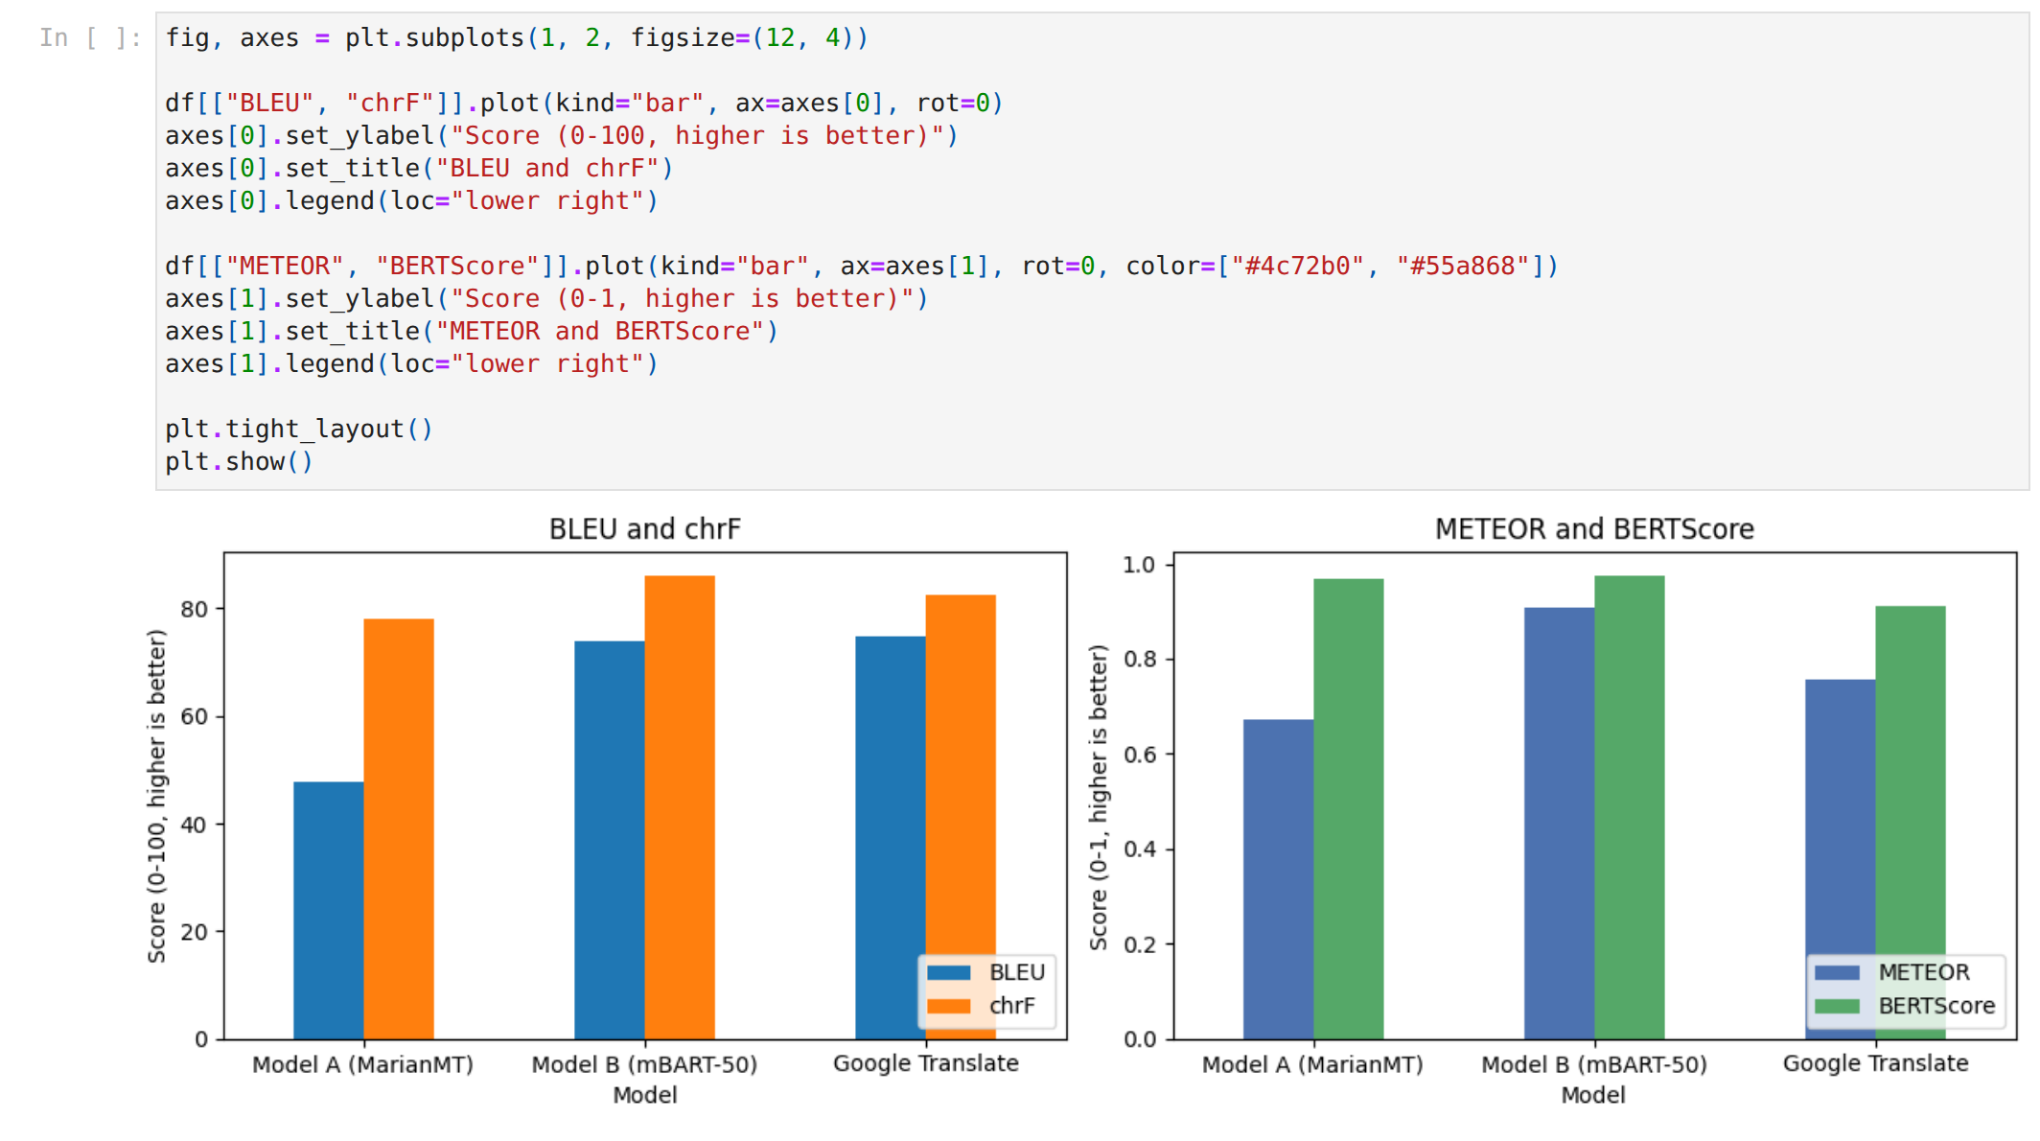
Figure 10 — BLEU/chrF and METEOR/BERTScore by system. Inference: The left panel shows large gaps on word- and character-overlap metrics; the right panel shows near-equal BERTScore — the two metric families disagree about how far apart the models are.

Extras
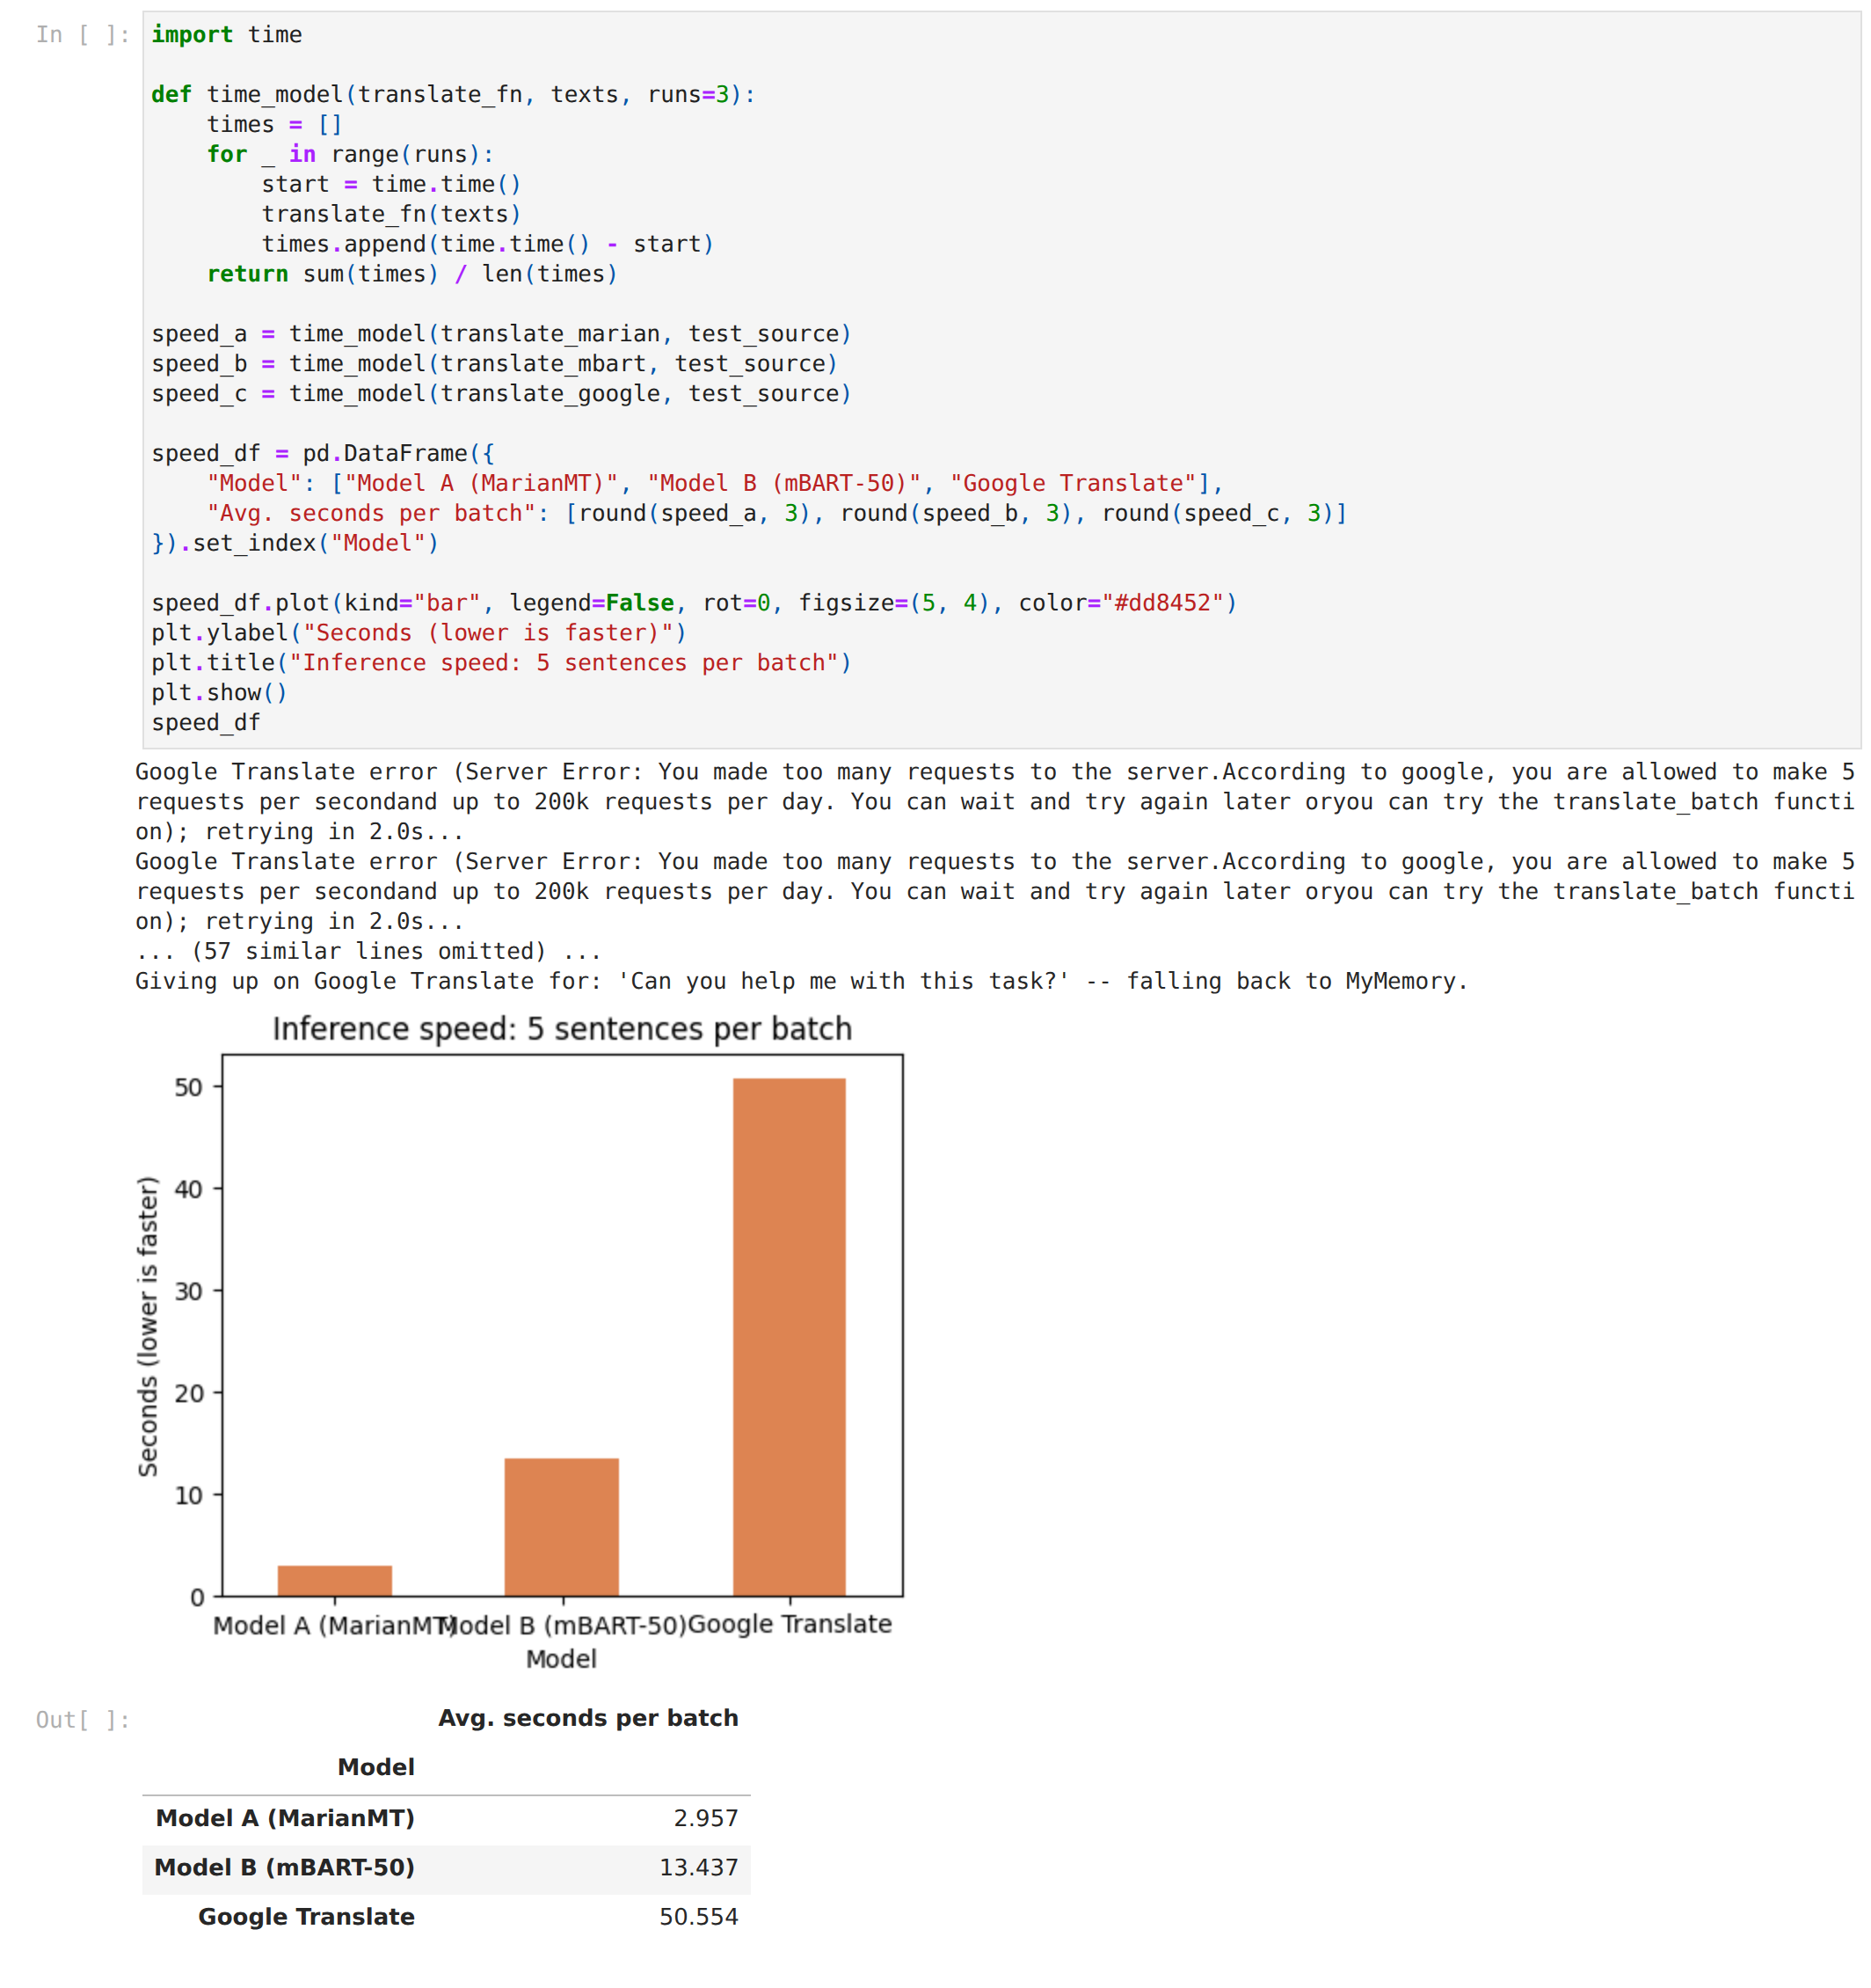
Figure 11 — Inference speed per five-sentence batch. Inference: MarianMT is 4.5× faster than mBART-50 on CPU (3.0 s versus 13.4 s), the price of a 50-language model; the web engine's 50 s is dominated by retry delays and is not a model-speed figure.
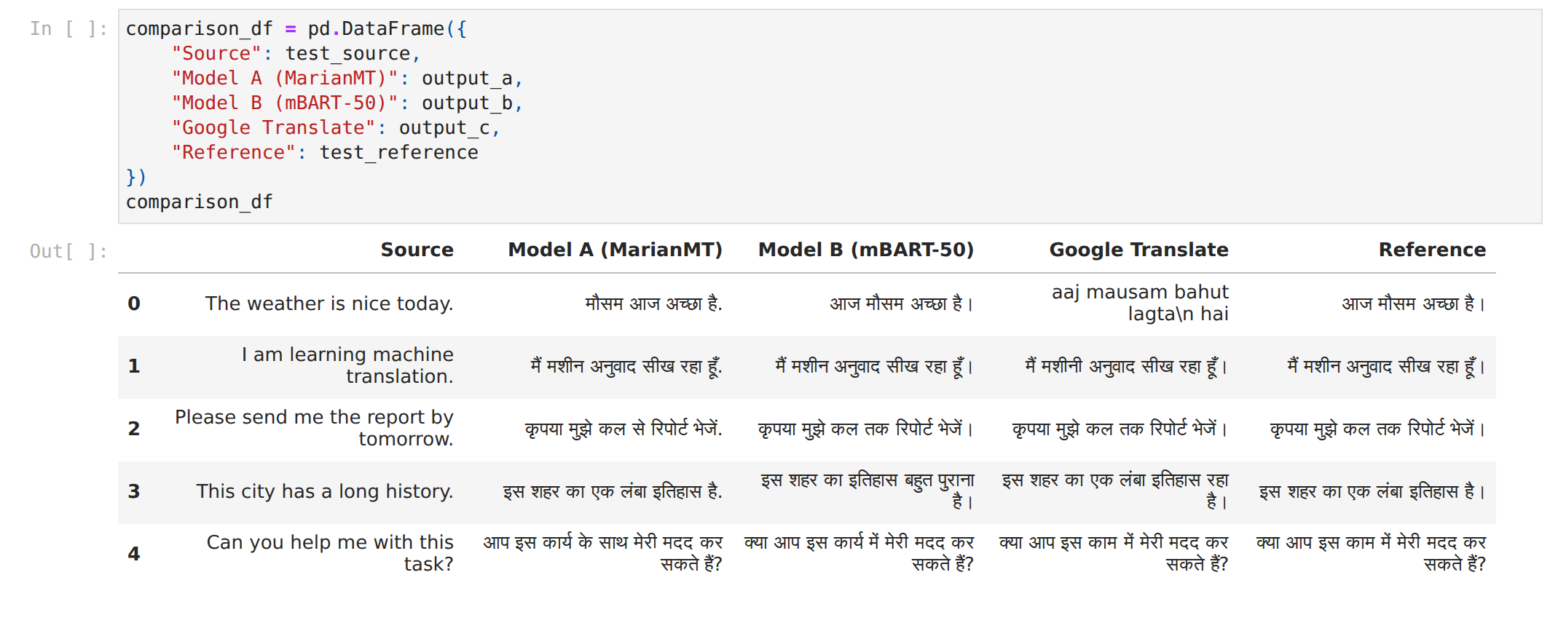
Table 5 — Sentence-by-sentence comparison of all three systems against the reference. Inference: Reading the rows confirms the metrics: mBART-50's differences from the reference are single words (कार्य vs काम); MarianMT's are punctuation plus two postpositions; MyMemory's first row is wrong in script and meaning.

Results summary
System | BLEU ↑ | chrF ↑ | METEOR ↑ | TER ↓ | WER ↓ | BERTScore ↑ | Sec / batch
Model A — MarianMT (opus-mt-en-hi) | 47.88 | 78.21 | 0.672 | 30.30 | 0.333 | 0.968 | 2.96
Model B — mBART-50 | 73.79 | 86.14 | 0.906 | 12.12 | 0.121 | 0.975 | 13.44
"Google Translate" (MyMemory fallback) | 74.74 | 82.43 | 0.756 | 21.21 | 0.212 | 0.911 | 50.55*
Table 6 — Results summary for the three systems.
* includes three failed Google attempts with 2 s delays per sentence; not a model-speed measurement.

Observations
- mBART-50 is the best open model on every metric: BLEU 73.8 vs 47.9, TER 12.1 vs 30.3. Its outputs match the reference exactly on 3 of 5 sentences and use the Hindi full stop (।), which the reference also uses.
- MarianMT's lower scores are partly punctuation. It ends sentences with "." rather than "।", which costs it on every word-level metric even when the words are right (sentences 2 and 4). Its two real errors are "कल से" (from tomorrow) for "कल तक" (by tomorrow), and "कार्य के साथ" (a literal "with this task"). BERTScore, which is embedding-based, rates it almost equal to mBART (0.968 vs 0.975).
- The "Google Translate" row is MyMemory. Google's endpoint rejected all 15 requests (rate limit), so the fallback engine produced every output. Its first sentence is romanised Hindi ("aaj mausam bahut lagta hai"), which is wrong in script and meaning, yet corpus BLEU is still highest because the other four sentences are near-exact matches. This row should be read as a third-party free engine, not Google.
- Speed: MarianMT is 4.5× faster than mBART-50 on CPU (3.0 s vs 13.4 s per 5-sentence batch), the usual bilingual-vs-multilingual trade-off. The 50 s for the web engine is dominated by retries.
- Back-translation returned "Please send me a report from tomorrow" for "by tomorrow", exposing the same "कल से" error as the metrics did; it is a useful reference-free check.
- Transliteration ITRANS→Devanagari gave "आप् … हैन्" because ITRANS treats a final consonant as halant; the input should be written "aapa … haiM" in ITRANS, or the HK/Velthuis scheme used.
- Language ID was confident for en/hi/es but only 0.71 for French (0.29 Catalan), showing that short texts with shared vocabulary are harder.
- Five sentences is a very small test set; corpus BLEU on it swings by tens of points on a single sentence. The ranking is indicative only.

Conclusion
Hence, learned the concepts of machine translation. Six concepts — NMT, OCR translation, transliteration, language identification, back-translation and pivot translation — were demonstrated for English ↔ Hindi with pretrained MarianMT models and supporting libraries. Two open models were compared with six metrics: mBART-50 gave the best quality (BLEU 73.8, TER 12.1, BERTScore 0.975) while MarianMT was 4.5× faster with lower but acceptable quality (BLEU 47.9, BERTScore 0.968). The Google Translate reference could not be obtained because of rate limiting; the fallback MyMemory engine was scored instead. Metric choice matters: word-level metrics penalised MarianMT's punctuation, whereas BERTScore rated the two models almost equal. A larger standard test set (e.g. FLORES-200 or WMT) would be needed for a reliable comparison.

