ASSIGNMENT NO: 07
Title: TTS, STT

Problem Statement
- Use library on sophisticated models (2)
- 2 languages minimum
- Performance evaluation metrics (2-4)
- Scriptures as input (corpus)

Algorithm / Implementation

Algorithm A — Text-to-Speech with MMS-TTS and Bark (Models 1 and 2)
- Install transformers, accelerate, torch, torchaudio, soundfile, librosa, jiwer and sacrebleu.
- Define the scripture corpus: 12 King James Bible verses (English) and 12 Bhagavad Gita verses (Hindi), each stored with its source reference.
- MMS-TTS: load one VITS checkpoint per language with VitsModel.from_pretrained (facebook/mms-tts-eng and facebook/mms-tts-hin) and the matching AutoTokenizer; tokenise the verse and read model(**inputs).waveform.
- Bark: load suno/bark-small with BarkModel and AutoProcessor; choose a speaker preset per language (v2/en_speaker_6, v2/hi_speaker_2); generate the waveform with model.generate(**inputs).
- For both models record the synthesis time and the sampling rate; audio duration = number of samples ÷ sampling rate.

Algorithm B — Speech-to-Text with Whisper and MMS-ASR (Models 3 and 4)
- Whisper: load openai/whisper-small through the transformers automatic-speech-recognition pipeline and force the decoding language to English or Hindi.
- MMS-ASR: load facebook/mms-1b-all (wav2vec 2.0 with a CTC head) with Wav2Vec2ForCTC; select the language adapter (eng or hin) with set_target_lang and load_adapter; take the argmax of the logits and decode.
- Resample the TTS audio to 16 kHz with librosa before both recognisers.
- Normalise the original and transcribed text (lower-case, punctuation removed) so that the two recognisers, which format text differently, are compared on words only.

Algorithm C — Round trip and evaluation
- Synthesise each verse once per TTS model, then transcribe every audio clip with both STT models: 2 TTS × 2 STT × 24 verses = 96 round trips.
- Compute WER and CER (jiwer) and BLEU (sacrebleu) for each TTS → STT pairing and language, over the 12 verses.
- Compute RTF per model and language: TTS synthesis time ÷ audio duration, and STT transcription time ÷ audio duration.
- Tabulate the metrics in pandas DataFrames and plot WER and BLEU by pairing with matplotlib.

Core code
# TTS 1: MMS-TTS
tok = AutoTokenizer.from_pretrained("facebook/mms-tts-hin")
mdl = VitsModel.from_pretrained("facebook/mms-tts-hin").eval()
waveform = mdl(**tok(text, return_tensors="pt")).waveform

# TTS 2: Bark
processor = AutoProcessor.from_pretrained("suno/bark-small")
bark = BarkModel.from_pretrained("suno/bark-small")
audio = bark.generate(**processor(text, voice_preset="v2/hi_speaker_2"))

# STT 1: Whisper
asr = pipeline("automatic-speech-recognition", model="openai/whisper-small")
text = asr({"array": audio_16k, "sampling_rate": 16000},
generate_kwargs={"language": "hindi", "task": "transcribe"})["text"]

# STT 2: MMS-ASR
proc = AutoProcessor.from_pretrained("facebook/mms-1b-all")
model = Wav2Vec2ForCTC.from_pretrained("facebook/mms-1b-all")
proc.tokenizer.set_target_lang("hin"); model.load_adapter("hin")
ids = torch.argmax(model(**proc(audio_16k, sampling_rate=16000, return_tensors="pt")).logits, dim=-1)[0]
text = proc.decode(ids)

# Metrics
wer = jiwer.wer(refs, hyps)
cer = jiwer.cer(refs, hyps)
bleu = sacrebleu.corpus_bleu(hyps, [refs]).score
rtf = processing_time / audio_duration

Platform
Open-source Linux; Python 3, Jupyter notebook (Google Colab compatible, GPU runtime); transformers, torch, torchaudio, librosa, soundfile, jiwer, sacrebleu, pandas, matplotlib. Models: facebook/mms-tts-eng, facebook/mms-tts-hin (MMS-TTS), suno/bark-small (Bark), openai/whisper-small (Whisper) and facebook/mms-1b-all (MMS-ASR).

Input
# | Language | Source | Size
1 | English | King James Bible — 12 verses (Genesis, Exodus, Psalms, Proverbs, Ecclesiastes, Isaiah, Matthew, John, Romans) | 12 lines, 145 words, 732 characters
2 | Hindi | Bhagavad Gita — 12 verses (chapters 2, 3, 4, 6 and 18) | 12 lines, 153 words, 748 characters

English corpus (King James Bible)
Reference | Verse
Genesis 1:1 | In the beginning God created the heaven and the earth.
Genesis 1:3 | And God said, Let there be light: and there was light.
Exodus 20:3 | Thou shalt have no other gods before me.
Psalm 23:1 | The Lord is my shepherd; I shall not want.
Psalm 46:1 | God is our refuge and strength, a very present help in trouble.
Proverbs 1:7 | The fear of the Lord is the beginning of knowledge.
Ecclesiastes 3:1 | To every thing there is a season, and a time to every purpose under the heaven.
Isaiah 40:31 | But they that wait upon the Lord shall renew their strength.
John 1:1 | In the beginning was the Word, and the Word was with God, and the Word was God.
John 3:16 | For God so loved the world, that he gave his only begotten Son.
Matthew 5:9 | Blessed are the peacemakers: for they shall be called the children of God.
Romans 8:28 | And we know that all things work together for good to them that love God.

Hindi corpus (Bhagavad Gita)
Reference | Verse
Gita 2.20 | आत्मा न कभी जन्म लेती है, न कभी मरती है।
Gita 2.14 | हे कुंतीपुत्र, सर्दी-गर्मी और सुख-दुःख इंद्रियों के विषयों से उत्पन्न होते हैं।
Gita 2.47 | तुम्हारा अधिकार केवल कर्म करने में है, उसके फल में कभी नहीं।
Gita 2.48 | हे अर्जुन, आसक्ति को त्यागकर और योग में स्थित होकर कर्म करो।
Gita 2.50 | समबुद्धि वाला व्यक्ति इस जीवन में पाप और पुण्य दोनों को त्याग देता है।
Gita 3.35 | अपना धर्म, भले ही अपूर्ण हो, दूसरे के धर्म से श्रेष्ठ है।
Gita 4.7 | हे भारत, जब-जब धर्म की हानि होती है, तब-तब मैं प्रकट होता हूँ।
Gita 4.8 | साधुओं की रक्षा और दुष्टों के विनाश के लिए मैं युग-युग में जन्म लेता हूँ।
Gita 6.5 | मनुष्य को स्वयं अपने बल से अपना उद्धार करना चाहिए, स्वयं को कभी गिरने नहीं देना चाहिए।
Gita 6.35 | अभ्यास और वैराग्य से मन को वश में किया जा सकता है।
Gita 2.63 | क्रोध से मोह उत्पन्न होता है, और मोह से बुद्धि नष्ट हो जाती है।
Gita 18.66 | सभी कर्तव्यों को छोड़कर केवल मेरी शरण में आ जाओ।

Output

Part 1 — Corpus and text-to-speech models
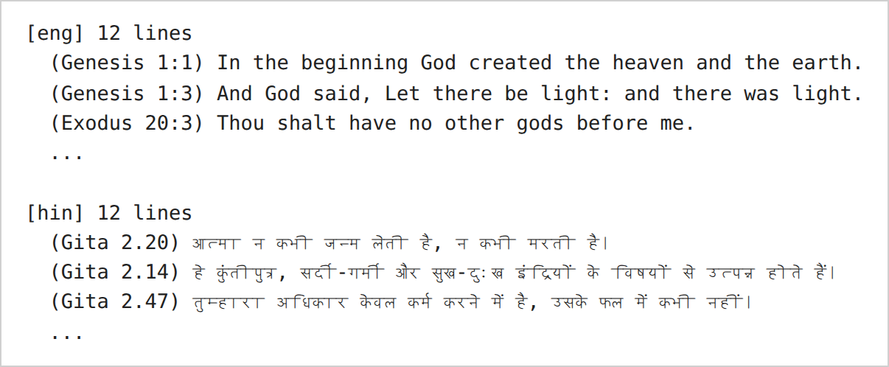
Figure 1 — The scripture corpus loaded into the notebook.
Inference: The corpus has 12 verses per language, each kept with its source reference, so every later result can be traced to one verse.
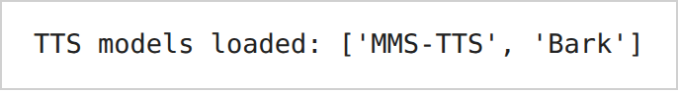
Figure 2 — Loading the MMS-TTS and Bark models.
Inference: Both TTS models loaded, so every verse can be synthesised by either model.
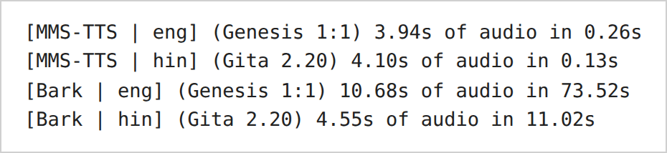
Figure 3 — Speech synthesised from the first verse by each TTS model, in each language: audio length and synthesis time.
Inference: MMS-TTS was much faster than Bark on the same verses (Hindi: 0.13 s against 11.02 s). Bark's English audio is also longer than MMS-TTS's for the same verse (10.68 s against 3.94 s). The 73.52 s that Bark took for the English verse is far above its average speed in Table 3 (RTF 2.589 would give about 28 s), so this call is not typical of Bark.

Part 2 — Speech-to-text models
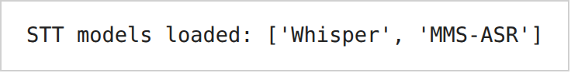
Figure 4 — Loading the Whisper and MMS-ASR models.
Inference: Both STT models loaded, so every audio clip can be transcribed by either model.
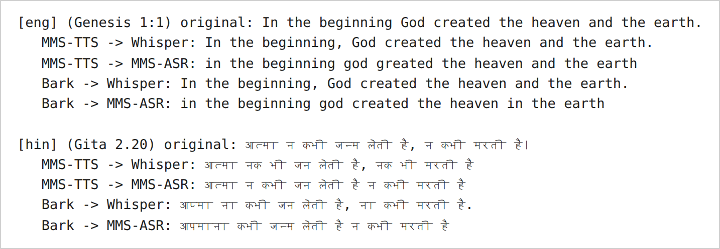
Figure 5 — Quick check: first verse through every TTS → STT pairing.
Inference: On the English verse both recognisers recovered nearly every word; MMS-ASR writes no capital letters or punctuation, which is why the text is normalised before scoring. On the Hindi verse every pairing changed at least one word, and "जन्म" was written as "जन" in three of the four pairings.

Part 3 — Full round trip
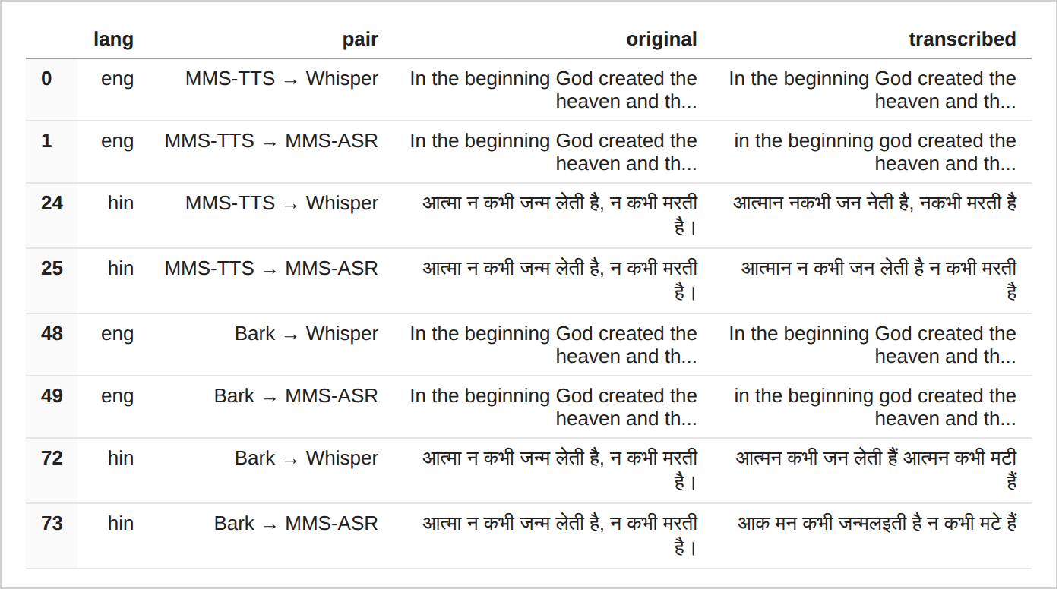
Table 1 — Sample of original and transcribed text across the four pairings.
Inference: The English transcriptions stay close to the original in both recognisers. The Hindi transcriptions differ in several words, and in the Bark rows (72, 73) the Hindi text is further from the original than in the MMS-TTS rows (24, 25).

Part 4 — Performance metrics
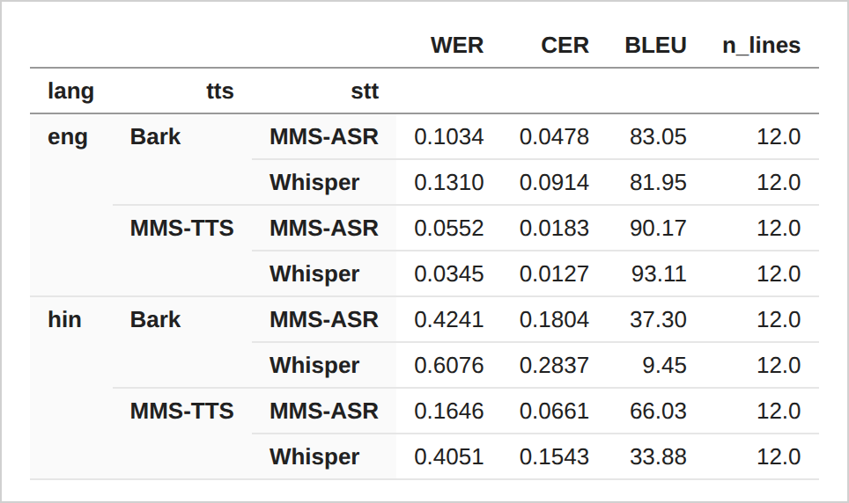
Table 2 — WER, CER and BLEU per language and TTS → STT pairing.
Inference: English WER lies between 0.0345 and 0.1310 and Hindi WER between 0.1646 and 0.6076, so Hindi loses more words in every pairing. MMS-TTS audio gives the lower error rates in all four language and recogniser cases. WER and BLEU do not always rank the pairings the same way: on Hindi, MMS-TTS → Whisper has a lower WER (0.4051) than Bark → MMS-ASR (0.4241) but also a lower BLEU (33.88 against 37.30).
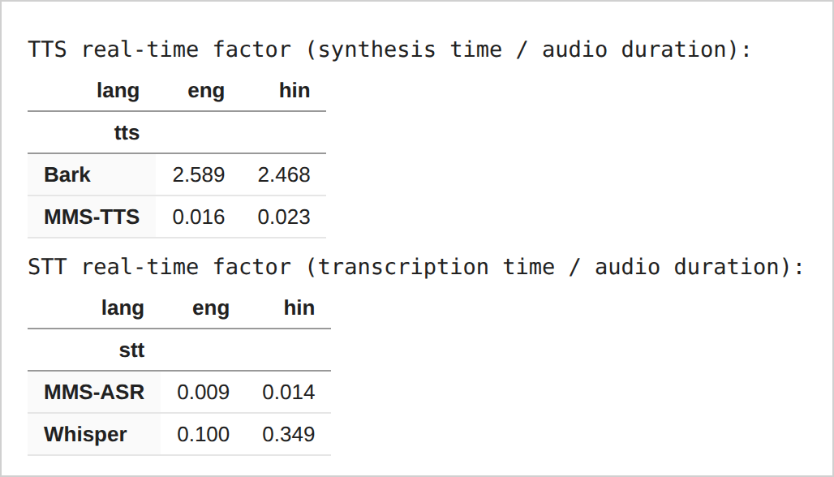
Table 3 — Real-time factor of each TTS and STT model.
Inference: MMS-TTS, MMS-ASR and Whisper all run faster than real time (RTF below 1); Bark does not (RTF 2.589 and 2.468). MMS-ASR is faster than Whisper, and Whisper is slower on Hindi (0.349) than on English (0.100).
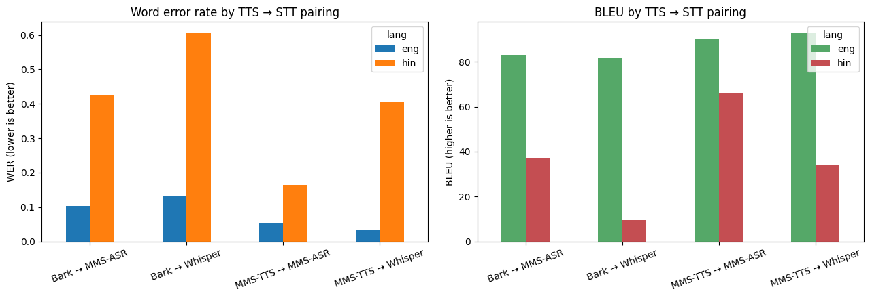
Figure 6 — WER and BLEU by TTS → STT pairing.
Inference: The Hindi bars are higher than the English bars for WER and lower for BLEU in all four pairings. The best pairing in each language uses MMS-TTS audio.

Part 5 — Visual analysis
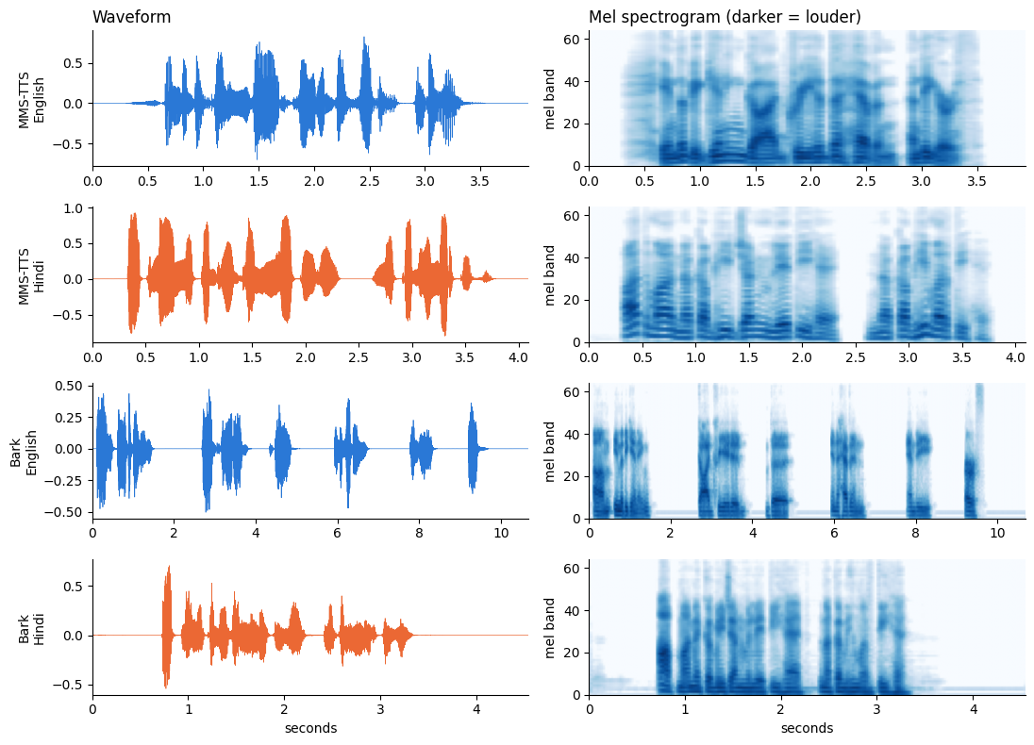
Figure 7 — Waveform and mel spectrogram of the first verse, for each TTS model and language.
Inference: MMS-TTS clips are about 4 s long, and the Hindi clip has a clear pause near 2.5 s. Bark's English clip is 10.68 s long, with long silent gaps between short bursts of speech.
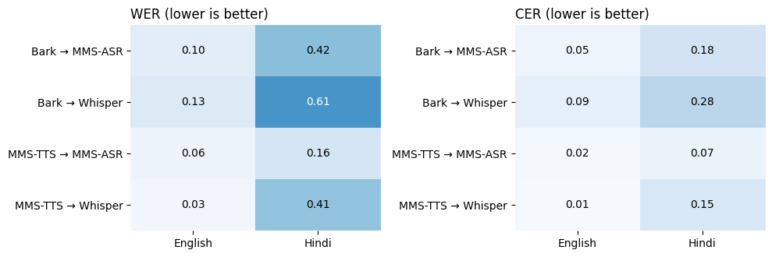
Figure 8 — WER and CER heatmaps for the four TTS → STT pairings.
Inference: The darker cells are all in the Hindi column. The darkest is Bark → Whisper on Hindi (WER 0.61) and the lightest is MMS-TTS → Whisper on English (WER 0.03), which matches Table 2.
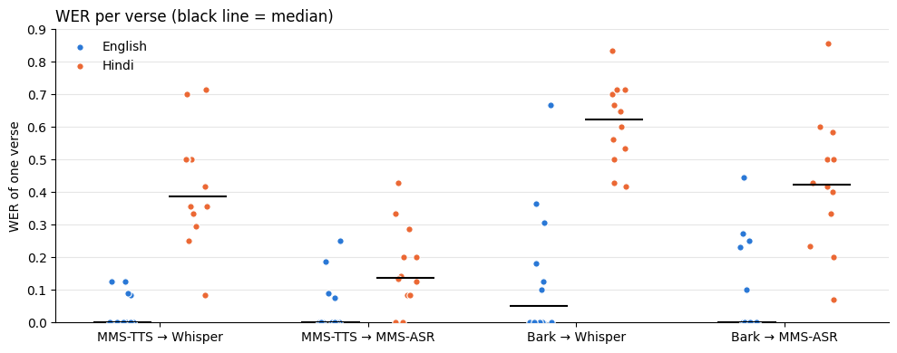
Figure 9 — WER of each verse, for each pairing and language (black line = median).
Inference: In three of the four pairings the median English verse has a WER of 0, so English errors come from a few verses. Hindi verses sit higher: the median is about 0.14 for MMS-TTS → MMS-ASR and about 0.62 for Bark → Whisper.
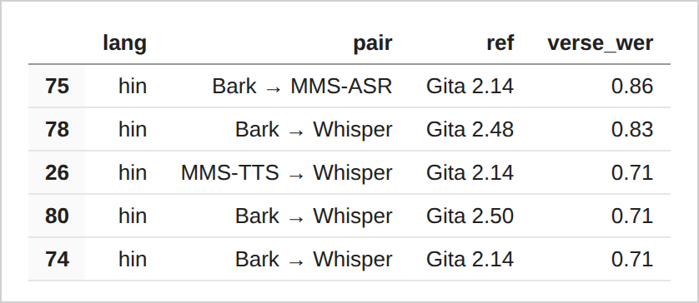
Table 4 — The five verse results with the highest WER.
Inference: All five are Hindi. Gita 2.14 appears three times (Bark → MMS-ASR 0.86, MMS-TTS → Whisper 0.71, Bark → Whisper 0.71), so this verse is hard for several pairings.
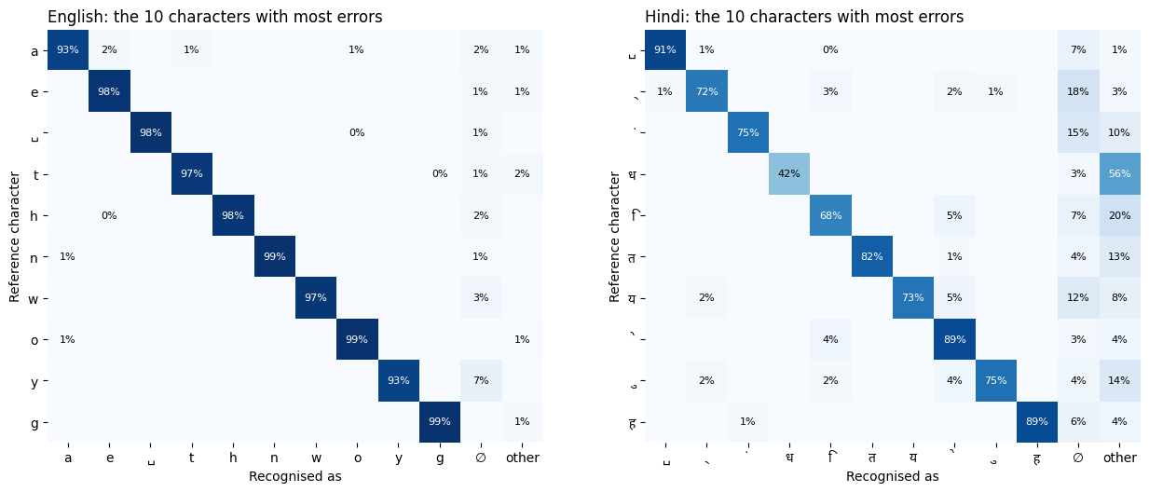
Figure 10 — Character confusion matrix: reference character against recognised character, for English and Hindi.
Inference: English characters are recognised correctly at least 93% of the time; the largest loss is y, with 7% missed. Hindi is lower and uneven: the letter ध is recognised in only 42% of its occurrences, and 56% are recognised as some other character. The small marks on the Hindi side are vowel signs and similar combining marks; ␣ is the space.
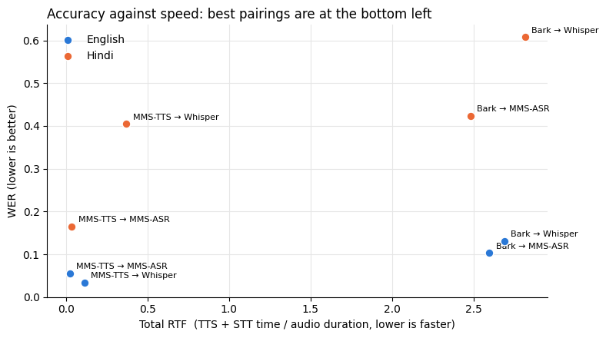
Figure 11 — WER against total real-time factor for each pairing.
Inference: MMS-TTS → MMS-ASR is the fastest pairing (total RTF 0.025 English, 0.037 Hindi) and has the lowest Hindi WER (0.1646). MMS-TTS → Whisper has the lowest English WER (0.0345) and is a little slower. The Bark pairings have a total RTF between 2.48 and 2.82 and a higher WER than MMS-TTS with the same recogniser, in both languages.

Observations
- MMS-TTS and MMS-ASR use a per-language checkpoint or adapter, whereas Bark and Whisper use one multilingual checkpoint for both English and Hindi.
- WER, CER and BLEU measure how well the transcribed text recovers the original verse after the text → speech → text round trip; RTF measures processing speed. Because each pairing mixes one synthesiser with one recogniser, pairings that share a TTS model isolate the recognisers, and pairings that share an STT model isolate the synthesisers.
- English: the lowest WER was MMS-TTS → Whisper (WER 0.0345, CER 0.0127, BLEU 93.11); the highest was Bark → Whisper (WER 0.1310, CER 0.0914, BLEU 81.95).
- Hindi: the lowest WER was MMS-TTS → MMS-ASR (WER 0.1646, CER 0.0661, BLEU 66.03); the highest was Bark → Whisper (WER 0.6076, CER 0.2837, BLEU 9.45). Every pairing had a higher WER in Hindi than in English.
- Same recogniser, different synthesiser: MMS-TTS audio gave a lower WER than Bark audio in all four cases (two languages × two recognisers); for example Hindi with Whisper: 0.4051 against 0.6076.
- Same synthesiser, different recogniser: on Hindi, MMS-ASR gave a lower WER than Whisper for both TTS models (0.1646 against 0.4051 on MMS-TTS audio; 0.4241 against 0.6076 on Bark audio). On English the result depends on the TTS model: Whisper was better on MMS-TTS audio (0.0345 against 0.0552) and MMS-ASR was better on Bark audio (0.1034 against 0.1310).
- Speed: MMS-TTS ran faster than real time (RTF 0.016 English, 0.023 Hindi) and Bark ran slower than real time (RTF 2.589 English, 2.468 Hindi). MMS-ASR (RTF 0.009, 0.014) was faster than Whisper (RTF 0.100, 0.349).
- Errors seen in Figure 5: MMS-TTS → MMS-ASR wrote "greated" for "created" (Genesis 1:1); Bark → MMS-ASR wrote "in the earth" for "and the earth"; for Gita 2.20, Bark → MMS-ASR wrote "आपमाना कभी" where the original has "आत्मा न कभी".
- Hindi errors are concentrated in some verses: Gita 2.14 appears three times among the five highest verse WERs (Table 4).
- Each language has 12 verses, so these figures come from a small sample, and the RTF values come from one run on a Google Colab GPU runtime.

Conclusion
Hence, learned the concepts of TTS and STT. Four pretrained models — MMS-TTS and Bark for text-to-speech, Whisper and MMS-ASR for speech-to-text — were used through the transformers library on two languages (English and Hindi), with King James Bible and Bhagavad Gita verses as the input corpus. All four TTS → STT pairings were evaluated with four metrics: WER, CER, BLEU and RTF. In this run, MMS-TTS → Whisper gave the lowest English WER (0.0345), MMS-TTS → MMS-ASR gave the lowest Hindi WER (0.1646), Bark → Whisper gave the highest Hindi WER (0.6076), and every pairing scored worse on Hindi than on English.

