ASSIGNMENT NO: 08
Title: Sentiment Analysis

Problem Statement
Sentiment Analysis using NLTK / Watson –Tone analyzer

Objectives
- To study and explore IBM Watson Tone Analyzer API.
- To learn concepts of sentiment analysis using NLTK.

Algorithm / Implementation

Algorithm A — Data preparation (Corpus A)
- Install nltk, scikit-learn, pandas, matplotlib and requests. Download the NLTK resource twitter_samples.
- Load Corpus A (NLTK twitter_samples: 5,000 positive and 5,000 negative tweets). Shuffle with a fixed seed and keep 4,000 tweets per class for training and 1,000 per class for testing.

Algorithm B — Naive Bayes and Logistic Regression (NLTK)
- Clean each tweet: remove links, tokenise with TweetTokenizer (lower-case, handles removed, repeated letters reduced) and keep only tokens that contain a letter, so emoticons and numbers are dropped.
- Build the feature set of each tweet as a dictionary {word: True}.
- Train nltk.classify.NaiveBayesClassifier on the 8,000 training tweets (4,000 positive and 4,000 negative).
- Print the ten most informative features of Naive Bayes with show_most_informative_features(10).
- Train a Logistic Regression (maximum entropy) model on the same features with nltk.classify.SklearnClassifier(LogisticRegression()).
- Classify a text with nb.classify(features(text)) or lr.classify(features(text)). Both models know two classes, so they answer positive or negative.

Algorithm C — Evaluation
- Test both models on the 2,000 held-out tweets of Corpus A.
- Compute four metrics with scikit-learn: accuracy and the macro average of precision, recall and F1.

Algorithm D — IBM Watson Tone Analyzer (REST API)
- Create a Tone Analyzer instance in IBM Cloud and copy the apikey and the service url from its credentials.
- Exchange the apikey for an IAM access token: POST https://iam.cloud.ibm.com/identity/token with grant_type urn:ibm:params:oauth:grant-type:apikey.
- Send the text: POST {url}/v3/tone?version=2017-09-21 with the header Authorization: Bearer <token> and the JSON body {"text": ...}.
- Read document_tone.tones from the response: each item has tone_name and a score from 0 to 1.

Algorithm E — AI4Bharat IndicSentiment (Hindi and English)
- Download the Hindi test file (data/test/hi.json) of the dataset ai4bharat/IndicSentiment from Hugging Face with huggingface_hub and read it with pandas. Each review has a Hindi text, an English text and a label (positive or negative).
- Shuffle the reviews and use 70% for training and 30% for testing.
- English reviews: test the two tweet-trained models of Algorithm B, and also train both models on the English training reviews.
- Hindi reviews: train both models on the Hindi training reviews (the tweet-trained models cannot read Hindi). Hindi words are made by splitting on spaces and removing punctuation and symbol characters, so that vowel signs are kept.
- Compute accuracy, precision, recall and F1 for each language and model.

Core code
nb = NaiveBayesClassifier.train(train_set)
lr = SklearnClassifier(LogisticRegression(max_iter=1000)).train(train_set)
label = nb.classify(features("what a lovely day"))

p, r, f, _ = precision_recall_fscore_support(y_true, y_pred, average="macro")

resp = requests.post(f"{WATSON_URL}/v3/tone", params={"version": "2017-09-21"},
headers={"Authorization": f"Bearer {token}"}, json={"text": text})

Platform
64-bit Open source Linux; Python 3, Jupyter notebook (Google Colab compatible); NLTK (Naive Bayes classifier, SklearnClassifier, twitter_samples), scikit-learn, pandas, matplotlib, requests, huggingface_hub; IBM Watson Cloud (Tone Analyzer REST API).

Input
# | Corpus | Source | Size
1 | A: twitter_samples | NLTK corpus, files positive_tweets.json and negative_tweets.json | 10,000 tweets (5,000 positive, 5,000 negative); 4,000 + 4,000 for training, 1,000 + 1,000 for testing
2 | B: AI4Bharat IndicSentiment | Product reviews from AI4Bharat (IIT Madras), Hugging Face dataset ai4bharat/IndicSentiment; each review in Hindi and in English, labelled positive or negative | 998 reviews (506 positive, 492 negative); 698 for training and 300 for testing

Output

Part 1 — Corpus A (NLTK)
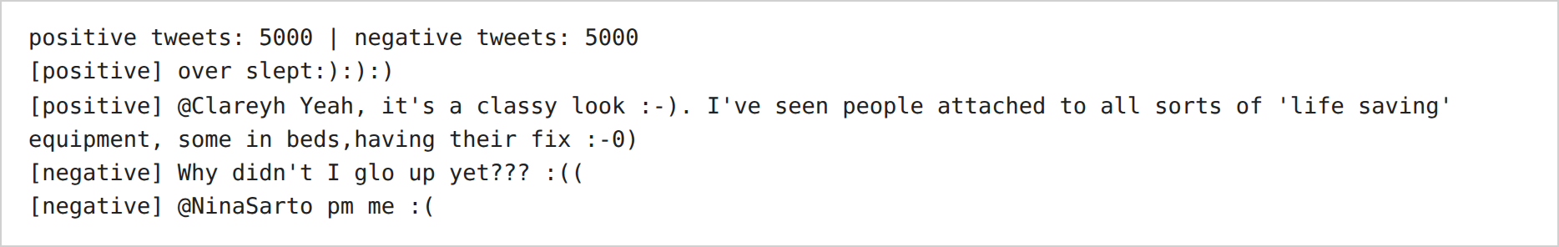
Figure 1 — Loading NLTK twitter_samples (Corpus A).
Inference: The corpus has 5,000 positive and 5,000 negative tweets. The tweets are short and informal, and the labels come from emoticons such as :) and :(.

Part 2 — Models
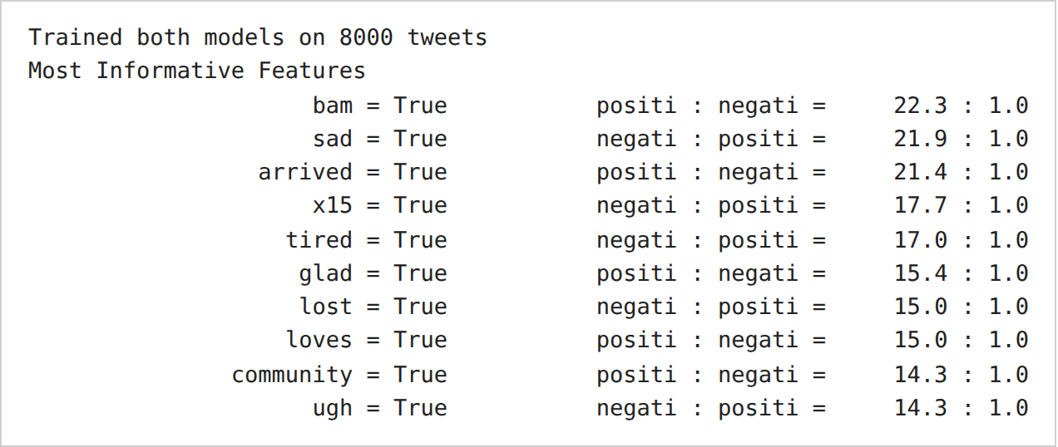
Figure 2 — Training Naive Bayes and Logistic Regression, and the ten most informative features of Naive Bayes.
Inference: Both models were trained on 8,000 tweets. The most informative words of Naive Bayes mostly carry clear sentiment: sad, tired, lost and ugh for negative; glad and loves for positive. Some are noise, such as x15 and bam.

Part 3 — Performance metrics
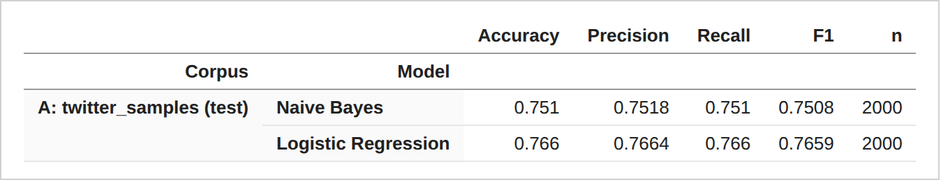
Table 1 — Accuracy, precision, recall and F1 of both models on the held-out tweets of Corpus A.
Inference: Logistic Regression scored higher than Naive Bayes on the 2,000 held-out tweets: 0.766 against 0.751 accuracy. The two classes have the same size, so precision, recall and F1 are close to accuracy.

Part 4 — Corpus B: AI4Bharat IndicSentiment (Hindi and English)
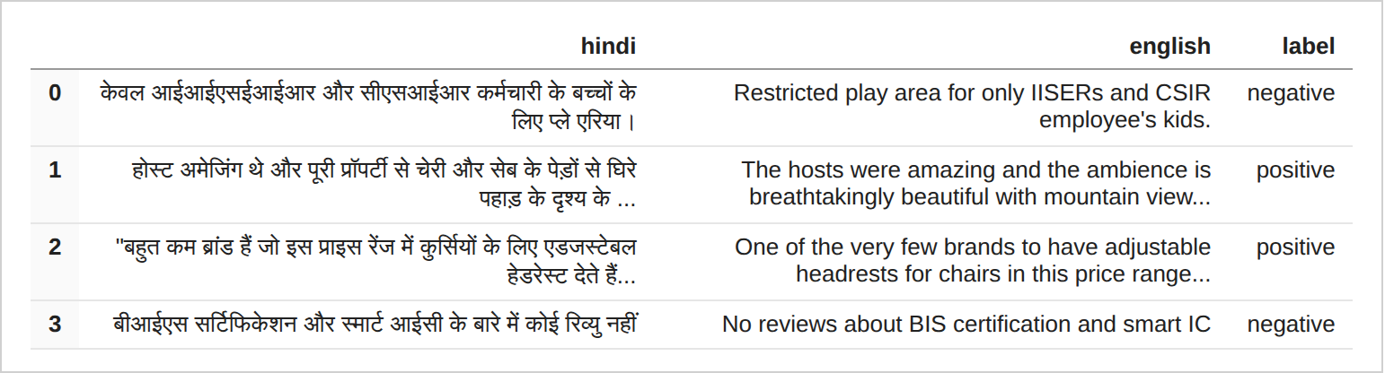
Table 2 — Four sample reviews from IndicSentiment (Hindi, English, label).
Inference: Each row has a Hindi review, its English version and a label. The reviews are about different products and places, and some labels depend on small details.
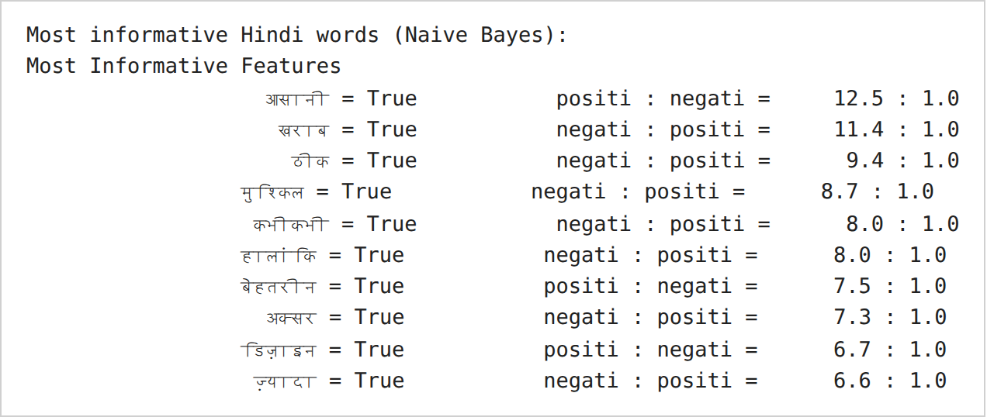
Figure 3 — Most informative Hindi words of the Naive Bayes classifier.
Inference: Naive Bayes found Hindi sentiment words without any Hindi lexicon: खराब (bad) and मुश्किल (difficult) point to negative, and बेहतरीन (excellent) and आसानी (ease) point to positive. The word कभीकभी is कभी-कभी (sometimes) with its hyphen removed.
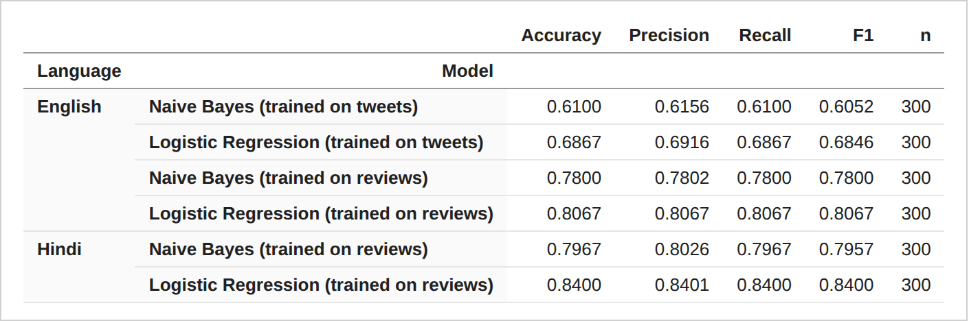
Table 3 — Accuracy, precision, recall and F1 on IndicSentiment, by language and model.
Inference: Models trained on reviews did best. Logistic Regression on Hindi reviews reached 0.84 accuracy, and on English reviews 0.8067. The models trained on tweets fell to 0.61 (Naive Bayes) and 0.6867 (Logistic Regression) on English reviews, against 0.751 and 0.766 on tweets, so a model does not carry over fully to another domain. Logistic Regression scored higher than Naive Bayes in every row. The test set has only 300 reviews, so differences of a few points can be noise.

Part 5 — IBM Watson Tone Analyzer
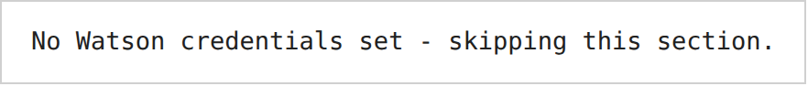
Figure 4 — Watson Tone Analyzer cell output.
Inference: No Watson credentials were set, so the cell skipped the service. This report has no Watson results.

Part 6 — Visual analysis
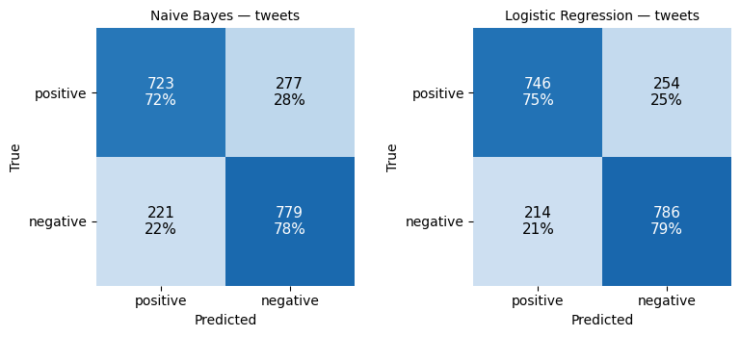
Figure 5 — Confusion matrices of both models on the 2,000 held-out tweets (Corpus A).
Inference: Naive Bayes labelled 498 of 2,000 tweets wrongly and Logistic Regression 468. Both models do better on negative tweets (78% and 79% correct) than on positive tweets (72% and 75% correct).
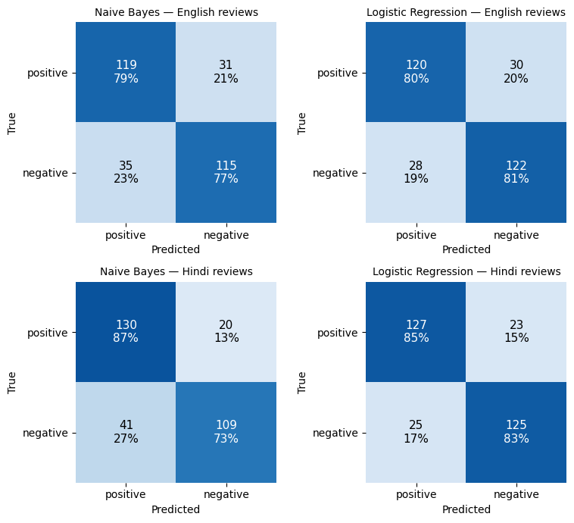
Figure 6 — Confusion matrices on the 300 test reviews of Corpus B, for models trained on reviews.
Inference: Naive Bayes on Hindi reviews labelled 41 of 150 negative reviews as positive (27%), against 20 of 150 positive reviews as negative (13%), so it leans to positive. Logistic Regression is more balanced on Hindi (85% and 83% correct) and has the fewest errors on English reviews (58 of 300).
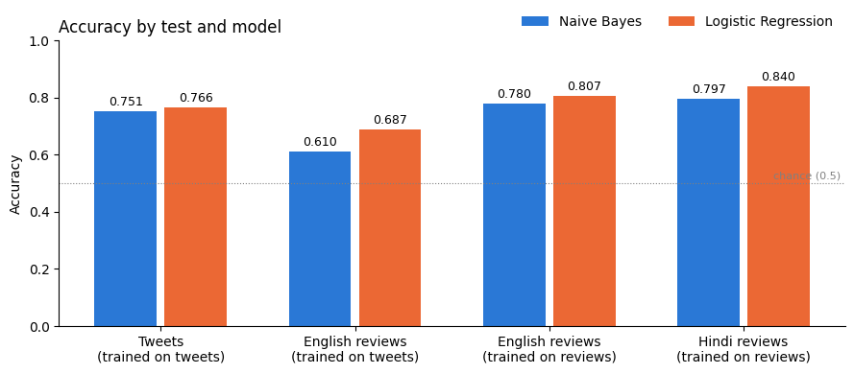
Figure 7 — Accuracy of Naive Bayes and Logistic Regression in every setup.
Inference: Logistic Regression is higher than Naive Bayes in all four setups, by 1.5 to 7.7 points. Both models fall on English reviews when trained on tweets, and both reach their best score on Hindi reviews trained on Hindi data.
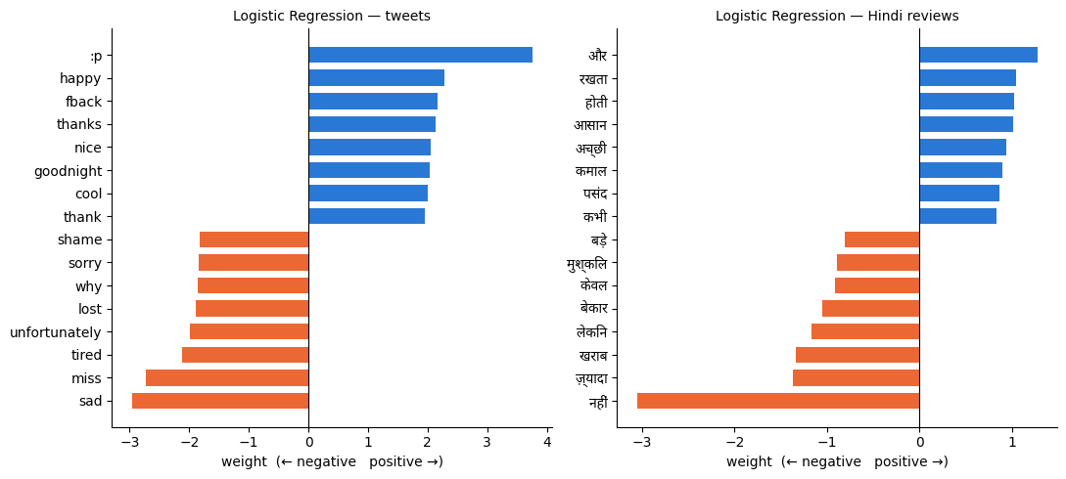
Figure 8 — Words with the largest Logistic Regression weights, for tweets and for Hindi reviews.
Inference: For tweets, the strongest words match common sense: happy, thanks and nice for positive; sad, miss, tired and sorry for negative. Two entries are noise: :p is an emoticon that passed the letter filter, and fback is slang for follow back. For Hindi, नहीं (not), खराब (bad) and बेकार (useless) are the strongest negative words, and कमाल (great), अच्छी (good) and पसंद (like) are positive. Some general words, such as और (and), also carry weight.

Conclusion
Hence, learned the concepts of sentiment analysis using IBM Watson Tone analyzer API / NLTK. On tweets, Logistic Regression scored 0.766 accuracy against 0.751 for Naive Bayes. On IndicSentiment, models trained on the same language did best, reaching 0.84 for Hindi with Logistic Regression, while the tweet-trained models fell to 0.61 and 0.6867 on English reviews.

