School of Computer Science & Engineering, MIT-WPU
Comprehensive Course Assessment 1 (CCA1) — Cloud Computing & Natural Language Processing

Finding the Intended Meaning of Indian Proverbs: Experiments on Marathi, Hindi and Assamese Book Corpora
Group 16 — Panel B
Member | PRN | Language | Corpus (book)
Sahish Nagulwar | 1032233310 | Marathi | Manwaring, Marathi Proverbs (1899)
Ibrahim Ansari | 1032233145 | Hindi | Fallon, A Dictionary of Hindustani Proverbs (1886)
Chayan Raj Bharati | 1032233134 | Assamese | Gurdon, Some Assamese Proverbs (1896)

Team problem statement: Develop a multilingual NLP framework that identifies Indian idioms and distinguishes their literal meaning from culturally intended figurative meaning across Hindi, Marathi, Tamil, Bengali, etc., while modeling cultural context and linguistic variation.

Abstract
A proverb means something other than what its words say. The Assamese saying "Gachat kathal, othat tel" translates to "the jackfruit is on the tree, the oil is on the lips", but what it actually means is closer to "do not count your chickens before they hatch". A model that reads it literally has misread it. This project studies how far NLP models can recover the intended meaning of a proverb from its literal text, in three Indian languages, with one language per team member. For each language we built a corpus from a public-domain proverb compilation, because such books record the intended meaning of each proverb next to its literal translation. The corpora contain 545 Marathi, 344 Hindi and 103 Assamese proverbs. On each corpus we measured the vocabulary overlap between the literal and figurative layers, trained a classifier, and ran a retrieval experiment in which a model must find the correct explanation for a given proverb. TF-IDF is the lexical baseline and LaBSE/MuRIL embeddings are the multilingual condition. In all three languages, a proverb shares about as much vocabulary with its own explanation as with a random one (Jaccard 0.046 to 0.070, versus 0.029 to 0.055). Marathi theme classification reaches 0.307 accuracy against a 0.157 majority baseline, and the Hindi literal-vs-figurative classifier reaches 0.726 against 0.500 chance. Retrieval P@1 falls from 0.347/0.129/0.081 with English queries to 0.120/0.029/0.024 with source-language queries (Assamese/Marathi/Hindi); LaBSE run on the romanized text does not improve on this, staying at or near the random baseline for source-language queries, which points to native-script recovery as the next step.

1. Introduction
Standard NLP pipelines assume that the meaning of a sentence can be built up from the meanings of its words. Proverbs break that assumption. Their intended meaning is fixed by cultural convention, and the literal reading, although grammatical, is usually wrong. The problem is worse in Indian languages, where the stock of proverbs is large and varies by region, and where digital resources that record intended meanings are scarce.
Table 1 shows one entry from each corpus in the form every experiment below works with: the proverb as printed (romanized), its literal translation, and the figurative meaning the compiler recorded for it. The rows are quoted exactly as extracted, OCR errors included, to show the raw material the models actually see.
Language | Proverb | Literal translation | Figurative meaning
Assamese | ধান পুৰীয়া কঠাল পাতৰ তলতে লুকাল  (Dhan puriya kathal patar talate lukal.) | The biggest jack fruit of all, i.e., that one worth a pura of dhan, lay hidden underneath the leaves. | Applied to those who hide their light under a bushel.
Marathi | सदा पिका सदा भिका  (Sada pika sada bhika) | Perpetual crops, perpetual poverty. | However good the konbi's [kunbi, farmer] crops are he remainB poor because of bis habit of borrowing.
Hindi | अभी सेर में एक पूनी भी नहीं कती है  (OCR: Abkl ser mek pint bhi naJvik kati hai.) | Of the pound of cotton not a skein ii yet sp jn [is yet spun]. | Scarce a fraction of the work is yet done.
Table 1: One entry from each corpus. The romanized line, literal translation and figurative meaning are quoted as extracted (OCR errors retained; readings in brackets). The native-script forms are our reconstructions from the romanization, since the script text in the scans did not survive OCR; that gap is the native-script recovery discussed in the conclusion.
Each member of the team picked one language and one book, built a dataset that pairs every proverb with its literal meaning and its explanation, and ran one set of models on it. We used books rather than web text for a practical reason: proverb compilations annotated by their compilers are one of the few sources where the intended meaning of each proverb is written down next to the literal text. That annotation is what our models train and evaluate on, and web corpora do not have it. All three books are in the public domain on the Internet Archive. One extraction pipeline, based on how many common English function words appear in each block of text, was written once and adapted to each book.

2. Research questions
RQ1 (Sahish Nagulwar, Marathi): How accurately can the figurative theme of a Marathi proverb be predicted from its literal text alone, and how well does lexical retrieval link a proverb to its intended explanation when the query is in English and when it is in romanized Marathi?
RQ2 (Ibrahim Ansari, Hindi): Can a classifier learn to tell the literal rendering of a Hindustani proverb apart from its figurative explanation, and how well does lexical retrieval link a proverb to its own explanation when the query crosses from English to romanized Hindustani?
RQ3 (Chayan Raj Bharati, Assamese): In a low-resource setting, how much can lexical models and multilingual transformer embeddings link an Assamese proverb's literal text to its intended meaning, and does the cultural commentary that accompanies each proverb help this alignment?

3. Research contributions

3.1 Sahish Nagulwar (Marathi)
The main output of this track is a machine-readable corpus of 545 Marathi proverbs from Manwaring (1899). Each entry has the romanized Marathi text, a literal English translation, the compiler's explanation of the intended meaning (349 entries) and the book's section heading as a theme label. The experiments on it also produced one observation that holds across tracks: translated word features beat source-language character features when the proverbs are very short, which is the opposite of the Assamese result.

3.2 Ibrahim Ansari (Hindi)
This track contributes a corpus of 344 Hindustani proverbs from Fallon (1886), each with romanized text, literal translation and the dictionary's gloss of the intended meaning (334 entries). Since the dictionary has no subject sections, the classification experiment here models the team problem statement itself: it tests whether literal renderings and figurative explanations can be told apart as two kinds of text.

3.3 Chayan Raj Bharati (Assamese)
This track contributes a corpus of 103 Assamese proverbs from Gurdon (1896), each with romanized text, literal translation, theme label and cultural commentary, along with the extraction pipeline (PanelB_16_build_corpus.py) that the other two tracks adapted to their books. The experiments compare TF-IDF with multilingual embeddings on theme classification and on retrieval of the correct commentary, and measure where word overlap stops being useful for finding the intended meaning.

4. Methodology

4.1 Shared pipeline
All three tracks follow the same steps. First, the OCR text of the book is downloaded from the Internet Archive and split into proverb entries. Blocks inside each entry are labelled as source-language proverb, literal English translation, or explanation, based on the fraction of common English function words they contain, plus a few cue phrases. OCR noise is then cleaned up. Second, where the book provides subject headings, these become theme labels. Third, each member runs a classification experiment and a retrieval experiment. In the retrieval experiment, every explanation in the corpus is ranked by cosine similarity to a query, and we record the rank of the correct one (Precision@k and MRR, with a random baseline). The query is either the English literal translation or the source-language text. The second case is the cross-lingual one, and for it each notebook also has a LaBSE embedding condition.

4.2 Sahish Nagulwar (Marathi)
In Manwaring (1899), section page-headers give the theme labels. Inside each entry, the romanized Marathi line is found by its low share of English function words. The block after it is split at the first sentence boundary: the first sentence is the literal translation, the rest is the explanation. Theme classification runs over the 13 sections that have at least 12 proverbs (466 proverbs; the book's "Unclassified" section is left out), with logistic regression and balanced class weights, once with word TF-IDF on the literal translations and once with character 2-4-gram TF-IDF on the romanized Marathi, under stratified 5-fold cross-validation. Retrieval runs over the 349 entries that have explanations.

4.3 Ibrahim Ansari (Hindi)
In Fallon (1886), romanized proverb lines are found the same way. The lines after them are taken as the literal translation, and the parenthesized note as the gloss. Entries that the OCR mangled too badly are dropped by an English-ratio filter, which left 344. The dictionary is alphabetical, so there are no theme labels. Instead, each proverb contributes two texts, its literal rendering (class "literal") and its gloss (class "figurative"), 668 sentences in total, and logistic regression over word TF-IDF is trained to tell them apart under stratified 5-fold cross-validation. Retrieval runs over the 334 glossed entries.

4.4 Chayan Raj Bharati (Assamese)
Gurdon (1896) yielded 103 proverbs, 75 of them with commentary. Theme buckets are assigned from the book's subject headings through a keyword map (9 buckets plus "other"). Classification uses logistic regression with balanced class weights, once with word TF-IDF on the literal translations and once with character 2-4-gram TF-IDF on the romanized Assamese, with 5-fold stratified cross-validation over the 94 proverbs in buckets that have at least 6 members. Retrieval runs over the 75 commentaries, with both query forms and the LaBSE condition.

5. Description of corpora

5.1 Marathi: Manwaring, "Marathi Proverbs" (1899)
Manwaring, A. (1899). Marathi Proverbs. Oxford: Clarendon Press. Public domain; Internet Archive: https://archive.org/details/marathiproverbs00manwgoog. The book has about 1,900 proverbs arranged in subject sections (Agriculture, Animals, Ethical, Religious, Nature and others). Each entry prints the Devanagari original, a romanized transliteration, a literal English translation and, for most entries, an explanation of the intended meaning. The extracted corpus has 545 proverbs, 349 of them with explanations. It contains 2670 romanized-Marathi tokens (vocabulary 2066), 11915 translation tokens (vocabulary 6442) and 5575 explanation tokens. A proverb averages 4.9 tokens, its translation 21.9, and its explanation 10.2. The size follows from the acceptance rule: an entry was kept only when the romanized line and the translation could be recovered cleanly from the OCR and a section heading was in scope, and damaged entries were dropped rather than patched. This is the largest corpus of the three tracks because the Clarendon Press print gives the best OCR of the three books.
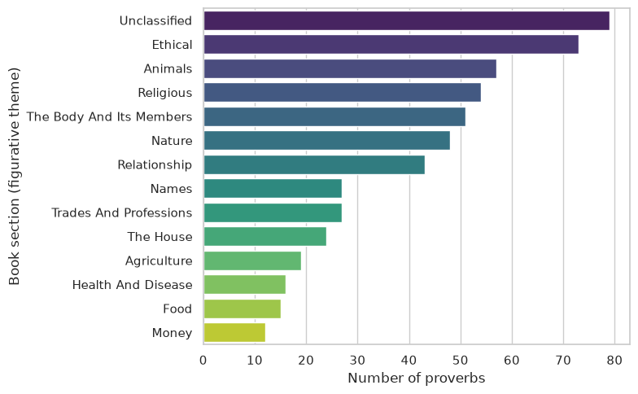
Figure 1: Number of Marathi proverbs in each of the book's subject sections.
Inference: The book's sections are unequal: Ethical, Animals and Religious dominate while Money and Food have barely a dozen proverbs each. Class imbalance of this size is why macro-F1 is reported next to accuracy and why balanced class weights are used in the classifier.
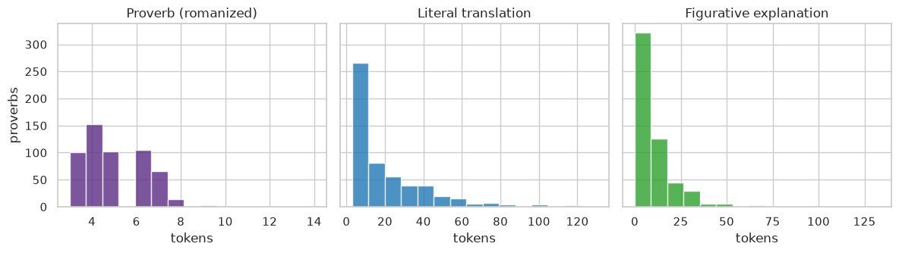
Figure 2: Token-length distributions for the Marathi proverb, its literal translation, and the explanation. The proverbs average 4.9 tokens.
Inference: Marathi proverbs are very short (most under 6 tokens) while their explanations run two to three times longer. Little surface text per proverb is a first hint that source-language character features will struggle here.

5.2 Hindi: Fallon, "A Dictionary of Hindustani Proverbs" (1886)
Fallon, S. W. (1886). A Dictionary of Hindustani Proverbs. Banaras: Medical Hall Press. Public domain; Internet Archive: https://archive.org/details/in.ernet.dli.2015.42145. The dictionary has several thousand Hindustani proverbs and idioms, with Marwari, Panjabi, Maggah, Bhojpuri and Tirhuti variants. Each entry prints the proverb in native script, a romanized transliteration, a literal English translation, and a parenthesized note that states the intended sense or the situation the proverb is used in. The extracted corpus has 344 proverbs, 334 with glosses. It contains 2301 romanized tokens (vocabulary 1731), 3454 translation tokens (vocabulary 1446) and 3935 gloss tokens. A proverb averages 6.7 tokens, its translation 10.0, and its gloss 11.4. The extractor found 449 candidate entries in the OCR and kept 344: the two-column print gives the worst OCR of the three books, so the filters are strictest here, and size was traded for quality on purpose. Every kept entry has all three fields intact, which both experiments depend on.
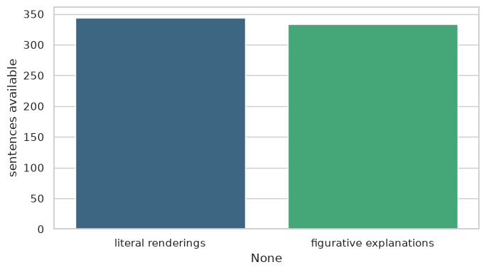
Figure 3: Number of Hindi literal renderings and figurative glosses available for the classification dataset.
Inference: Almost every extracted Hindi proverb (334 of 344) came with a gloss, so the literal and figurative classes are nearly balanced. Chance for the classifier is therefore a clean 0.500.
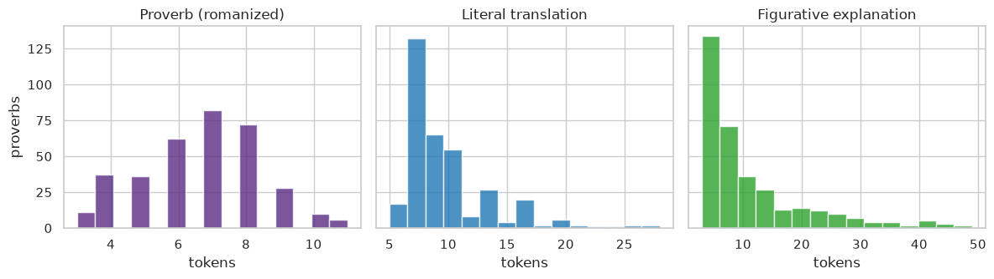
Figure 4: Token-length distributions for the Hindi proverb, its literal translation, and the gloss.
Inference: Literal translations and glosses are of similar length in Fallon (about 10-11 tokens each), so any classifier separation between them cannot be explained by length alone; it has to come from wording.

5.3 Assamese: Gurdon, "Some Assamese Proverbs" (1896)
Gurdon, P. R. (1896). Some Assamese Proverbs. Shillong: Assam Secretariat Printing Office. Public domain; Internet Archive: https://archive.org/details/someassameseprov00gurdrich. The book is an annotated collection of Assamese proverbs. Each proverb is printed in Assamese script with a romanized transliteration, a literal English translation, and a note that explains the cultural context and the intended usage. The extracted corpus has 103 proverbs, 75 with commentary. It contains 944 Assamese tokens (vocabulary 793), 2,751 translation tokens (vocabulary 1,147) and 3,782 commentary tokens. A proverb averages 9.2 tokens, its translation 26.7, and its commentary 36.7. The book predates standardized orthography, so the romanization uses 19th-century spellings. The parser found 218 numbered entries in the OCR and 103 passed the field filters (at least three recoverable words of romanized text and of translation). The size is small but bounded by the source: Gurdon is the only annotated Assamese proverb compilation in the public domain, and the kept entries support 5-fold cross-validation and a retrieval pool of 75 commentaries.
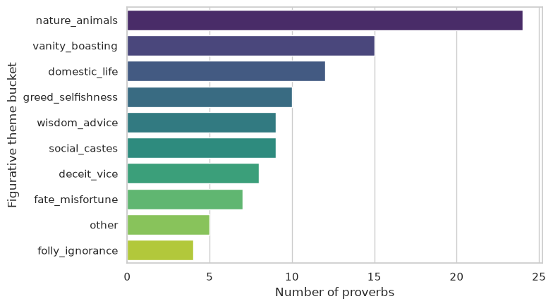
Figure 5: Number of Assamese proverbs in each figurative theme bucket.
Inference: Nature and animal imagery is the largest bucket in Gurdon, followed by vanity and domestic life. With 103 rows split over 10 buckets, several classes have under 10 examples, which is the practical limit of what 5-fold cross-validation can support.
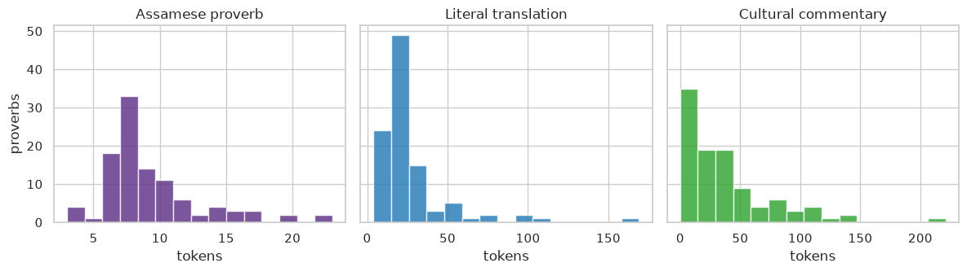
Figure 6: Token-length distributions for the Assamese proverb, its literal translation, and the commentary.
Inference: Assamese proverbs are the longest of the three languages (mean 9.2 tokens) and their commentaries the longest of all (mean 36.7). The size gap between a proverb and its explanation is the visual form of the literal/figurative asymmetry.

5.4 From raw book to usable corpus
Figure 7 shows the steps every corpus went through. The same steps are applied to all three books; only the entry-splitting rule differs, because the three books lay out their entries differently.
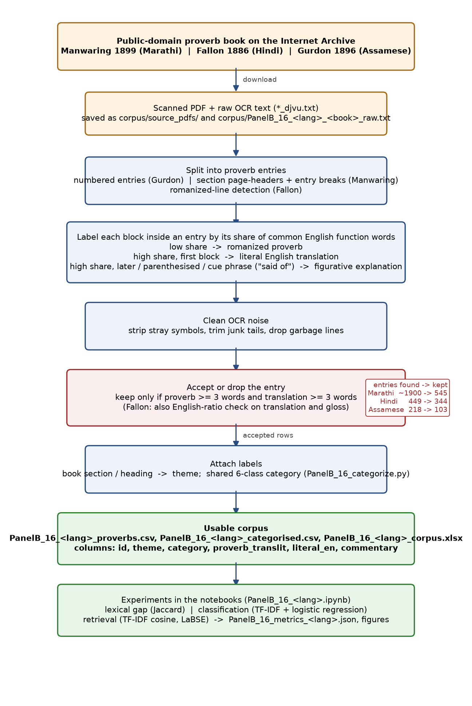
Figure 7: Pipeline from the scanned book to the usable corpus and on to the experiments. The red box is where entries are dropped; the counts beside it are the number of entries found in the OCR against the number kept.
Inference: Most of the loss happens at the accept-or-drop step, not at OCR: Fallon loses about a quarter of its candidates and Gurdon about half, because their older, denser prints leave many entries without a clean proverb-translation pair. Everything downstream works only with rows that have all fields.

5.5 Category scheme across the three corpora
The books label their proverbs differently: Manwaring has thirteen subject sections, Gurdon has subject headings that we bucketed into ten themes, and Fallon is alphabetical with no labels at all. To make the corpora comparable, every row was also given one of six shared categories: Human Nature & Character, Society & Relationships, Nature & Animals, Livelihood & Agriculture, Fortune & Fate, and Wisdom & Advice. Marathi and Assamese rows were mapped from the labels their books already carry. Hindi rows, having no labels, were assigned by keyword rules over the literal translation and gloss (PanelB_16_categorize.py); rows that matched no rule were left as Uncategorised rather than forced into a class. The category and the basis for it are stored per row in the categorised CSVs and in the Excel workbooks.
Category | Marathi | Hindi | Assamese | Total
Human Nature & Character | 140 | 18 | 37 | 195
Society & Relationships | 175 | 49 | 21 | 245
Nature & Animals | 105 | 54 | 24 | 183
Livelihood & Agriculture | 46 | 45 | 0 | 91
Fortune & Fate | 0 | 20 | 7 | 27
Wisdom & Advice | 0 | 24 | 9 | 33
Uncategorised | 79 | 134 | 5 | 218
Total | 545 | 344 | 103 | 992
Table 2: Rows per shared category and language.
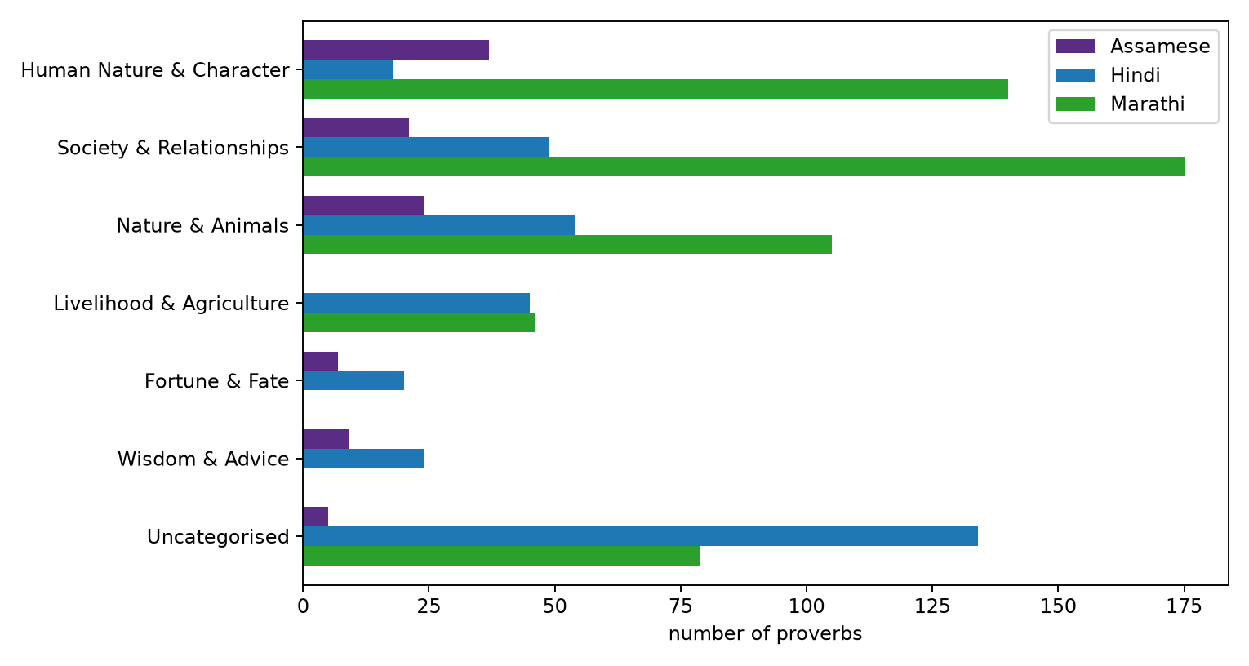
Figure 8: Number of proverbs in each shared category, by language.
Inference: Society and human character dominate in all three languages, and nature imagery is a strong third, so the three books sample similar ground even though they were compiled by different people in different regions. The large Hindi Uncategorised bar is a limit of keyword rules on OCR-noisy glosses, and the empty Marathi bars for Fate and Advice reflect that Manwaring has no such sections rather than an absence of such proverbs.

6. Implementation and results
Each member implemented their models in a Jupyter notebook, submitted with this report (PanelB_16_marathi.ipynb, PanelB_16_hindi.ipynb, PanelB_16_assamese.ipynb). The notebooks share the pipeline described in Section 4, and all figures below come from them. The LaBSE condition was run locally on CPU with the sentence-transformers library, and its rows appear in each retrieval table.

6.1 Sahish Nagulwar (Marathi)
The overlap between a proverb's literal translation and its own explanation is 0.046 (Jaccard), and the overlap with a random explanation is 0.030. The two distributions are shown in Figure 7.
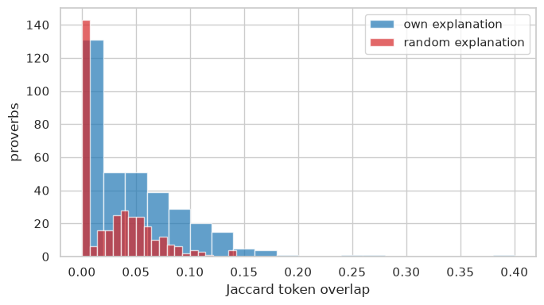
Figure 9: Jaccard overlap between each Marathi proverb's literal translation and its own explanation, compared with a random explanation.
Inference: The overlap distribution against a proverb's own explanation sits almost on top of the random one. On this corpus, knowing which explanation belongs to a proverb tells you almost nothing about which words it will use.
Theme classification results over 466 proverbs and 13 sections (5-fold CV):
Model | Accuracy | Macro-F1
Majority-class baseline | 0.157 | 0.021
Word TF-IDF + LogReg (English literal) | 0.307 | 0.255
Char 2-4-gram TF-IDF + LogReg (romanized Marathi) | 0.217 | 0.187
Table 3: Marathi theme classification (stratified 5-fold CV).
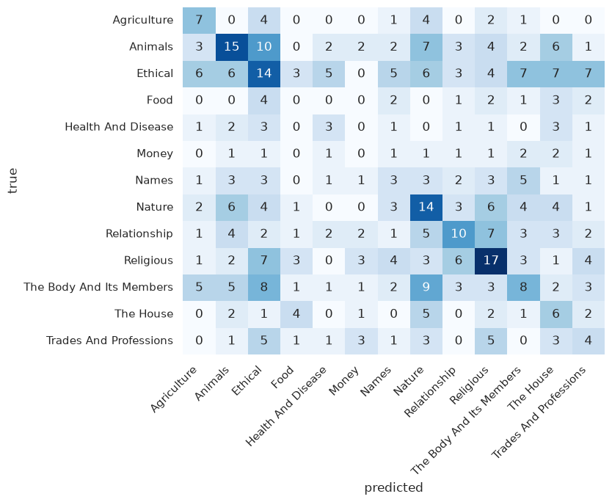
Figure 10: Confusion matrix (cross-validated) for Marathi theme classification from the romanized text.
Inference: The diagonal is visible but weak, and errors spread widely across the moral sections (Ethical, Religious). Themes with distinctive nouns are recovered; abstract themes are confused with each other.
Retrieval results over the 349 proverbs with explanations:
Query form | P@1 | P@5 | MRR
TF-IDF, English literal translation | 0.129 | 0.212 | 0.174
TF-IDF, romanized source language | 0.029 | 0.046 | 0.047
LaBSE, English literal translation | 0.063 | 0.143 | 0.116
LaBSE, romanized source language | 0.006 | 0.029 | 0.027
Random baseline | 0.003 | 0.014 | 0.018
Table 4: Marathi retrieval of the correct explanation.
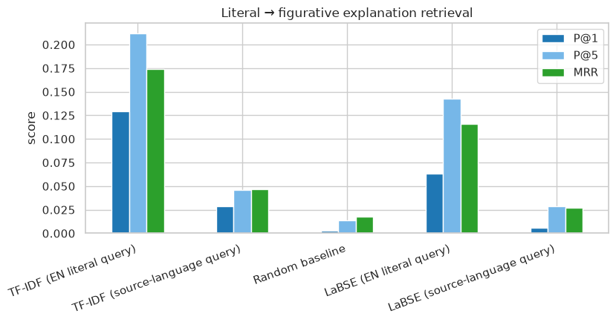
Figure 11: Marathi retrieval scores for TF-IDF and LaBSE, with English-literal and romanized-Marathi queries.
Inference: TF-IDF with English queries is the only condition that clears P@1 of 0.10; the Marathi-query condition and both LaBSE conditions sit near the floor. The gap between the first two bars is the cross-lingual loss.
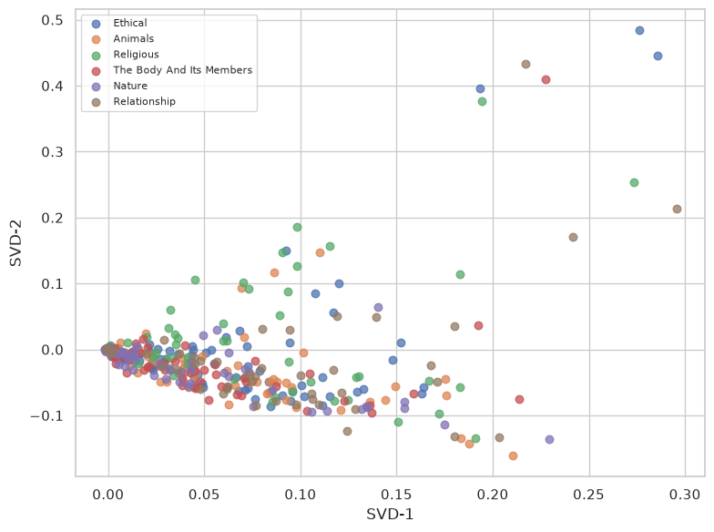
Figure 12: 2-D SVD projection of the Marathi literal translations for the six largest themes.
Inference: The six largest themes overlap heavily in the projection, with only Animals and Relationship pulling slightly apart. Surface vocabulary places most proverbs in one undifferentiated cloud.
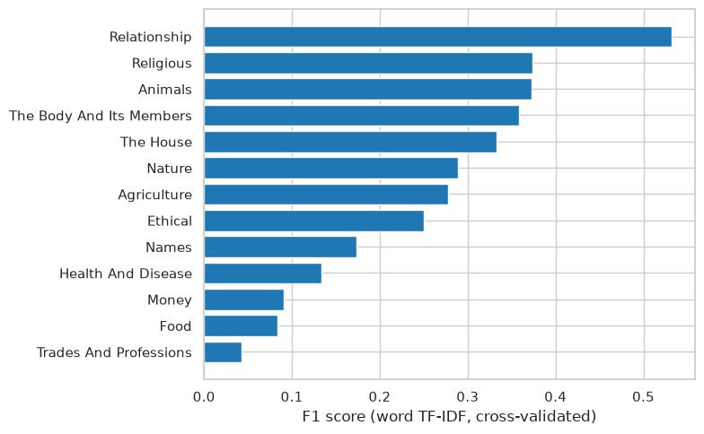
Figure 13: F1 per theme for the Marathi word TF-IDF classifier. Sections with recurring vocabulary of their own (Relationship, Religious, Animals) score highest, and the smallest sections score lowest.
Inference: Relationship, Religious and Animals are the sections the classifier actually learns; Money, Food and Trades are close to zero. Per-theme F1 tracks section size and vocabulary distinctiveness rather than anything semantic.

6.2 Ibrahim Ansari (Hindi)
The overlap between a proverb's literal translation and its own gloss is 0.051 (Jaccard), against 0.029 for a random gloss (Figure 11).
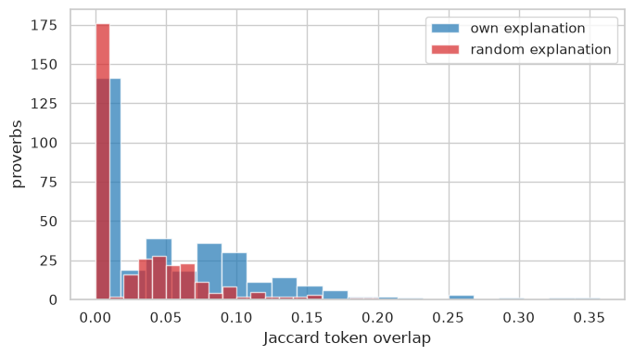
Figure 14: Jaccard overlap between each Hindustani proverb's literal translation and its own gloss, compared with a random gloss.
Inference: Own-gloss and random-gloss overlap are both near zero. In Fallon the figurative layer is written in a different vocabulary from the literal layer almost entirely.
Classification results over 668 sentences (5-fold CV):
Model | Accuracy | Macro-F1
Chance baseline | 0.500 | 0.333
Word TF-IDF + LogReg | 0.726 | 0.724
Table 5: Hindi literal-vs-figurative classification.
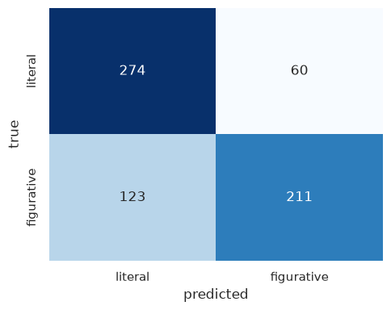
Figure 15: Confusion matrix (cross-validated) for the Hindi literal vs figurative classifier.
Inference: Both classes are recognised at similar rates (about 240 correct out of 334 each), so the classifier is not simply favouring one register. Roughly a quarter of each class is still misassigned.
Retrieval results over the 334 proverbs with glosses:
Query form | P@1 | P@5 | MRR
TF-IDF, English literal translation | 0.081 | 0.138 | 0.114
TF-IDF, romanized source language | 0.024 | 0.045 | 0.044
LaBSE, English literal translation | 0.066 | 0.159 | 0.119
LaBSE, romanized source language | 0.009 | 0.027 | 0.031
Random baseline | 0.003 | 0.015 | 0.019
Table 6: Hindi retrieval of the correct gloss.
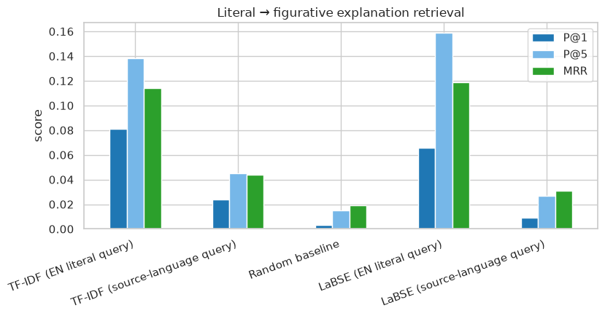
Figure 16: Hindi retrieval scores for TF-IDF and LaBSE, with English-literal and romanized-Hindustani queries.
Inference: All bars are low in absolute terms and the Hindi-query conditions are close to random. Fallon's short, OCR-noisy glosses give both TF-IDF and LaBSE little to match on.
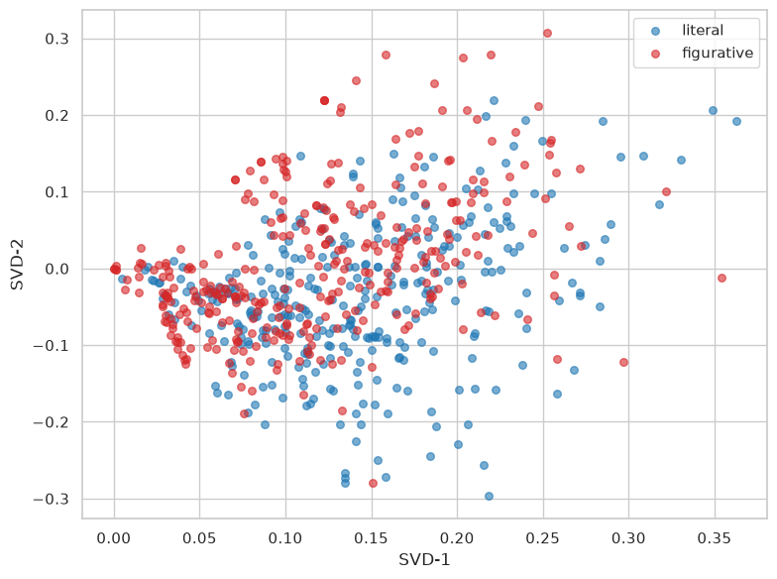
Figure 17: 2-D SVD projection of Hindi literal renderings and figurative glosses. The two groups sit in different regions.
Inference: The two registers occupy visibly different regions of the projection, which is what makes the 0.726 accuracy possible. The separation is stylistic, not a sign that meaning has been captured.
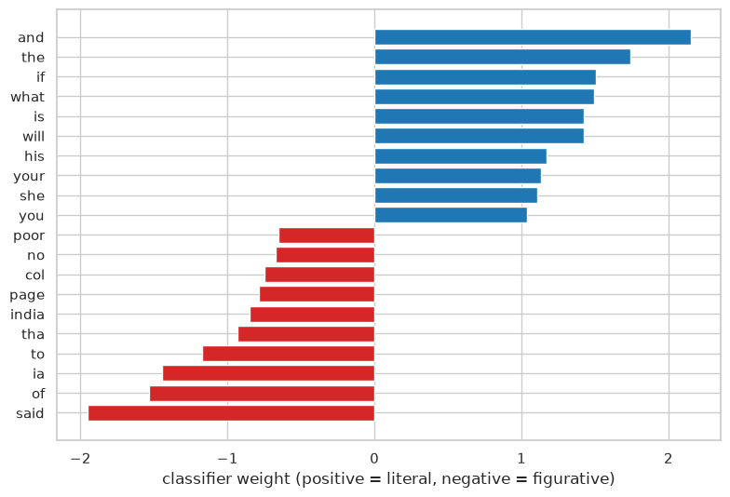
Figure 18: The 10 strongest Hindi classifier weights for each class. The literal side is carried by ordinary sentence words; the figurative side leans on the word said and on dictionary artifacts (page, col) that leaked through the OCR.
Inference: The literal side is carried by ordinary sentence words; the figurative side by 'said' and by dictionary artifacts such as 'page' and 'col'. Some of the classifier's accuracy therefore comes from print formatting that survived OCR, not from meaning.

6.3 Chayan Raj Bharati (Assamese)
The overlap between a proverb's literal translation and its own commentary is 0.070 (Jaccard), against 0.055 for a random commentary (Figure 15).
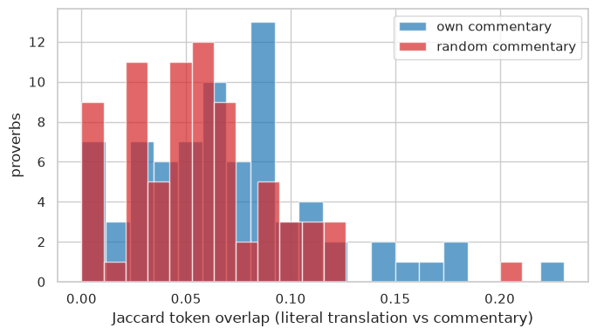
Figure 19: Jaccard overlap between each Assamese proverb's literal translation and its own commentary, compared with a random commentary.
Inference: The own-commentary curve is only slightly right of the random one. Even with Gurdon's long commentaries, a proverb shares almost no vocabulary with its own explanation.
Theme classification results over 94 proverbs and 8 buckets (5-fold CV):
Model | Accuracy | Macro-F1
Majority-class baseline | 0.255 | 0.051
Word TF-IDF + LogReg (English literal) | 0.148 | 0.140
Char 2-4-gram TF-IDF + LogReg (romanized Assamese) | 0.224 | 0.183
Table 7: Assamese theme classification (stratified 5-fold CV).
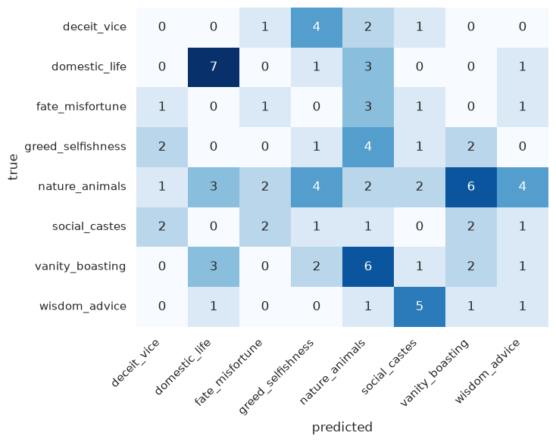
Figure 20: Confusion matrix (cross-validated) for Assamese theme classification from the literal translations.
Inference: Predictions scatter over the whole matrix; no theme has a strong diagonal. With 94 examples across 8 buckets the classifier is learning very little structure from the literal text.
Retrieval results over the 75 proverbs with commentary:
Query form | P@1 | P@5 | MRR
TF-IDF, English literal translation | 0.347 | 0.6 | 0.463
TF-IDF, romanized source language | 0.12 | 0.267 | 0.194
LaBSE, English literal translation | 0.2 | 0.4 | 0.289
LaBSE, romanized source language | 0.013 | 0.107 | 0.084
Random baseline | 0.013 | 0.067 | 0.065
Table 8: Assamese retrieval of the correct commentary.
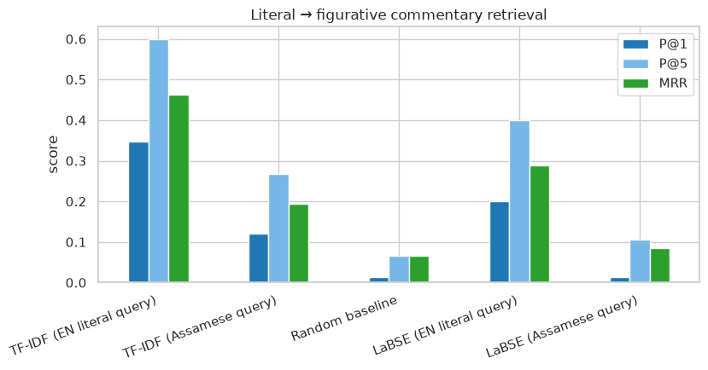
Figure 21: Assamese retrieval scores for TF-IDF and LaBSE, with English-literal and romanized-Assamese queries.
Inference: English-literal TF-IDF is the clear winner (P@1 0.35); the Assamese-query TF-IDF bar drops to 0.12 and LaBSE with Assamese queries falls to the random line. Romanized Assamese is effectively unreadable to LaBSE.
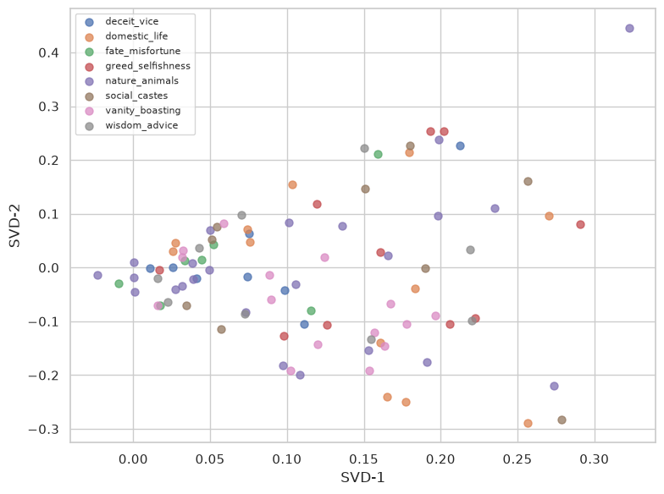
Figure 22: 2-D SVD projection of the Assamese literal translations, colored by theme.
Inference: Nature/animal and domestic proverbs form loose clusters at the edges while the moral themes mix in the middle. Concrete imagery separates in vector space; abstract vice themes do not.
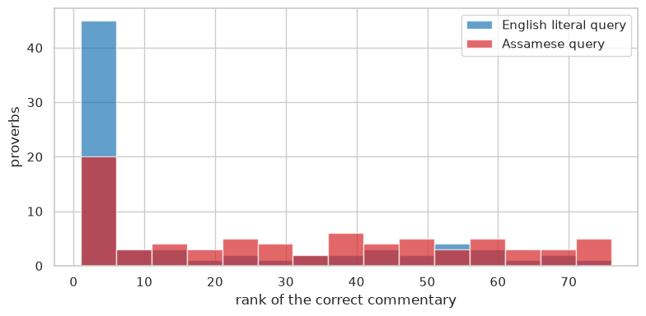
Figure 23: Rank of the correct Assamese commentary under each TF-IDF query form. English queries pile up at the low ranks; Assamese queries spread over the whole list.
Inference: With English queries the correct commentary is usually in the first few ranks; with Assamese queries the ranks spread almost uniformly over the list. The histogram shows the same collapse the P@1 numbers report, one proverb at a time.

7. Discussion

7.1 Sahish Nagulwar (Marathi)
Theme classification worked better than expected for a corpus this noisy. Both models are well above the majority baseline: word TF-IDF on the translations reached accuracy 0.307 (macro-F1 0.255) and character n-grams on the romanized Marathi reached 0.217 (0.187), where the baseline is 0.157 (0.021). The ordering is the opposite of the Assamese track, where character features on the source text won. A plausible reason is length: Manwaring's romanized proverbs average only 4.9 tokens, against 9.2 for Assamese, so character n-grams have little to work with here. Retrieval behaves like the Assamese track at lower absolute numbers, since the explanations average only 10.2 tokens. English queries reach P@1 0.129, about 40 times the random baseline, and Marathi queries drop to 0.029. The LaBSE condition did not handle that drop on this data: English queries reach P@1 0.063, below TF-IDF, and Marathi queries 0.006, close to the random baseline. LaBSE expects Devanagari, and the 1899 romanization falls outside its training data. The main limitations are OCR noise in the 1899 print, the first-sentence heuristic used to split translation from explanation, and the fact that section headings are only a rough label for figurative meaning.

7.2 Ibrahim Ansari (Hindi)
The classifier could tell literal renderings apart from figurative glosses with accuracy 0.726 (macro-F1 0.724) over 668 sentences, where chance is 0.500. So the two kinds of text differ in wording, and by enough for a simple model to pick up. Reading through the corpus suggests why: glosses use stock phrases like "said of" or "said to", while literal renderings describe concrete scenes. The classifier weights add a caveat, though: some of the separation comes from dictionary artifacts, such as page and column references that leaked into the glosses through OCR, and not from meaning. At the same time the two layers share almost no actual vocabulary (Jaccard 0.051 against a proverb's own gloss, 0.029 against a random one), which limits lexical retrieval: P@1 is 0.081 for English queries and 0.024 for romanized-Hindustani queries. Of the three tracks this one has the weakest cross-lingual retrieval. The LaBSE condition did not improve it: P@1 0.066 with English queries and 0.009 with romanized queries. As in the other tracks, the model expects native script and the 1886 romanization is foreign to it. The main limitations are heavy OCR noise in the 1886 two-column print, romanization instead of Devanagari, and glosses that sometimes quote an equivalent English idiom instead of describing the meaning.

7.3 Chayan Raj Bharati (Assamese)
Three things came out of the Assamese experiments. First, theme classification is hard with 94 training examples: in raw accuracy the classifiers do not beat always predicting the largest class, though under macro-F1 both are about three times better than the baseline (0.140 and 0.183 vs 0.051), and the character n-gram model on the Assamese text does better than word features on the translations. Sub-word units apparently survive the old 1896 spelling, while translation changes the words a classifier would rely on. Second, a proverb shares about as much vocabulary with its own commentary as with a random one (0.070 vs 0.055), yet TF-IDF retrieval from the English literal text still finds the correct commentary well above chance (P@1 = 0.347 vs 0.013), because a few concrete content words such as dheki and paddy appear in both texts. Third, with the Assamese text as the query, P@1 falls to 0.120 and most surviving matches are untranslated proper nouns. The LaBSE condition was supposed to handle this case, but it did not: with English queries it reaches P@1 0.200, below TF-IDF, and with romanized Assamese queries 0.013, which is the random baseline. LaBSE was trained on native-script Assamese, and the 19th-century romanization gives it nothing to anchor on. The main limitations are OCR noise, romanized rather than native-script Assamese, the small corpus, and theme buckets that come from the compiler's subject headings.

8. Conclusion
The three tracks used three books and 992 extracted proverbs, and they agree on the main point: the intended meaning of a proverb cannot be recovered from word overlap. In Marathi, Hindi and Assamese alike, a proverb shares about as much vocabulary with its own explanation as with a random one (Jaccard 0.046/0.051/0.070 own, against 0.030/0.029/0.055 random). Some figurative structure is still learnable from the surface text. Marathi section themes are predicted at 0.307 accuracy against a 0.157 baseline, the Hindi literal-vs-figurative classifier reaches 0.726 against 0.500, and Assamese theme classification is about three times better than its baseline in macro-F1. One result differs between tracks in an instructive way: character features on the source text win for Assamese, whose proverbs average 9.2 tokens, and lose for Marathi, whose proverbs average 4.9. Finally, retrieval of the intended meaning falls sharply at the language boundary in every track (P@1 0.347 to 0.120 for Assamese, 0.129 to 0.029 for Marathi, 0.081 to 0.024 for Hindi). The LaBSE condition, run on the romanized text, did not close that gap: with source-language queries it stays at or near the random baseline in all three languages (0.013, 0.006 and 0.009). The model expects these languages in native script, and the books give 19th-century romanization. So the next step is to recover the native-script text, by OCR of the original script or by reverse transliteration, and to re-run the embedding condition on it. The three corpora built here give the team a common test bed for that.

9. Submitted files
As per the CCA1 submission requirements, the following files accompany this report.
Report (one per team): PanelB_16_Report.docx (this document, single column, within the 10-20 page limit).
Code (one notebook per member, plus the shared extraction scripts): PanelB_16_marathi.ipynb (Sahish Nagulwar), PanelB_16_hindi.ipynb (Ibrahim Ansari), PanelB_16_assamese.ipynb (Chayan Raj Bharati), PanelB_16_extract_marathi.py, PanelB_16_extract_hindi.py, PanelB_16_build_corpus.py, PanelB_16_categorize.py.
Raw corpora (scanned books, PDF): corpus/source_pdfs/ holds the three books as scanned from the Internet Archive: PanelB_16_Manwaring_1899_Marathi_Proverbs.pdf, PanelB_16_Fallon_1886_Dictionary_of_Hindustani_Proverbs.pdf, PanelB_16_Gurdon_1896_Some_Assamese_Proverbs.pdf.
Raw text after OCR (.txt): corpus/PanelB_16_marathi_manwaring1899_raw.txt (395 KB), corpus/PanelB_16_hindi_fallon1886_raw.txt (1.5 MB), corpus/PanelB_16_assamese_gurdon1896_raw.txt (179 KB). These are the unedited OCR outputs of the three PDFs and the direct input to the extraction scripts; every row of the cleaned corpora can be traced back to a line in them.
Excel workbooks (.xlsx): corpus/PanelB_16_marathi_corpus.xlsx, PanelB_16_hindi_corpus.xlsx, PanelB_16_assamese_corpus.xlsx each carry the cleaned corpus, a by-category sheet and the full raw OCR text as a third sheet; corpus/PanelB_16_all_corpora_categorised.xlsx combines all three with the category summary and the scheme definition.
Data / corpora: corpus/PanelB_16_marathi_proverbs.csv (545 rows), corpus/PanelB_16_hindi_proverbs.csv (344 rows), corpus/PanelB_16_assamese_proverbs.csv (103 rows), and the raw OCR sources they were extracted from: corpus/PanelB_16_marathi_manwaring1899_raw.txt, corpus/PanelB_16_hindi_fallon1886_raw.txt, corpus/PanelB_16_assamese_gurdon1896_raw.txt.
Native-script sample: corpus/PanelB_16_native_script_showcase.csv holds 133 of the cleanest entries (40 Assamese, 56 Marathi, 37 Hindi) with the proverb restored to its native script by hand from the romanization, shown next to the romanized form and the annotations. It is a curated sample, not a full conversion: the books' script text did not survive OCR, and full native-script recovery is the future work named in the conclusion.
Categorised data: corpus/PanelB_16_marathi_categorised.csv, PanelB_16_hindi_categorised.csv, PanelB_16_assamese_categorised.csv (each row with its shared category and the basis for it), produced by PanelB_16_categorize.py.
Intermediate files: report/PanelB_16_metrics_marathi.json, report/PanelB_16_metrics_hindi.json and report/PanelB_16_metrics_assamese.json (the numbers used in this report, written by the notebooks), and the figure images under report/figures/.

References
Fallon, S. W. (1886). A dictionary of Hindustani proverbs. Banaras: Medical Hall Press. https://archive.org/details/in.ernet.dli.2015.42145
Feng, F., Yang, Y., Cer, D., Arivazhagan, N., & Wang, W. (2022). Language-agnostic BERT sentence embedding. Proceedings of the 60th Annual Meeting of the Association for Computational Linguistics, 878-891.
Gurdon, P. R. (1896). Some Assamese proverbs. Shillong: Assam Secretariat Printing Office. https://archive.org/details/someassameseprov00gurdrich
Kakwani, D., Kunchukuttan, A., Golla, S., N.C., G., Bhattacharyya, A., Khapra, M. M., & Kumar, P. (2020). IndicNLPSuite: Monolingual corpora, evaluation benchmarks and pre-trained multilingual language models for Indian languages. Findings of EMNLP 2020, 4948-4961.
Khanuja, S., Bansal, D., Mehtani, S., et al. (2021). MuRIL: Multilingual representations for Indian languages. arXiv:2103.10730.
Manwaring, A. (1899). Marathi proverbs. Oxford: Clarendon Press. https://archive.org/details/marathiproverbs00manwgoog

