RETROD POINT OF SALE (POS)
Complete Implementation Roadmap & Architecture Blueprint
DOCUMENT VERSION  1.0 (Production Blueprint) | CURRENT STAGE  Phase 1: UI Implementation | STACK ARCHITECTURE  Vite · React · TS · Tailwind | TARGET PLATFORM  Retrod Web & POS Terminal

1. POS Implementation Methodology & 5-Phase Pipeline
This roadmap establishes the technical and operational blueprint for building the complete Retrod POS application. To ensure high speed of execution, rapid feedback loops, and clean separation between UI components and backend services, our engineering workflow executes through five dedicated phases.
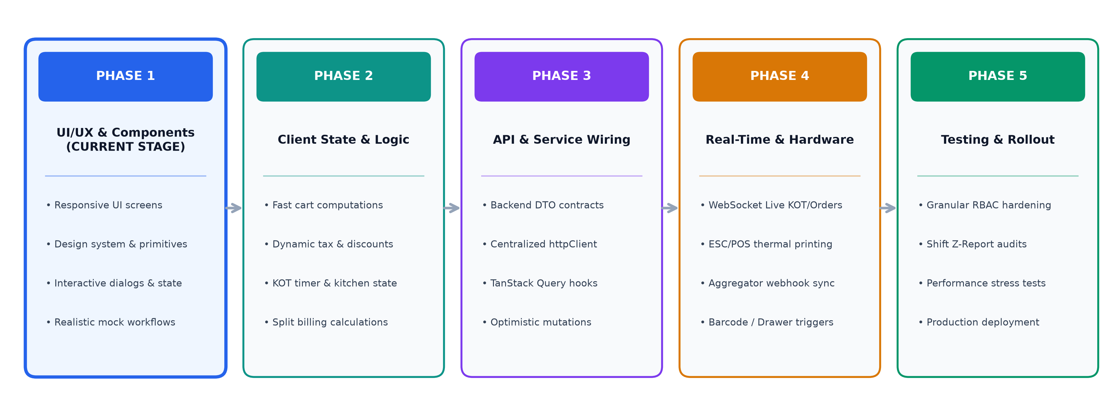
CURRENT SPRINT FOCUS: We are actively in Phase 1 (UI Implementation). The deliverable for this stage is the full completion of all 10 module screens, interactive modals, responsive order cards, and domain-agnostic UI primitives with realistic local state before connecting live REST endpoints.

2. Complete Scope Breakdown: What We Are Including in POS
The Retrod POS system is organized into three major functional operational domains encompassing 10 specialized pillars:
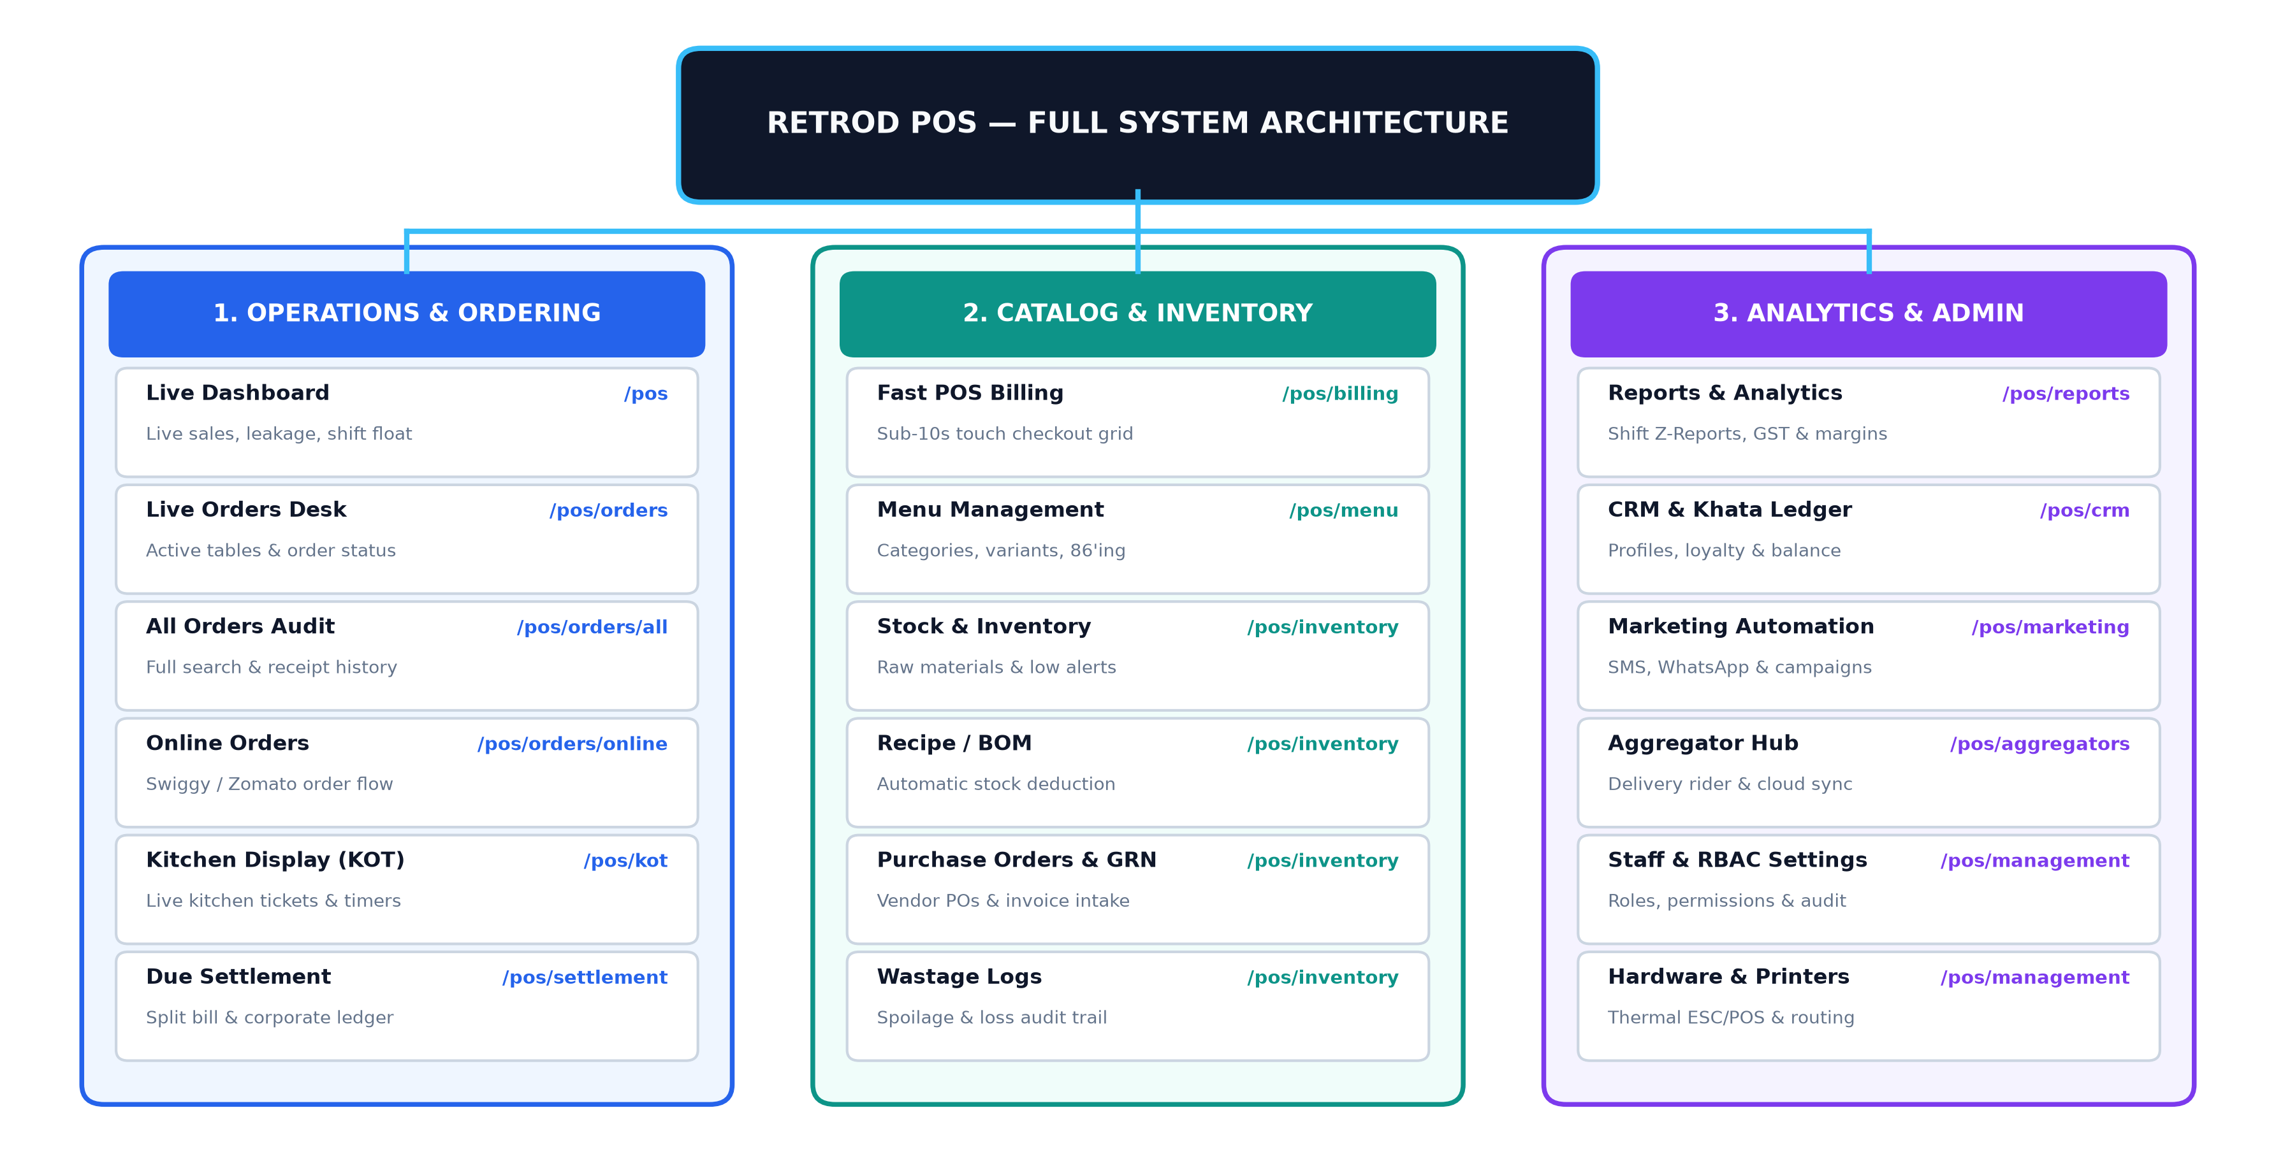
Detailed Operational Pillars & Features Included
Pillar 1: Executive Dashboard (/pos)
- Real-time Sales Statistics: Live cards for Total Sales, Unpaid orders, Cash/Card/UPI splits, Complementary discounts.
- Dynamic Sales Graphs: Hourly sales velocity, Dine-in vs Takeaway vs Delivery volume breakdown.
- Leakage & Risk Indicators: High-visibility alerts tracking bill voids, cancelled KOT items, and unauthorized discounts.
- Shift Cash Float Manager: Register opening cash, midday cash-in top-ups, expense payouts, and closing variance.
- Aggregator Live Status: Health ping, pending orders, and volume summary for Swiggy, Zomato, and Direct Web.
Pillar 2: Daily Operations & Order Hub (/pos/orders, /pos/kot, /pos/settlement)
- Live Orders Desk (/pos/orders): Interactive table and takeaway card grid, status tracking (Kitchen, Ready, Billed), quick action drawer.
- Order History Audit (/pos/orders/all): Comprehensive searchable ledger of all past orders with biller, date, and mode filters.
- Online Order Stream (/pos/orders/online): Dedicated channel queue for Zomato/Swiggy with 1-click Accept, Food Ready, and Rider Handover triggers.
- Kitchen Order Ticket - KOT (/pos/kot): Real-time kitchen display system (KDS) with live timers, overdue warnings, and item strike-off.
- Due Settlement (/pos/settlement): Customer credit ledger reconciliation, corporate billing, split-payments, and partial receipts.
Pillar 3: Fast POS Billing Terminal (/pos/billing)
- Sub-10s Touch Catalog Grid: Visual categories, search bar, dietary badges (Veg/Non-Veg), variant selection modal.
- Interactive Cart Workspace: Quantity multipliers, special cooking notes, item-level discounts, customer tagging.
- Multi-Mode Checkout Box: Instant Cash buttons, Dynamic UPI QR code generation, Card machine swipe, Split Tender.
- Thermal Invoice Dispatch: Standard 80mm/58mm thermal receipt generation with SMS/WhatsApp e-bill dispatch.
Pillar 4: Menu & Catalog Management (/pos/menu)
- Category & Item Master: Multi-tier hierarchy, pricing slabs, tax rules (GST/VAT), barcode and SKU bindings.
- Variants & Modifiers: Configurable add-on groups (Extra Cheese, Size choices, Spice levels) with pricing rules.
- Channel 86'ing (Item On/Off): One-click toggle to disable sold-out items across POS, QR menus, Swiggy, and Zomato simultaneously.
- Promotions & Discounts: Percentage and flat discounts, happy hour rules, coupon codes, and manager override safeguards.
Pillar 5: Inventory & Supply Chain (/pos/inventory)
- Raw Material Tracking: Stock in hand, units of measure, reorder threshold alerts, and valuation metrics.
- Recipe Bill of Materials (BOM): Automatic deduction of raw material stock upon punching food items on the POS.
- Purchase Orders & GRN: Vendor PO creation, goods received note verification against supplier invoices.
- Wastage & Spoilage Audits: Physical stock variance counts and loss registration with mandatory reason codes.
Pillar 6: CRM & Customer Khata (/pos/crm)
- Customer Profile Directory: Comprehensive spend history, favorite dishes, visit frequency, and average order value (AOV).
- Loyalty Program Engine: Configurable points accrual on billing and instant redemption during checkout.
- Credit / Khata Ledger: Corporate and VIP customer credit limits, outstanding balances, and payment collection logging.
Pillar 7: Marketing Automation (/pos/marketing)
- Targeted WhatsApp & SMS: Automated birthday/anniversary greetings and win-back offers for inactive diners.
- Post-Dining Feedback: Digital QR/SMS star ratings and feedback collection with instant escalation for negative reviews.
Pillar 8: Reports & Business Intelligence (/pos/reports)
- Shift & EOD Z-Reports: End-of-day register closure reports, cash expected vs physical count variance summary.
- Item & Category Analytics: Menu engineering matrix (Star items, Plowhorses, Puzzles, Dogs) and hourly sales trends.
- Tax & Compliance Reports: GST/VAT breakdown, cancelled invoice registry, discount audit reports.
Pillar 9: Aggregator & Delivery Center (/pos/aggregators)
- Multi-Brand Cloud Kitchen Console: Single-screen management of multiple virtual brands operating from one kitchen.
- Rider Dispatch Coordination: Delivery partner assignment, pickup timers, and dispatch verification.
Pillar 10: Store Management & RBAC (/pos/management)
- Role-Based Access Control: Granular permission matrix for Owner, Store Manager, Cashier, Waiter, and Kitchen staff.
- Printer & Hardware Setup: IP/Bluetooth thermal printer routing (e.g., Bar orders to Bar printer, Kitchen to KOT printer).
3. Frontend Technical Architecture & Standards
The frontend strictly adheres to the clean architecture defined in AGENTS.md, enforcing modularity, reusable primitives, and type safety:
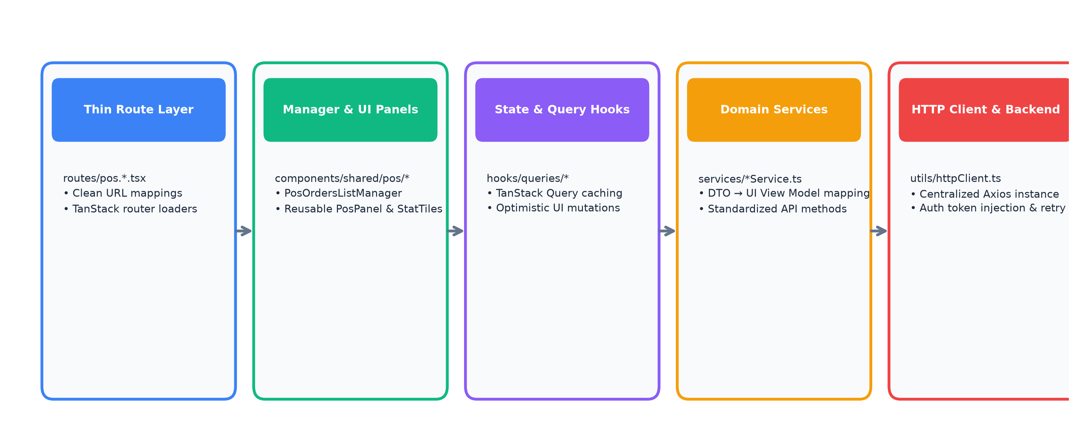
CORE ENGINEERING RULES: 1. Routes stay thin: routes/pos.*.tsx contain no direct axios calls or deep JSX.
2. Components never call httpClient directly: UI consumes custom TanStack Query hooks.
3. One HTTP Client: utils/httpClient.ts handles JWT injection, baseURL configuration, and retry logic.
4. Domain-agnostic UI: components/ui and components/form maintain zero business logic for clean reuse.

4. Phase 1 Screen Deliverables & Execution Matrix
The table below details all POS screens, their manager components, routes, and current development status:
Module & Route | Screen Manager Component | Status | Key Capabilities & Specs
/pos (Dashboard) | PosDashboardManager.tsx | IN PROGRESS | Sales strip, graph, leakage monitor, cash float, online health
/pos/orders (Live) | PosOrdersListManager.tsx | IN PROGRESS | Live table grid, status filters, action drawer, table bill
/pos/orders/all | PosAllOrdersManager.tsx | IN PROGRESS | Complete searchable history, date picker, invoice receipt modal
/pos/orders/online | PosOnlineOrdersManager.tsx | IN PROGRESS | Swiggy/Zomato live queue, countdown timer, accept/ready triggers
/pos/kot (Kitchen) | PosKotManager.tsx | IN PROGRESS | KDS cards, urgency color badges, item strike-off, reprint
/pos/settlement | PosSettlementManager.tsx | IN PROGRESS | Due payment ledger, split bill modal, credit khata tracking
/pos/billing (Fast POS) | PosBillingManager.tsx | NEXT UP | Sub-10s touch catalog, interactive cart, multi-payment checkout
/pos/menu | PosMenuManager.tsx | NEXT UP | Category hierarchy, item drawer, variants & 86'ing toggles
/pos/inventory | PosInventoryManager.tsx | NEXT UP | Raw material stock table, low alerts, PO forms, wastage logs
/pos/reports | PosReportsManager.tsx | NEXT UP | Sidebar nav, EOD Z-reports, sales charts, GST & CSV export
/pos/management | PosManagementManager.tsx | NEXT UP | Staff RBAC permissions matrix, printer hardware routing
/pos/crm | PosCrmManager.tsx | NEXT UP | Customer directory, visit metrics, loyalty points redemption
/pos/marketing | PosMarketingManager.tsx | NEXT UP | SMS/WhatsApp campaign builder, automated birthday triggers
/pos/aggregators | PosAggregatorsManager.tsx | NEXT UP | Multi-brand console, live platform status, commission logs

5. High-Level Milestone & Rollout Timeline
The execution plan is sequenced into focused delivery milestones to guarantee predictable rollout:
- Sprint 1 (Weeks 1-2): Core UI Foundation & Operations Hub: Deliver complete UI screens for Dashboard, Live Orders, Online Orders, KOT Screen, Settlement, and Fast Billing with interactive mock state.
- Sprint 2 (Weeks 3-4): Catalog, Inventory & Admin UI Hubs: Deliver complete UI screens for Menu Management, Inventory & BOM, Reports & Analytics, CRM, Marketing, and System Management.
- Sprint 3 (Weeks 5-6): State Management & Order Engine Logic: Implement full client-side cart calculation engine (GST/VAT, service charges, discounts), KOT state timers, and split-payment calculators.
- Sprint 4 (Weeks 7-8): Backend API Integration & Services: Connect all UI Managers to live REST APIs via TanStack Query and Axios httpClient with optimistic cache updates and error handling.
- Sprint 5 (Weeks 9-10): Hardware Integrations, Real-time Sync & Hardening: Implement WebSocket live KOT/Order feeds, ESC/POS thermal printing, RBAC permission testing, Z-Report audits, and final production rollout.

