10 january 2026

FRONTEND SOFTWARE DEVELOPMENT PROJECT REPORT
BELLS UNIVERSITY DIGITAL NOTICE BOARD

Group member list
Member names | Roles played | Matric number
Bello Mubarak | React Component Developer & Lead developer | 2024/13199
Tijani Aleem | Website deployer | 2024/13127
Ogunibi Olamide | Testing & Documentation Lead | 2024/13148
Ugwaka Chukwunonso | Github publisher | 2024/13091
Kazeem Samad | Report writer | 2024/13395
Elias oluwatimileyin | Figma designer and prototyping | 2024/13376

1.0 Introduction & Project Overview
This report documents the design and development process of the Bells University Digital Notice Board, a responsive web application built for the ICT 235 Frontend Development module. The primary goal was to create a functional, user-centered platform for managing campus announcements. Our team adopted a structured workflow, beginning with collaborative UI/UX design in Figma, followed by implementation in React.js, and concluding with deployment on Vercel.
The application enables students and staff to create, view, search, filter, and delete notices with an intuitive interface. Key features include dark/light theme switching, priority tagging, and persistent local storage. You can view the live application here: Bells Notice Board.
2.0 Methodology: From Design to Development
Our process followed a design-first, iterative approach, which ensured clarity and consistency before writing any code.
2.1 Phase 1: UI/UX Design in Figma
Objective: Establish visual hierarchy, layout, and user flow.
Process:
- Our design team (Elias oluwatimileyin) created high-fidelity mockups in Figma, focusing on a clean, accessible interface.
- The design defined the 3-panel layout (sidebar, main content, stats panel), color palette, typography, and component structure.
- Interactive prototypes were built to simulate user interactions like adding or deleting a notice.
- The final design served as the single source of truth for the development team.
- Output: Published Figma prototype: https://tart-device-61470686.figma.site.

Screenshot of the figma prototype
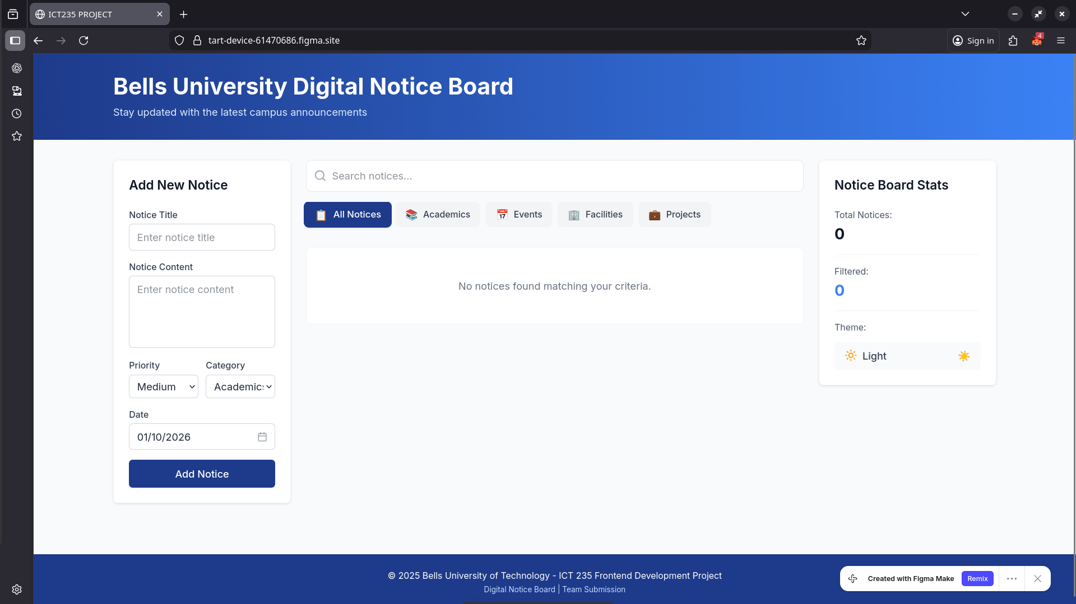

2.2 Phase 2: Design-to-Code Translation
Challenge: The project brief suggested using Locofy, but its paid model was not feasible for our student budget.
Solution: We used AnimaApp, a free alternative Figma plugin, to generate foundational React code from our design frames.
Process:
- AnimaApp converted our Figma components into basic React JSX and CSS.
- This automated output provided a crucial head-start, giving us the core HTML structure and styling.
- Importantly, we used the Figma design as inspiration, not a rigid template. We adapted the generated code extensively to fit our functional needs and improve maintainability.
2.3 Phase 3: Development & Enhancement
The AnimaApp code was a skeleton. Our development team manually implemented all interactive logic:
- State management for notices, theme, and filters.
- CRUD operations (Create, Read, Update, Delete) with confirmation dialogs.
- Advanced features like search, category filtering, and localStorage persistence.
- Refined styling to ensure perfect responsiveness and polish beyond the auto-generated CSS.
3.0 Implementation & Technical Details
3.1 Tech Stack
- Frontend Library: React.js (with Hooks for state management)
- Styling: Pure CSS with custom properties (CSS variables) for theming
- Design & Prototyping: Figma
- Design-to-Code: AnimaApp (as a Locofy alternative)
- Version Control: Git & GitHub
- Deployment: Vercel (for continuous deployment)
3.2 Key Features Implemented
- Dynamic Notice Management: Users can add notices with title, content, date, category, and priority.
- Visual Priority System: Notices are tagged with High (Red), Medium (Yellow/Amber), and Low (Green) indicators, providing instant visual context.
- Robust Filtering: Combine search terms with category filters (All, Academics, Events, Facilities, Projects).
- Theme Switching: A persistent dark/light mode toggle that respects user system preferences.
- Data Persistence: All notices are saved to the browser's localStorage, surviving page refreshes.
3.3 Design Decisions
- Color-Coded Priority: We deliberately chose intuitive traffic-light colors (Red/Green) for priority levels to enhance usability at a glance.
- Inspiration vs. Copy: While our layout honors the Figma design, we made pragmatic adjustments during development to optimize the user experience and code structure.

4.0 Team Roles & Contributions
Success was driven by clear role distribution:
Team Member | Role | Key Contribution
Bello Mubarak | React Component Developer & Lead Developer | Led the development process, built core React components including NoticeForm and Controls, implemented state management logic, and coordinated team efforts throughout the project lifecycle.
Elias oluwatimileyin | Figma Designer & Prototyping Lead | Created the complete visual design system in Figma, established the color palette and typography, built interactive prototypes, and ensured design consistency across all application screens.
Tijani Aleem | Website Deployer & DevOps | Configured the Vercel deployment pipeline, managed hosting environment, set up continuous deployment, and ensured the application remained live and accessible throughout development and testing phases.
Ugwaka Chukwunonso | GitHub Publisher & Version Control Manager | Established and maintained the GitHub repository, managed branching strategies, handled pull requests and merges, and ensured proper version control practices were followed by all team members.
Ogunibi Olamide | Testing & Documentation Lead | Conducted comprehensive user testing across different devices and browsers, identified and documented bugs, created user documentation, and verified all features met specified requirements.
Kazeem Samad | Report Writer & Project Documenter | Authored the complete project report, documented development processes, challenges, and solutions, maintained project documentation, and compiled final submission materials.

5.0 Challenges & Solutions
- Challenge: Implementing Mobile Responsiveness - One significant technical hurdle we faced was ensuring the application displayed properly across various mobile devices. The initial desktop-focused design from Figma didn't automatically translate well to smaller screens, causing layout issues and poor user experience on phones.
Solution: Our team adopted a mobile-first CSS approach using extensive media queries. Bello Mubarak led the implementation of flexible grid layouts that would collapse from three columns on desktop to a single column on mobile. We prioritized touch-friendly interface elements with appropriate tap targets and tested extensively on real mobile devices to ensure all interactive elements remained accessible. The sidebar components were repositioned, and font sizes were carefully adjusted for readability on smaller screens without compromising the design aesthetic established in the Figma prototypes.
- Challenge: Budget constraints with recommended tool (Locofy).
Solution: Researched and adopted the free-tier of AnimaApp, which provided a similar design-to-code workflow suitable for our academic project.
- Challenge: Translating static design into a dynamic, stateful application.
Solution: Used the generated code as a structural foundation and then iteratively layered on React state and event handlers to create a fully interactive experience.
- Challenge: Ensuring consistent styling across different components.
Solution: Implemented a CSS custom properties (variables) system for theming, which made global style changes and dark mode implementation straightforward.
6.0 Conclusion & Future Work
The Bells University Digital Notice Board project successfully demonstrates a complete modern frontend development lifecycle: from team-based design in Figma, through pragmatic use of a code-generation tool (AnimaApp), to manual implementation of advanced features and final deployment.
The application is fully functional, visually aligned with its design inspiration, and meets all specified requirements. This project provided invaluable hands-on experience in collaborative software development, responsive design, and React.js programming.
Live Application: https://bellsnotice-board.vercel.app
Design Prototype: https://tart-device-61470686.figma.site

