Milestone 3 Report

Handwritten Answers to Milestone Questions:
“Testing Requirements” Questions:
- The shortest terminal word is one consisting of just a single symbol, such as an integer, e.g. S => expr => oper => constants => ints => 5
The next shortest terminal word consists of two symbol, such as (), e.g. S => ()
- 5
()
(5)
(())
((5))
- For all even lengths, just use nested parentheses. For all odd lengths, use nested parentheses with an integer in the middle.

“Example Input” Questions:
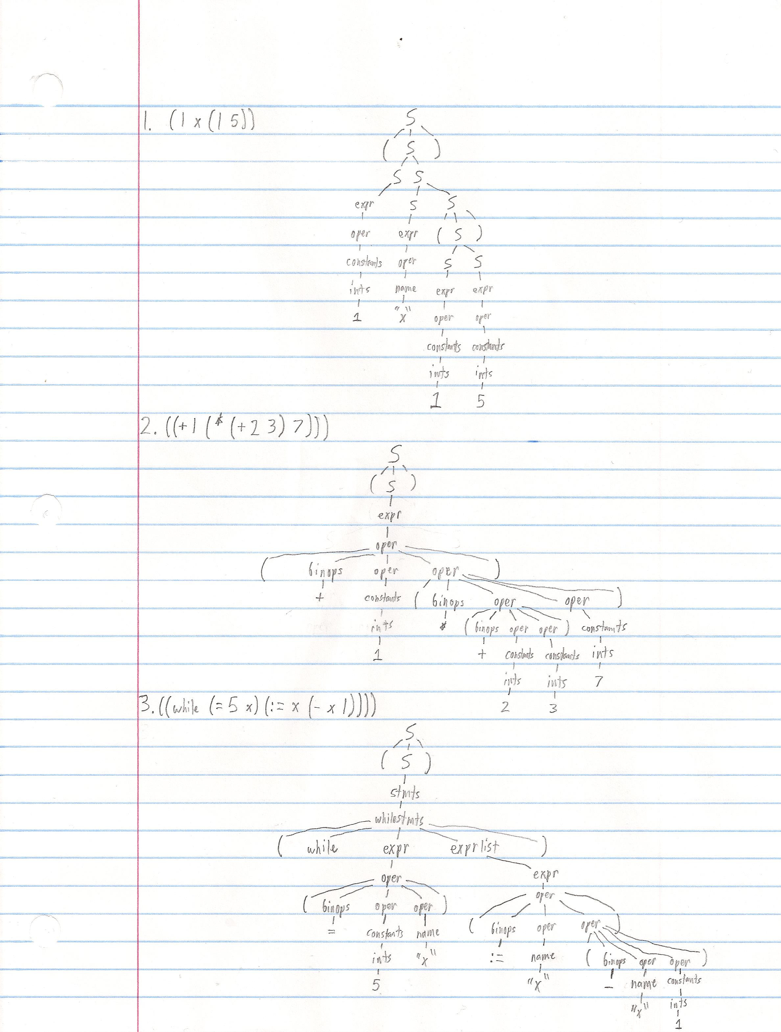
Specification (what do you think the purpose of this milestone is)
The purpose of this milestone was to learn the basic concepts associated with parsing. In particular, we focused on implementing a top-down recursive descent parser, one of the most basic types. In addition, we needed to make sure we understood how to eliminate left recursion and left factoring in the given IBTL grammar in order to parse it properly.

Processing (how did you go about solving the problem)
I started by attempting to implement the basic grammar shown in the videos on the Coursera compilers course using the given algorithm. It wasn't working properly until I finally realized that I was supposed to remove left recursion and left factoring; I reviewed the class notes to accomplish this, and it started working. I then generalized the algorithm to work on an arbitrary grammar rather than hardcoding functions for each production. I then refactored the IBTL grammar to get it working with my parser and started testing it with my tests from when I wrote the lexer. After some debugging, however, I eventually found that some of my tests had incorrect syntax, and that my parser was actually correctly failing! Once I fixed these testing issues, I wrote up the mechanism for storing and printing the parse tree explicitly (since previously it was all implicit in the program's stack and couldn't really be printed or returned).

Testing Requirement (how did you test for correctness)
I have 12 test files, 5 of which are intended to pass, and 7 of which are intended to fail. The passing ones all hold various categories of IBTL statements. Between the 5 passing tests, all operators and keywords are used at least once; they are often used multiple times and in various situations as well. The 7 failing tests all cause the parser to correctly return an error due to situations such as mismatched parentheses, a lack of arguments to a statement, or too many arguments.

Retrospective (what did you learn in this milestone)
I learned all about parsing in general, specifically top-down recursive descent parsing. I had previously worked with removing left recursion and left factoring in class, but it wasn't until I started working on the parser that I fully understood the reasons for those procedures.

