Milestone Report

Handwritten Answers to Milestone Questions:
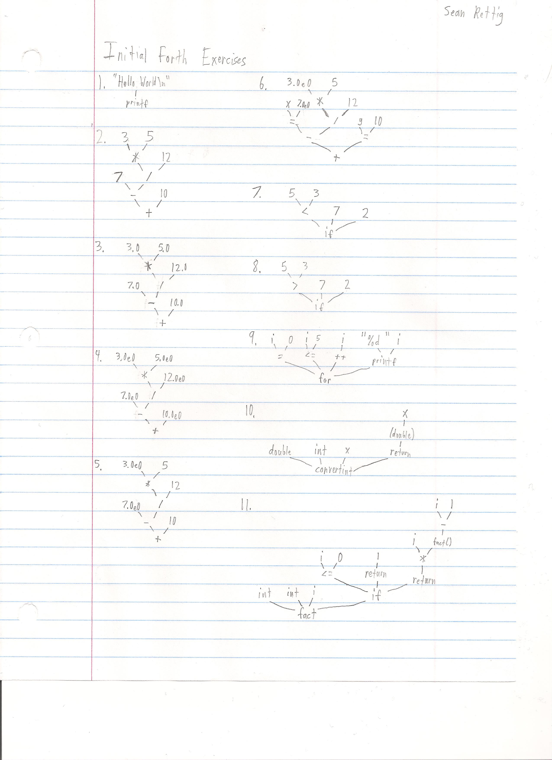

The gforth code generated by exercises 1-12 is also included in stutest.in:
1. ." Hello World\n"

2. 7 3 5 * 12 / - 10 + .

3. 7.0e 3.0e 5.0e f* 12.0e f/ f- 10.0e f+ f.

4. 7.0e0 3.0e0 5.0e0 f* 12.0e0 f/ f- 10.0e0 f+ f.

5. 7.0e0 3.0e0 5 s>f f* 12 s>f f/ f- 10 s>f f+ f.

6.

: x 7.0e0 ;

: y 10 ;

x 3.0e0 5 s>f f* 12 s>f f/ f- y s>f f+

7.

: func7

5 3 < if

7

else

2

endif ;

func7 .

8.

: func8

5 3 < if

7

else

2

endif ;

func8 .

9.

: func9

5 1 + 0 ?do

i .

loop ;

func9

10.

: fact dup 0 <= if drop 1 else dup 1 - recurse * endif ;

11.

: fib dup 0 = if drop 0 else dup 1 = if drop 1 else dup 1 - recurse swap 2 - recurse + endif endif ;

Data structure and pseudocode for n-ary tree traversal to create postfix expression:
class node:

value = ""

children = []

id = ""

timesseen = 0

assign id to each node

# times seen pass

traverse_seen(node):

node.timesseen++

for child in node.children:

traverse_seen(child)

# expression creation pass

traverse_add(node):

node.timesseen--

if node.timesseen == 0:

expression.append(node.value)

for child in node.children:

expression.extend(traverse(child))

expression = []

traverse_seen(root)

traverse_add(root)

print expression

Specification (what do you think the purpose of this milestone is)
The purpose of this milestone was to familiarize ourselves with gforth and prepare our working environment for the later milestones.

Processing (how did you go about solving the problem)
I learned how to create expression trees from class, though it seemed like the given exercises went over some things that we had not covered. I did what made sense and I think I did them correctly. As for the gforth, I just went through the linked gforth tutorial while doing the exercises to do them. It was quite frustrating, and the gforth docs on the same site seem to be a much better resource than the tutorial.

Testing Requirement (how did you test for correctness)
I'm not sure how relevant this question is to milestone 1, but I tested my gforth implementations of the algorithms by entering the originals into Python (with slight modifications) and made sure I got the same results.

Retrospective (what did you learn in this milestone)
I learned how to use gforth! It's extremely different from any other language I have ever used, and not just because it's a stack-based postfix language; every little thing I had known from other languages was wrong, and was constantly frustrated with minor syntax mistakes. This started to go away with time, and will get better. The paradigms of gforth themselves are quite interesting though, despite the unintuitiveness of its use.

