K = 11

True Positive 350.0

True Negative 329.0

False Negative 250.0

False Positive 271.0

Precision 0.563607085346

Recall 0.583333333333

F-Measure 0.573300573301

Dataset 1 (1000 Values)

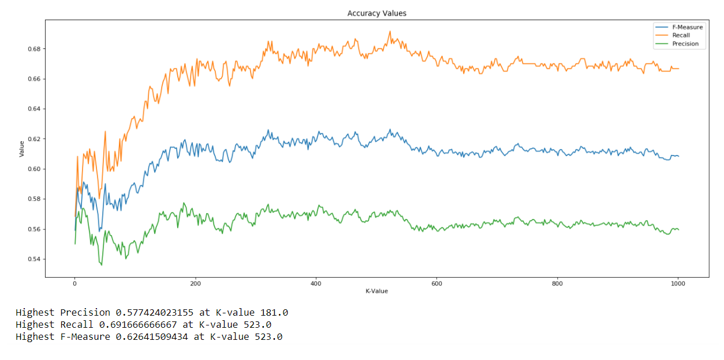

Dataset 2 (1000 Values)

