**COMP 551**

**ASSIGNMENT 3**

**AHMET AKGUL – 260 624 068**

# 2. Yelp Dataset

## Random Classifier

**Training F1-Measure:** 0.180419612228

Confusion Matrix:

[[104 102 114 97 105]

[115 134 136 124 132]

[225 197 183 195 197]

[490 496 481 487 514]

[459 486 461 479 487]]

**Validation F1-Measure:** 0.169737750897

Confusion Matrix:

[[15 16 15 22 16]

[12 21 22 21 20]

[47 33 24 28 32]

[71 74 78 67 66]

[69 72 47 55 57]]

**Test F1-Measure:** 0.186163692511

Confusion Matrix:

[[ 38 31 28 25 21]

[ 41 36 34 34 45]

[ 60 48 58 76 58]

[148 157 134 124 139]

[119 149 124 125 148]]

## Most Frequent Classifier Score

**Training F1-Measure:** 0.104267004647

Confusion Matrix:

[[ 0 0 0 522 0]

[ 0 0 0 641 0]

[ 0 0 0 997 0]

[ 0 0 0 2468 0]

[ 0 0 0 2372 0]]

**Validation F1-Measure:** 0.105014749263

Confusion Matrix:

[[ 0 0 0 84 0]

[ 0 0 0 96 0]

[ 0 0 0 164 0]

[ 0 0 0 356 0]

[ 0 0 0 300 0]]

**Test F1-Measure:** 0.103923019985

Confusion Matrix:

[[ 0 0 0 143 0]

[ 0 0 0 190 0]

[ 0 0 0 300 0]

[ 0 0 0 702 0]

[ 0 0 0 665 0]]

## Bernoulli Naive Bayes

**Training F1-Measure:** 0.577269725617

Confusion Matrix:

[[ 275 8 15 22 202]

[ 10 323 23 85 200]

[ 9 25 471 153 339]

[ 36 155 86 1211 980]

[ 53 124 73 248 1874]]

**Validation F1-Measure:** 0.330091223067

Confusion Matrix:

[[ 29 9 5 7 34]

[ 9 16 12 26 33]

[ 2 23 28 54 57]

[ 8 33 27 123 165]

[ 13 25 9 69 184]]

**Test F1-Measure:** 0.341137874213

Confusion Matrix:

[[ 42 24 5 18 54]

[ 22 46 32 31 59]

[ 9 36 44 99 112]

[ 10 58 61 246 327]

[ 10 37 27 150 441]]

## Decision Tree

**Training F1-Measure:** 1.0

Confusion Matrix:

[[ 522 0 0 0 0]

[ 0 641 0 0 0]

[ 0 0 997 0 0]

[ 0 0 0 2468 0]

[ 0 0 0 0 2372]]

**Validation F1-Measure**: 0.261495450896

Confusion Matrix:

[[ 16 15 15 14 24]

[ 14 10 24 22 26]

[ 12 18 40 57 37]

[ 19 35 56 135 111]

[ 20 15 33 115 117]]

**Test F1-Measure:** 0.279169541182

Confusion Matrix:

[[ 29 21 31 34 28]

[ 28 23 45 59 35]

[ 17 30 59 127 67]

[ 35 39 97 298 233]

[ 22 38 60 251 294]]

## Linear SVC

**Training F1-Measure**: 0.997870801179

Confusion Matrix:

[[ 520 0 0 0 2]

[ 0 640 0 0 1]

[ 0 0 996 1 0]

[ 0 0 0 2454 14]

[ 0 0 0 2 2370]]

**Validation F1-Measure:** 0.413976371409

Confusion Matrix:

[[ 36 23 8 9 8]

[ 14 25 16 27 14]

[ 7 23 50 65 19]

[ 10 11 31 171 133]

[ 4 9 18 102 167]]

**Test F1-Measure:** 0.400687403274

Confusion Matrix:

[[ 55 33 15 20 20]

[ 33 58 41 36 22]

[ 12 42 77 118 51]

[ 12 31 83 341 235]

[ 15 12 41 236 361]]

# Yelp

## Bernoulli Naive Bayes Hyper-Parameter Tuning (Bag of Words)

For the Bernoulli Naïve Bayes training model, there is only one parameter to tune, alpha. This alpha is the additive smoothing parameter. A value of 0 means no smoothing. We will first vary this between 0 and 20.

### Iteration 1

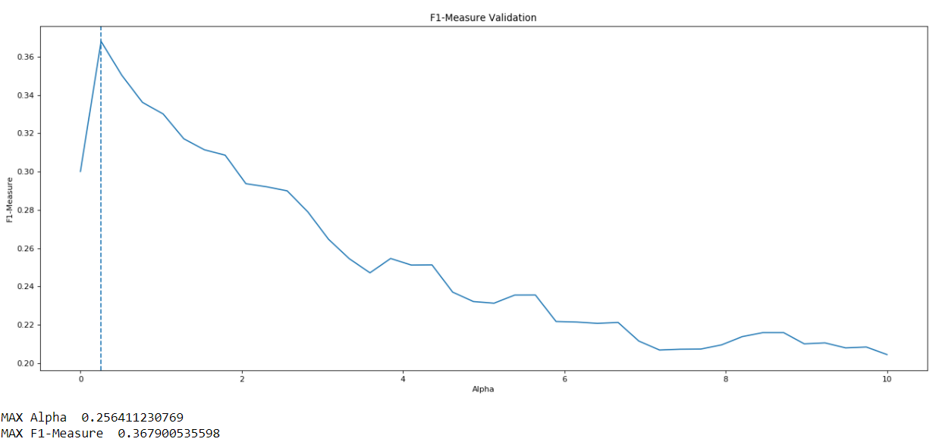

The higher F1-measures occur on the validation set for alpha values between 0 and 2. Now we update the iteration loop and re-run the program for values of alpha between 0 and 2.

### Iteration 2

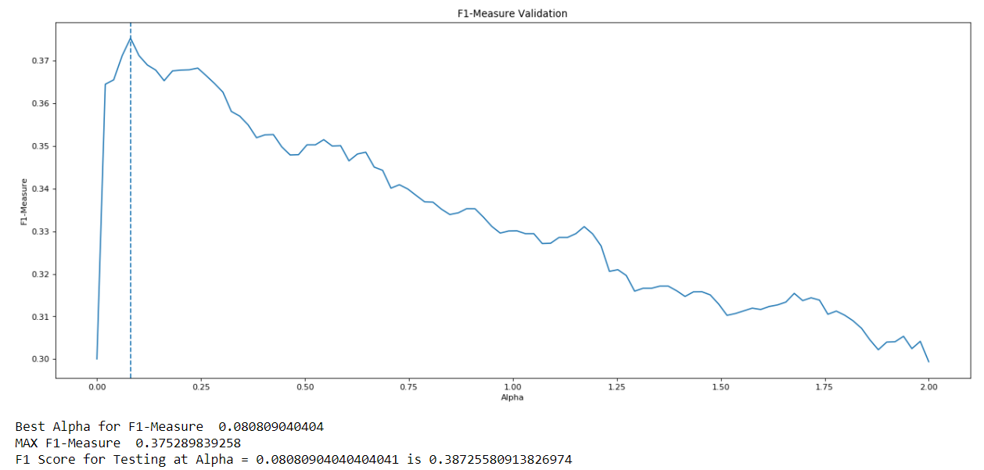

**Testing F1-Measure:** 0.3873

The testing F1-measure at alpha = 0.081 is 0.3873. We run through once more for values of alpha between 0 and 0.3.

### Iteration 3

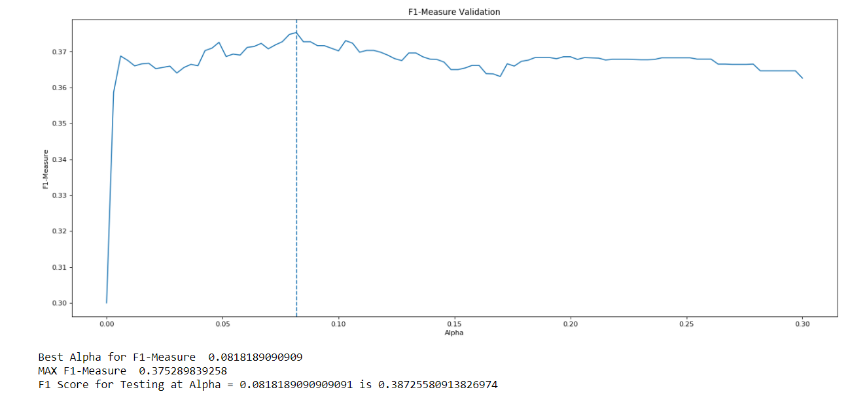

**Testing F1-Measure:** 0.3872

At the value of alpha = 0.0818, the validation F1-measure is the highest—0.3753. At this value, the testing F1-Measure is 0.3872. This is the best tuning we can do for this model given the yelp dataset and a Bag of Words representation.

{'alpha': 0.0818, 'binarize': 0.0, 'class_prior': None, 'fit_prior': True}

**Training F1-Measure:** 0.722816991255

Confusion Matrix:

[[ 380 3 4 4 131]

[ 15 410 24 36 156]

[ 6 11 660 62 258]

[ 25 45 46 1489 863]

[ 24 50 55 238 2005]]

**Validation F1-Measure:** 0.375289839258

Confusion Matrix:

[[ 36 12 5 4 27]

[ 12 19 18 20 27]

[ 5 17 41 48 53]

[ 8 24 27 136 161]

[ 11 14 12 84 179]]

**Test F1-Measure:** 0.387255809138

Confusion Matrix:

[[ 59 23 14 10 37]

[ 30 47 38 27 48]

[ 12 38 61 86 103]

[ 8 33 68 283 310]

[ 10 18 30 179 428]]

# Yelp

## Linear SVC Hyper-Parameter Tuning (Bag of Words)

For Linear SVC, there were more parameters to consider when tuning the model. These parameters were C, the penalty parameter of the error term, Dual vs Primal, which specifies which optimization problem to solve, loss, which specifies the loss function, max iterations, which are the maximum number of iterations the model will run while training the data, and tol, which is the tolerance for stopping criteria.

For C, I considered values from the array [0.01, 0.1, 1.0, 10, 100, 1000].

For tolerance, I considered values from the array [1e-6, 1e-5, 1e-4, 1e-3,1e-2,1e-1, 1, 10]

Because in this dataset the number of training samples (7000) is less than the number of features (10,000), I am setting Dual to true and solving the dual problem.

For maximum iterations I am considering values between the range 1000 and 10,000. The default value was 1000, this will essentially show whether increasing the iterations allows for accuracy improvements.

For loss, I am considering squared-hinge and hinged loss.

### Iteration 1

Model with rank: 1

Mean validation score: 0.486 (std: 0.003)

Parameters: {'C': 0.1, 'dual': True, 'loss': 'squared_hinge', 'max_iter': 2466, 'tol': 0.001}

Model with rank: 2

Mean validation score: 0.485 (std: 0.006)

Parameters: {'C': 0.1, 'dual': True, 'loss': 'hinge', 'max_iter': 5709, 'tol': 0.001}

Model with rank: 3

Mean validation score: 0.456 (std: 0.002)

Parameters: {'C': 1.0, 'dual': True, 'loss': 'squared_hinge', 'max_iter': 9370, 'tol': 0.01}

This first iteration shows that the model prefers iterations that are above 1000. For the next iteration I will decrease the range. The model also seems to prefer lower tolerance values, hence we can remove some of the larger tolerance values, such as 1 and 10.

The best F1-Measure for validation is 0.486.

### Iteration 2

Model with rank: 1

Mean validation score: 0.514 (std: 0.005)

Parameters: {'C': 0.01, 'dual': True, 'loss': 'squared_hinge', 'max_iter': 4710, 'tol': 0.001}

Model with rank: 1

Mean validation score: 0.514 (std: 0.005)

Parameters: {'C': 0.01, 'dual': True, 'loss': 'squared_hinge', 'max_iter': 4066, 'tol': 0.0001}

Model with rank: 1

Mean validation score: 0.514 (std: 0.005)

Parameters: {'C': 0.01, 'dual': True, 'loss': 'squared_hinge', 'max_iter': 9689, 'tol': 0.001}

This iteration shows that the model generally prefers Squared Hinge loss. Hence, I will only consider that loss for the next iteration. Again, the model prefers lower tolerance values, so I will decrease the array some more.

This iteration resulted in a validation F1-Measure of 0.514.

### Iteration 3

Model with rank: 1

Mean validation score: 0.514 (std: 0.005)

Parameters: {'C': 0.01, 'max_iter': 7449, 'tol': 1e-06}

Model with rank: 1

Mean validation score: 0.514 (std: 0.005)

Parameters: {'C': 0.01, 'max_iter': 6358, 'tol': 0.0001}

Model with rank: 1

Mean validation score: 0.514 (std: 0.005)

Parameters: {'C': 0.01, 'max_iter': 3775, 'tol': 0.0001}

{'C': 0.01, 'class_weight': None, 'dual': True, 'fit_intercept': True, 'intercept_scaling': 1, 'loss': 'squared_hinge', 'max_iter': 7449, 'multi_class': 'ovr', 'penalty': 'l2', 'random_state': None, 'tol': 1e-06, 'verbose': 0}

**Training F1-Measure:** 0.85867638506

Confusion Matrix:

[[ 458 2 7 18 37]

[ 18 509 30 47 37]

[ 8 10 743 152 84]

[ 4 0 17 2084 363]

[ 1 2 9 213 2147]]

**Validation F1-Measure:** 0.467650693044

Confusion Matrix:

[[ 41 18 7 9 9]

[ 14 23 24 22 13]

[ 0 13 50 81 20]

[ 4 7 27 194 124]

[ 0 2 5 93 200]]

**Test F1-Measure:** 0.456741680687

Confusion Matrix:

[[ 74 27 9 16 17]

[ 33 50 46 39 22]

[ 12 26 77 138 47]

[ 9 9 57 375 252]

[ 7 2 11 208 437]]

# Yelp

## Decision Tree Hyper Parameter Tuning (Bag of Words)

There are many parameters to tune for the decision tree. Not all these values were considered. The first parameter considered is max depth, which is the maximum depth of the tree. The default for this is infinity. I first considered values between 0 and 50.

The second parameter I considered is max features, which is the maximum number of features to consider when looking for the best split. The default for this is the number of features in the model, which is 10,000. I considered the options None, which considers n_features, ‘sqrt’, which considers sqrt(n_features), and ‘log2’, which considers log2(n_features).

The third parameter I considered is max leaf nodes, which defines the maximum number of leaf nodes the model will have. The default for this is an unlimited number of leaf nodes. I first considered between 0 and 8,000 leaf nodes. This is because 8000 is essentially the maximum number of leaf nodes I could get with the given yelp training and validation data (used K-folds cross validation).

The fourth parameter I considered is min impurity decrease. This decides whether a node will be split. The split happens if the decrease in impurity is greater than or equal to this value. The default for this parameter is 0. I considered values between 0 and 0.5.

The fifth parameter I considered is min samples leaf. This is the minimum number of samples required to be at a leaf node. The default is 1. I considered values between 1 and 20.

The sixth and final parameter I considered is min samples split. This is the minimum number of samples required to split an internal node. The default is 2. I considered values between 2 and 20.

### Iteration 1

Model with rank: 1

Mean validation score: 0.308 (std: 0.002)

Parameters: {'max_depth': 23, 'max_features': None, 'max_leaf_nodes': 10000, 'min_impurity_decrease': 0, 'min_samples_leaf': 4, 'min_samples_split': 6}

Model with rank: 2

Mean validation score: 0.303 (std: 0.007)

Parameters: {'max_depth': 23, 'max_features': None, 'max_leaf_nodes': None, 'min_impurity_decrease': 0, 'min_samples_leaf': 5, 'min_samples_split': 8}

Model with rank: 3

Mean validation score: 0.301 (std: 0.001)

Parameters: {'max_depth': 26, 'max_features': None, 'max_leaf_nodes': None, 'min_impurity_decrease': 0, 'min_samples_leaf': 1, 'min_samples_split': 9}

The best validation F1-measure is 0.308. It is clear the maximum leaf nodes is optimum between 20 and 30. For the next iteration, I want to introduce min impurity decrease as a uniform variable between 0 and 0.5.

### Iteration 2

Model with rank: 1

Mean validation score: 0.239 (std: 0.014)

Parameters: {'max_depth': 32, 'max_features': None, 'max_leaf_nodes': 1000, 'min_impurity_decrease': 0.0017847551550062902, 'min_samples_leaf': 8, 'min_samples_split': 4}

Model with rank: 2

Mean validation score: 0.223 (std: 0.026)

Parameters: {'max_depth': 17, 'max_features': None, 'max_leaf_nodes': 15000, 'min_impurity_decrease': 0.0021257207973072734, 'min_samples_leaf': 1, 'min_samples_split': 2}

Model with rank: 3

Mean validation score: 0.191 (std: 0.024)

Parameters: {'max_depth': 10, 'max_features': 'sqrt', 'max_leaf_nodes': 10000, 'min_impurity_decrease': 0.00048700757764565952, 'min_samples_leaf': 9, 'min_samples_split': 7}

Minimum impurity should stay at as close as possible to 0. The best validation F1-measure decreased to 0.239.

### Iteration 3

Model with rank: 1

Mean validation score: 0.313 (std: 0.005)

Parameters: {'max_depth': 24, 'max_features': None, 'max_leaf_nodes': None, 'min_impurity_decrease': 0.000438451445691912, 'min_samples_leaf': 6, 'min_samples_split': 2}

Model with rank: 2

Mean validation score: 0.305 (std: 0.004)

Parameters: {'max_depth': 25, 'max_features': None, 'max_leaf_nodes': 15000, 'min_impurity_decrease': 0.00024863477331978133, 'min_samples_leaf': 3, 'min_samples_split': 9}

Model with rank: 3

Mean validation score: 0.301 (std: 0.008)

Parameters: {'max_depth': 39, 'max_features': None, 'max_leaf_nodes': None, 'min_impurity_decrease': 9.8586025656947074e-05, 'min_samples_leaf': 6, 'min_samples_split': 5}

The best validation F1-measure is 0.313. For the next iteration I will increase the range for min samples split between 2 and 200.

### Iteration 4

Model with rank: 1

Mean validation score: 0.320 (std: 0.010)

Parameters: {'max_depth': 25, 'max_features': None, 'max_leaf_nodes': 26406, 'min_impurity_decrease': 0.00051830527754645494, 'min_samples_leaf': 3, 'min_samples_split': 2}

Model with rank: 2

Mean validation score: 0.320 (std: 0.001)

Parameters: {'max_depth': 28, 'max_features': None, 'max_leaf_nodes': 61954, 'min_impurity_decrease': 0.00052115656459021263, 'min_samples_leaf': 7, 'min_samples_split': 16}

Model with rank: 3

Mean validation score: 0.319 (std: 0.001)

Parameters: {'max_depth': 28, 'max_features': None, 'max_leaf_nodes': 117155, 'min_impurity_decrease': 0.00054116549571744141, 'min_samples_leaf': 7, 'min_samples_split': 9}

The best validation F1-measure is 0.32. It occurs at a depth of 25, 10000 features, 26406 max_leaf_nodes, 0.000518 minimum impurity decrease, 3 minimum samples per leaf, and 2 minimum samples per split.

{'class_weight': None, 'criterion': 'gini', 'max_depth': 25, 'max_features': None, 'max_leaf_nodes': 26406, 'min_impurity_decrease': 0.0005183052775464549, 'min_impurity_split': None, 'min_samples_leaf': 3, 'min_samples_split': 2, 'min_weight_fraction_leaf': 0.0, 'presort': False, 'random_state': None, 'splitter': 'best'}

**Training F1-Measure:** 0.456494980587

Confusion Matrix:

[[ 220 44 11 169 78]

[ 68 131 60 292 90]

[ 42 35 243 560 117]

[ 62 39 71 1889 407]

[ 56 16 47 936 1317]]

**Validation F1-Measure:** 0.309005474262

Confusion Matrix:

[[ 26 14 6 26 12]

[ 10 8 11 46 21]

[ 9 13 23 95 24]

[ 9 10 25 221 91]

[ 8 5 8 167 112]]

**Test F1-Measure:** 0.299015102134

Confusion Matrix:

[[ 41 17 9 57 19]

[ 26 19 26 86 33]

[ 14 16 29 195 46]

[ 21 11 39 438 193]

[ 19 7 23 358 258]]

# Yelp

## Gaussian Naïve-Bayes Hyper-Parameter Tuning (Frequency)

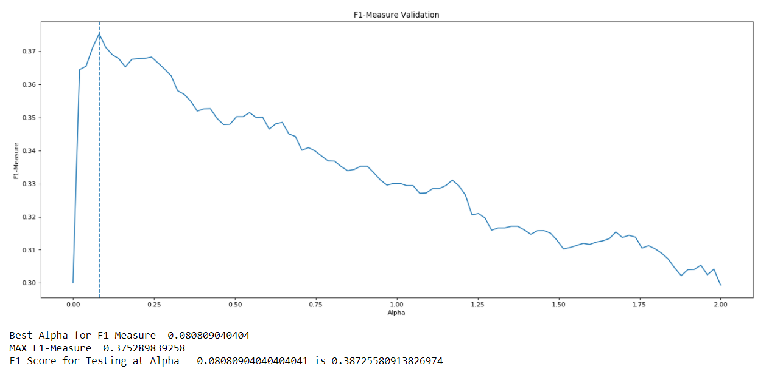

Best F1-measure occurs between 0 and 0.25. Re-iterate to find best value

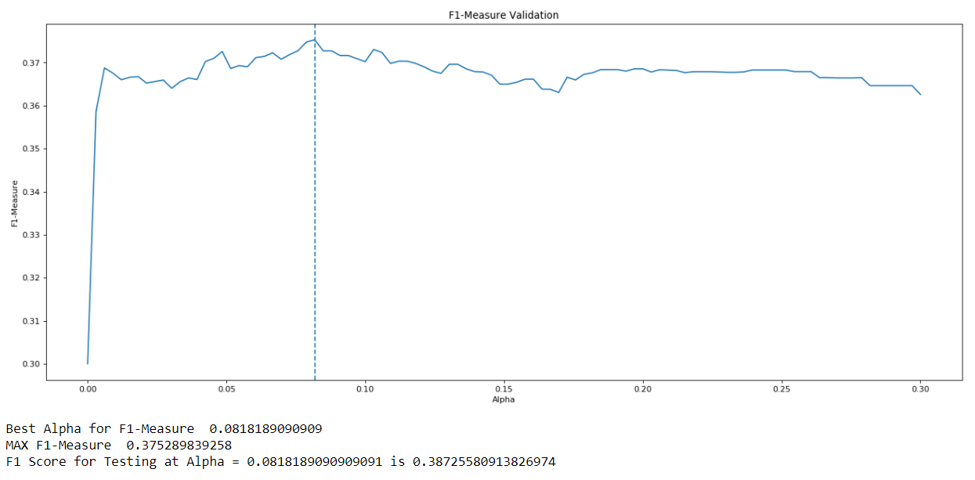

Best F1-measure occurs at alpha = 0.0818 and the testing F1-measure is 0.387.

Note that the best F1-measure on the validation set occurs at the same alpha value, and the testing F1-measure at this point is only slightly better.

{'alpha': 0.0818, 'binarize': 0.0, 'class_prior': None, 'fit_prior': True}

**Training F1-Measure:** 0.722816991255

Confusion Matrix:

[[ 380 3 4 4 131]

[ 15 410 24 36 156]

[ 6 11 660 62 258]

[ 25 45 46 1489 863]

[ 24 50 55 238 2005]]

**Validation F1-Measure:** 0.375289839258

Confusion Matrix:

[[ 36 12 5 4 27]

[ 12 19 18 20 27]

[ 5 17 41 48 53]

[ 8 24 27 136 161]

[ 11 14 12 84 179]]

**Test F1-Measure:** 0.387255809138

Confusion Matrix:

[[ 59 23 14 10 37]

[ 30 47 38 27 48]

[ 12 38 61 86 103]

[ 8 33 68 283 310]

[ 10 18 30 179 428]]

# Yelp

## Linear SVC Hyper-Parameter Tuning (Frequency)

Model with rank: 1

Mean validation score: 0.447 (std: 0.008)

Parameters: {'C': 100, 'max_iter': 2450, 'tol': 1e-06}

Model with rank: 2

Mean validation score: 0.447 (std: 0.006)

Parameters: {'C': 100, 'max_iter': 9022, 'tol': 0.01}

Model with rank: 3

Mean validation score: 0.446 (std: 0.007)

Parameters: {'C': 100, 'max_iter': 2290, 'tol': 0.01}

The frequency representation on the Yelp dataset did not show any improvements. Note, this could be because the random classifier did not run through the same number of iterations. In Bag of Words representation, the model ran through 3 times as many iterations, as I had more time to train. Now that training is taking long, and the assignment is due very soon, I am unable to train the model for as long as I would like.

{'C': 100, 'class_weight': None, 'dual': True, 'fit_intercept': True, 'intercept_scaling': 1, 'loss': 'squared_hinge', 'max_iter': 2450, 'multi_class': 'ovr', 'penalty': 'l2', 'random_state': None, 'tol': 1e-06, 'verbose': 0}

**Training F1-Measure:** 0.891559550272

Confusion Matrix:

[[ 493 8 5 12 4]

[ 18 545 16 53 9]

[ 6 16 784 158 33]

[ 3 1 25 2227 212]

[ 1 1 8 235 2127]]

**Validation F1-Measure:** 0.45823811089

Confusion Matrix:

[[ 43 19 5 9 8]

[ 18 23 19 25 11]

[ 4 14 48 82 16]

[ 6 5 30 195 120]

[ 5 2 10 88 195]]

**Test F1-Measure:** 0.453660238328

Confusion Matrix:

[[ 77 19 8 22 17]

[ 32 50 47 41 20]

[ 17 30 74 134 45]

[ 8 15 63 383 233]

[ 2 9 21 216 417]]

# Yelp

## Decision Tree Hyper-Parameter Tuning (Frequency)

Model with rank: 1

Mean validation score: 0.312 (std: 0.013)

Parameters: {'max_depth': 25, 'max_features': None, 'max_leaf_nodes': 116, 'min_impurity_decrease': 0.00034614266116079795, 'min_samples_leaf': 2, 'min_samples_split': 195}

Model with rank: 2

Mean validation score: 0.310 (std: 0.020)

Parameters: {'max_depth': 20, 'max_features': None, 'max_leaf_nodes': 927, 'min_impurity_decrease': 0.00033034519106199799, 'min_samples_leaf': 2, 'min_samples_split': 75}

Model with rank: 3

Mean validation score: 0.310 (std: 0.017)

Parameters: {'max_depth': 20, 'max_features': None, 'max_leaf_nodes': 360, 'min_impurity_decrease': 0.00039506476060957921, 'min_samples_leaf': 1, 'min_samples_split': 95}

The Decision tree model for the Frequency representation of the Yelp dataset does slightly worse that the Bag of Words representation. Note: The difference is only 0.01 F-measure for the validation set.

{'class_weight': None, 'criterion': 'gini', 'max_depth': 25, 'max_features': None, 'max_leaf_nodes': 116, 'min_impurity_decrease': 0.00034614266116079795, 'min_impurity_split': None, 'min_samples_leaf': 2, 'min_samples_split': 195, 'min_weight_fraction_leaf': 0.0, 'presort': False, 'random_state': None, 'splitter': 'best'}

**Training F1-Measure:** 0.451092729318

Confusion Matrix:

[[ 203 53 33 112 121]

[ 74 120 84 193 170]

[ 40 61 279 351 266]

[ 49 41 126 1501 751]

[ 59 27 63 511 1712]]

**Validation F1-Measure:** 0.309577715889

Confusion Matrix:

[[ 26 12 3 26 17]

[ 12 11 18 29 26]

[ 6 10 30 66 52]

[ 14 10 32 144 156]

[ 9 10 8 121 152]]

**Test F1-Measure:** 0.302908462128

Confusion Matrix:

[[ 33 16 10 40 44]

[ 25 9 39 76 41]

[ 16 12 52 135 85]

[ 17 21 61 326 277]

[ 17 10 19 218 401]]

# IMDB

## Bernoulli Naïve Bayes Hyper-Parameter Tuning (Bag of Words)

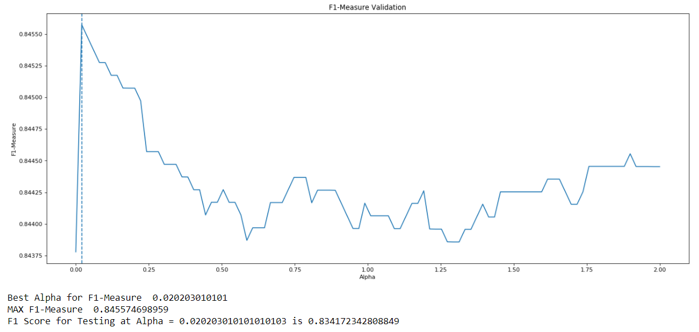

The best F1-Measures occur between 0 and 0.2 for values of alpha. Re-iterating after updating loop:

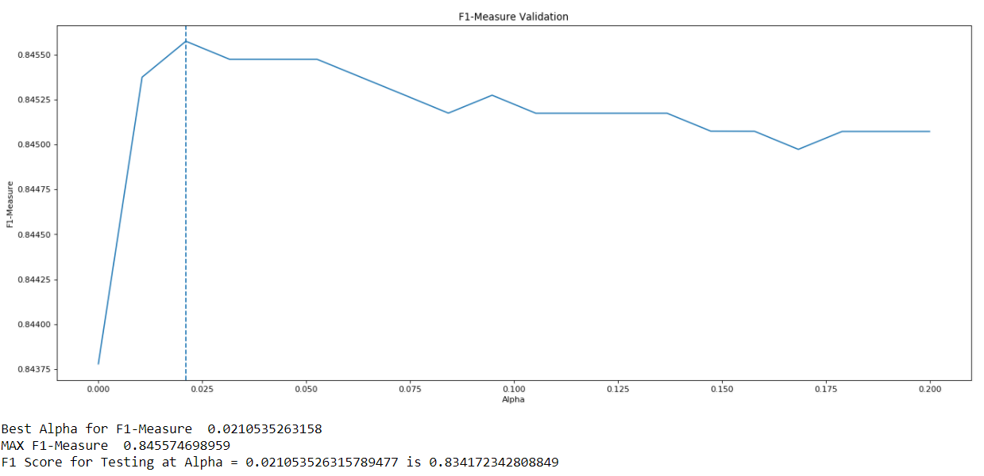

The best validation F1-measure occurs at alpha = 0.02105, and the testing F1-measure at this value is 0.8342.

# IMDB

## Linear SVC Hyper-Parameter Tuning (Bag of Words)

Model with rank: 1

Mean validation score: 0.883 (std: 0.004)

Parameters: {'C': 0.01, 'dual': False, 'max_iter': 4056, 'tol': 0.01}

Model with rank: 1

Mean validation score: 0.883 (std: 0.004)

Parameters: {'C': 0.01, 'dual': False, 'max_iter': 8331, 'tol': 0.01}

Model with rank: 3

Mean validation score: 0.868 (std: 0.006)

Parameters: {'C': 0.1, 'dual': False, 'max_iter': 8678, 'tol': 0.1}

# IMDB

## Decision Tree Hyper-Parameter Tuning (Bag of Words)

Model with rank: 1

Mean validation score: 0.743 (std: 0.006)

Parameters: {'max_depth': 27, 'max_features': None, 'max_leaf_nodes': 1053, 'min_impurity_decrease': 0.00026333022487043378, 'min_samples_leaf': 17, 'min_samples_split': 169}

Model with rank: 2

Mean validation score: 0.741 (std: 0.005)

Parameters: {'max_depth': 22, 'max_features': None, 'max_leaf_nodes': 1802, 'min_impurity_decrease': 0.00041782087619818666, 'min_samples_leaf': 13, 'min_samples_split': 47}

Model with rank: 3

Mean validation score: 0.740 (std: 0.004)

Parameters: {'max_depth': 21, 'max_features': None, 'max_leaf_nodes': 1538, 'min_impurity_decrease': 0.0002483325133484494, 'min_samples_leaf': 16, 'min_samples_split': 109}

# IMDB

## Gaussian Naïve Bayes Hyper-Parameter Tuning (Frequency)

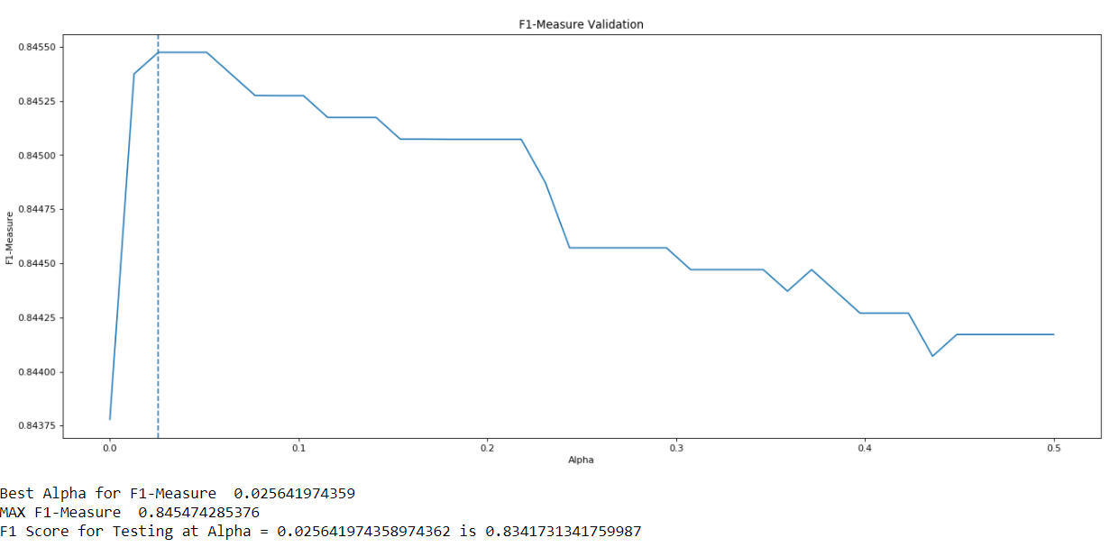

# IMDB

## Linear SVC Hyper-Parameter Tuning (Frequency)

Model with rank: 1

Mean validation score: 0.887 (std: 0.004)

Parameters: {'C': 100, 'dual': False, 'max_iter': 5758, 'tol': 0.01}

Model with rank: 2

Mean validation score: 0.887 (std: 0.004)

Parameters: {'C': 100, 'dual': False, 'max_iter': 4945, 'tol': 1e-05}

Model with rank: 3

Mean validation score: 0.880 (std: 0.008)

Parameters: {'C': 1000, 'dual': False, 'max_iter': 7093, 'tol': 0.1}

IMDB Decision Tree Bag of Words