# Question 1

## 1.1

**Visualizing the Dataset**

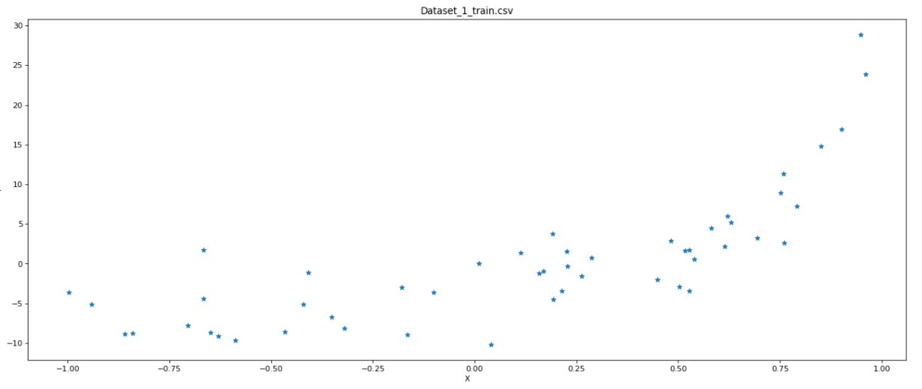

**Visualizing the 20-Degree Polynomial Fit**

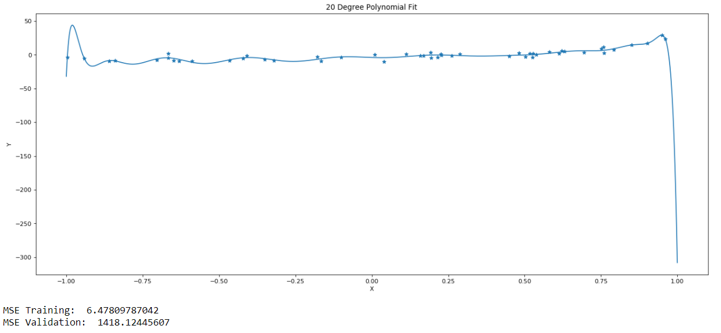

**MSE Training = 6.47**

**MSE Validation = 1418**

The quality of the fit looks fine if our target vector is between -0.8 and 0.8. However, there is clear overfitting. For any target Y greater than 0.8, the predicted value will be off significantly. We need to add regularization to the fit.

## 1.2

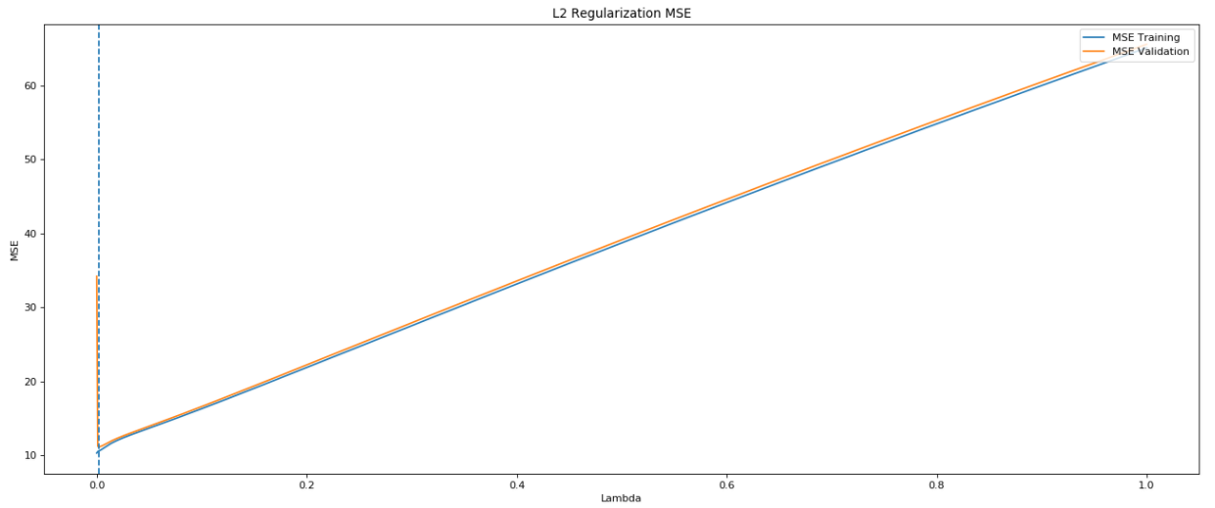

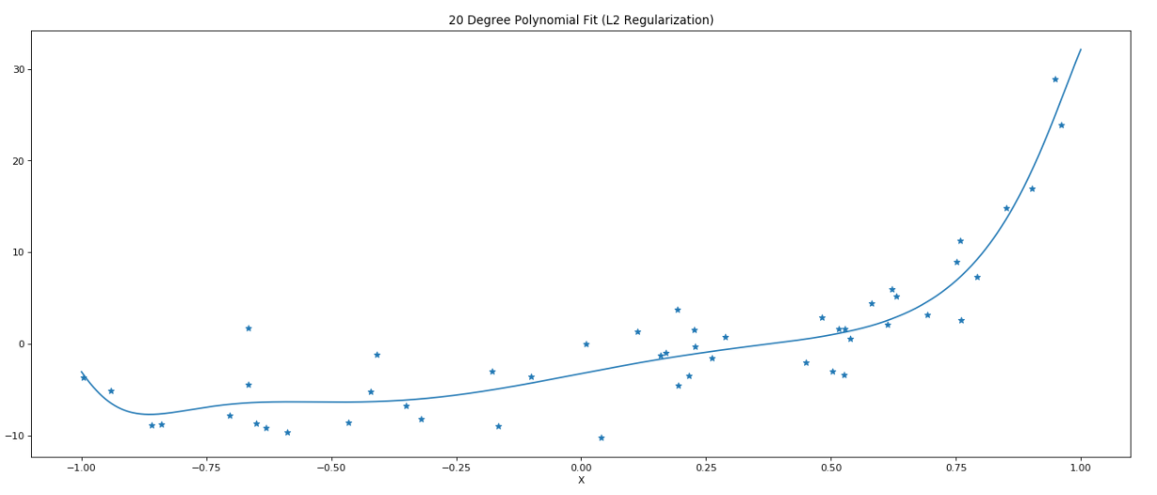

The best L2 regularization occurs at **Lambda = 0.002003**. At this point, the minimum MSE for training is **10.57**, and the minimum MSE for validation is **11.16**, and the minimum MSE for testing is **12.84.**

## 1.3

It looks like the fit with regularization is a 6th degree polynomial. I am inferring this from the number of highs and lows of the graph. The fit has 2 local maximum, and 3 global minimum. This would mean that in theory, this function would cross the X-axis 5 times, and therefore be a 6th degree polynomial.

Question 2

