In this assignment, we will try to use what we've learned from perceptrons to synthesize spiking networks that can do binary (binomial) classification.
The first step is to find a parameter setting in which spiking neurons behave as perceptrons (threshold units).
- Starting from the provided script brian2_activation_function.py, modify the parameters such that the activation function has a sharp onset at input 0. Tip: In the integrate-and-fire neuron, the input current at which the neuron starts to fire is Vt*gl
Cm = 0.05*pF; gl = 1e-9*siemens; taus = 20*ms
Vt = 10*mV; Vr = 0*mV;
sigma = 0./sqrt(ms)*mV
eqs = '''
dv/dt = - gl*v/Cm
+ sigma*xi
+ iext/Cm : volt (unless refractory)
iext : amp'''
P = NeuronGroup(100, eqs, threshold='v>Vt', reset='v = Vr',
refractory=50*ms, method='milstein')
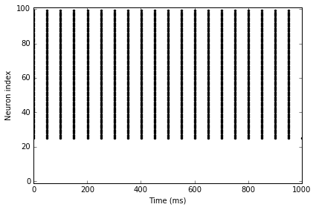
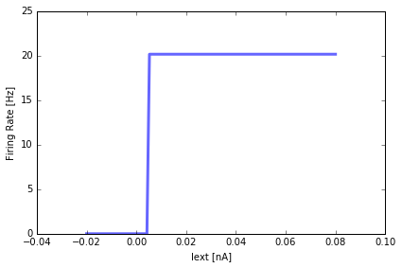
- Show that the Perceptron has the property that rescaling the weights and the bias (e.g. by multiplying with a positive constant) does not change the output.
Thanks to this property, we can directly plug-in the learned parameters to our spiking neuron.
The perceptron learning rule is the following:
f(x) = 1 if dot(w,x) + b > 0
0 otherwise
If you restrain scaling to a positive constant for the weights w and the bias b, you will change the output of the expression dot(w,x) + b, but whether this is above zero or not will not change with scaling alone.
If the bias changes as w changes, this is the case.
- Plug the parameters you've found under 1. into the provided script brian2_perceptron_learn.py and use weights and biases trained with the perceptron learning rule (see ann_train_perceptron.py for an example). The script will compute the output firing rate for each input sample.
- Find a decision rule, i.e. a procedure for mapping the output to a class.
You can simply set a threshold at 50. If the output is over 50, then declare true.
- What classification accuracy do you get? 62% (compared to “1”) on the perceptron learning rule without spiking.
- How does this compare to the ideal Perceptron? What would be ways of improving this?
Possibly adjusting the activation function to shift closer to zero would help a little bit, but in general, the output rates do not seem to be that diagnostic.

- Can you find a decision rule that would reject the classification when confidence is low?
You can specify a decision rule which cuts out the middle range of responses, e.g. which eliminates outputs 40 to 49, and which would classify a 38 as a false and a 50 as a true, but this reduces “coverage” of the dataset.
- (Optional) You can train the neuron to recognize between hand-written digits 3 and 8 by replacing the line:
data, labels = data_load_mnist([3,8])
with
data, labels = data_load_mnist([3,8])
data = data[:n_samples,:]
labels = labels[:n_samples]==3
Tip: you can see what the digits look like with: stim_show(data)
Do you get better or worse classification accuracy compared to the 2D data under step 2.? Try to explain the result, given the fact that recognizing hand-written digits is a much harder task than classifying 2D points.
Better performance was achieved on the MNIST data, 83% correct.

