A Real-Time Research Project/Societal-Related Project Report

On

#### PERSONAL VOICE ASSISTANT

Submitted in fulfillment of the requirements for the award of the

#### Bachelor of Technology

In

#### Department of Computer Science and Engineering

##### By

**B. Retvik Varma 22241A66E3**

Under the Esteemed guidance of

#### P. Deepthi

#### Assistant Professor



**Department of Computer Science and Engineering**

**GOKARAJU RANGARAJU INSTITUTE OF ENGINEERING AND TECHNOLOGY**

**(Autonomous)**

**Bachupally, Kukatpally, Hyderabad, Telangana, India, 500090**

**2023-2024**

I



## GOKARAJU RANGARAJU

**INSTITUTE OF ENGINEERING AND TECHNOLOGY**

**(Autonomous)**

## CERTIFICATE

This is to certify that the Real-Time Research Project/ Societal Related Project entitled “**Personal Voice Assistant**” is submitted by **B. Retvik Varma (22241A66E3), G. Mukesh (22241A66E8), LT. Adwaith Reddy (22241A66G5), D. Neeraj Reddy (22241A66E5),** in fulfillment of the award of a degree in BACHELOR OF TECHNOLOGY in Computer Science and Engineering during the academic year **2023-2024.**

INTERNAL GUIDE HEAD OF THE DEPARTMENT

**V. Y. Bharadwaj Dr. G. Karuna**

**Assistant Professor Professor**

**EXTERNAL EXAMINER**



Many people helped us directly and indirectly to complete our project successfully. We would like to take this opportunity to thank one and all. First, we wish to express our deep gratitude to our internal guide **V. Y. Bharadwaj**, **Assistant Professor**, Department of AIMLE for his/her support in the completion of our project report. We wish to express our honest and sincere thanks to **Mr.** **V. Y. Bharadwaj and Mr. P. Ramesh** for coordinating in conducting the project reviews, **Dr. G. Karuna, HOD,** Department of AIMLE for providing resources, and to the principal **Dr. J. Praveen** for providing the facilities to complete our Real Time Research Project/ Societal Related Project. We would like to thank all our faculty and friends for their help and constructive criticism during the project completion phase. Finally, we are very much indebted to our parents for their moral support and encouragement to achieve goals.

**B.Retvik Varma 22241A66E3**

## 

## DECLARATION

We hereby declare that the Real-Time Research Project/ Societal Related Project entitled “**Personal Voice Assistant**” is the work done during the period from **2023-2024** and is submitted in the fulfillment of the requirements for the award of the degree of Bachelor of Technology in Computer Science and Engineering from **Gokaraju Rangaraju Institute of Engineering and Technology (Autonomous under Jawaharlal Nehru Technology University, Hyderabad).** The results embodied in this project have not been submitted to any other university or Institution for the award of any degree or diploma.

**B. Retvik Varma 22241A66E3**

|  |  |  |
| --- | --- | --- |
|  | **Table of Contents** |  |
| **Chapter** | **Title** | **Page No.** |
|  | Abstract | 1 |
| 1 | Introduction | 2 |
| 2 | System Requirements | 3 |
|  | 2.1 Software Requirements | 3 |
|  | 2.2 Hardware Requirements | 3 |
|  | 2.3 Data Set | 3 |
| 3 | Literature Survey | 4 |
| 4 | Proposed Model, Modules Description. | 6 |
|  | 4.1 Modules |  |
| 5 | UML Diagrams | 7-9 |
| 6 | Source Code | 10-12 |
| 7 | Implementation, Experimental Results, and Test Cases | 13-15 |
| 8 | Future Scope and Conclusion | 16 |

|  |  |  |
| --- | --- | --- |
| **LIST OF FIGURES** | | |
| **Fig. No.** | **Title** | **Page No.** |
|  |  |  |
|  |  |  |
|  |  |  |
|  |  |  |
|  |  |  |
|  |  |  |
|  |  |  |
|  |  |  |
|  |  |  |
|  |  |  |

|  |  |  |
| --- | --- | --- |
| **LIST OF TABLES** | | |
| **Table No.** | **Table Name** | **Page No.** |
|  |  |  |
|  |  |  |
|  |  |  |
|  |  |  |
|  |  |  |
|  |  |  |
|  |  |  |
|  |  |  |
|  |  |  |
|  |  |  |

# ABSTRACT

* The purpose of this study is to design and develop an AI Integrated Personal Voice Assistant using Python programming language, Visual Studio Code as the development environment, and OPENAI for advanced natural language understanding. The project aims to create a user-friendly, efficient, and highly responsive voice assistant that leverages the power of artificial intelligence to provide a seamless and intuitive user experience.
* The purpose of this study is to develop a voice assistant that is more intelligent and capable than existing systems. The methodology will involve using natural language processing (NLP) and machine learning (ML) techniques to train the assistant to understand and respond to a wide range of voice commands.
* The expected major findings of this study are that the AI-integrated personal voice assistant will be able to perform tasks more accurately and efficiently than existing systems. It will also be able to learn and adapt to the user's preferences over time.

# INTRODUCTION

Today the development of artificial intelligence (AI) systems, that are able to organize a natural human-machine interaction (through voice, communication, gestures, facial expressions, etc.) are gaining in popularity. One of the most studied and popular was the direction of interaction, based on the understanding of the machine by the machine of the natural human language. It is no longer a human learns to communicate with a machine, but a machine learns to communicate with a human, exploring his actions, habits, behavior and trying to become his personalized assistant. The work on creating and improving such personalized assistants has been going on for a long time. These systems are constantly improving and going beyond personal computers and have already firmly established themselves in various mobile devices and gadgets. One of the most popular voice assistants are Siri, from Apple, Amazon Echo, which responds to the name of Alexa from Amazon.

# SYSTEM REQUIREMENTS

# Software requirements:

# Operating System: Windows

# Simulation Tools: Visual Studio Code

# Python: Version 3.9.6

# Packages: Pyttsx3, Speech Recognition, Pyaudio, Web browser

# Hardware Requirements:

# Processor: Multi-core processor (64-bit).

# Memory (RAM): 4GB or more recommended.

# Graphics: Integrated graphics are sufficient.

# Storage: minimum 10GB of free disk space needed

# Optional: Headset for improved voice recognition and user privacy

# Microphone and speakers for voice input and output

# Data Sets:

# No Datasets were used.

# LITERATURE SURVEY

# Title & Year:

# Title: Personal Voice Assistant

# Author: Reddy K. V., Lahari, S., Naveen A., & Sarath Chandra G.

# Year: 2020

**Methodology:**

The tasks can be performed using certain methodologies in which each technique has its functionality and different operations to be performed. Each technique has a different process logic to be executed.

Techniques to be implemented:

* Offline Speech Recognition: - The application can recognize the voice from the user's end without an internet connection.
* Content Opener: - The application can open files, folders, drives, and documents present in the system.
* Making Notes: - The application can create, read, write, and delete notes.
* Search: - The application can search YouTube videos, songs, Wikipedia, and google for any information on the internet.
* Updates: - The application gives updates regarding the date, time, day, weather, humidity, temperature

**Research Gap Identification:**

The existing landscape of voice assistants is not without limitations. Current voice assistants predominantly rely on pattern recognition techniques, lacking contextual understanding and accuracy. They are also heavily dependent on internet connectivity, storing data in cloud servers, which can pose security and privacy concerns. Additionally, background noise interference remains a challenge for speech recognition software. These limitations create a research gap for the development of voice assistants that use natural language processing techniques, work offline, and store data locally, addressing issues related to accuracy, data management, and user experience.

**Synthesis and Analysis:**

# The proposed voice assistant system integrates speech recognition, NLP, threading, and

# web scraping to provide a versatile and efficient user experience. It addresses the limitations

# of existing systems and offers improved accuracy, offline functionality, and reduced data

# management complexity.

# PROPOSED MODEL

# Proposed System:

# Overview:

# The proposed system, AI Integrated Personal Voice Assistant, seeks to overcome the limitations of existing voice assistants. By integrating AI and leveraging Wikipedia's natural language processing capabilities, this project aims to create a voice assistant that can understand and respond to complex user queries, provide personalized recommendations, and adapt to individual user preferences over time. The system will also prioritize user privacy and data security.

# Key Features:

# Taking the input as speech patterns through microphone.

# Audio data recognition and conversion into text.

# Comparing the input with predefined commands.

# Giving the desired output.

**UML DIAGRAMS**

Use-Case Diagram:

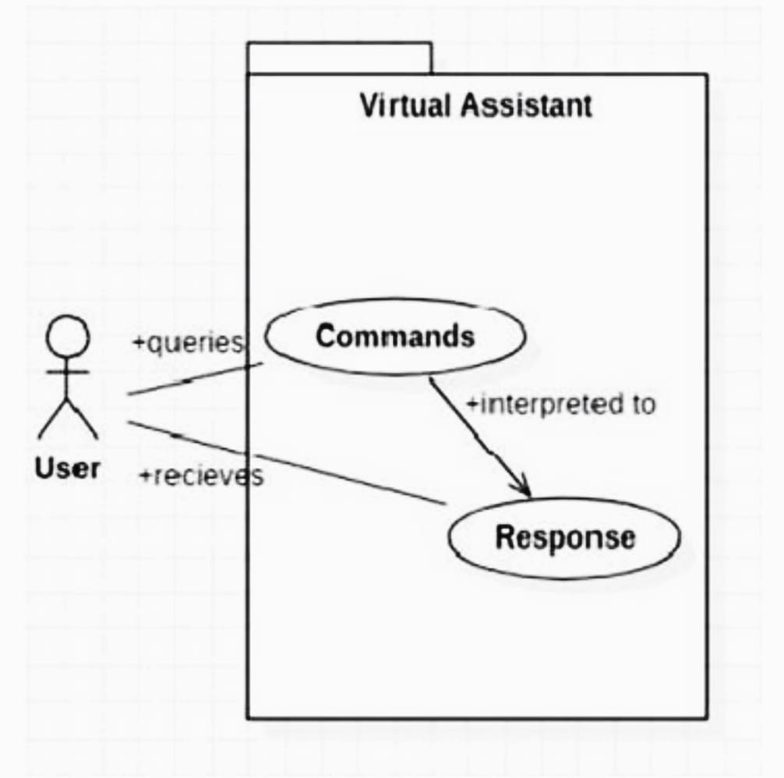

Class Diagram:

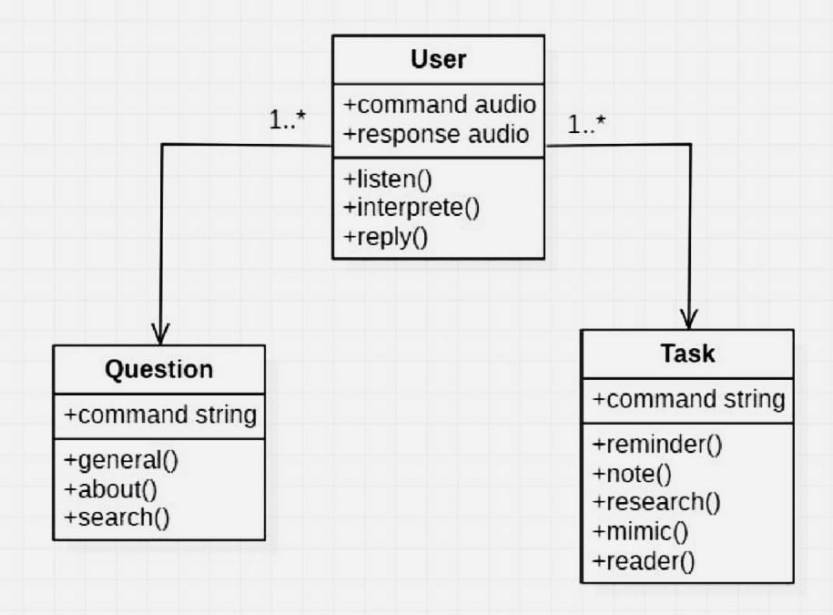

Sequence Diagram:

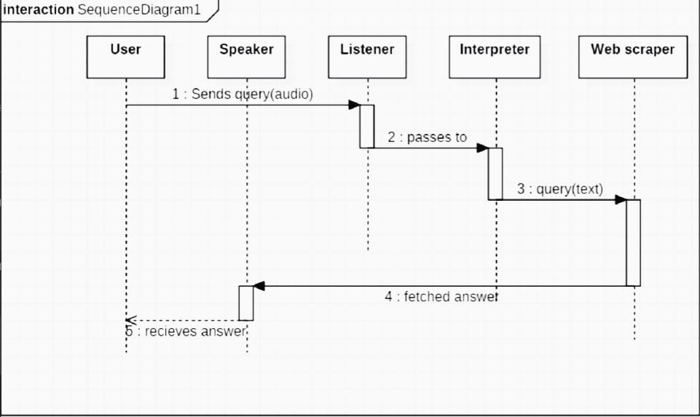

Activity Diagram:

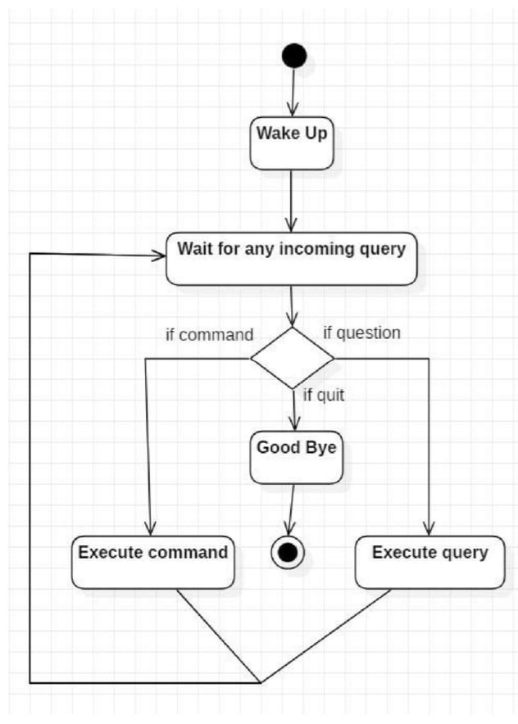

**Source Code:**

import pyttsx3

import speech_recognition as sr

import datetime

import wikipedia

import webbrowser

import sys

import os

import smtplib

import pyautogui

import pywhatkit as kit

engine = pyttsx3.init('sapi5')

voices = engine.getProperty('voices')

engine.setProperty('voice',voices[0].id)

def speak(audio):

    engine.say(audio)

    engine.runAndWait()

def greetMe():

    hour= int(datetime.datetime.now().hour)

    if hour>=0 and hour<=12:

        print("Good Morning,sir")

        speak("Good Morning,sir")

    elif hour >12 and hour<=18:

        print("Good Afternoon,sir")

        speak("Good Afternoon,sir ")

    else:

        print("Good Evening,sir")

        speak("Good Evening,sir")

    speak(" I am Siri, How can I help you ?")

def takeCommand():

    r=sr.Recognizer()

    with sr.Microphone() as source:

        print("Listening....")

        r.pause_threshold=1

        r.energy_threshhold=400

        audio=r.listen(source,0,4)

    try:

        print("Recognizing.....")

        speak("Recognizing")

        query=r.recognize_google(audio, language='en-in')

        print(f"you said:{query}\n")

    except Exception as e:

        print("Say That Again....")

        speak("Say That Again")

        return "None"

    return query

def sendEmail(to,content):

    server=smtplib.SMTP('smtp.gmail.com',587)

    server.ehlo()

    server.starttls()

    server.login('noreply@gmail.com','Interstellar')

    server.sendmail('noreply@gmail.com',to,content)

    server.close()

if __name__=="__main__":

    greetMe()

    while True:

        query= takeCommand().lower()

        if 'wikipedia' in query:

            speak('Searching wikipedia...')

            quer=query.replace("wikipedia","")

            results= wikipedia.summary(query, sentences=2)

            speak("According to wikipedia")

            print(results)

            speak(results)

        elif 'open youtube' in query:

            webbrowser.open("youtube.com")

        elif 'open google' in query:

            webbrowser.open("google.com")

        elif 'time' in query:

            strTime=datetime.datetime.now().strftime("%H:%M:%S")

            speak(f"The time is {strTime}")

        elif 'open code' in query:

            codePath=r"C:\Users\91905\AppData\Local\Programs\Microsoft VS Code\Code.exe"

            os.startfile(codePath)

elif 'send email' in query:

            try:

                speak("what should I send")

                content=takeCommand()

                to="mran@gmail.com"

                sendEmail(to,content)

                speak("email has been sent")

                print("email has been sent")

            except Exception as e:

                print(e)

                speak("sorry my friend, I am not able to send the email")

                print("sorry my friend, I am not able to send the email")

        elif 'play my album' in query:

            music_dir=r'C:\Users\91905\Music\Playlists'

            playlists=os.listdir(music_dir)

            os.start file(os.path.join(music_dir, playlists[8]))

        elif 'play music' in query:

            speak('Which song you wanna play')

            print("which song you wanna play")

            try:

                cm=takeCommand()

                kit.playonyt(f"{cm}")

            except:

                speak("please repeat the song name")

                print("please repeat the song name")

        elif "pause" in query:

            pyautogui.press("space bar")

            speak("video paused")

        elif "play" in query:

            pyautogui.press("space bar")

            speak("video played")

elif 'siri sleep' in query:

            print("Have a good day,Sir")

            speak("Have a good day,Sir")

            sys.exit();

**IMPLEMETATION, EXPERIMENTAL RESULTS &TEST CASES**

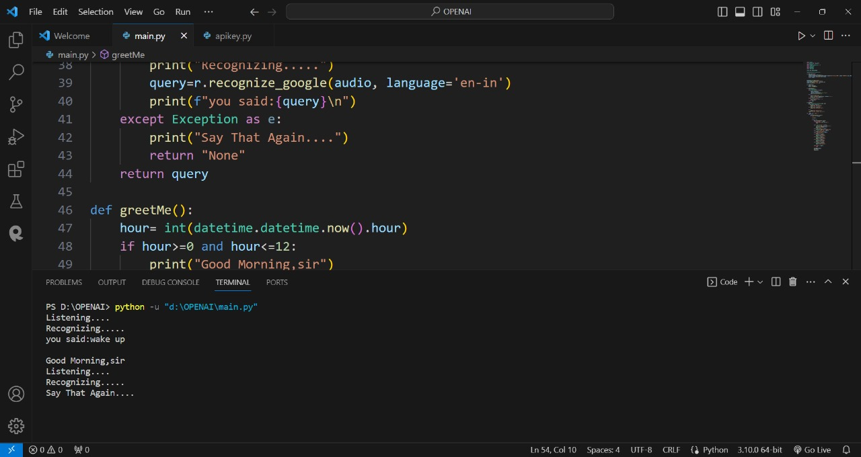

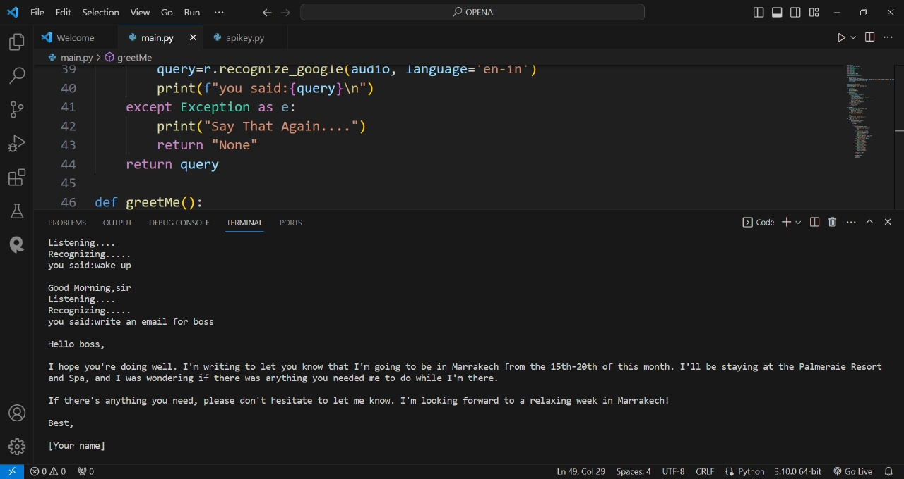

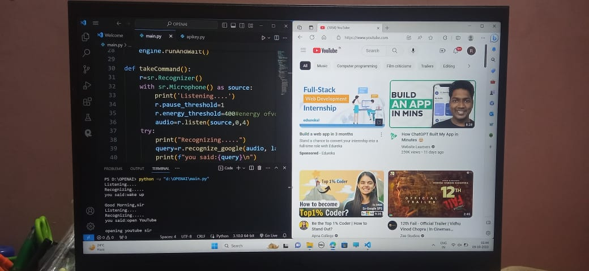

# PIC8.jpg

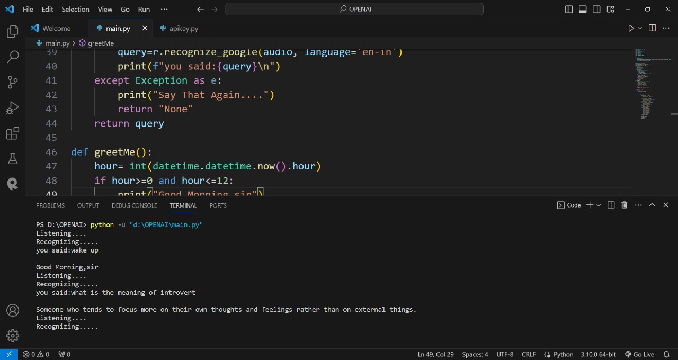

**Future Scope**

This chapter aims to delve into the intricacies of AI-integrated voice-based Personal Assistants and provide a comprehensive overview of their design, development, and transformative impact on the modern digital landscape. By exploring the fundamentals of these intelligent systems, we seek to unravel their inner workings and uncover the vast potential they hold for shaping the future of human-computer interaction.

**CONCLUSION**

In this project, various techniques were used to identify the polarity of the tweets. The algorithm performed is the Decision tree which provides an accuracy of 28 percent. As only a few algorithms were tested, it is required to test other algorithms or create hybrid methods so that the accuracy of the results can be increased. Given the current crisis going on in our country, this model recommends that patents decide on the usage of technology to reduce human efforts to some extent.

**REFERENCES**

* Ali S. Jain & Jason, F. (2023). Personal desktop voice assistant. International Journal of Advanced Research in Computer Science and Engineering, 12(4), 224.
* Fapal A. Kanade, T. Janrao, B. Kamble M. & Raule, M. (2023). Personal virtual assistant for windows using python. International Journal of Computer Applications, 184(23), 1-6.
* Reddy, K. V., Lahari, S., Naveen, A., & Sarath Chandra, G. (2020). Personal voice assistant. Journal of Emerging Technologies and Innovative Research, 7(6), 830-836.
* Dhanraj V. K., Lokesh Kriplani , & Mahajan, S. (2022). Research paper on desktop voice assistant. International Journal of Innovative Technology and Research, 11(5), 115-120.
* Goutam, P. C. Jalpure, M. S. Gavade , A. S., Chaudhary, P., & Gundavade, A. V. (2022). Voice assistant using python. International Journal of Engineering Research and Technology, 11(9), 1241-1245.