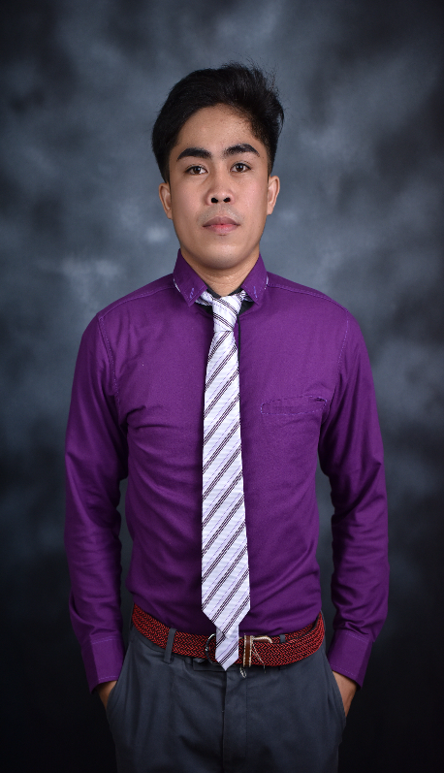

**JEXTER E. TOMAS**

Purok 2 Sagana, Santiago City

Contact No. : 0921-8356-618

Email: [jextertomas@gmail.com](mailto:jextertomas@gmail.com)

**Objective:**

Seeking an opportunity where I will be able to utilize my organizational skills, educational background and ability to work well with people which will allow me to grow personally and professionally.

**___________________________________________________________________**

**Technical Skills:**

- HTML, CSS, JAVASCRIPT, CAKEPHP, PHP, LARAVEL, JQUERY, NODE JS, VUE, REACT, BOOTSTRAP, MYSQL, GIT, EXPRESS.

**Other Skills:**

- Problem Solving, Debugging, Team Collaboration, Learning and Adaptability, Time Management.

**Personal Information:**

Age : 23 years old

Gender : Male

Citizenship : Filipino

Date of Birth : November 26, 2000

Place of Birth : Sagana, Santiago City

Religion : Roman Catholic

Father’s Name : Aristotle A. Tomas

Occupation : Driver

Mother’s Name : Emerlita E. Tomas

Occupation : Housewife

**Education Background:**

College : Northeastern College

Bachelor of Science in Information Technology 2019-2023

High School : Sagana National High School 2013-2019

Elementary School : Sagana Elementary School 2007-20013

**Achievements:**

* ISU Roadshow General Programming 1st Place.

**Trainings:**

* On-The-Job Trainee at Brain Network Japan/Brain IT Consultancy.

**___________________________________________________________________**

I hereby certify to the best of my knowledge that the above information is true and correct.

**Jexter E. Tomas**

Applicant