Banking Database Report
Design and Implementation of a Banking Database Management System Using MySQL

Submitted by: GROUP1

Course:
DTS304: Data Management

Lecturer:
Dr. A. Enesi

Department of Computer Science

Federal University of Technology, Minna

July 2026

GROUP1 MEMBERS
NAME | MATRIC No.
Nwafor Catherine Ebere | 2023/1/91286CT
Muhammad Hauwa Egbako | 2023/1/91318CT
Haruna Imran Isah | 2023/1/94635CT
Onuoha Glide Deberechukwu | 2023/1/91284CT
Mohammed Jibrin Emigi | 2024/2/101059CT
Adeyemo Faridat Bisola | 2024/2/98580CT
Esan Ifeoluwa Mfon-Obong | 2024/2/98959CT
Daniel Friday Alechenu | 2023/1/91330CT
Oyibo Timothy | 2024/2/99395/CT
Olajide Kehinde Hezekiah | 2023/1/92218CT
Nwocha Godswill Chukwudor | 2023/1/91304CT
Mark Uchechukwu David | 2023/1/91292CT

Table of Contents
GROUP1 MEMBERS 2
INTRODUCTION 4
METHODOLOGY 5
CONCEPTUAL DESIGN 5
ER DIAGRAM 5
DATABASE TABLES 6
IMPLEMENTATION 6
RESULT DISCUSSION 6
CONCLUSION 7
APPENDIX – MISCELLANEOUS && SCREENSHOTS 7

INTRODUCTION
A database management system or (DBMS) is a computerised data-keeping system. It is a software system that manages, stores, and retrieves data efficiently in structured format. DBMS acts as a bridge between a central database and multiple clients, including applications and users.
Before the introduction of modern DBMS, data was managed using basic file systems on hard drives. While this approach allowed users to store, retrieve and update files as needed, it came with numerous challenges like: data redundancy, inconsistency, difficult access, poor security, and a lack of backup/recovery.
Banks are financial institutions that accept deposits from the public and create a demand deposit while making loans. Banks and financial institutions use DBMS to store, manage, and retrieve a large amount of financial data efficiency and security. This in turn supports key banking operations such as transaction processing, customer relationship management and fraud detection.
The bank is organised into branches, and each branch has a unique identifier, a name, and an address/location. A branch serves an arbitrary number of customers. The branch also has a number of employees.
Each customer has a unique identifier, a first and last name, phone number, email and address. A customer also can have one or more bank accounts.
A bank account has a unique identifier and its current balance. Each account is associated with one active card, and the card contains its unique identifier, its expiration date and its card type. An account can also apply for loans and perform transactions.
The database keeps track of these loans, with each loan having a unique identifier, the amount, interest rate and repayment status.
Furthermore the database holds records of transactions, each having a unique identifier, the amount, the transaction type, and the date of the transaction.
The purpose of this database is to manage and store information related to a bank. It aims to provide a structured representation of various entities and their relationships within the banking system.

METHODOLOGY

CONCEPTUAL DESIGN
The database was developed using the Relational Database Design Methodology.
The development process included: Requirement analysis, Entity identification, Atrribute definition, Relationship design, Normalization, Database Implementation and Testing.
We followed theses principles to reduce redundancy and errors and maintain data integrity.
The entities recognised were, Customer, Branch (of the bank), Account (of the customer), Transaction, Employee, Loan and Card.

ER DIAGRAM

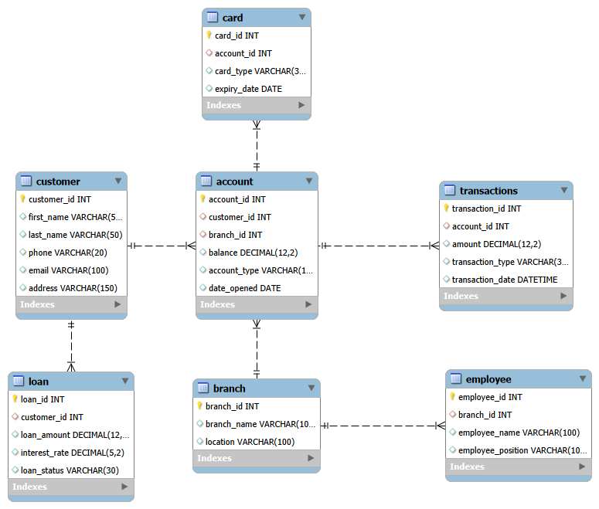
Relationships amongst the entities:
The Account table has a foreign key reference to the Customer table (via customer_id).
Relationship: One Customer to Many Accounts (1:N)
The Account table has a foreign key reference to the Branch table (via branch_id).
Relationship: One Branch to Many Accounts (1:N)
The Card table has a foreign key reference to the Account table (via account_id).
Relationship: One Account to Many Cards (1:N)
The Transactions table has a foreign key reference to the Account table (via account_id).
Relationship: One Account to Many Transactions (1:N)
The Loan table has a foreign key reference to the Customer table (via customer_id).
Relationship: One Customer to Many Loans (1:N)
The Employee table has a foreign key reference to the Branch table (via branch_id).
Relationship: One Branch to Many Employees (1:N)

DATABASE TABLES
There are 7 tables, one for each identified entity. These are:
- Customer: stores information about indiviudals that interact with the bank as customers.
- Branch: contains information about the different branches or offices of the bank.
- Account: represents the different accounts that customers or groups of cunstomers can have in the bank.
- Transaction: stores information about the various transation performed in the bank.
- Employee: individuals who are bank employees.
- Loan: stores information about the loans granted by the bank to customers.
- Card: stores information about cards issued by the bank to customers and their respective accounts.

Table Structures
Customer
Field | Type
CustomerID | INT
FirstName | VARCHAR(50)
LastName | VARCHAR(50)
Phone | VARCHAR(20)
Email | VARCHAR(100)
Address | VARCHAR(150)

Branch
Field | Type
BranchID | INT
BranchName | VARCHAR(100)
Location | VARCHAR(100)

Account
Field | Type
AccountID | INT
CustomerID | INT
BranchID | INT
Balance | DECIMAL(12,2)
AccountType | VARCHAR(30)
DateOpened | DATE

Transaction
Field | Type
TransactionID | INT
AccountID | INT
Amount | DECIMAL(12,2)
TransactionType | VARCHAR(30)
TransactionDate | DATETIME

Employee
Field | Type
EmployeeID | INT
BranchID | INT
Name | VARCHAR(100)
Position | VARCHAR(50)

Loan
Field | Type
LoanID | INT
CustomerID | INT
Amount | DECIMAL(12,2)
InterestRate | DECIMAL(5,2)
Status | VARCHAR(30)

Card
Field | Type
CardID | INT
AccountID | INT
CardType | VARCHAR(20)
ExpiryDate | DATE

IMPLEMENTATION
The system was implemented using SQL and MySQL Workbench 8.0 CE.
Steps in implementation included:
- Creating the database
- Creating all the tables
- Defining the primary keys
- Defining the foreign key
- Populating the tables with sample data
- Executing SQL queries on the DB

SQL SCRIPTS

Creating Schema and Tables

CREATE DATABASE IF NOT EXISTS Bank;
USE Bank;
-- since these tables are dependent, that have foreign keys
-- we will drop them first so data integrity is maintained
DROP TABLE IF EXISTS Transactions;
DROP TABLE IF EXISTS Employee;
DROP TABLE IF EXISTS Loan;
DROP TABLE IF EXISTS Card;
-- parent tables dropped last
DROP TABLE IF EXISTS Account;
DROP TABLE IF EXISTS Customer;
DROP TABLE IF EXISTS Branch;

CREATE TABLE Customer(
customer_id INT PRIMARY KEY AUTO_INCREMENT,
first_name VARCHAR(50),
last_name VARCHAR(50),
phone VARCHAR(20),
email VARCHAR(100),
address VARCHAR(150)
);

CREATE TABLE Branch(
branch_id INT PRIMARY KEY AUTO_INCREMENT,
branch_name VARCHAR(100),
location VARCHAR(100)
);

CREATE TABLE Account(
account_id INT PRIMARY KEY AUTO_INCREMENT,
customer_id INT,
branch_id INT,
balance DECIMAL(12,2),
account_type VARCHAR(12),
date_opened DATE,
FOREIGN KEY(customer_id) REFERENCES `Customer`(customer_id),
FOREIGN KEY(branch_id) REFERENCES `Branch`(branch_id)
);

CREATE TABLE Transactions(
transaction_id INT PRIMARY KEY AUTO_INCREMENT,
account_id INT,
amount DECIMAL(12,2),
transaction_type VARCHAR(30),
transaction_date DATETIME,
FOREIGN KEY(account_id) REFERENCES `Account`(account_id)
);

CREATE TABLE Employee(
employee_id INT PRIMARY KEY AUTO_INCREMENT,
branch_id INT,
employee_name VARCHAR(100),
employee_position VARCHAR(100),
FOREIGN KEY(branch_id) REFERENCES `Branch`(branch_id)
);

CREATE TABLE Loan(
loan_id INT PRIMARY KEY AUTO_INCREMENT,
customer_id INT,
loan_amount DECIMAL(12,2),
interest_rate DECIMAL(5,2),
loan_status VARCHAR(30),
FOREIGN KEY(customer_id) REFERENCES `Customer`(customer_id)
);

CREATE TABLE Card(
card_id INT PRIMARY KEY AUTO_INCREMENT,
account_id INT,
card_type VARCHAR(30),
expiry_date DATE,
FOREIGN KEY(account_id) REFERENCES `Account`(account_id)
);

Populating the Database

Executing SQL commands on the Database

RESULT DISCUSSION

CONCLUSION

APPENDIX – MISCELLANEOUS && SCREENSHOTS

