

CHAPTER 2

## Behavioral Equivalence

**TOPICS TO BE COVERED :**

***Introduction*** ***2******-4***

***Strong Bisimulation 5******-8***

***Strong Bisimulation Review 5******-8***

***The Internal Action 9******-11***

***he Internal Action Review 5******-8***



*Page: 1*



# Behavioral Equivalence:

# Introduction



***QUICK REVIEW***

* Behavioral equivalences serve to establish in which cases two reactive systems which may be concurrent, offer similar interaction capabilities relatively to other systems representing their operating environment
* Having theories which can be used to establish whether two systems are equivalent or whether one is a satisfactory “approximation” of another’s are events that really happen in an instance of time.

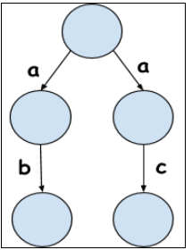***EXAMPLE***

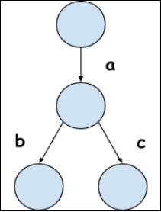

**Figure 1: a simple example of Behavioral Equivalent Transition Systems.**

*Page : 2*

Behavioral Equivalence:

# Strong Bisimulation

***QUICK REVIEW***

* Among the best known behavioral equivalences are the **bisimulation** equivalences (also called observational equivalences) of **Milner [1989] and Park [1989].**
* **Bisimulation is done by:**

A relation R between states of a transition system is a bisimulation just in case whenever (s, t) ∈(part of the set) R and a ∈ A,

1. if s a −→ s ′ then t a −→ t ′ for some t ′ such that (s ′, t′) ∈ R and

2. if t a −→ t ′ then s a −→ s ′ for some s ′ such that (s ′, t′) ∈ R.

In the case of an enriched transition system with colors there is an extra clause in the definition of a bisimulation that it preserves colors: if (s, t) ∈ R then 2 0. for all colors q, s ∈ q iff(if and only if) t ∈ q

***EXAMPLE***

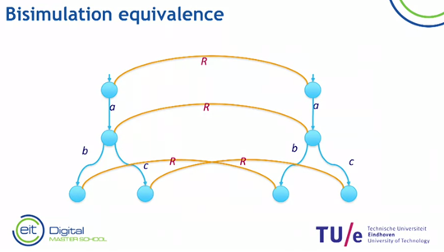

**Figure 2: Example of a Bisimulation Equivalence** 

*Page: 3*

Behavioral Equivalence:

# Trace Equivalence

***QUICK REVIEW***

* Two transition systems are trace equivalent if they have the same set of traces
* Two states **s, r** are trace equivalent iff(if and only if) Tr(**s**) = Tr(**r**)
* **Theorem**. Every transition has a unique minimal transition system that is bisimulation equivalent to it.

***EXAMPLE***

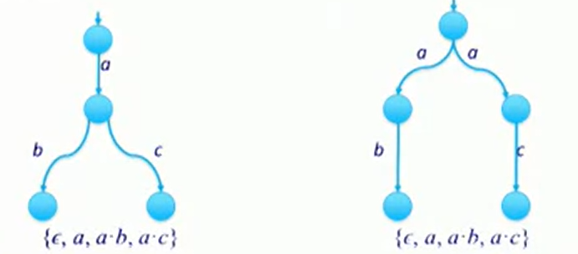

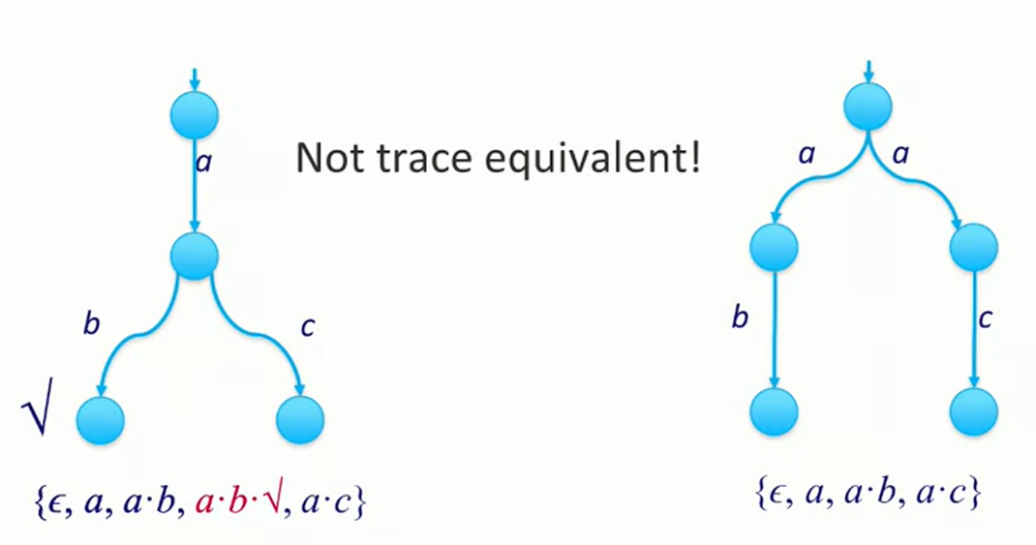**Figure 3: Example of two transitions that are trace equivalent**

**Figure 4: Example of two transitions that are not-trace equivalent** 

*Page : 4*



# Behavioral Equivalence:

# Reviewer for Strong bisimulation



***QUESTIONS***

* Which of the following transition system Bisimulation Equivalent, and when you find the Bisimulation Equivalent transition system give its Trace Equivalence.

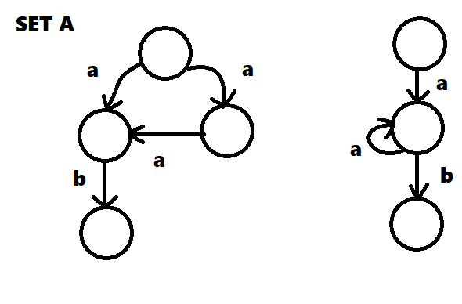

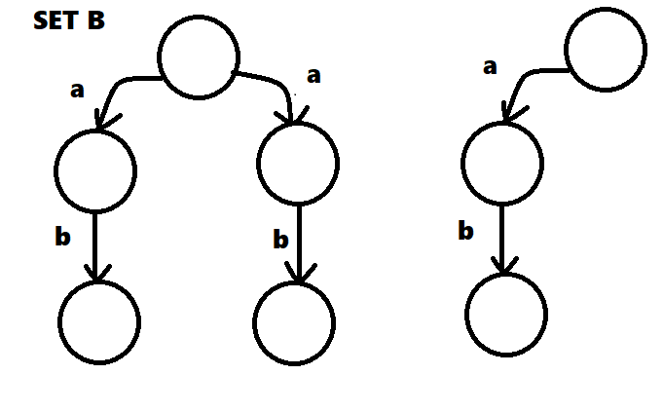



*Page : 5*

**ANSWER:**

*Page : 6*

Behavioural Equivalence:

# The Internal Action

***QUICK REVIEW***

* An **Internal action** is an action that takes place but cannot be observed directly
* Using a notion invented by **Robin Milner**. Namely the hidden action, often written as a tau (t).
* In this transition system (Figure 5) you see that there’s a double action of Switch_on and Switch_off and by using the internal action it can be displayed as this(Figure 6)

***EXAMPLE***

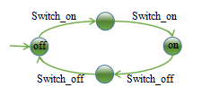

**Figure 5: Transition System with double Switch_on and Switch_off.**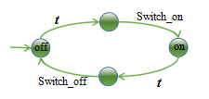



**Figure 6: Transition System after applying the Internal Action using Tau.**

*Page : 7*

Behavioral Equivalence:

# Branching Bisimulation

***QUICK REVIEW***

* Let (S,Act, →,s0,T)be a labelled transition system. We say that relation is a **branching bisimulation relation** if and only if it is symmetric and for all states s,t∈S it holds that if sRt:
* Two cases: where it is branching bisimulation
* If S can do an A step, then either the A is a tau, and the initial state of the state, s prime has to be related to t. Or if we have the case then the A step is mimicked by a number of taus and then an A. And the state directly before the A is related to the initial state and the two end states are related.
* If one of the states terminates, then there are a number of tau steps to a state that terminates, and the end states must be related. And two states. And this is exactly the same as with bisimilation. Two states are related are branching bisimilar. If we can find a branch bisimilation relation that relates the two. And two transition systems are branching bisimilar, if we can relate the initial states of the two transition systems.

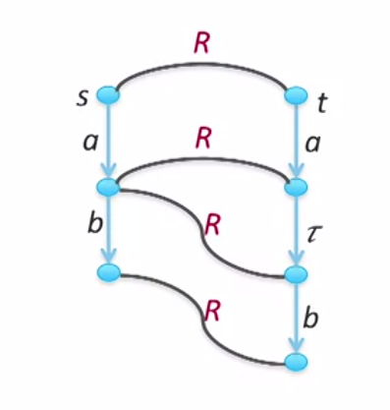***EXAMPLE***



*Page : 7*

*Page : 8*

**Figure 7: Example of a Branching   
bisimulation**

# 1Behavioural Equivalence :

# Rooted branching bisimulation

***QUICK REVIEW***

* A root branching bisimulation is just a branching by simulation relation that in addition satisfies the following:
* That if we have two related states, and if we do a step at the left hand side, then exactly this step is mimicked at the right hand side, and this A can also be an internal step. And the end result, and this is a remarkable point, should only be related by A branching bisimulation.
* Fun Fact, if two states are strongly bisimilar, then they are also rooted branching bisimilar, and if two states are rooted branching bisimilar, they are also branching bisimilar.

***EXAMPLE***

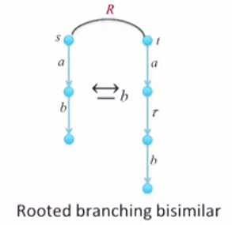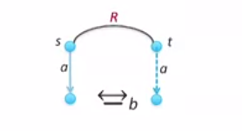

**Figure 8 & 9: Examples of Rooted Branching   
bisimilar relations.**



*Page : 9*

Behavioural Equivalence :

# Reviewer for the Internal Action

***QUESTIONS***

* Identify whether Set A and Set B our either Branching Bisimular and or Rooted Branching Bisimular.

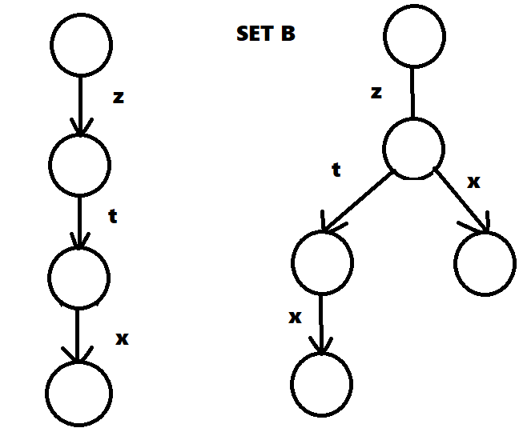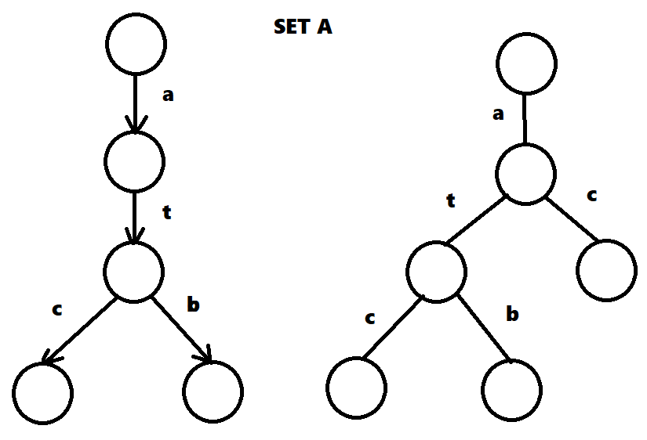

**Answer:**



*Page : 8*

*Page*