

CHAPTER 1

Behavioural Modelling

TOPICS TO BE COVERED :

An Automaton as a model for behaviour 2-4
Non-Deterministic Behaviour 5-8
The Definition of Automaton 9-11

Page : 1

Behavioural Modelling :

An Automaton as a Model for Behaviour

QUICK REVIEW
- According to Robert Milner in 1973 - Systems are always interacting with each other, and input comes, output comes , it goes all together. So a completely different model is required.
- Actions are events that really happen in an instance of time. Atomic events is really the best choice.
Figure 1. Simple Light Example

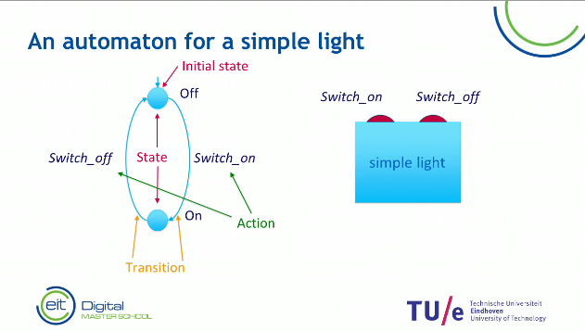
- The “off” and “on” are the States.
- The “off” is the Initial State. It is where the system will start.
- The actions are the Switch_on and Switch_off.
- The Transition that indicates that when the events happens, When you go to the “off” state and do the Switch_on action you’ll go to the “on” state.
- A Trace is simply switch sequence of actions and that shows what you can do with the system.
- The Trace in Figure 1 : Trace : Switch_on Switch_off Switch_on Switch_off Switch_on Switch_off …
Page : 2

Behavioural Modelling :

An Automaton as a Model for Behaviour

PROBLEM SOLVING
Figure 2. ATM Machine

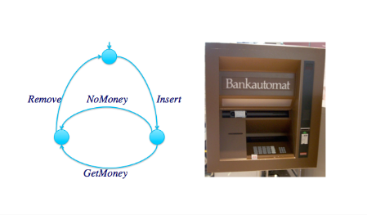
Exercise 1 : Is Remove Insert GetMoney Remove Insert GetMoney Remove Insert NoMoney ..… the trace of the machine and why?

Exercise 2 : Is Insert GetMoney Remove Insert GetMoney Remove Insert NoMoney ..… the trace of the machine and why?

Exercise 3 : Is Insert GetMoney GetMoney Remove Insert NoMoney .... the trace of the machine and why?

Page : 3

Behavioural Modelling :

An Automaton as a Model for Behaviour

PROBLEM SOLVING II

Figure 3. Hungry
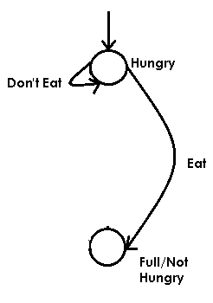

Exercise 4 : What is the Trace of Figure 3?

Page : 4

Behavioural Modelling :

Non-deterministic behaviour

QUICK REVIEW
- A State is non-deterministic if and only if it has at least two outgoing transitions with the same label.
Figure 4. Two outgoing transitions with the same label.
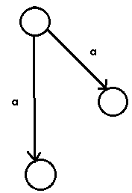
- A labelled transition system is non-deterministic if it has at least one non-deterministic state.
- According to Milner(Milner’s Weather Condition) : Using non-determinism we can, in a very compact and effective way, model much more complex mechanisms that we actually do not really care about for our elementary modelling.

Page : 5

Figure 5. Alarm Clock Behavioural Design
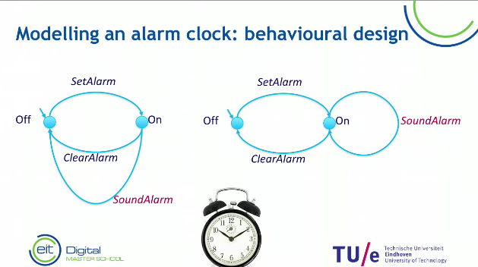
- The figure 5 shows different behaviour of the alarm clock, The left shows that after one SoundAlarmit will go to the state “off”. In the right after the SoundAlarm it will keep on repeating until it does the action ClearAlarm then it will go to the state “off”.
Figure 6. Alarm Clock - Non-deterministic behavioural design
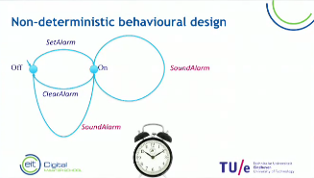
- The figure 6 shows that the SoundAlarm can repeat n times depending on the manufacturer until it can go to the state “off”. This shows non-determinism.

Page : 6

Behavioural Modelling :

non-deterministic Behaviour

PROBLEM SOLVING
Figure 7. Alarm Clock - Non-deterministic ATM Machine.
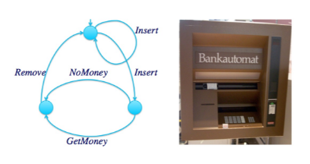
Exercise 1 : Is Insert Insert GetMoney Remove Insert ..... the trace of the machine(Figure 7) and why?
Figure 8. Transition System Sample
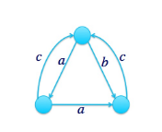
Exercise 2 : Is this transition system(Figure 8) non-deterministic and why?

Page : 7

Behavioural Modelling :

non-deterministic Behaviour

PROBLEM SOLVING II
Figure 9. Transition System Sample 2
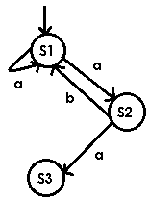
Exercise 3 : Is this transition system(Figure 9) non-deterministic and why?

Exercise 4 : What is the trace of this transition system(Figure 9)?

Page : 7

Page : 8

Behavioural Modelling :

The definition of an automaton

QUICK REVIEW
- A Transition system is described as a five tuple, namely a set of states.(Q, ∑, δ, q0, F).
- Q is a finite set of states.
- ∑ is a finite set of symbols called the alphabet.
- δ is the transition function where δ: Q × ∑ → Q
- q0 is the initial state from where any input is processed (q0 ∈ Q).
- F is a set of final state/states of Q (F ⊆ Q).
Figure 10. Transition System with an infinite state space
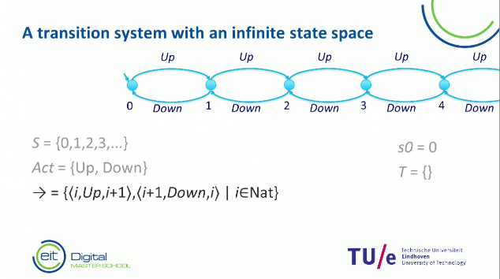
Figure 11. Unreachable and deadlocked states
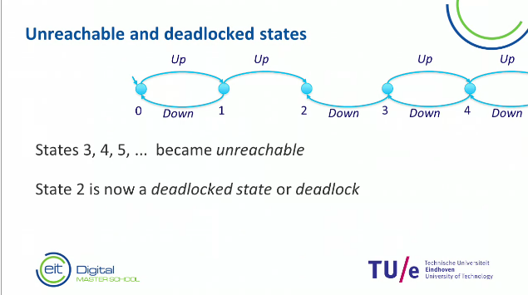
If you are stuck in a certain state, then that is called a deadlock state. In figure 11, State 2 is a deadlock state.
Page : 8

Page : 4

Page : 9

Behavioural Modelling :

The definition of an automaton

PROBLEM SOLVING
Figure 12. Alarm Clock - 5 Tuple Exercise
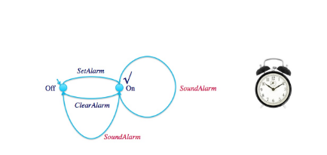
Exercise 1 : Give the following :
Page : 8

What are the states (S = ...?),
the actions (Act = ...?),
the transitions (-> = ...?),
the terminating state (T = ...?),
and the initial state (S0 = ...?)?

Page : 10

Behavioural Modelling :

The definition of an automaton

PROBLEM SOLVING
Figure 13. ATM Machine - 5 Tuple Exercise
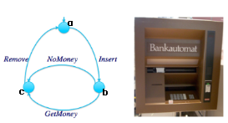
Exercise 2 : Give the following :
Page : 8

What are the states (S = ...?),
the actions (Act = ...?),
the transitions (-> = ...?),
the terminating state (T = ...?),
Page : 11

and the initial state (S0 = ...?)?

