

CHAPTER 3

More Behavioral Equivalences

TOPICS TO BE COVERED:

Alternating Bit Protocol 2-5
Diverge Preserving Branching Bi Simulation 6-8
Weak Trace Equivalence 9-12
Weak Bi Simulation 13-15
Language, Failures, and Completed Trace Equivalence 16-17


More Behavioral Equivalences:

The Alternating Bit Protocol

QUICK REVIEW
- Alternating Bit Protocol- is sending data from left to right, and the data must be sent via unreliable medium
- The idea is by adding an extra bit goes in the correct way
Figure 1. Alternating Bit Protocol Example

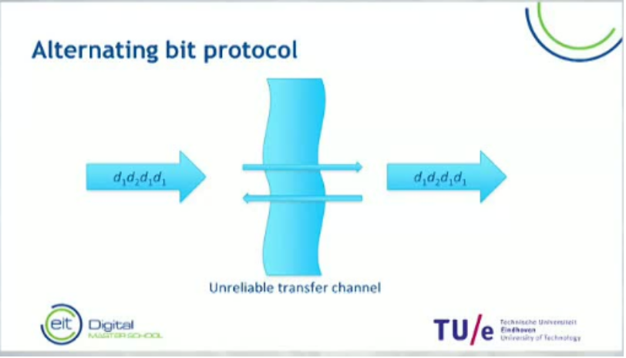
- Data can be sent from one side to another arriving correctly.
- Or data can be sent then lost, making the data will never arrive at the other side.

Figure 2. Alternating Bit Protocol Example
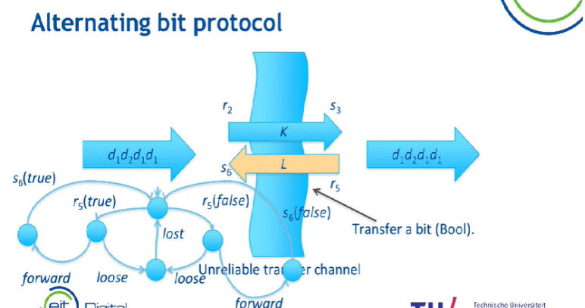
- Channels can decide to either forward the message or to lose the message

Figure 3. Alternating Bit Protocol Example

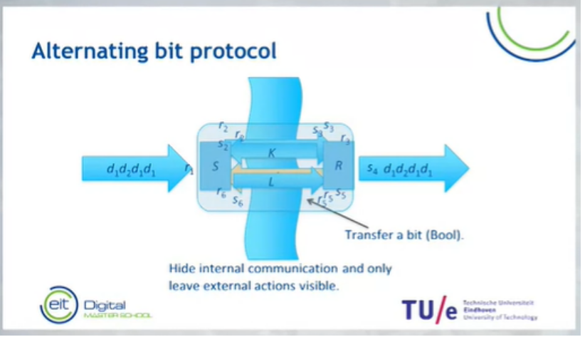
- In Alternating Bit Protocol, we expect that data is reliable
- We want to hide the inter communication of the two protocol entities and only look at their behavior.

More Behavioral Equivalences:

The Alternating Bit Protocol

PROBLEM SOLVING
Figure 4. Sender
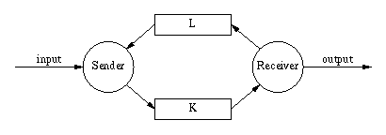
Exercise 1: Determine if the data is reliable or not?

More Behavioral Equivalences:

Alternating Bit Protocol

PROBLEM SOLVING II

Figure 5. Receive
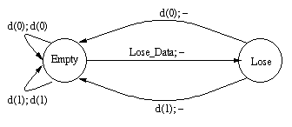
Exercise 3: How is this considered an alternating bit?

More Behavioral Equivalences:

Divergence Preserving Branching Bi-simulation

QUICK REVIEW
- Branching Bi simulation removes divergences
- All states on a tile loop will merge and will remove the tau loop
- Only if two states are related and if both states are able to do an infinite number of taus, and it’s the only extra condition that we add to divergence preserving branching simulation.

Figure 6. Divergence Preserving Branching Bi Simulation Example

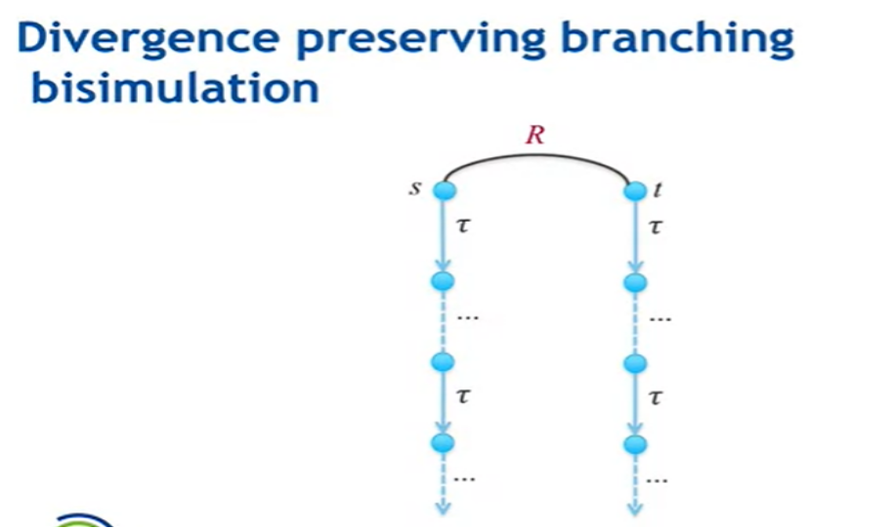

More Behavioral Equivalences:

Divergence Preserving Branching Bi-simulation

PROBLEM SOLVING III
Figure 7. Alarm Clock

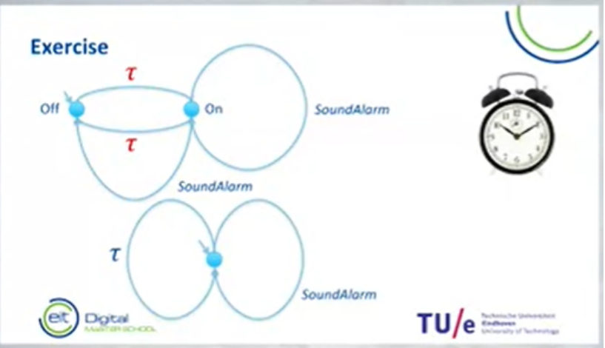

Exercise 3: Is the behavior of the transition system similar?

Exercise 4: If yes why or how are they similar?

More Behavioral Equivalences:

Divergence Preserving Branching Bi-simulation

PROBLEM SOLVING III
Figure 8. Bi Simulation

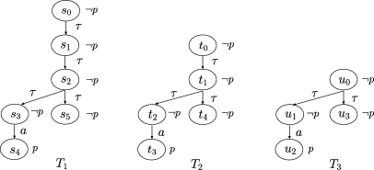

Exercise 5: Which of these three is a branching bi simulation

More Behavioral Equivalences:

Weak Trace Equivalence:

QUICK REVIEW
- Two transitions systems are weak trace equivalent if both have the same weak traces.
- If you have a small transition system, applying a weak trace equivalence can make your small transition system even smaller.
- One of the properties of a weak trace reduction is it allows the removal of all internal action from behaviors.
- Only apply a weak trace equivalence to reduce small transition systems.

Figure 9. Weak Trace Equivalence
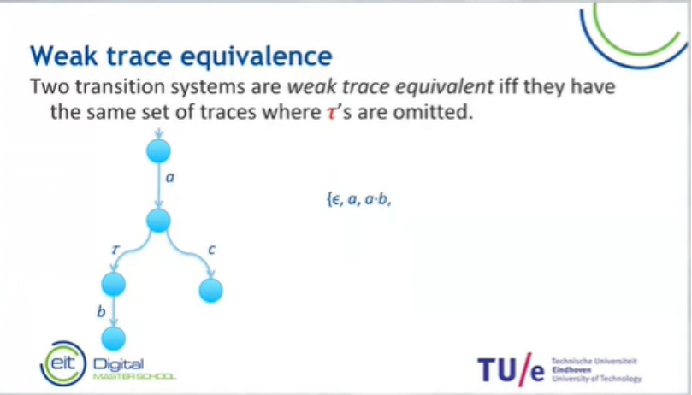

More Behavioral Equivalence:

Weak Trace Equivalence:

PROBLEM SOLVING IV
Figure 10. Weak Trace Equivalence
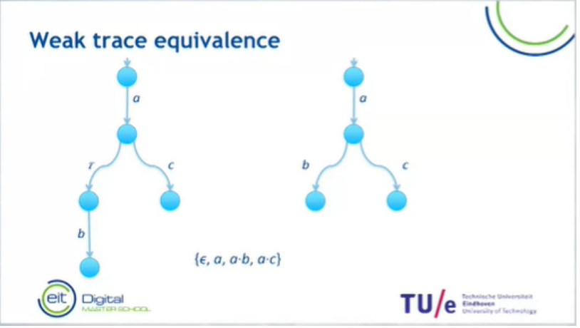
Exercise 6: Is these two transition systems a weak trace equivalent?

Exercise 7: If yes, what makes them a weak trace equivalent?

More Behavioral Equivalence:

Weak Trace Equivalence

PROBLEM SOLVING V
Figure 11. Weak Trace Equivalence

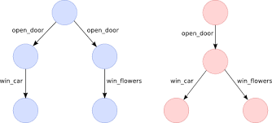

Exercise 8: Which of the two is a weak trace equivalence?

Exercise 9: how are they a weak trace equivalence?

More Behavioral Equivalence:

Weak Bi Simulation

QUICK REVIEW
- Weak Bi Simulation is slightly less efficient than branching simulation.
- Milner defined it as the equivalence that deals with internal steps

Figure 12. Weak Bi-simulation
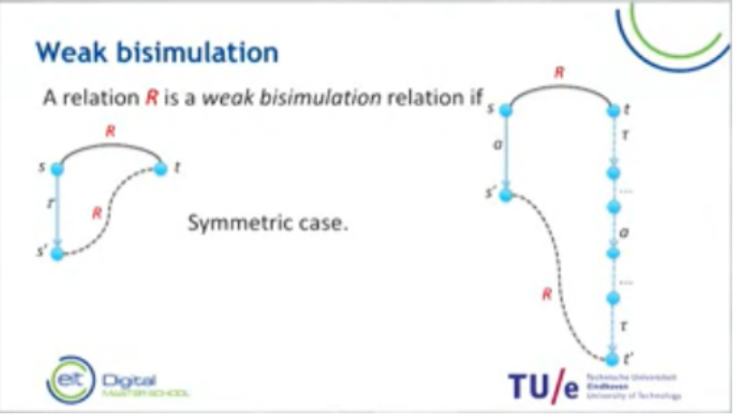

More Behavioral Equivalence:

Weak Bi Simulation

PROBLEM SOLVING V I
Figure 13. Weak Trace Equivalence

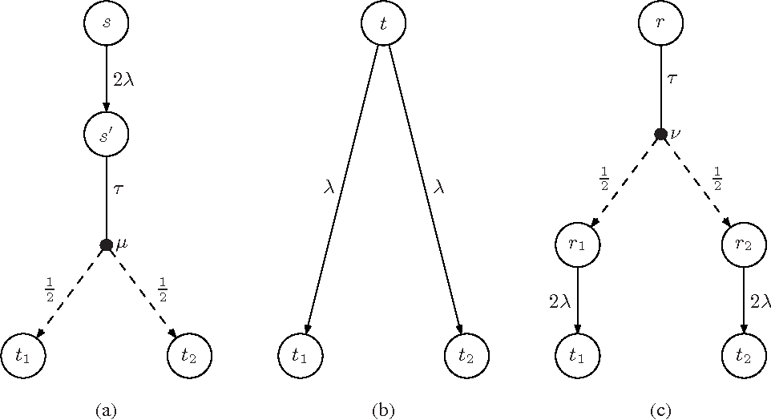

Exercise 10: Is any of this situation a correct weak trace equivalence?

More Behavioral Equivalence:

Weak Bi Simulation

PROBLEM SOLVING V II
Figure 14. Weak Trace Equivalence

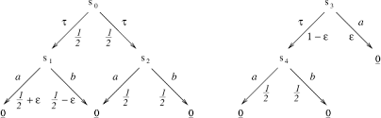

Exercise 11: Which of the two is a weak trace equivalence?

More Behavioral Equivalence:

Language, Failures, and Completed Trace Equivalence

QUICK REVIEW
- A completed trace is a trace that typically ends with a deadlock or a terminating state
- The problem with completed trace equivalents is that it is not a preserved common operation
- Blocking is the prevention of something from happening
- Some empty states are refusal state
- If two pairs are failures, then it is a failure equivalent

Figure 15. Trace Equivalence

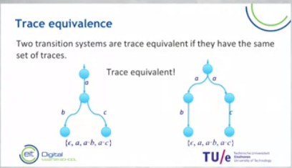

More Behavioral Equivalence:

Language, Failures, and Completed Trace Equivalence

Figure 16. Trace Equivalence
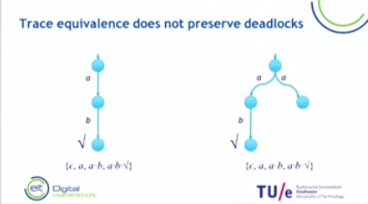

More Behavioral Equivalence:

Language, Failures, and Completed Trace Equivalence

PROBLEM SOLVING V III
Figure 17. Language, Failures and Completed Trace Equivalence

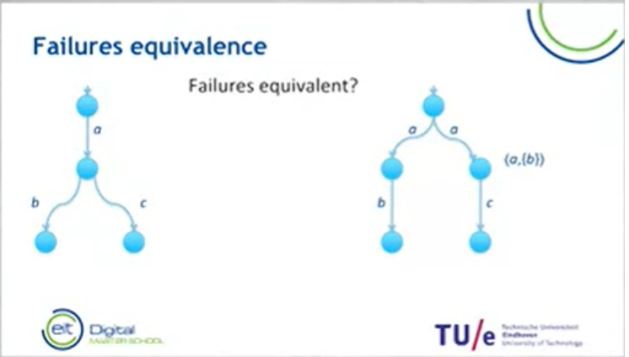
Exercise 12: So, are these two transition systems failures?

More Behavioral Equivalence:

Language, Failures, and Completed Trace Equivalence

PROBLEM SOLVING VIII
Figure 18. Trace Equivalence

Figure 10. Language, Failures and Completed Trace Equivalence
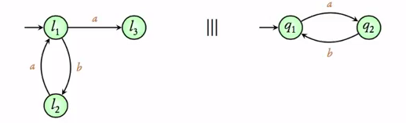
Exercise 13: Which of these two-transition systems is a failure?

More Behavioral Equivalence:

When to use which behavioral equivalences

QUICK REVIEW
- Bi simulation is always safe
- Trace Equivalence reduces behavior
- The next best choice is failure equivalence
- For more complex situation’s divergence preserving branch bi-simulation is always safe to use it removes all internal steps
- Tau loops means there is internal activity that is happening
- For internal activity that takes a lot of time use retrace equivalence

Figure 14. Behavioral Equivalence
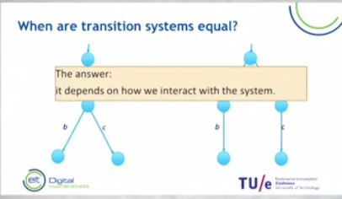

More Behavioral Equivalence:

When to use which behavioral equivalences

PROBLEM SOLVING IX
Figure 15. Trace Equivalence

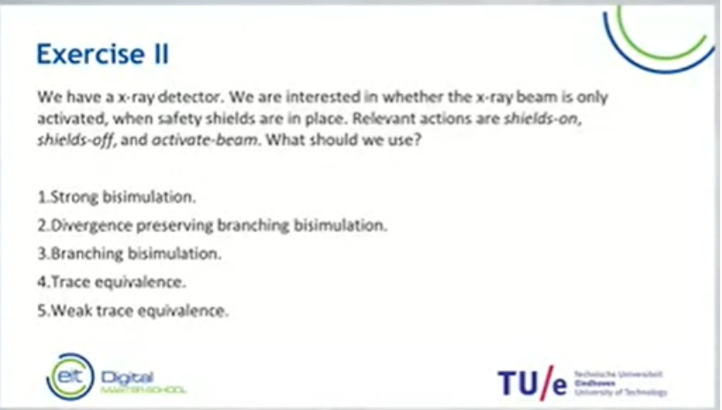

Exercise 15: Choose the most appropriate behavioral equivalence for the problem?

More Behavioral Equivalence:

Transition systems with data, time and probabilities

QUICK REVIEW

- There are several labeled transition systems (Data, Time, Probabilities, and other conceivable behavioral)
- Transition systems do not restrict to plain behavior
- We can have multiple probabilistic choices

PROBLEM SOLVING X SSSDSSSSSSSS
Figure 16. Trace Equivalence

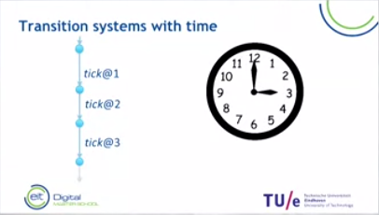

Exercise 17: Is this a correct transition system with time?

