Feeding Frenzy: testing mutual feeding benefits in dolphin–gannet hunting
Reuben Stanley | University of Western Australia
Working draft · 9 November 2026 · timestep sensitivity completed
1 Introduction and current evidence
Abstract  Dolphins and Cape gannets feed on the same fish schools, but association alone does not establish mutual benefit. A shared herd–strike rule produced substantial dolphin gains in two small pilots: 41 to 48 captures (+17.1%) across two development schools, then 87 to 101 (+16.1%) across two fresh schools and two random settings, with all four follow-up differences positive. Eight further independent schools tested generalisation. Their primary 36T dolphin totals rose from 168 to 176 (+4.8%), with an interval spanning zero; the mean gannet effect was +5.12 captures. Halving the timestep on these eight schools, rather than the earlier pilot cohorts, gave dolphin totals of 179 in both conditions and a gannet mean of +2.50. The coarse-grid 72T dolphin totals were 352 and 380 (+8.0%), a secondary result. Observed pilot gains therefore coexist with heterogeneous generalisation and numerical sensitivity. They motivate a wider regime map without establishing broad dolphin facilitation or convergence. Results remain conditional on uncalibrated herding, perception and contact-success assumptions.  Motivation  The South African sardine run brings schooling fish into contact with several predators. Environmental conditions help explain the migration and aggregation of prey [1], while observations describe associations between feeding dolphins and gannets [2]. At the scale of one already-located school, the relevant question is whether those associations improve feeding returns, rather than merely bringing predators to the same resource. | Two possible services  Dolphins may concentrate fish and affect their vertical accessibility to diving birds. Gannet attacks may in turn disturb schooling and expose fish to dolphins. The second pathway is a hypothesis to test. Both predators also consume prey, and time spent herding or waiting can reduce feeding. Combined catch alone is therefore insufficient evidence that both species benefit.  Prior evidence  Models of successive predator attacks show how disturbance changes aggregations [3]. Underwater observations associate recent attacks with increased gannet feeding success [4], but do not supply the matched dolphin-only counterfactual needed here. The present contribution is a species-specific comparison of feeding returns under controlled initial conditions, not a claim that multiple-predator simulation is new.  Hypothesis and objectives  The overarching hypothesis is that dolphin–gannet hunting provides mutual feeding benefits: both species achieve greater individual feeding returns together than independently. The programme retains three objectives: (1) measure gannet feeding across initial prey depths; (2) establish dolphin herding and targeting rules, then test the effect of adding gannets; and (3) test whether controlled relative attack timing improves both returns. This draft reports a development and replication test for objective 2, followed by matching gannet-only controls and an initial-depth pilot for objective 1. Objective 3 remains a separate intervention.

2 Model and behavioural assumptions
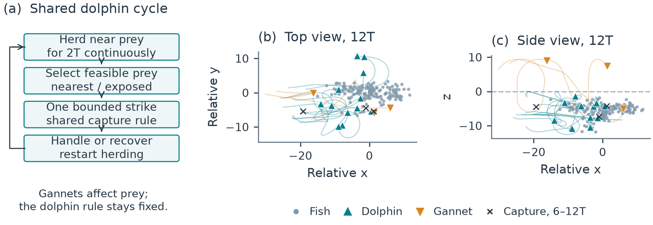
Figure 1. Model rules and a recorded encounter. (a) Dolphins repeat a near-prey herding period, one strike and recovery; birds affect dolphins through fish dynamics. (b,c) Recorded top and side views at 12T for development school 2 with exposed targeting and gannets. Paths cover 6–12T; crosses mark three actual captures. Coordinates are relative to the surviving prey centroid; z=0 is the surface. The snapshot illustrates behaviour, not verified whole-school containment.
Fish and domain  The model follows 160 point-represented fish in three dimensions. Horizontal motion is open and has a preferred migration direction. The surface is z=0, with water at negative z. Fish use a Couzin-type separation, alignment and attraction framework [5], extended with migration, habitat and predator-response terms. Repulsion has priority over social alignment and attraction. Fish speed is fixed at 3 model length units per T and native movement noise is zero. Nearby submerged predators alter escape steering, alignment, attraction and turning. Airborne birds provide no threat cue.  Dolphin herding cycle  Each of 12 dolphins follows an inherited local waypoint ahead of, beside and below a tracked fish patch. A feeding cycle requires 2T continuously within 4.5 units of at least one currently observed fish. Losing proximity resets the clock. Patch handoff or fragmentation does not itself reset it. This proximity criterion is a proxy for contributing pressure: it does not demonstrate a completed bait ball, complementary pod coverage or pressure on the same fish throughout.  Target selection  After the herding interval, a dolphin selects a physically feasible fish within range 6. The nearest rule ranks candidates by distance. The exposed rule first prefers fewer neighbours within radius 2, then lower predicted interception and turning time. Dense prey remain eligible. Each attack is bounded by a 6T bout, speed 6 and turning limit π/2 per T. Recovery lasts 2T after capture or 0.75T after failure, followed by a new herding cycle. Dolphins have exact fish positions, velocities and identities within range 25; they receive no bird-entry signal. | Gannet rules  Three gannets have global current prey information within detection depth 12. DBSCAN identifies groups using radius 2 and a minimum neighbourhood count of four. Eligible clusters are sampled in proportion to accessible fish count; the bird targets a dense accessible location within the selected group. Birds retain separate approach, plunge, submerged pursuit, ascent and recovery stages. Their physical dive and travel limits remain distinct from visibility. Observed Cape gannet dive trajectories motivate finite constraints [6], but do not calibrate model units or physiological maxima.  Capture  Food requires an eligible swept contact between point prey and an offset mouth sphere (radius 0.4, forward offset 0.3), followed by a fixed 0.7 draw. The first eligible contact closes the bout, successful or not; each captured fish is removed once and may differ from the selected target. Predators observe the same step-start fish state and propose motion. Fish advance under submerged-predator cues; contacts are resolved jointly in time order, then controller memory commits the actual resolved step. No density-dependent capture bonus is imposed.

3 Experimental design and development results
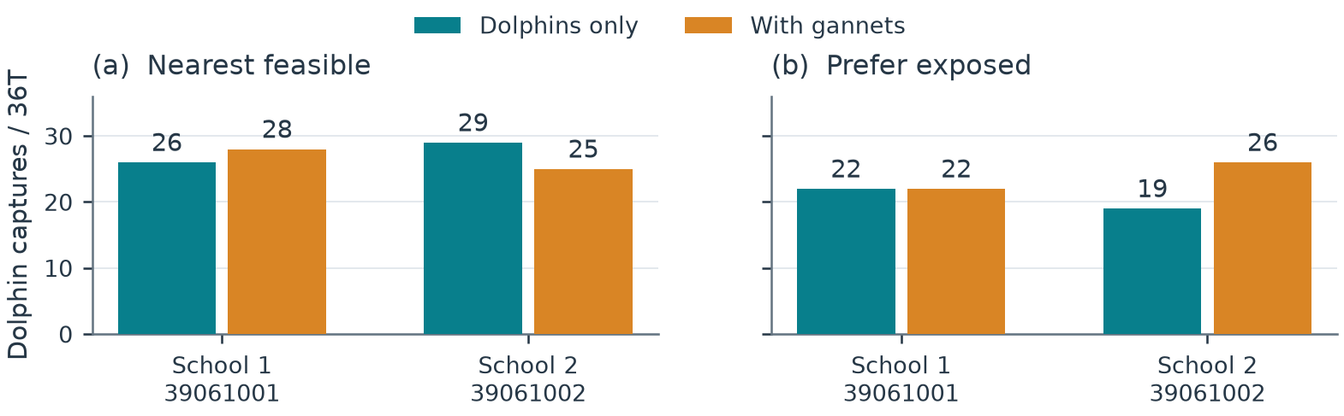
Figure 2. Development comparisons. Bars show dolphin captures in matched 36T encounters with 12 dolphins alone or with three gannets. Each target rule was tested on two development schools using one set of random draws. Nearest targeting produced totals of 55 alone and 53 with birds; exposed targeting produced 41 and 48. The initial response to adding gannets led us to select exposed targeting for follow-up. Individual outcomes are shown without confidence intervals.
Matched comparisons  Each policy was evaluated with dolphins alone (D) and with dolphins plus gannets (DG). Fish state, dolphin abundance, capabilities, initial readiness and controller state were matched within each pair. Paired encounters also began with matching random sequences for each dolphin’s capture success and for resolving simultaneous contacts. The dolphin rule was identical between conditions. Gannets changed the fish state and competed for prey; they did not directly unlock dolphin attacks.  Outcome and duration  For species s, feeding return is Y_s=C_s/(N_s T), where C_s counts uniquely removed fish, N_s is predator abundance and T is elapsed time. Effects compare mixed with same-policy alone conditions. Development encounters lasted 36T. The eight-school extension lasts 72T, with 36T fixed in advance as primary; 72T and 36–72T increments are secondary. A separate 24-case sensitivity batch repeats the same schools and D/G/DG conditions at 36T with timestep halved from 0.00125T to 0.000625T. All travel, herding, missed attacks and recovery count. Predator-free preparation is excluded. Complete depletion fixes subsequent captures; native stepping and effort accounting end at depletion.  Development set  The development comparison used two starting schools, labelled schools 1 and 2, and one set of random draws. Testing both target rules on both schools, with and without gannets, gave eight full encounters. The timestep was 0.00125T. No changes were made to the capture, fish-response or gannet rules between target policies. Requested herding is a fixed minimum cycle duration; it is not a prescribed fraction of total encounter time. | Observed effects  Nearest targeting changed dolphin captures from 26 to 28 and from 29 to 25 across the development schools. Exposed targeting changed 22 to 22 and 19 to 26: 41 to 48 overall (+17.1%), with differences of 0 and +7. A follow-up on two fresh schools, each under two random settings, gave 87 alone and 101 mixed (+16.1%); all four paired differences were positive. The four repetitions still represent only two independent schools. All exposed-policy cohorts used the same controller, native fish engine and conditional contact-success probability of 0.7. Nearest targeting nevertheless produced more dolphin food in the development mixed encounters, 53 versus 48. A larger response to partner presence is distinct from maximum feeding.  Selection rule and uncertainty  We selected exposed targeting for its response to adding gannets, although nearest targeting produced more captures with dolphins alone. Exposed mixed hunting also fell below nearest targeting alone on the development schools, 48 versus 55 captures. The follow-up fixes the exposed rule and tests its same-policy partner effect. It does not test whether mixed hunting beats the best-tested independent policy: nearest targeting was not evaluated on the fresh schools. With two development schools, the observed differences do not establish an optimal policy. Repeated runs from one school are not independent schools.

4 Eight-school replication and numerical sensitivity
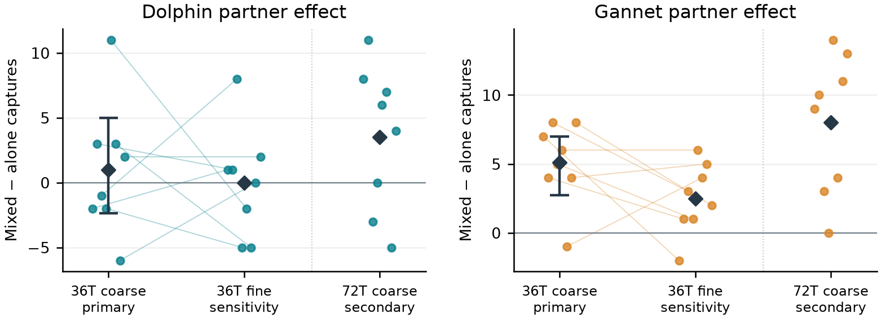
Figure 3. Partner effects on the same eight schools. Points show mixed-minus-alone captures; lines join each school across coarse (0.00125T) and fine (0.000625T) grids at 36T. Diamonds show equal-school means. Only coarse 36T primary estimates have 97.5% marginal bootstrap intervals (approximate 95% familywise coverage, with small-sample limitations). Fine 36T and coarse 72T outcomes are descriptive checks, not additional independent schools. Earlier cohorts are excluded.
Frozen design  Eight new schools were declared before feeding outcomes. Each retained the original sampler, 160 fish and a predator-free 20T checkpoint. Every fixed candidate passed the original 36T stability screen and additional 36T route check; none was replaced. One stochastic setting per school produced matched D, G and DG encounters with 12 dolphins and/or 3 gannets. The fine batch reused physical starts, actor states and private random-stream initialisations, changing only the timestep and using 160 rather than 80 steps per 0.1T sample. Sealed event prefixes, physical states, contact accounting and stream replays passed on both grids.  Primary outcome  At the coarse-grid 36T primary horizon, dolphin captures totalled 168 alone and 176 with gannets; gannet captures totalled 35 alone and 76 with dolphins. Equal-school mean effects were +1.00 dolphin and +5.12 gannet captures. The 97.5% marginal percentile intervals were −2.38 to +5.00 and +2.75 to +7.00, respectively. Both species gained in 3 of 8 schools. | Independent units and uncertainty  There are eight independent starting schools, not sixteen. A fixed-seed, 10,000-draw bootstrap resamples whole paired dolphin–gannet school vectors with equal weights. The two coarse-primary intervals target approximate 95% familywise coverage; small-sample coverage may be unstable. The fine grid has no prespecified interval estimate. Neither development nor the earlier two-school pilot is pooled into these estimates.  Longer encounter  At 72T on the coarse grid, dolphin totals were 352 alone and 380 mixed; gannet totals were 85 and 149. Both effects were positive in 5 of 8 schools. None of 24 encounters depleted all prey. These are secondary continuations of the same trajectories; 36–72T increments and effort appear separately in the notebook.  Numerical sensitivity  At fine-grid 36T, dolphins captured 179 fish alone and 179 mixed (mean effect 0); gannets captured 49 and 69 (+2.50). Effect signs agreed across grids in only 3 of 8 dolphin and 6 of 8 gannet comparisons. Fine-minus-coarse school effects ranged from −13 to +9 for dolphins and −9 to +5 for gannets. Both species gained in three schools on each grid, but only schools 39064502 and 39064508 overlapped. Identical starting streams do not force identical event sequences after trajectories diverge. This check repeated the eight new schools, not the original positive two-school cohorts. It shows numerical sensitivity in the generalisation test; convergence and a broad dolphin benefit remain unestablished.

5 Earlier gannet controls, depth and timing
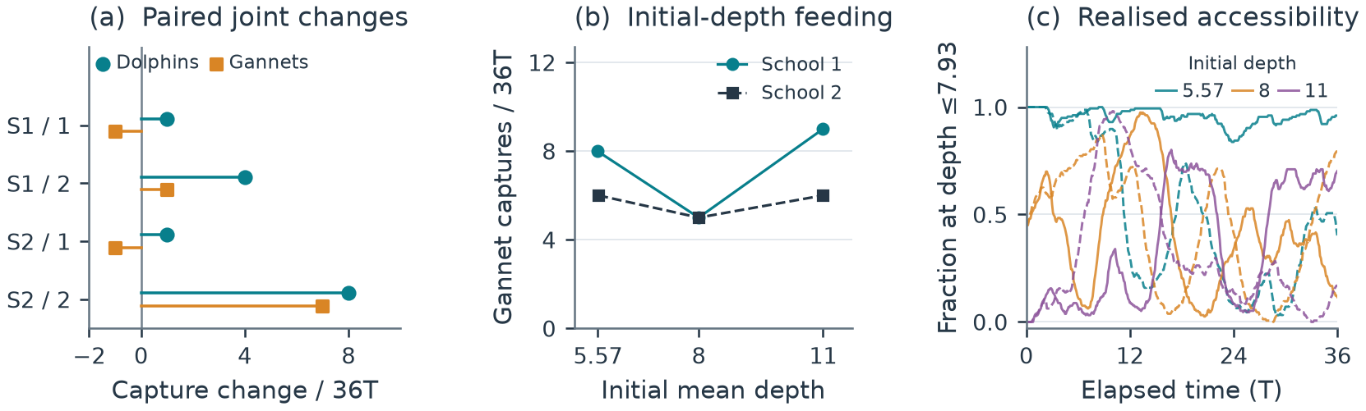
Figure 4. Earlier two-school controls and initial-depth pilot, kept separate from the eight-school replication. Matching gannet-only controls and initial-depth results. (a) Changes in dolphin and gannet captures when hunting together; S1 and S2 identify the two fresh schools, and 1 and 2 identify random settings 61001 and 61002. Both species gain in two of four repetitions. (b) Gannet-only captures across initial mean depths, using setting 61001; lines join the same school. (c) The fraction of surviving fish within the reference depth envelope changes during each encounter. Colour identifies initial depth; solid and dashed curves identify schools 1 and 2. Initial depth is not maintained, and the connecting lines in (b) are not fitted response curves.
Matching gannet controls  Before the eight-school extension, eight additional 36T gannet-only encounters were completed. Four unshifted controls match the earlier two-school follow-up and its two random settings. Their birds retain the same capabilities, initial states and private capture and target-choice streams as the mixed counterparts. Four other encounters translate each school to initial mean depths 8 and 11 using setting 61001. Translation preserves geometry without clipping; the preferred fish depth remains 5 with deadband 3–7. These earlier outcomes do not enter Figure 3.  Joint feeding response  Gannet capture changes in the four unshifted comparisons were −1, +1, −1 and +7 fish. Both species gained in the second repetition of each school; in the other two, dolphin gains accompanied one fewer gannet capture. Pooled gannet captures increased from 26 to 32 (+23.1%), but the largest gain accounts for seven fish while the other three differences sum to −1. Mean gannet changes across repetitions were zero and +3 for the two schools. The matching dolphin means were +2.5 and +4.5. These outcomes show conditional joint gains, not a uniform reciprocal advantage. | Initial-depth result  The unshifted schools began at mean depths 5.56 and 5.58. At setting 61001, gannet captures were 8 and 6 without translation, 5 and 5 at initial mean depth 8, and 9 and 6 at initial mean depth 11. There was no monotonic decline. Initially, all unshifted fish, about 44–45% at mean depth 8, and none at mean depth 11 lay within the reference target-depth envelope of 7.93. Native prey movement then changed accessibility; the deepest starting treatment became reachable.  What depth does and does not test  Initial translation is a transient intervention. The fish retain their original habitat preference and can change depth throughout the encounter; selective consumption also changes survivor statistics. The depth envelope is a coarse geometric eligibility reference, not guaranteed interception or a calibrated physiological maximum. These runs therefore cannot establish a maintained-depth barrier or an optimal feeding depth.  Objective 3: attack timing  An isolated timing hook reproduced the disabled baseline exactly. The first enabled 8T check found no cue at any of six legal bird launches. Retrospective screening then identified one later opportunity in a different random setting. A separately declared, post-hoc 36T engineering run delayed one bird launch by 0.076T before loss of locality cancelled the wait. Its realised launch lag was 0.873T, short of the requested 1T. Dolphin and gannet captures, 24 and 11, matched the baseline. This demonstrates a partial deferral, without establishing a timing advantage.

6 Discussion, limitations and next steps
Interpretation  Target choice and starting school affect feeding outcomes. At the coarse-grid primary horizon, the dolphin interval included zero while the gannet interval lay above it. Halving the timestep changed the mean dolphin partner effect from +1.00 to 0 and the gannet effect from +5.12 to +2.50 captures. The positive gannet mean persists across these two grids, but its magnitude and school-level outcomes change. Joint gains in three schools on each grid do not indicate the same beneficiaries. Numerical sensitivity and eight-school uncertainty prevent a general mutual-benefit claim; no outcome-driven model tuning was performed.  Behavioural assumptions  The main uncertainty is whether 2T near fish represents useful herding effort and whether exposed prey are a reasonable targeting preference. The model does not assign complementary drivers and barriers, reserve targets or coordinate feeding turns. Herding represents contributions to within-pod collaboration through fish dynamics, while each individual uses the same local rule. Neither an attractive trajectory nor a labelled herding state proves sustained whole-school containment.  Perception and capture  Dolphins have exact local prey information, while birds have idealised global information within depth limits. The mouth geometry is simplified, prey are point-represented, and predator body-spacing avoidance is disabled. Capture success after eligible contact remains 0.7 for both species and is uncalibrated. The gannet field values of 13% and 36% describe success per observed attack technique [4], not conditional mouth-contact success and not first versus second attempts. They cannot be inserted directly as the model parameter. | Scope of the evidence  Time and length have no validated joint physical scale. The study omits learning, fatigue, hunger, satiety and energetic costs, and its finite prey supply is not replenished. Capture return is therefore not energetic profitability or fitness. Work on non-coordinating predators [7] and the broader seabird–subsurface-predator literature [8] also cautions against equating a feeding association with deliberate communication or reciprocal cooperation. A model gain identifies a mechanism worth testing, not evidence that real animals use the implemented rule.  Conclusion  Substantial dolphin pilot gains (+17.1% and +16.1%) coexist with heterogeneous generalisation. The eight-school coarse-grid effect was +4.8% at 36T, with an interval spanning zero, and +8.0% at the secondary 72T horizon. Its fine-grid 36T dolphin effect was zero. The model also gives a positive mean gannet effect on both grids, with changing magnitudes and school-level outcomes. The finer check did not rerun the original positive cohorts, and 72T was not repeated on the fine grid. A wider, declared regime map, numerical checks and biological calibration are needed to identify when partner benefits persist. The present evidence does not establish general mutual facilitation, energetic profitability or cooperation.  Reproducibility and draft status  The coarse timestep is 0.00125T and the fine timestep is 0.000625T; fine 36T and coarse 72T each require 57,600 steps. The notebook includes 72 feeding encounters: 24 earlier cases, 24 coarse eight-school cases and 24 fine cases, with 72 sealed horizon records for the two new batches. Its 22 default code cells reproduce all four figures and export 14 tables without native simulation. Earlier cohorts and three timing checks remain separate. Original manifests and seals are preserved. The unchanged optional historical model runner retains its documented platform limits and does not claim a new fine-grid runtime. Code and data: https://github.com/reuben-trade/FishSim-Dolphin-Gannet-Pilot.

References
[1] Teske PR et al. The sardine run in southeastern Africa is a mass migration into an ecological trap. Science Advances. 2021;7:eabf4514. doi:10.1126/sciadv.abf4514.
[2] O’Donoghue SH. The sardine run: investigating sardine and predator distribution in relation to environmental conditions using GIS and remotely sensed products. PhD thesis, University of KwaZulu-Natal; 2009.
[3] Lett C, Semeria M, Thiebault A, Tremblay Y. Effects of successive predator attacks on prey aggregations. Theoretical Ecology. 2014;7:239–252. doi:10.1007/s12080-014-0213-0.
[4] Thiebault A, Semeria M, Lett C, Tremblay Y. How to capture fish in a school? Effect of successive predator attacks on seabird feeding success. Journal of Animal Ecology. 2016;85:157–167. doi:10.1111/1365-2656.12455.
[5] Couzin ID, Krause J, James R, Ruxton GD, Franks NR. Collective memory and spatial sorting in animal groups. Journal of Theoretical Biology. 2002;218:1–11. doi:10.1006/jtbi.2002.3065.
[6] Ropert-Coudert Y, Grémillet D, Ryan P, Kato A, Naito Y, Le Maho Y. Between air and water: the plunge dive of the Cape Gannet Morus capensis. Ibis. 2004;146:281–290. doi:10.1111/j.1474-919x.2003.00250.x.
[7] Mohapatra S, Sinha Mahapatra P. Behavioural response of prey to repeated attacks by non-coordinating predators. Scientific Reports. 2025;15:22977. doi:10.1038/s41598-025-05946-6.
[8] Licht M, Correia E, Wikelski M, Krause J. How volant seabirds benefit from sub-surface predators during multi-predator feeding aggregations. Philosophical Transactions of the Royal Society B. 2026;381:20250199. doi:10.1098/rstb.2025.0199.

