Feeding Frenzy: local rules and conditional feeding benefits in dolphin–gannet hunting
Reuben Stanley | University of Western Australia
Working draft · 9 November 2026 · complete balanced higher-count map
1 Question and local-rule perspective
Abstract  Adding another predator can expose prey while increasing competition. We test this balance under one fixed dolphin herd–strike rule, using matched encounters with and without gannets. Original pilots gave dolphin gains of 17.1% and 16.1%. A balanced exploratory map crosses three minimum herding intervals with six bird counts on four previously observed schools. The largest mixed dolphin total tied at H=1T/G=9 and H=1T/G=18: 91→127 captures against same-H controls (+39.6%). All 18 settings and species-matched controls are retained; selection and small-sample uncertainty preclude an optimum claim. A separate eight-school check showed substantial timestep sensitivity, including zero mean dolphin gain on its finer grid. Conditional benefits require independent numerical and biological validation.  Question  The South African sardine run brings several predators to the same moving resource [1], [2]. Their association does not show whether either species obtains more food than it would alone. We ask when adding gannets improves dolphin feeding while the dolphin rule remains unchanged, and separately whether gannets also benefit. The comparison begins with an already located fish school; it does not measure searching for prey or energetic profitability. | Ecological motivation  Successive predator attacks can disrupt prey aggregations in models [3], and underwater observations link attack history to gannet feeding success [4]. Those observations do not provide the matched dolphin-only counterfactual. Dolphins may concentrate prey for birds, while bird attacks may expose fish to dolphins. Competition and time spent herding can offset either service. Increased combined catch alone is insufficient evidence of mutual benefit.  Local rules and collective response  Collective-behaviour models explain how local responses can produce group-level structure [5]. Here, local predator pressure and fish responses may change prey concentration, movement and accessibility, altering interception opportunities. This motivates a chain from individual rules through collective fish state and eligible contacts to captures. The chain guides diagnostics; a correlation between its stages does not establish causal mediation or intentional cooperation.  Scope and objectives  The main study retains one exposed-prey dolphin rule selected during development. It measures the effect of adding birds and explores conditions under which that effect changes. Matching gannet-only controls test reciprocal feeding returns. Earlier initial-depth and attack-timing pilots remain supporting investigations; the parameter map does not demonstrate depth control, a timing advantage or an unrestricted optimal hunting strategy.

2 Model and behavioural assumptions
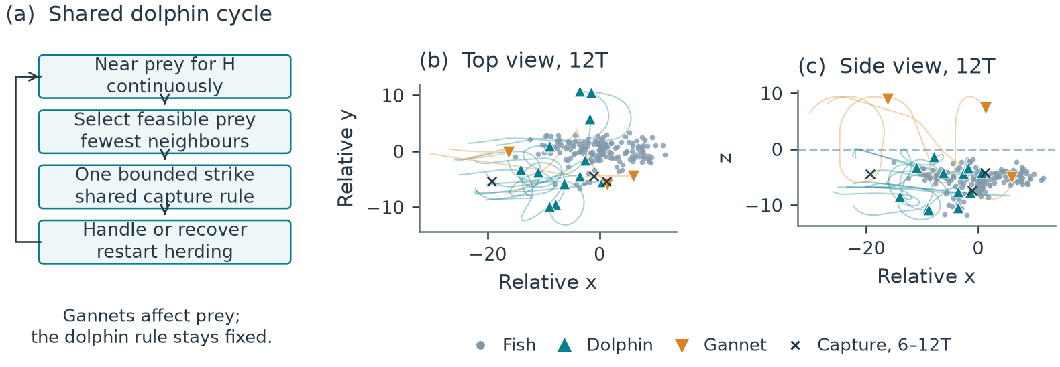
Figure 1. One shared dolphin cycle and an illustrative recorded encounter. Continuous near-prey pressure for H is followed by a feasible strike preferring fewer prey neighbours and ordinary recovery. Bird presence does not change this dolphin rule. Top and side views show original development school 39061002 at 12T; paths and captures cover 6–12T. The snapshot was fixed before the sweep and does not certify compactness, completed herding or a causal mechanism.
Fish and inherited engine  We use the inherited native C++ FishSim engine, with Python predator controllers, experiment harnesses and analysis added for this project. The 160 point-represented fish use separation, alignment and attraction [5], with repulsion taking priority, plus migration, habitat and predator-response terms. Horizontal space is open; water lies below z=0. Fish speed is 3 model units per T and native movement noise is zero. Nearby submerged predators change escape steering and social responses; airborne birds provide no threat cue.  Dolphin herding cycle  Each of 12 dolphins follows local waypoints ahead of, beside and below a tracked prey patch. A cycle requires H continuously within 4.5 units of at least one observed fish; lost proximity resets the clock. The original H=2T is extended to H=1,2 or 3T. This pressure represents a contribution to pod herding, without assigned drivers, barriers or feeding turns. It does not certify a compact baitball, complementary coverage or pressure on the same fish throughout. | Feasible exposed-prey strikes  After H, a dolphin ranks feasible fish within range 6 by fewer neighbours inside radius 2, then predicted interception and turning time. Dense fish remain eligible; outward motion is not required. A strike is bounded by 6T, speed 6 and turning limit π/2 per T. Recovery lasts 2T after capture or 0.75T after failure. Dolphins know local fish states exactly within range 25 and receive no bird-count, dive-event or post-dive bonus. The cycle repeats with the same rule in every species-presence comparison.  Gannet perception and roster  Birds have idealised global prey information within detection depth 12. DBSCAN uses radius 2 and minimum neighbourhood count 4; eligible clusters are sampled by accessible fish count, then a dense accessible location is targeted. Approach, plunge, underwater pursuit, ascent and recovery remain constrained [6]. One bird uses G0; three use G0–G2. Counts 6/9/12/18 place 2/3/4/6 birds at each original launch site. Count changes coverage or local multiplicity; body-spacing avoidance is absent.  Contact and step order  An eligible swept contact between point prey and an offset mouth sphere (radius 0.4, forward offset 0.3) succeeds with fixed q=0.7. The first eligible contact closes the bout whether it succeeds or fails; each captured fish is removed once. Predators propose motion from the same step-start fish state. Fish advance under submerged-predator cues, contacts resolve jointly in time order, and controller memory commits the resolved step. No density-dependent capture bonus is imposed.

3 Comparisons and evidence design
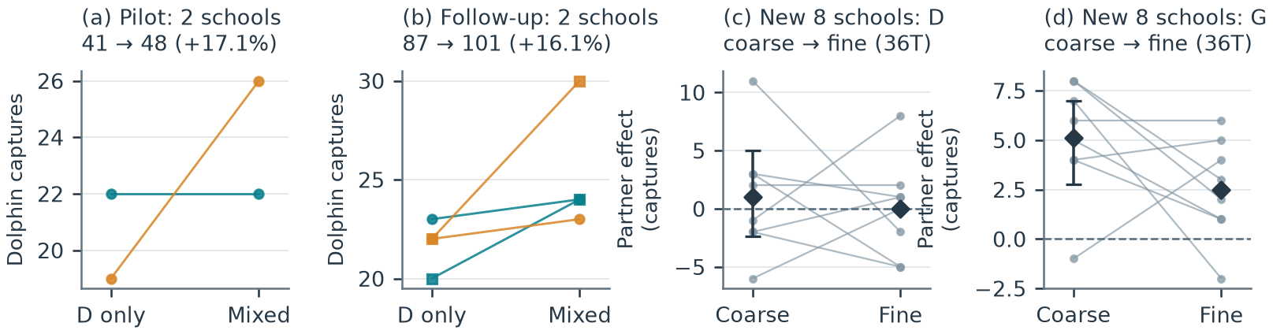
Figure 2. Distinct cohorts under the same dolphin rule. Colour identifies school within each two-school panel; circles/squares identify capture-stream settings 61001/61002. Lines join dolphin-only and mixed outcomes. The development totals 41→48 and follow-up 87→101 involve four distinct pilot school geometries overall; the two follow-up settings do not add independent schools. Separate panels show the same eight later schools across coarse/fine 36T grids, with mean diamonds and 97.5% marginal bootstrap intervals only for the coarse primary means. The fine check did not rerun the earlier positive cohorts.
Counterfactual and return  The baseline has the same dolphin number, H, target preference, physical abilities, initial readiness and private random streams, without gannets. Birds change prey dynamics and competition rather than unlocking dolphin attacks. Feeding return is Y_s=C_s/(N_s T), where C_s is uniquely removed prey and N_s is predator abundance. All travel, herding, failed attacks and recovery count. Complete depletion fixes later food while native stepping ends; food retains the full nominal encounter denominator.  Original positive cohorts  The original exposed-prey development pilot gave 22→22 and 19→26 dolphin captures across two schools: 41→48 overall (+17.1%). A follow-up on two fresh schools, each under two stream settings, gave 87→101 (+16.1%), with all four differences positive. These are two independent schools per cohort, not one independent unit per repetition. The controller was chosen during development; subsequent same-rule partner tests do not establish policy optimality.  Independent replication and grids  Eight further schools were declared before feeding outcomes and passed fixed predator-free stability and route screens. Each had matched D-only, G-only and mixed encounters with 160 fish, 12 dolphins and/or 3 gannets. Coarse runs used dt=0.00125T and 72T, with 36T prespecified as primary. Fine runs reused the same physical starts, actor states and private-stream initialisations at dt=0.000625T for 36T. They are paired numerical treatments of eight schools, not 16 independent schools. Halving dt doubles the 36T updates from 28,800 to 57,600 without changing hunting duration. | Declared exploratory map  The map contains 108 condition-school outcomes: H={1,2,3}T crossed with G={0,1,3,6,9,12,18} on four previously observed schools, plus G-only controls. It retains 60 original executions, including eight exact historical replays, and adds 48 higher-count encounters. The first-school 12-case pilot is a subset of those 48. All use 36T, dt=.00125T, one capture-stream setting and q=.7. No new schools or replays were added by the extension. School seeds affect evolved fish state, readiness and private streams; a stopped recorder-diagnostic attempt remains excluded provenance.  Pairing, uncertainty and selection  The primary dolphin effect is mixed minus same-H D-only return. The reciprocal effect uses per-bird return against same-count G-only controls, shared across H. A fixed 10,000-draw bootstrap resamples whole four-school vectors across the entire map. Its 95% intervals are exploratory and pointwise, without multiplicity correction. A stronger secondary comparison chooses the highest-mean D-only H across this discovery bank, with smaller-H ties, and reselects it within each draw; it is not a per-school oracle or global optimum.

4 Complete parameter response
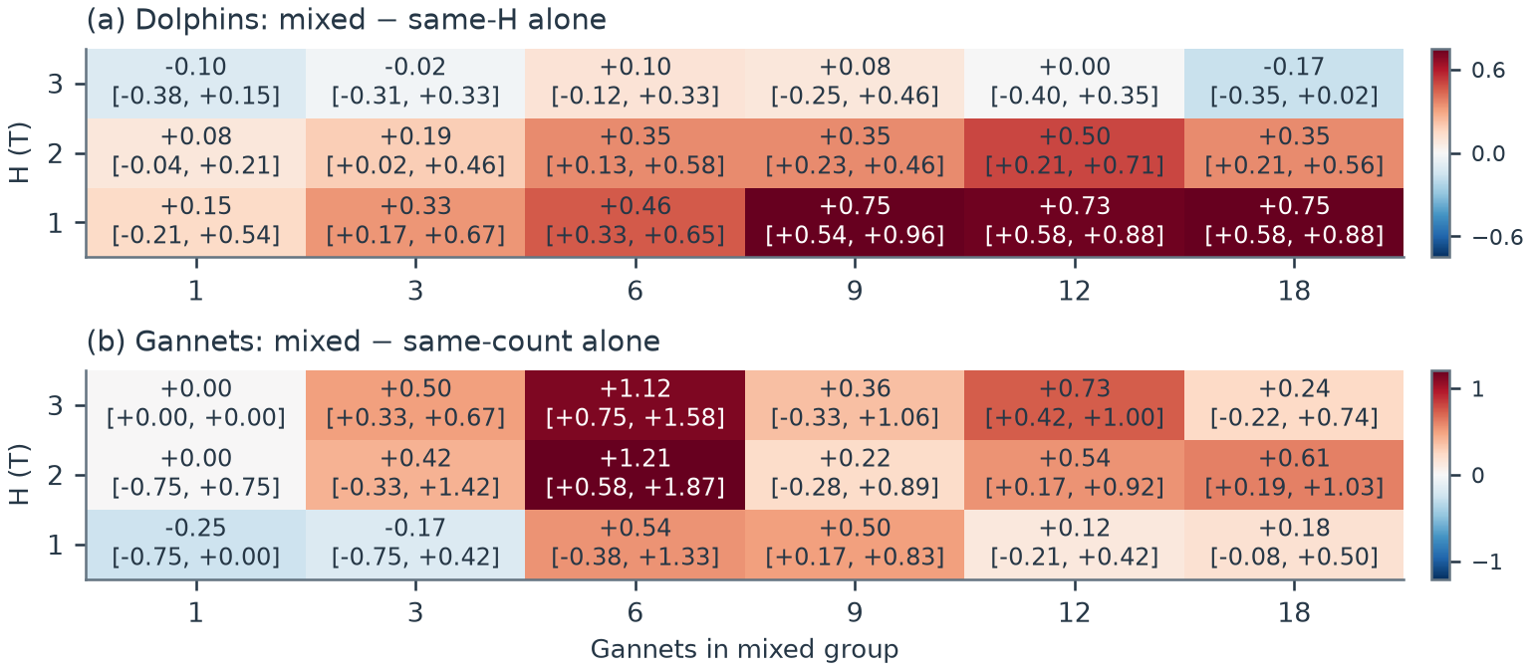
Figure 3. Complete balanced H×G map on the same four previously observed schools: all 18 mixed settings. Cell values show mean paired captures per predator over 36T; brackets show exploratory pointwise 95% whole-school bootstrap intervals. (a) Same-H D-only controls. (b) Same-count G-only controls shared across H. Colour scales differ. All 72 school contrasts, absolute returns and stronger best-tested-D-only comparisons are supplied in the notebook. Neither the 108 condition-school rows nor the searched cells are independent replicates or confirmed optima.
Whole-map outcome  All 48 new encounters and 60 retained outcomes passed sealed physical/raw-event audits. Across all 18 mixed settings, mean same-H dolphin effects were positive in 14, zero in 1 and negative in 3. Mixed food ranged from 1.35 to 2.65 captures per dolphin over 36T. Figure 3 retains every setting and sign.  Dolphin response at fixed behaviour  The original six-bird discovery gave 91→113 captures at H=1T (+24.2%). The expanded maximum tied at H=1T/G=9 and H=1T/G=18: 91→127 (+39.6%). The fewer-birds tie convention reports G=9, with school changes +8, +12, +5, +11. Its mean same-H effect was +0.75 captures per dolphin per 36T, pointwise 95% interval [+0.54, +0.96]. In-sample selection remains exploratory.  Gannet and joint returns  Count-matched mean per-bird effects were positive in 14/18 settings, zero in 2 and negative in 2. At H=1T/G=9, gannets changed 34→52, a mean +0.50 captures per bird per 36T, interval [+0.17, +0.83]; school differences were +8, +0, +7, +3. Both species gained in 3/4 schools there. Joint gains in all four occurred at H=2/G=6, H=2/G=12, H=2/G=18. At H2/G12, dolphins changed 86→110 and gannets 31→57. All school contrasts remain in the notebook. | Stronger dolphin-only benchmark  The best-tested across-school D-only mean remained H=1T, with 91 total captures. The G=9 representative mixed total was 127 (+39.6% against that benchmark), mean change +0.75 captures per dolphin per 36T, interval [+0.54, +0.96]. H is reselected within every bootstrap draw. This stronger secondary comparison differs from adding birds at fixed H and does not establish optimal dolphin behaviour. H2/G12 also exceeded that benchmark (110 versus 91), interval [+0.21, +0.58] per dolphin per 36T.  What the map can establish  The same four starting setups were already observed in the pilots. Their shared controls, condition rows and exact replays do not multiply replication. The extension was exploratory after positive pilot outcomes; all new bird counts and H settings were retained regardless of sign. Pointwise n=4 intervals do not correct searching 18 settings. Any benefit remains conditional on this discovery bank, fixed contact probability, nested three-site roster and coarse timestep.

5 Collective state, opportunities and robustness
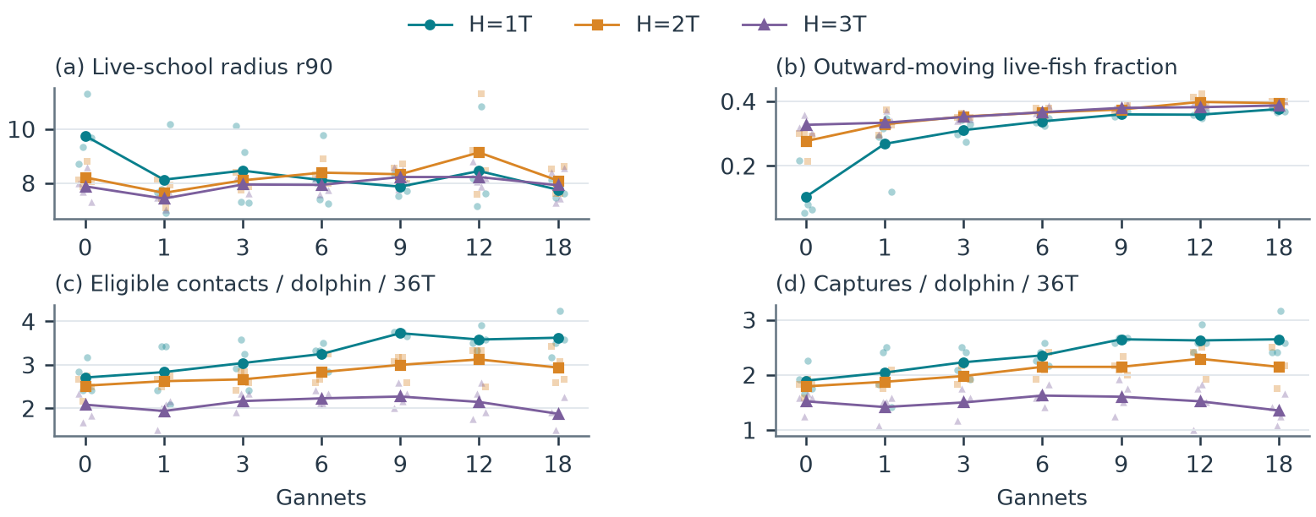
Figure 4. Descriptive response across every dolphin-bearing H×G setting, including G=0. Faint points show all four schools and lines show equal-school means. Live-fish r90 and outward fraction are time-averaged over observed nonempty saved frames without selected post-dive windows. Eligible contacts and captures use the full 36T denominator. Prey removal and survivor selection can change fish-state summaries; these associations do not establish causal mediation, completed herding or biological cooperation.
Collective fish state  Across all 21 dolphin-bearing settings, equal-school time-mean live-fish r90 ranged from 7.42 to 9.76 model units and outward-moving fractions from 0.104 to 0.398. Figure 4 retains every school and H without selecting post-dive windows. These summaries condition on surviving fish and observed nonempty frames; they neither certify containment nor isolate bird disturbance from consumption and competition.  Contact opportunities and food  At H=1T with 9 birds, pooled dolphin eligible contacts changed 130→179, launches 251→281, and food 91→127. Conditional eligible-contact success remained fixed. The realised capture/contact ratio reflects encountered targets and random draws, not a fitted field attack-success parameter. State and event diagnostics locate response changes but cannot partition disturbance, competition and survivor selection into causal effects.  Numerical sensitivity remains  In the independent eight-school coarse 36T primary test, dolphins captured 168 alone and 176 mixed; gannets captured 35 and 76. Mean effects were +1.00 dolphin and +5.125 gannet captures per school; 97.5% marginal intervals were −2.375 to +5 and +2.75 to +7. Halving dt gave dolphins 179→179 and gannets 49→69. The zero dolphin mean includes four positive, three negative and one zero school effect; it does not mean every school lost its benefit. Dolphin effect signs agreed in 3/8 schools and gannet signs in 6/8. Three schools had joint gains on each grid, but only two overlapped. This check did not refine the original positive cohorts or the new sweep. | Longer encounters and validation  At coarse 72T, the same eight-school trajectories gave dolphin totals 352→380 and gannet totals 85→149, with joint gains in 5/8 schools. None fully depleted the prey. These are secondary continuations, not additional replicates, and 72T was not repeated on the fine grid. A separate held-out plan would freeze a selected mixed setting and D-only benchmark before fresh outcomes. No held-out result is included here, and the exploratory map does not establish convergence.  Earlier depth and timing checks  Earlier G-only depth translations on two schools showed no monotonic fall in food: native fish movement changed accessibility during encounters. They test transient initial states, not maintained-depth exclusion. An isolated timing implementation reproduced its disabled baseline; a post-hoc 36T engineering check partially deferred one dive, then lost locality, with captures unchanged. Full depth, timing and source receipts remain in the notebook. Neither side investigation establishes the mechanism behind a sweep response.

6 Discussion and conclusion
Conditional feeding benefits  The expanded map has 14/18 positive mean same-H dolphin responses within four known schools. Its largest mixed return was 127 captures against the best-tested D-only total of 91. That selected comparison needs the full map and school-level uncertainty. Original positive pilots remain observations of this implemented rule; the separate eight-school replication shows that gains need not persist across schools or numerical grids. Dolphin and gannet benefits remain separate outcomes, neither guaranteed by greater combined food.  Behavioural and numerical limits  Near-prey duration is a simplified herding proxy, local prey information is exact and bird perception is idealised. Point-represented prey and absent predator body spacing affect opportunities. The eligible-contact probability 0.7 is uncalibrated for both species; the field gannet success figures 13% and 36% refer to observed attack techniques [4], not first/second attempts or conditional mouth contacts. Large trajectory and sign changes after halving dt prevent a numerical-convergence claim.  Discovery and future validation  The sweep is benefit-motivated exploration following development, not a claim that no outcome-informed selection occurred. The eight-school replication alone retained its declared model and sample without outcome-dependent changes. Any future validation must freeze the selected H, bird count and D-only benchmark before examining new schools, retain same-H partner effects as primary, and distinguish numerical sensitivity from independent biological replication. One stochastic setting per discovery school cannot partition starting-state effects from random variation. | Biological interpretation  Time and length lack a validated joint physical scale. Captures exclude energetic costs, fatigue, hunger, satiety and learning; finite prey are not replenished. Feeding return is therefore neither energetic profitability nor fitness. Literature on non-coordinating predators [7] and seabird associations with subsurface predators [8] also cautions against interpreting association or a model gain as deliberate communication or reciprocal cooperation.  Software and reproducibility  Fish dynamics inherit the native C++ engine at https://github.com/yangyushi/FishSim; this project supplies Python predator control, experimental design and analysis. The notebook preserves 132 earlier execution records and adds 48 higher-count encounters, retaining eight historical exact replays within the earlier total. Its 21 default code cells rebuild four figures and export 19 tables without native simulation. The separately tested optional runner covers the eight-school H2 coarse/fine model, not this parameter sweep. All old manifests and source closures remain intact. Code: https://github.com/reuben-trade/FishSim-Dolphin-Gannet-Pilot.  Conclusion  The original shared-rule pilots gave dolphin gains of 17.1% and 16.1%. The complete balanced map reports all 18 settings and controls: 14 have positive mean same-H dolphin effects; the largest mixed total tied at H=1T/G=9 and H=1T/G=18 (91→127). These are conditional discovery-bank results, with numerical sensitivity and held-out validation unresolved. The model identifies conditions worth testing; finite uncalibrated encounters do not establish general mutual facilitation, energetic profitability or biological cooperation.

References
[1] Teske PR et al. The sardine run in southeastern Africa is a mass migration into an ecological trap. Science Advances. 2021;7:eabf4514. doi:10.1126/sciadv.abf4514.
[2] O’Donoghue SH. The sardine run: investigating sardine and predator distribution in relation to environmental conditions using GIS and remotely sensed products. PhD thesis, University of KwaZulu-Natal; 2009.
[3] Lett C, Semeria M, Thiebault A, Tremblay Y. Effects of successive predator attacks on prey aggregations. Theoretical Ecology. 2014;7:239–252. doi:10.1007/s12080-014-0213-0.
[4] Thiebault A, Semeria M, Lett C, Tremblay Y. How to capture fish in a school? Effect of successive predator attacks on seabird feeding success. Journal of Animal Ecology. 2016;85:157–167. doi:10.1111/1365-2656.12455.
[5] Couzin ID, Krause J, James R, Ruxton GD, Franks NR. Collective memory and spatial sorting in animal groups. Journal of Theoretical Biology. 2002;218:1–11. doi:10.1006/jtbi.2002.3065.
[6] Ropert-Coudert Y, Grémillet D, Ryan P, Kato A, Naito Y, Le Maho Y. Between air and water: the plunge dive of the Cape Gannet Morus capensis. Ibis. 2004;146:281–290. doi:10.1111/j.1474-919x.2003.00250.x.
[7] Mohapatra S, Sinha Mahapatra P. Behavioural response of prey to repeated attacks by non-coordinating predators. Scientific Reports. 2025;15:22977. doi:10.1038/s41598-025-05946-6.
[8] Licht M, Correia E, Wikelski M, Krause J. How volant seabirds benefit from sub-surface predators during multi-predator feeding aggregations. Philosophical Transactions of the Royal Society B. 2026;381:20250199. doi:10.1098/rstb.2025.0199.

