Feeding Frenzy: testing mutual feeding benefits in dolphin–gannet hunting
Reuben Stanley | University of Western Australia
Working draft · 9 November 2026 · eight-school extension
1 Introduction and current evidence
Abstract  Dolphins and Cape gannets feed on the same fish schools, but association alone does not establish mutual benefit. We compare species-specific feeding returns in a three-dimensional agent-based model. Dolphins repeat local herding, a feasible strike and recovery. An exploratory policy comparison selected exposed-prey targeting for a same-policy partner test. A prespecified extension used eight independent new schools, each with dolphin-only, gannet-only and mixed 72T encounters. At the 36T primary horizon, mean mixed-minus-alone changes were +1.00 dolphin and +5.12 gannet captures; both species gained in 3 of 8 schools. Secondary 72T outcomes describe persistence within the same trajectories. Earlier depth experiments were transient initial-state contrasts. All results remain conditional on uncalibrated perception, herding and contact-success assumptions; controlled timing and numerical convergence remain separate tests.  Motivation  The South African sardine run brings schooling fish into contact with several predators. Environmental conditions help explain the migration and aggregation of prey [1], while observations describe associations between feeding dolphins and gannets [2]. At the scale of one already-located school, the relevant question is whether those associations improve feeding returns, rather than merely bringing predators to the same resource. | Two possible services  Dolphins may concentrate fish and affect their vertical accessibility to diving birds. Gannet attacks may in turn disturb schooling and expose fish to dolphins. The second pathway is a hypothesis to test. Both predators also consume prey, and time spent herding or waiting can reduce feeding. Combined catch alone is therefore insufficient evidence that both species benefit.  Prior evidence  Models of successive predator attacks show how disturbance changes aggregations [3]. Underwater observations associate recent attacks with increased gannet feeding success [4], but do not supply the matched dolphin-only counterfactual needed here. The present contribution is a species-specific comparison of feeding returns under controlled initial conditions, not a claim that multiple-predator simulation is new.  Hypothesis and objectives  The overarching hypothesis is that dolphin–gannet hunting provides mutual feeding benefits: both species achieve greater individual feeding returns together than independently. The programme retains three objectives: (1) measure gannet feeding across initial prey depths; (2) establish dolphin herding and targeting rules, then test the effect of adding gannets; and (3) test whether controlled relative attack timing improves both returns. This draft reports a development and replication test for objective 2, followed by matching gannet-only controls and an initial-depth pilot for objective 1. Objective 3 remains a separate intervention.

2 Model and behavioural assumptions
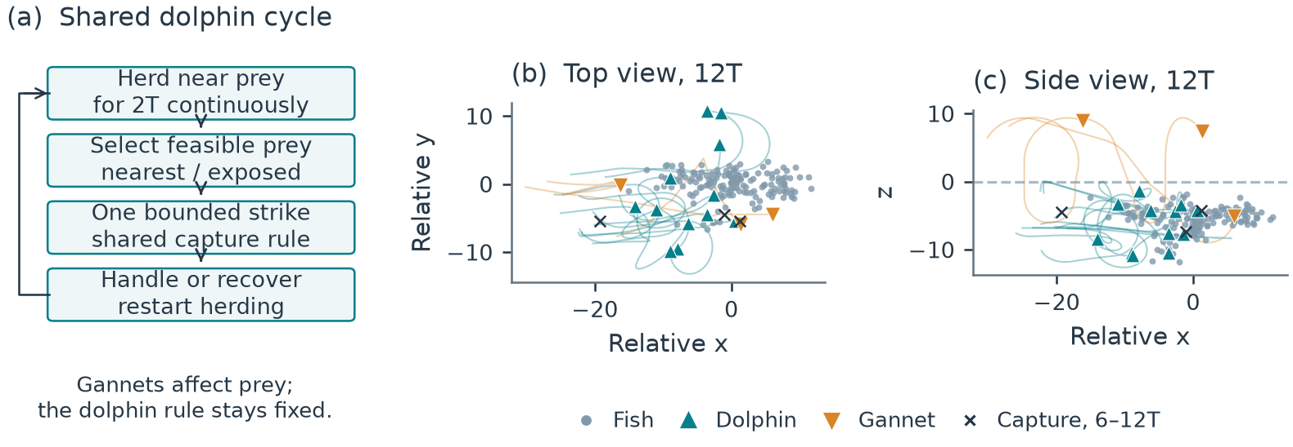
Figure 1. Model rules and a recorded encounter. (a) Dolphins repeat a near-prey herding period, one strike and recovery; birds affect dolphins through fish dynamics. (b,c) Recorded top and side views at 12T for development school 2 with exposed targeting and gannets. Paths cover 6–12T; crosses mark three actual captures. Coordinates are relative to the surviving prey centroid; z=0 is the surface. The snapshot illustrates behaviour, not verified whole-school containment.
Fish and domain  The model follows 160 point-represented fish in three dimensions. Horizontal motion is open and has a preferred migration direction. The surface is z=0, with water at negative z. Fish use a Couzin-type separation, alignment and attraction framework [5], extended with migration, habitat and predator-response terms. Repulsion has priority over social alignment and attraction. Fish speed is fixed at 3 model length units per T and native movement noise is zero. Nearby submerged predators alter escape steering, alignment, attraction and turning. Airborne birds provide no threat cue.  Dolphin herding cycle  Each of 12 dolphins follows an inherited local waypoint ahead of, beside and below a tracked fish patch. A feeding cycle requires 2T continuously within 4.5 units of at least one currently observed fish. Losing proximity resets the clock. Patch handoff or fragmentation does not itself reset it. This proximity criterion is a proxy for contributing pressure: it does not demonstrate a completed bait ball, complementary pod coverage or pressure on the same fish throughout.  Target selection  After the herding interval, a dolphin selects a physically feasible fish within range 6. The nearest rule ranks candidates by distance. The exposed rule first prefers fewer neighbours within radius 2, then lower predicted interception and turning time. Dense prey remain eligible. Each attack is bounded by a 6T bout, speed 6 and turning limit π/2 per T. Recovery lasts 2T after capture or 0.75T after failure, followed by a new herding cycle. Dolphins have exact fish positions, velocities and identities within range 25; they receive no bird-entry signal. | Gannet rules  Three gannets have global current prey information within detection depth 12. DBSCAN identifies groups using radius 2 and a minimum neighbourhood count of four. Eligible clusters are sampled in proportion to accessible fish count; the bird targets a dense accessible location within the selected group. Birds retain separate approach, plunge, submerged pursuit, ascent and recovery stages. Their physical dive and travel limits remain distinct from visibility. Observed Cape gannet dive trajectories motivate finite constraints [6], but do not calibrate model units or physiological maxima.  Capture  Food requires an eligible swept contact between point prey and an offset mouth sphere (radius 0.4, forward offset 0.3), followed by a fixed 0.7 draw. The first eligible contact closes the bout, successful or not; each captured fish is removed once and may differ from the selected target. Predators observe the same step-start fish state and propose motion. Fish advance under submerged-predator cues; contacts are resolved jointly in time order, then controller memory commits the actual resolved step. No density-dependent capture bonus is imposed.

3 Experimental design and development results
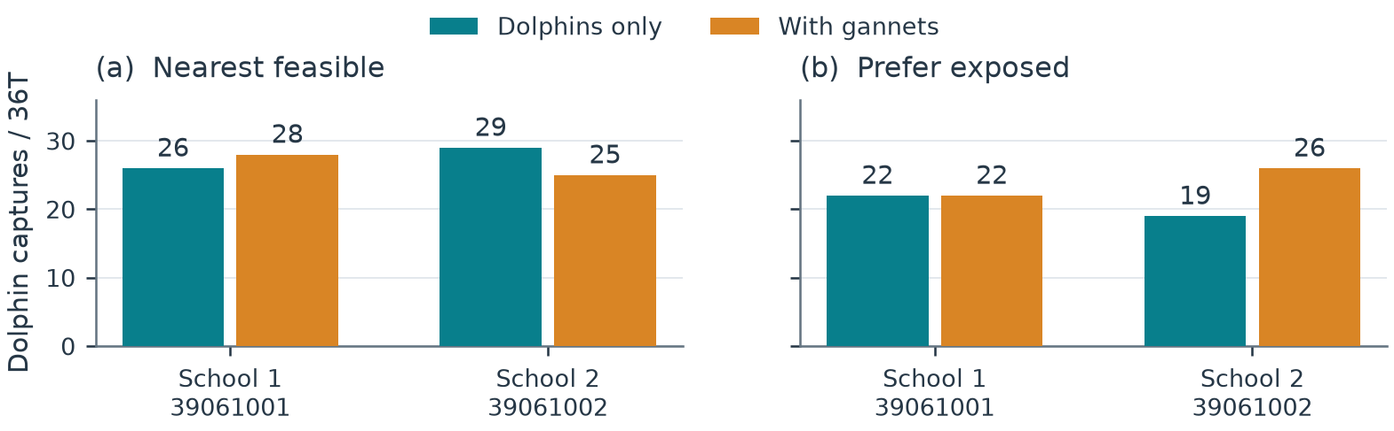
Figure 2. Development comparisons. Bars show dolphin captures in matched 36T encounters with 12 dolphins alone or with three gannets. Each target rule was tested on two development schools using one set of random draws. Nearest targeting produced totals of 55 alone and 53 with birds; exposed targeting produced 41 and 48. The initial response to adding gannets led us to select exposed targeting for follow-up. Individual outcomes are shown without confidence intervals.
Matched comparisons  Each policy was evaluated with dolphins alone (D) and with dolphins plus gannets (DG). Fish state, dolphin abundance, capabilities, initial readiness and controller state were matched within each pair. Paired encounters also began with matching random sequences for each dolphin’s capture success and for resolving simultaneous contacts. The dolphin rule was identical between conditions. Gannets changed the fish state and competed for prey; they did not directly unlock dolphin attacks.  Outcome and duration  For species s, feeding return is Y_s=C_s/(N_s T), where C_s counts uniquely removed fish, N_s is predator abundance and T is the prespecified elapsed horizon. Effects compare mixed with same-policy alone conditions for each species. Development encounters lasted 36T. The new extension lasts 72T with 36T fixed in advance as the primary horizon;72T and 36–72T increments are secondary. All travel, herding, missed attacks, handling and recovery count toward elapsed time. Predator-free 20T preparation is excluded. Complete prey depletion fixes later capture counts, while native stepping and effort accounting end at the actual depletion time. | Development set  The development comparison used two starting schools, labelled schools 1 and 2, and one set of random draws. Testing both target rules on both schools, with and without gannets, gave eight full encounters. The timestep was 0.00125T. No changes were made to the capture, fish-response or gannet rules between target policies. Requested herding is a fixed minimum cycle duration; it is not a prescribed fraction of total encounter time.  Observed effects  Nearest targeting changed dolphin captures from 26 to 28 in the first school and from 29 to 25 in the second. Exposed targeting changed 22 to 22 and 19 to 26. Its pooled gain was seven fish, or 17.1%, but it was not positive in both schools. Nearest targeting still produced more dolphin food in the mixed encounters, 53 versus 48. A larger response to partner presence is therefore distinct from maximum total feeding.  Selection rule and uncertainty  We selected exposed targeting for its response to adding gannets, although nearest targeting produced more captures with dolphins alone. Exposed mixed hunting also fell below nearest targeting alone on the development schools, 48 versus 55 captures. The follow-up fixes the exposed rule and tests its same-policy partner effect. It does not test whether mixed hunting beats the best-tested independent policy: nearest targeting was not evaluated on the fresh schools. With two development schools, the observed differences do not establish an optimal policy. Repeated runs from one school are not independent schools.

4 Prespecified replication on eight new schools
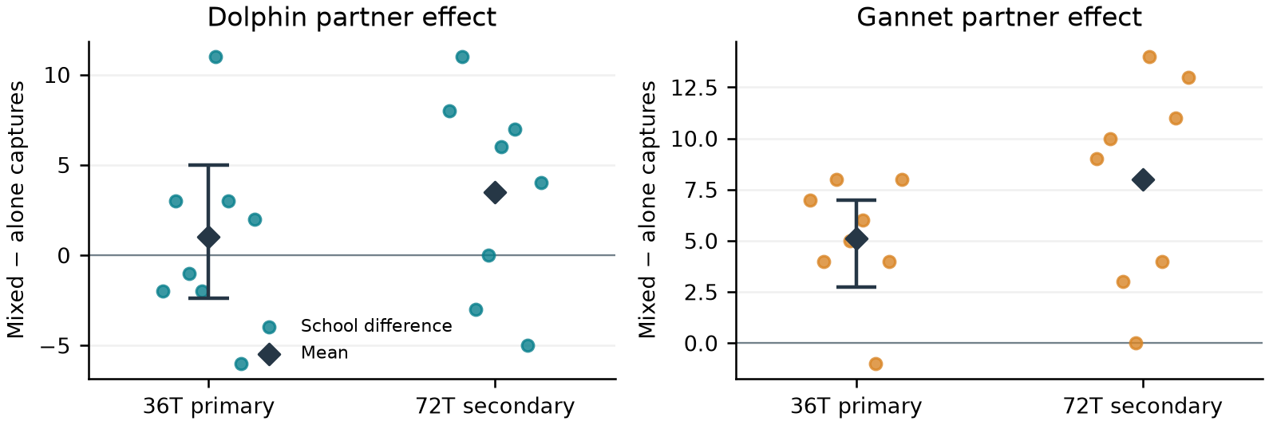
Figure 3. Eight-school replication of the unchanged exposed-prey rule. Each point is one school’s mixed-minus-alone capture difference. Diamonds show equal-school means. Bars at 36T are 97.5% marginal percentile bootstrap intervals for the two primary species (approximate 95% familywise coverage, with small-sample limitations). The 72T outcomes are descriptive extensions of the same trajectories. No historical development or two-school follow-up data enter these estimates.
Frozen design  Eight new starting schools were declared before feeding outcomes. Each retained the original sampler,160 fish, predator-free 20T checkpoint, physical model and exposed-prey controller. The original 36T stability screen and an additional 36T predator-free route check passed for every fixed candidate; none was replaced. One stochastic setting per school produced matched D, G and DG encounters, with 12 dolphins and/or 3 gannets. Private species capture and target-choice streams, contact ties and physical starts matched within triplets.  Primary outcome  Across eight independent schools at the prespecified 36T primary horizon, dolphin captures totalled 168 alone and 176 with gannets; gannet captures totalled 35 alone and 76 with dolphins. Equal-school mean differences were +1.00 dolphin captures and +5.12 gannet captures. The 97.5% marginal percentile intervals were -2.38 to +5.00 and +2.75 to +7.00, respectively. Both differences were strictly positive in 3 of 8 schools. | Independent units and uncertainty  The independent unit is the starting school, giving n=8 paired vectors. Means weight schools equally. A fixed-seed 10,000-draw bootstrap resamples entire paired dolphin–gannet school vectors. The two 97.5% marginal intervals target approximate 95% familywise coverage, but percentile interval coverage and tails can be unstable at this sample size. Development comparisons selected the policy; the earlier fresh two-school pilot motivated this extension. Neither is pooled into this estimate.  Longer encounter  At 72T, dolphin captures totalled 352 alone and 380 with birds; gannet captures totalled 85 alone and 149 with dolphins. Jointly positive school differences numbered 5 of 8. 0 of 24 encounters reached complete prey depletion. These are secondary outcomes from the same trajectories, not another independent sample. The 36–72T increments and observed effort are reported separately in the companion tables.  Verification  Each 36T checkpoint has its own sealed ordered event prefix, physical fish state and random-stream receipts. The 72T continuation was checked against that exact prefix and the saved 36T trajectory frame. All 24 cases passed unique-removal, eligible-contact, recovery, cycle-gating and random-stream replay checks. Actual native duration is distinguished from nominal horizons after depletion. These implementation checks do not establish biological calibration or timestep convergence.

5 Earlier gannet controls, depth and timing
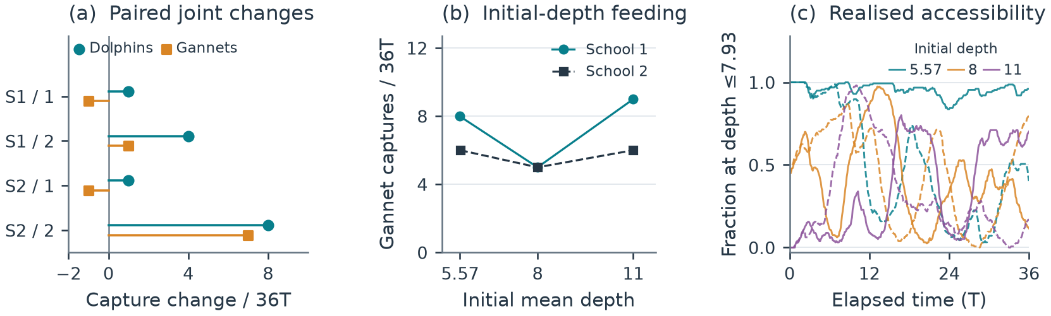
Figure 4. Earlier two-school controls and initial-depth pilot, kept separate from the eight-school replication. Matching gannet-only controls and initial-depth results. (a) Changes in dolphin and gannet captures when hunting together; S1 and S2 identify the two fresh schools, and 1 and 2 identify random settings 61001 and 61002. Both species gain in two of four repetitions. (b) Gannet-only captures across initial mean depths, using setting 61001; lines join the same school. (c) The fraction of surviving fish within the reference depth envelope changes during each encounter. Colour identifies initial depth; solid and dashed curves identify schools 1 and 2. Initial depth is not maintained, and the connecting lines in (b) are not fitted response curves.
Matching gannet controls  Before the eight-school extension, eight additional 36T gannet-only encounters were completed. Four unshifted controls match the earlier two-school follow-up and its two random settings. Their birds retain the same capabilities, initial states and private capture and target-choice streams as the mixed counterparts. Four other encounters translate each school to initial mean depths 8 and 11 using setting 61001. Translation preserves geometry without clipping; the preferred fish depth remains 5 with deadband 3–7. These earlier outcomes do not enter Figure 3.  Joint feeding response  Gannet capture changes in the four unshifted comparisons were −1, +1, −1 and +7 fish. Both species gained in the second repetition of each school; in the other two, dolphin gains accompanied one fewer gannet capture. Pooled gannet captures increased from 26 to 32 (+23.1%), but the largest gain accounts for seven fish while the other three differences sum to −1. Mean gannet changes across repetitions were zero and +3 for the two schools. The matching dolphin means were +2.5 and +4.5. These outcomes show conditional joint gains, not a uniform reciprocal advantage. | Initial-depth result  The unshifted schools began at mean depths 5.56 and 5.58. At setting 61001, gannet captures were 8 and 6 without translation, 5 and 5 at initial mean depth 8, and 9 and 6 at initial mean depth 11. There was no monotonic decline. Initially, all unshifted fish, about 44–45% at mean depth 8, and none at mean depth 11 lay within the reference target-depth envelope of 7.93. Native prey movement then changed accessibility; the deepest starting treatment became reachable.  What depth does and does not test  Initial translation is a transient intervention. The fish retain their original habitat preference and can change depth throughout the encounter; selective consumption also changes survivor statistics. The depth envelope is a coarse geometric eligibility reference, not guaranteed interception or a calibrated physiological maximum. These runs therefore cannot establish a maintained-depth barrier or an optimal feeding depth.  Objective 3: attack timing  An isolated timing hook reproduced the disabled baseline exactly. The first enabled 8T check found no cue at any of six legal bird launches. Retrospective screening then identified one later opportunity in a different random setting. A separately declared, post-hoc 36T engineering run delayed one bird launch by 0.076T before loss of locality cancelled the wait. Its realised launch lag was 0.873T, short of the requested 1T. Dolphin and gannet captures, 24 and 11, matched the baseline. This demonstrates a partial deferral, without establishing a timing advantage.

6 Discussion, limitations and next steps
Interpretation  The development comparison showed that the partner effect depends on target selection and starting school: exposed targeting had a positive pooled response while nearest targeting produced more total food. The prespecified eight-school extension estimates the same-policy partner effect with mean 36T changes of +1.00 dolphin and +5.12 gannet captures and joint positive differences in 3 of 8 schools. The dolphin primary interval included zero; the gannet interval lay above zero. The two primary intervals do not jointly support positive average partner effects for both species. This interpretation remains limited by eight schools, percentile-bootstrap uncertainty and uncalibrated model assumptions. Neither pooled total nor one favourable trajectory establishes uniform reciprocal benefit.  Behavioural assumptions  The main uncertainty is whether 2T near fish represents useful herding effort and whether exposed prey are a reasonable targeting preference. The model does not assign complementary drivers and barriers, reserve targets or coordinate feeding turns. Herding represents contributions to within-pod collaboration through fish dynamics, while each individual uses the same local rule. Neither an attractive trajectory nor a labelled herding state proves sustained whole-school containment.  Perception and capture  Dolphins have exact local prey information, while birds have idealised global information within depth limits. The mouth geometry is simplified, prey are point-represented, and predator body-spacing avoidance is disabled. Capture success after eligible contact remains 0.7 for both species and is uncalibrated. The gannet field values of 13% and 36% describe success per observed attack technique [4], not conditional mouth-contact success and not first versus second attempts. They cannot be inserted directly as the model parameter. | Scope of the evidence  Time and length have no validated joint physical scale. The study omits learning, fatigue, hunger, satiety and energetic costs, and its finite prey supply is not replenished. Capture return is therefore not energetic profitability or fitness. Work on non-coordinating predators [7] and the broader seabird–subsurface-predator literature [8] also cautions against equating a feeding association with deliberate communication or reciprocal cooperation. A model gain identifies a mechanism worth testing, not evidence that real animals use the implemented rule.  Conclusion  The eight-school primary comparison supports a gannet feeding gain under the tested model, while the dolphin interval spans negative and positive effects. It therefore does not establish a general mutual feeding advantage. The longer 72T comparison describes the same encounters and remains secondary. These findings concern fixed herd–strike rules, not deliberate coordination, energetic profitability or evolutionary stability. Numerical sensitivity and calibration of herding, perception and contact success remain open.  Reproducibility and draft status  The timestep is 0.00125T:36T requires 28,800 steps and 72T at most 57,600. The local notebook verifies 48 feeding encounters:24 earlier cases and 24 new eight-school cases with 48 separately sealed horizon records. All 20 default code cells pass, regenerate the four current figures and export 12 tables without native simulation. Earlier cohorts and three timing engineering checks remain separate. Original input manifests and case seals are preserved. The unchanged optional model runner has documented platform constraints. The finer-timestep follow-up is running and excluded from these results. Code and data: https://github.com/reuben-trade/FishSim-Dolphin-Gannet-Pilot.

References
[1] Teske PR et al. The sardine run in southeastern Africa is a mass migration into an ecological trap. Science Advances. 2021;7:eabf4514. doi:10.1126/sciadv.abf4514.
[2] O’Donoghue SH. The sardine run: investigating sardine and predator distribution in relation to environmental conditions using GIS and remotely sensed products. PhD thesis, University of KwaZulu-Natal; 2009.
[3] Lett C, Semeria M, Thiebault A, Tremblay Y. Effects of successive predator attacks on prey aggregations. Theoretical Ecology. 2014;7:239–252. doi:10.1007/s12080-014-0213-0.
[4] Thiebault A, Semeria M, Lett C, Tremblay Y. How to capture fish in a school? Effect of successive predator attacks on seabird feeding success. Journal of Animal Ecology. 2016;85:157–167. doi:10.1111/1365-2656.12455.
[5] Couzin ID, Krause J, James R, Ruxton GD, Franks NR. Collective memory and spatial sorting in animal groups. Journal of Theoretical Biology. 2002;218:1–11. doi:10.1006/jtbi.2002.3065.
[6] Ropert-Coudert Y, Grémillet D, Ryan P, Kato A, Naito Y, Le Maho Y. Between air and water: the plunge dive of the Cape Gannet Morus capensis. Ibis. 2004;146:281–290. doi:10.1111/j.1474-919x.2003.00250.x.
[7] Mohapatra S, Sinha Mahapatra P. Behavioural response of prey to repeated attacks by non-coordinating predators. Scientific Reports. 2025;15:22977. doi:10.1038/s41598-025-05946-6.
[8] Licht M, Correia E, Wikelski M, Krause J. How volant seabirds benefit from sub-surface predators during multi-predator feeding aggregations. Philosophical Transactions of the Royal Society B. 2026;381:20250199. doi:10.1098/rstb.2025.0199.

