* My SFU crowd simulation is supposed to simulate flow around the SFU Transportation center in between class periods, as students move from the convocation mall to the west mall center and vice versa, as well as to and from the bus stop. In between classes, everyone is moving around campus all at once, to/from a variety of different destinations. This can make it difficult to navigate the large resulting crowds.
* My simulation is set up like so: 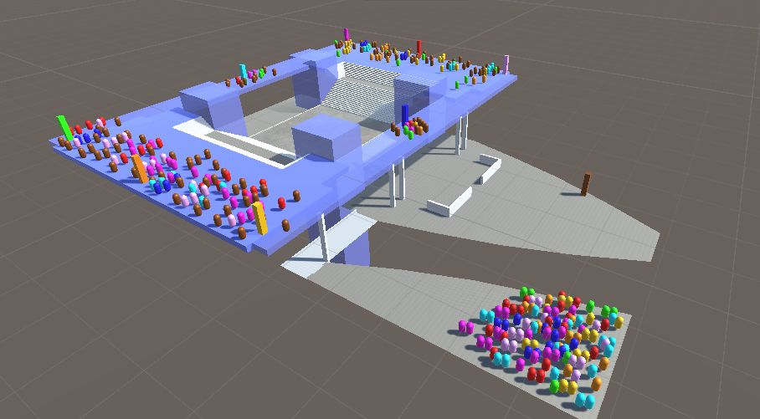

On the top level of this structure, there are 8 different destinations, representing places students may want to go. The ground level has a brown destination marker to represent the bus stop. Near the bottom of the image you can see that there is a crowd of students who just got off the bus, all located in the drop-off bay. Note that none of them intend to go towards the pick-up bay of the bus stop, it would be pointless for students who just got off the bus to immediately get back on. Likewise, there are no students who want to get from, for example, the yellow marker to the green marker.

* Here is the navmesh: 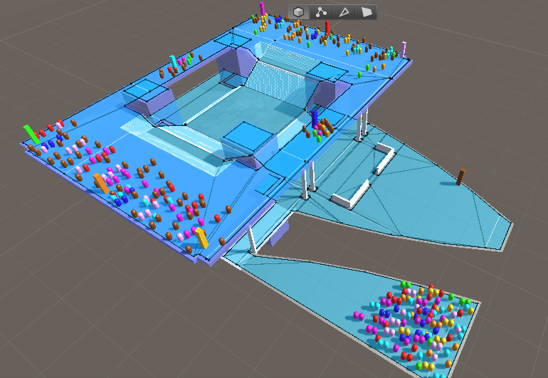

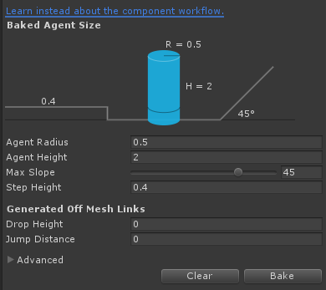

* Here are the agent parameters:

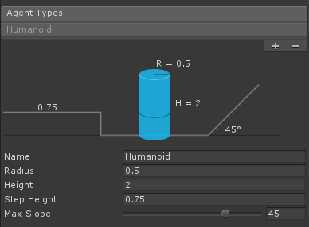

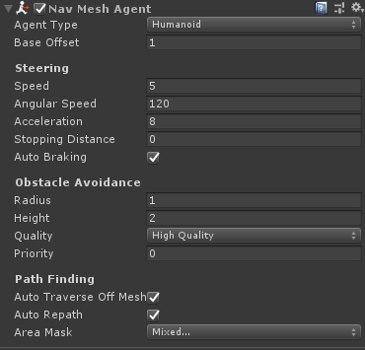

Different agents actually have a variety of speeds, ranging from 4.5 to 7, to simulate people’s different walking paces. The radius for obstacle avoidance is set to 1 to account for people’s preference for some degree of personal space.

* Simulation running with navmesh toggled: 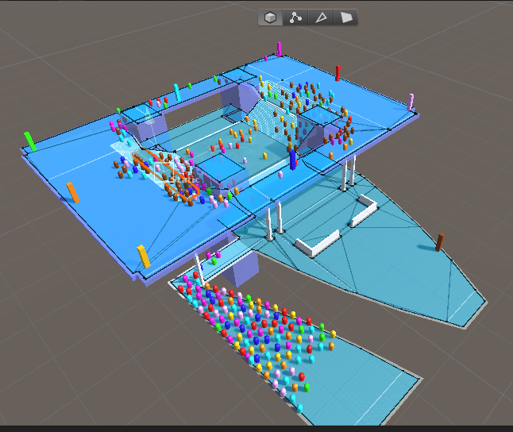
* Simulation running without navmesh toggled: 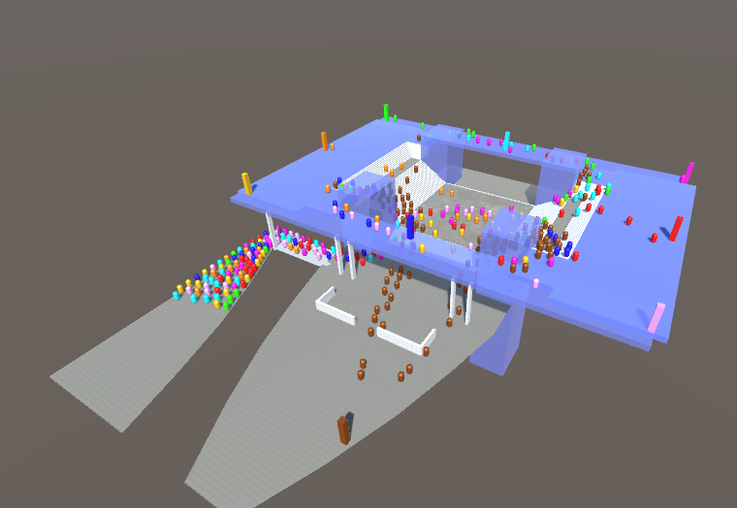
* Simulation running with color-differentiated trails, navmesh on: 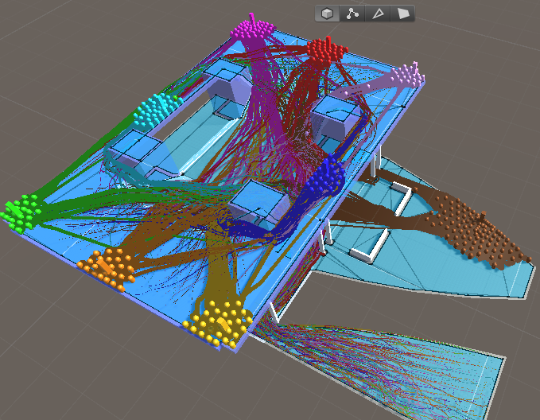

Agent radius increased to 1.5:

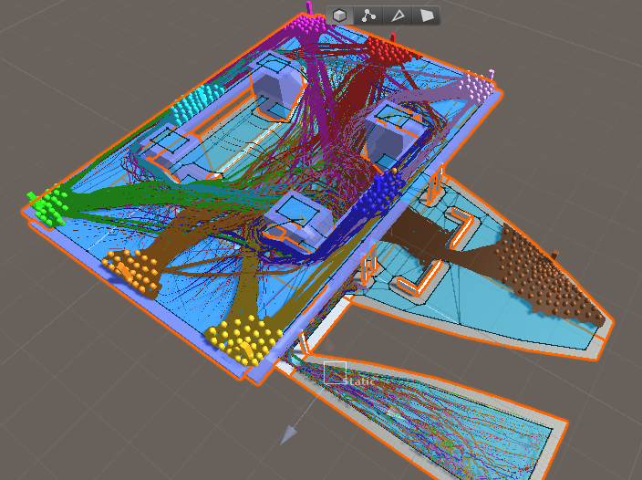

* Simulation running with color-differentiated trails, navmesh off: 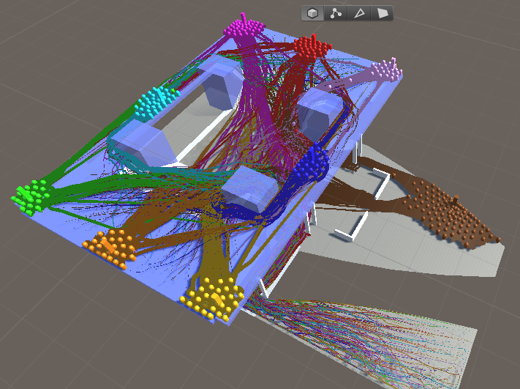
* A few things I noticed in the AI agent’s behavior that don’t neccesarily reflect the real world:
  + Many of the agents crossing from one side of the top level to the other didn’t show any aversion to walking up/down stairs. In real life, many people would opt to take one of the side walkways to avoid going up or down stairs.
  + Agents tended to take the straightest path to their destination without looking ahead. Real people would see crowds from a distance and take a less crowded path instead of doing everything in their power to take the most direct route (regardless of crowding or time wasted)
  + I assumed that every single agent was a good law abiding citizen and would not jaywalk, even if the crosswalk was extremely crowded. In the real world people would be willing to cross at nearly any point of the road.

Besides that, when I increased the agent radius to 1.5 I noticed more of them taking the top walkways to cross the transportation center, and every single agent going towards the bus stop went through the structure in the middle instead of around the sides of the road.

Overall this simulation demonstrates many of the discrepancies between simple AI and real humans. In addition, in a real situation the viewshed would matter. People coming down the stairs could make more informed decisions than people from the bus stop turning a corner and going up the stairs, because one group would have a better view of the area than the other. A more realistic simulation would integrate viewing what is ahead into the pathfinding AI.