Customer Segmentation Project
Segmenting customers based on behavior and demographics using K-Means clustering

1. Objective
The goal of this project is to segment customers based on their behavioral and demographic characteristics in order to understand distinct customer groups, their purchasing patterns, and preferences. These insights can support targeted marketing, retention strategy, and personalized customer experiences.

2. Dataset
A dataset of 600 customers was used, containing the following behavioral and demographic attributes:
- Demographic: Age, Gender, Region
- Behavioral: Purchase Frequency, Total Spend, Recency (days since last purchase), Tenure (months as customer)
- Preferences: Preferred Shopping Channel, Preferred Product Category, Loyalty Program Membership
The numeric behavioral and demographic features (Age, Annual Income, Purchase Frequency, Total Spend, Recency, Tenure) were used as clustering inputs. Categorical preference fields were retained for post-hoc profiling of each segment.

3. Methodology
- Standardized all numeric features using StandardScaler so that variables with larger ranges (e.g. income, spend) did not dominate the distance calculations.
- Applied K-Means clustering, testing K values from 2 to 8.
- Evaluated cluster quality using the Elbow Method (inertia) and Silhouette Score to identify a well-separated, interpretable number of segments.
- Selected K = 4, which produced coherent, business-interpretable segments with a strong silhouette score.
- Used Principal Component Analysis (PCA) to reduce the feature space to 2 dimensions for visualization of cluster separation.
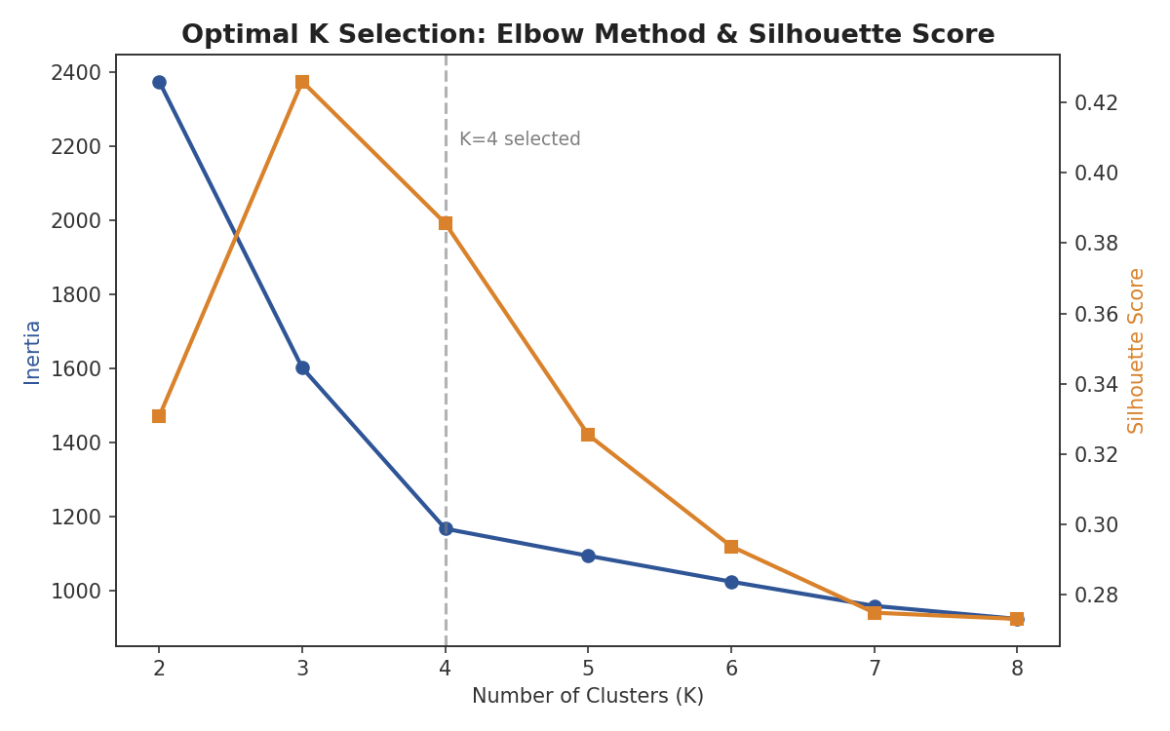
Figure 1: Elbow method (inertia) and silhouette score across candidate values of K.

4. Resulting Customer Segments
The K-Means model identified four distinct customer segments:
Segment | Customers | % of Total | Avg Age | Avg Income | Avg Purchase Freq | Avg Total Spend | Avg Recency (days) | Avg Tenure (mo)
High-Value Loyal | 143 | 23.8% | 41 | $93,845 | 28 | $3,981 | 13 days | 47 mo
Occasional Low-Spend | 199 | 33.2% | 27 | $42,767 | 7 | $430 | 55 days | 12 mo
Moderate Regular | 164 | 27.3% | 50 | $60,557 | 14 | $1,181 | 35 days | 31 mo
At-Risk High-Value | 94 | 15.7% | 51 | $86,011 | 4 | $2,577 | 183 days | 60 mo

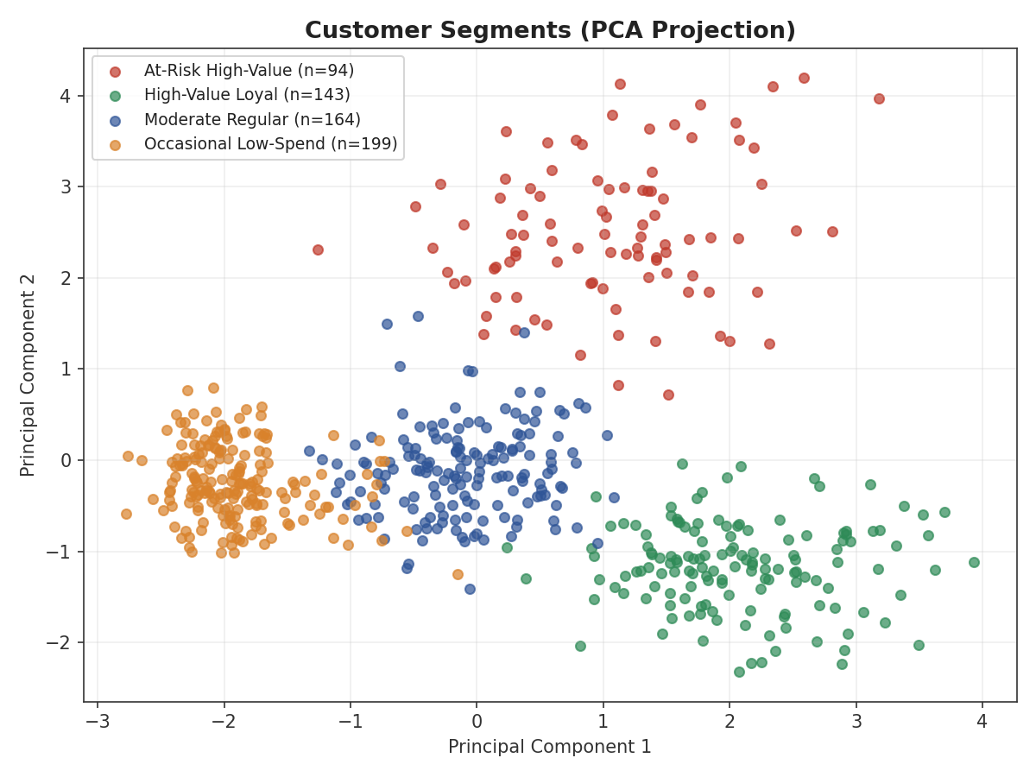
Figure 2: Customer segments projected onto the first two principal components, showing clear separation.
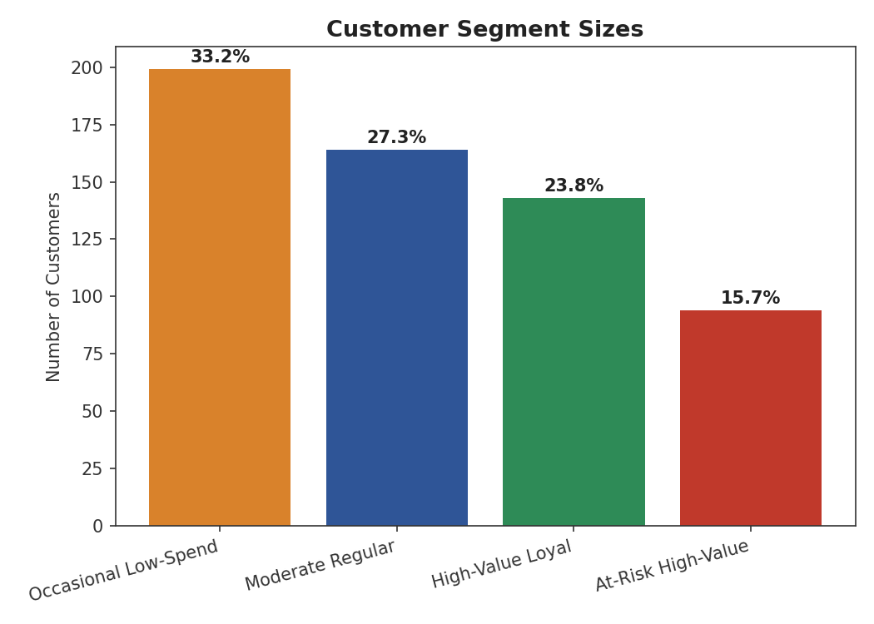
Figure 3: Relative size of each customer segment.

5. Segment Profiles & Characteristics
High-Value Loyal (23.8% of customers)
Older, higher-income customers who purchase frequently, spend the most on average, and have been active very recently. Long average tenure indicates strong loyalty. These are the most valuable customers and prime candidates for VIP loyalty perks, early access programs, and premium upsells.
Occasional Low-Spend (33.2% of customers)
The youngest and largest segment, with low income, low purchase frequency, and low total spend. Short tenure suggests many are newer or infrequent customers. This group represents growth potential — good targets for onboarding campaigns, first-purchase incentives, and awareness-building content.
Moderate Regular (27.3% of customers)
Middle-aged customers with moderate income and steady, regular purchasing behavior. Average spend and recency are both mid-range. This is a stable, dependable segment well-suited to cross-sell and category-expansion campaigns.
At-Risk High-Value (15.7% of customers)
Older customers with high income and historically high total spend, but very low recent purchase frequency and long recency (average 183 days since last purchase). Despite the longest average tenure, this segment shows clear signs of disengagement. This group is the highest priority for win-back and re-engagement campaigns, since they represent lost revenue that was previously strong.

6. Preferred Category by Segment
Beyond the core clustering variables, we examined each segment's preferred product category to inform merchandising and messaging.
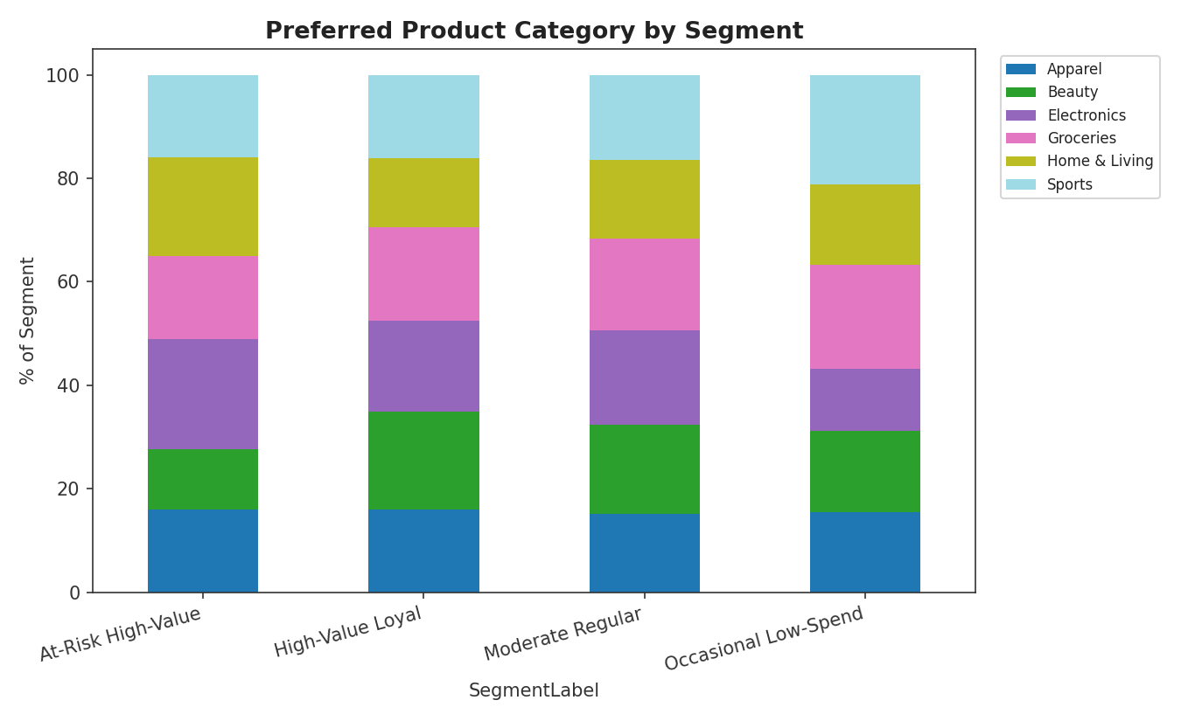
Figure 4: Distribution of preferred product category within each segment.

7. Business Recommendations
- High-Value Loyal: Protect and reward this segment with loyalty tiers, exclusive previews, and referral incentives.
- At-Risk High-Value: Launch targeted win-back campaigns (personalized offers, reactivation discounts) before they churn completely — this is the most urgent segment given their historical value.
- Occasional Low-Spend: Focus on engagement and education (onboarding flows, starter bundles) to increase purchase frequency over time.
- Moderate Regular: Use cross-sell and bundle promotions to increase basket size and category breadth.

8. Tools & Techniques Used
- Python (pandas, NumPy) for data preparation
- scikit-learn (StandardScaler, KMeans, PCA, silhouette_score) for clustering
- Matplotlib for visualization

9. Learning Outcomes
This project provided hands-on experience with the full customer analytics workflow: preparing behavioral and demographic data, selecting an appropriate number of clusters using statistical validation methods, applying unsupervised machine learning (K-Means), visualizing high-dimensional clusters with PCA, and translating clustering output into actionable, business-relevant customer segments.

