Reuben Rapose

J040

BTech Data Science

1. Training on data for 10 Epochs

Loss = 8.0277

Accuracy = 49%

1. Exercise 1

Epochs = 10

Loss = 0.402

Accuracy = 88%

1. Exercise 2

Data = MNIST data

Epochs = 10

Loss = 0.03

Layers = 3

Accuracy = 98.73%

Accuracy Loss = 95.94%

Validation Loss = 0.1425

1. Exercise 3

Data = CIFAR10

Epochs = 10

Loss = 1.4

Layers = 4

Accuracy = 52.33%

Validation set Accuracy = 42.47%

Validation Loss = 1.3

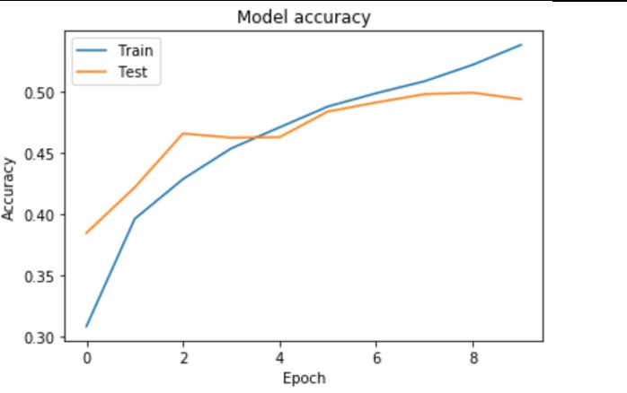

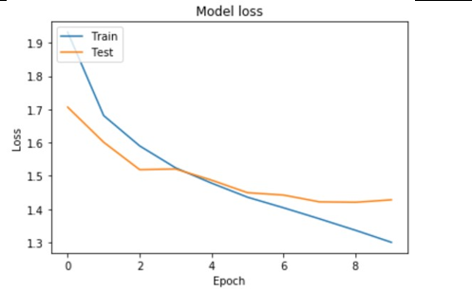

1. Improving accuracy

Data = IRIS

Epochs = 200

Loss = 0.04

Layers = 3

Accuracy = 99.15%