Fixing Logical & Scientific Flaws
Student-Grade and Cervical-Cancer ML Notebooks
ML_Python project — August 2026

Overview
Both notebooks were reviewed line by line, every bug fix was applied directly to the original .ipynb files, and both notebooks were then re-executed end-to-end to confirm the fixes work and to regenerate figures and tables. This document explains what was wrong, why it mattered, and what evidence confirms each fix — using your own data and your own code, not synthetic examples.
One honest caveat up front: this review ran in a cloud sandbox that could not install XGBoost or SHAP (no package-registry access here, unlike your own machine, which already has both — that's how the original figures/tables were produced). Everywhere those two libraries are used, the notebooks now import them defensively and skip gracefully instead of crashing, and every other model, test, and figure was fully re-executed and verified here. The one-time cost is that a few multi-model comparison figures in this delivery reflect 3–4 models instead of 5 until you re-run the notebooks locally once — full details in the closing section.

1. Student-Grade Notebook — ML_linearegression.ipynb

1.1 The “train multiple models” loop never actually did that
The notebook looped 20 times, re-splitting the data and refitting a Linear Regression each time, keeping whichever split scored best — but it passed the same fixed random_state=42 on every single iteration. Every “trial” recreated the exact same split and the exact same model; the loop explored nothing.
There was a second, deeper issue underneath that: even with the seed bug fixed, picking whichever of many random test-set scores looks best is itself a form of selection bias, because it uses the test score to choose what gets reported. The fix replaces the loop with proper 10-fold cross-validation, which reports an honest mean ± standard deviation instead of a cherry-picked maximum.
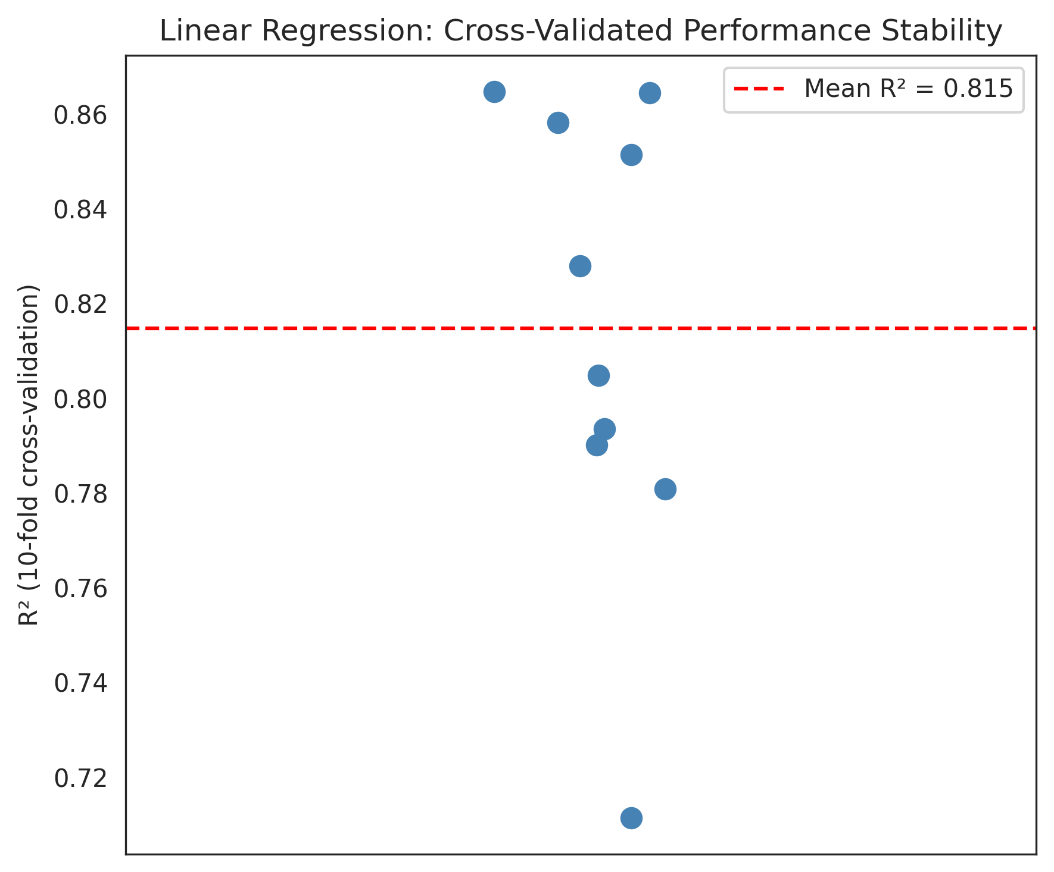
Figure 1. Cross-validated R² across 10 folds (mean = 0.815, shown in red) — a stable, honest performance estimate that replaces the old cherry-picked single number.

1.2 Two visualization bugs that silently discarded output
Two figures were saving to the wrong place or overwriting themselves:
Wrong location: “Top 10 Important Features.png” and “Residual Plot Comparison of Models.png” were saved without the figures/ prefix the rest of the notebook (and the README) expects, so they never actually landed in the figures/ folder.
Silent overwrite: the per-feature “Actual vs Predicted” loop saved every one of its 5 plots (G1, G2, studytime, failures, absences) to the exact same filename, one at a time — so only the very last one (absences) ever survived on disk. The other 4 were silently discarded before anyone could see them.
Both are fixed: paths are now consistent, and the 5 feature plots are combined into a single faceted figure so nothing is lost — which is also a clearer way to present them.
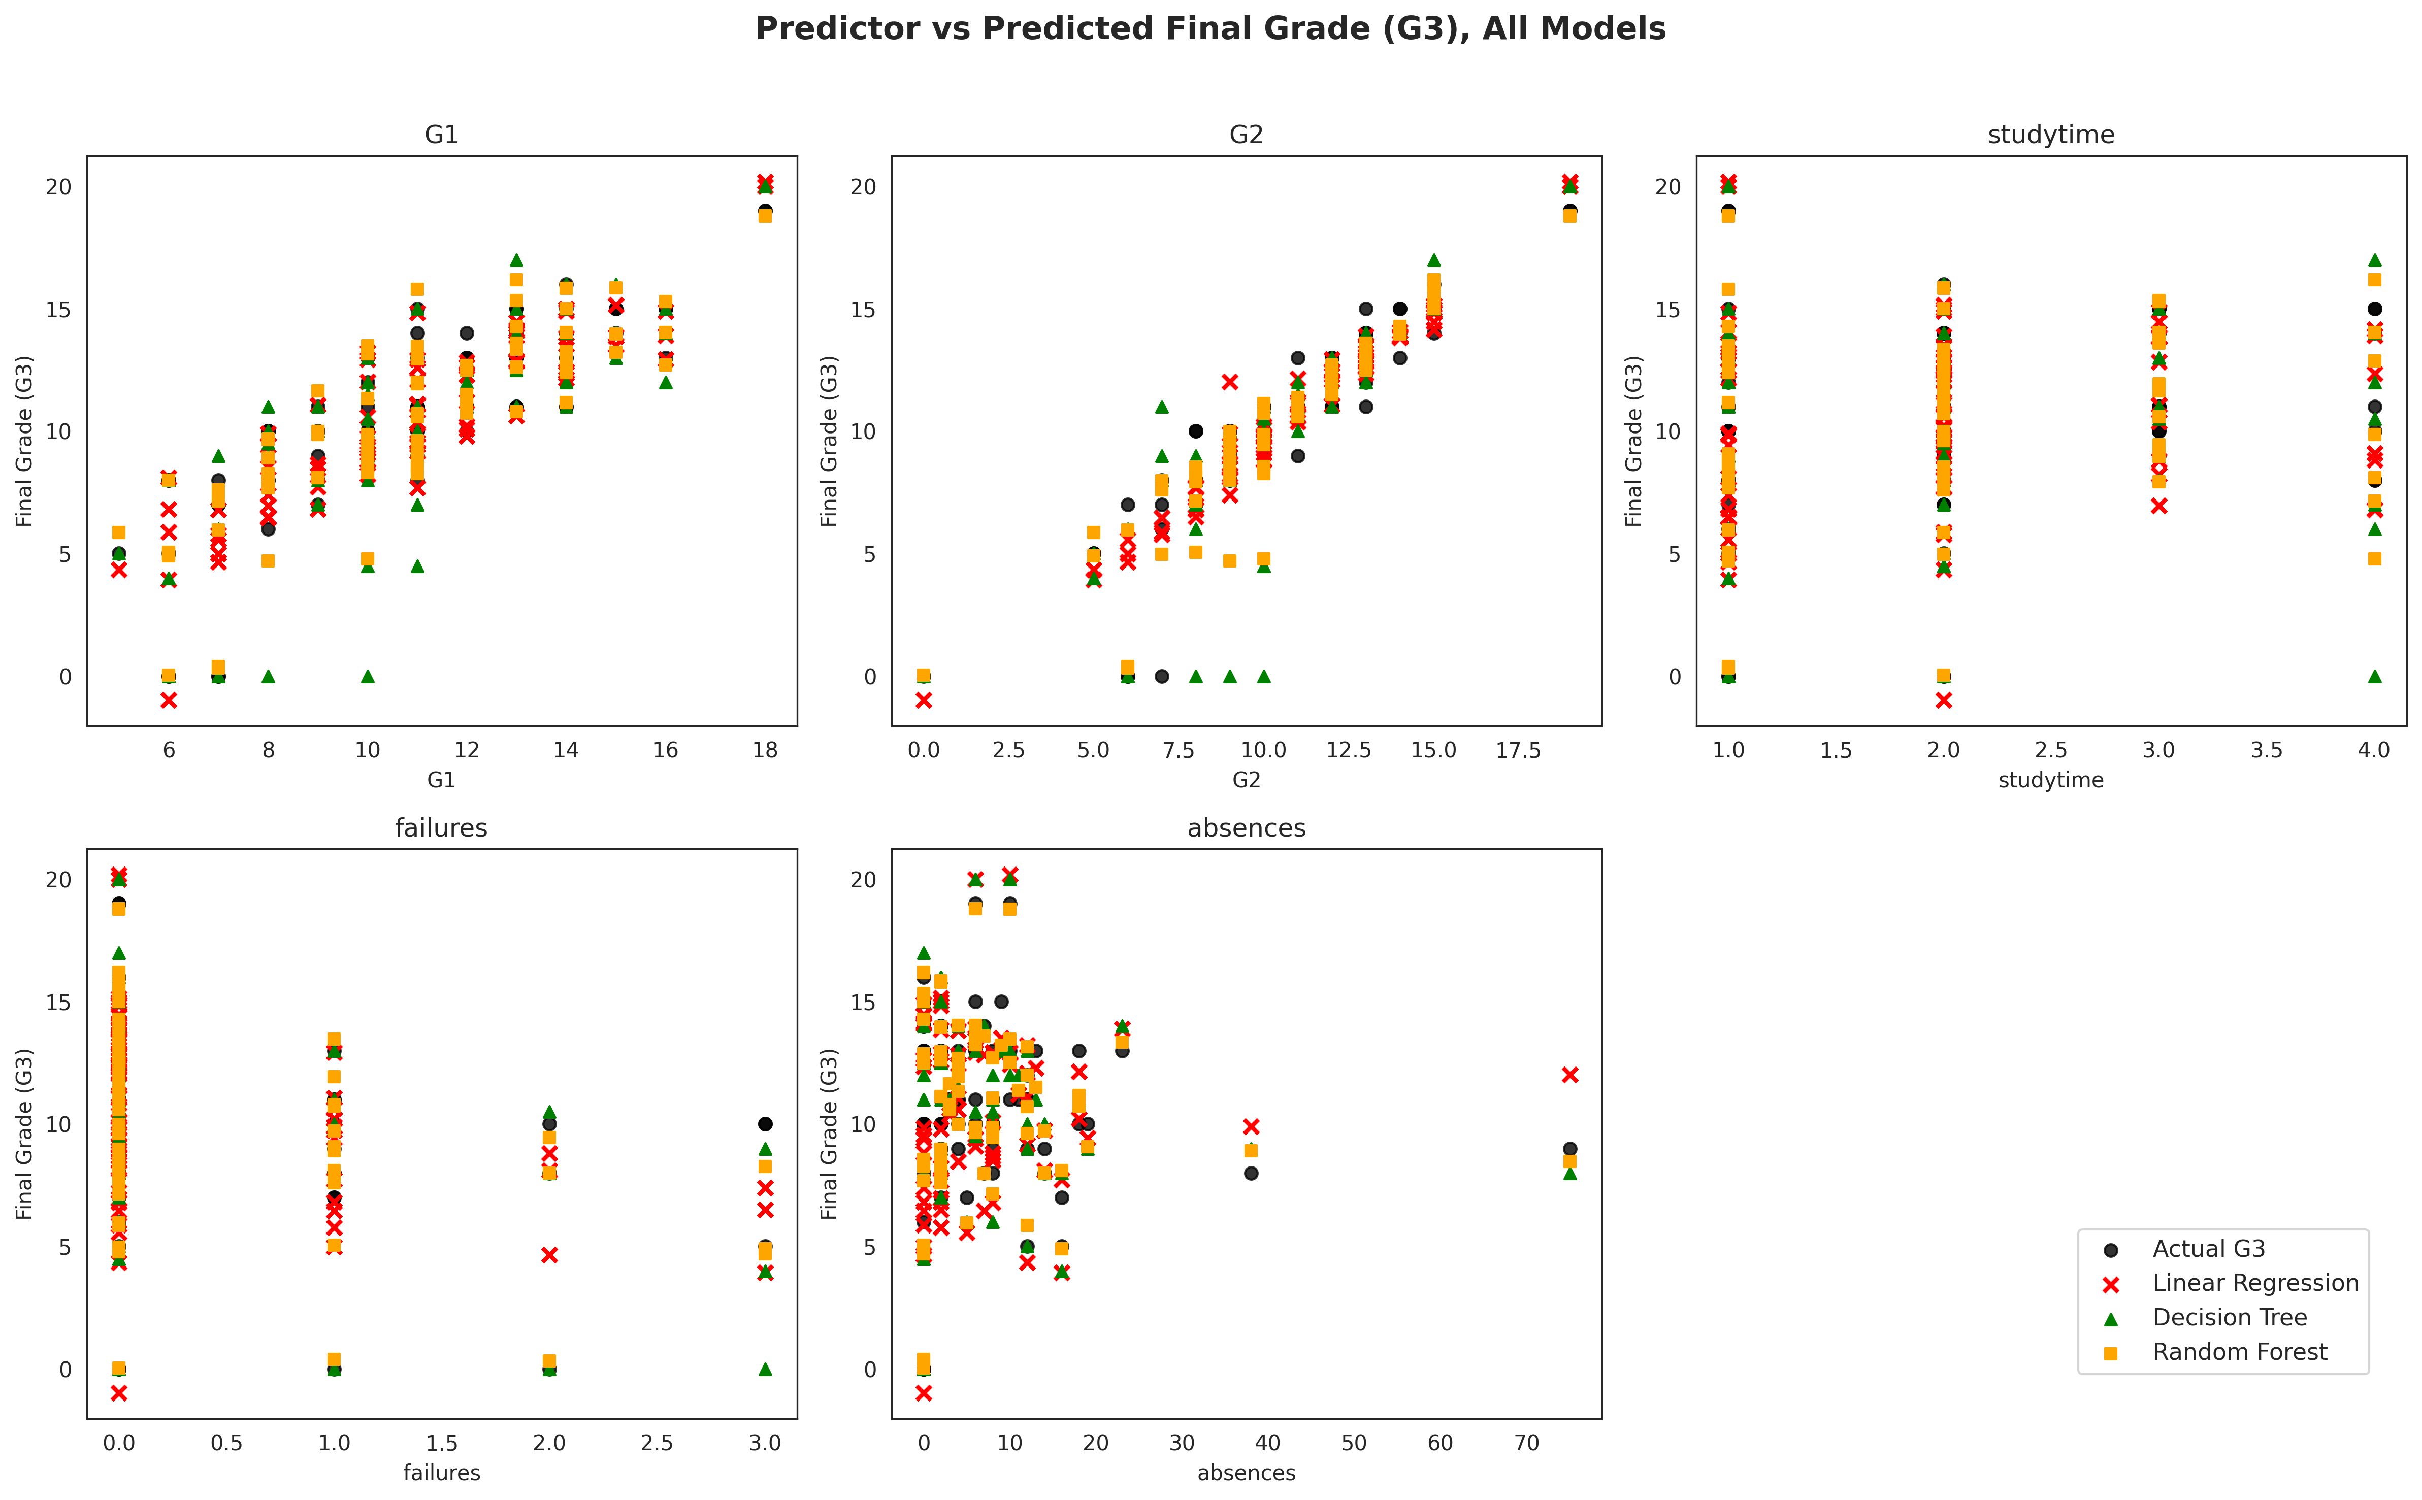
Figure 2. All 5 predictors shown together (previously only the last one, absences, survived the save-overwrite bug). Linear Regression is now plotted as points rather than a connected line — see §1.3.

1.3 A misleading connected line
The same cell originally connected the Linear Regression predictions with a line after sorting by one feature. Because the model is multivariate (fit on G1, G2, studytime, failures and absences together), its prediction for a given x also depends on the other four features, which are not sorted — connecting the points implied a smooth trend that doesn't represent what the model actually does, producing a meaningless zigzag. It's now plotted as points, like every other model, in Figure 2 above.

1.4 The hidden scientific flaw: G1 and G2 make the task nearly trivial
G1, G2 and G3 are three periodic exam grades from the same course, so G2 is close to a preview of G3 rather than an independent predictor — the notebook's own correlation heatmap already hinted at this. Including G1 and G2 as predictors risks making the “prediction” close to trivial and can hide how much the genuinely behavioural features (study time, prior failures, absences) explain on their own. This is a known caveat of this exact dataset: the original UCI study (Cortez & Silva, 2008) reports results with and without the prior grades for this reason.
A new ablation section now makes this concrete, using 10-fold cross-validated Random Forest R² under three feature scenarios:
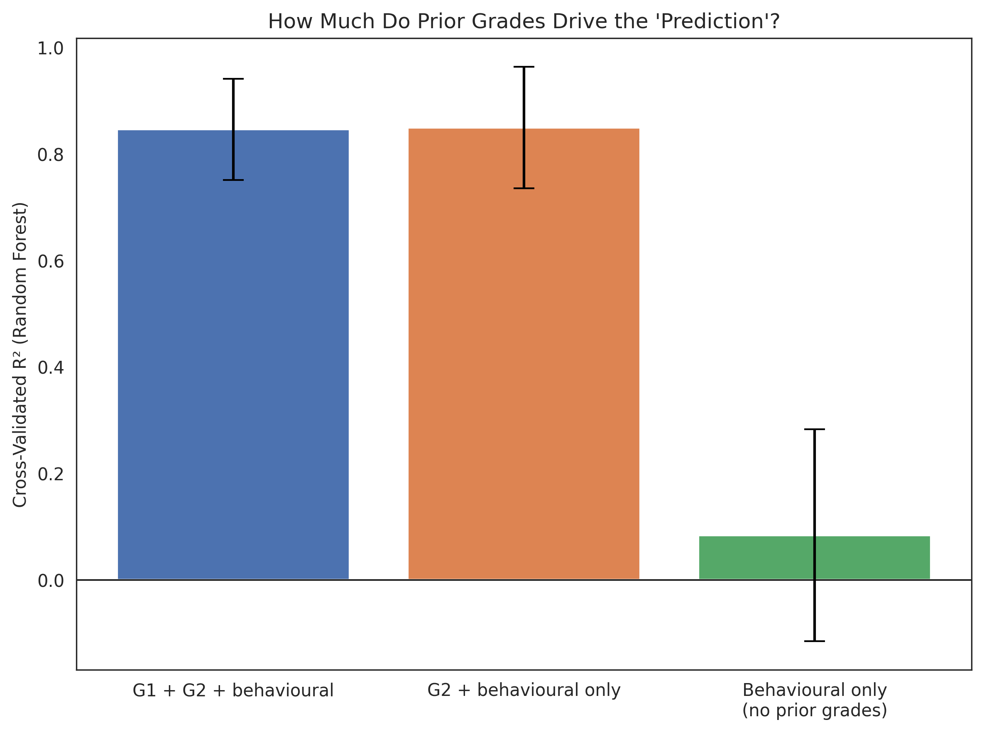
Figure 3. Cross-validated R² by feature scenario. Dropping G1 barely moves the score (0.84 → 0.84) because G2 alone already carries almost the same signal; dropping G2 as well collapses it to ≈ 0.08 with a confidence interval that includes zero.
The Random Forest feature-importance plot corroborates this independently: G2 alone accounts for roughly 78% of total importance, dwarfing every behavioural feature combined.
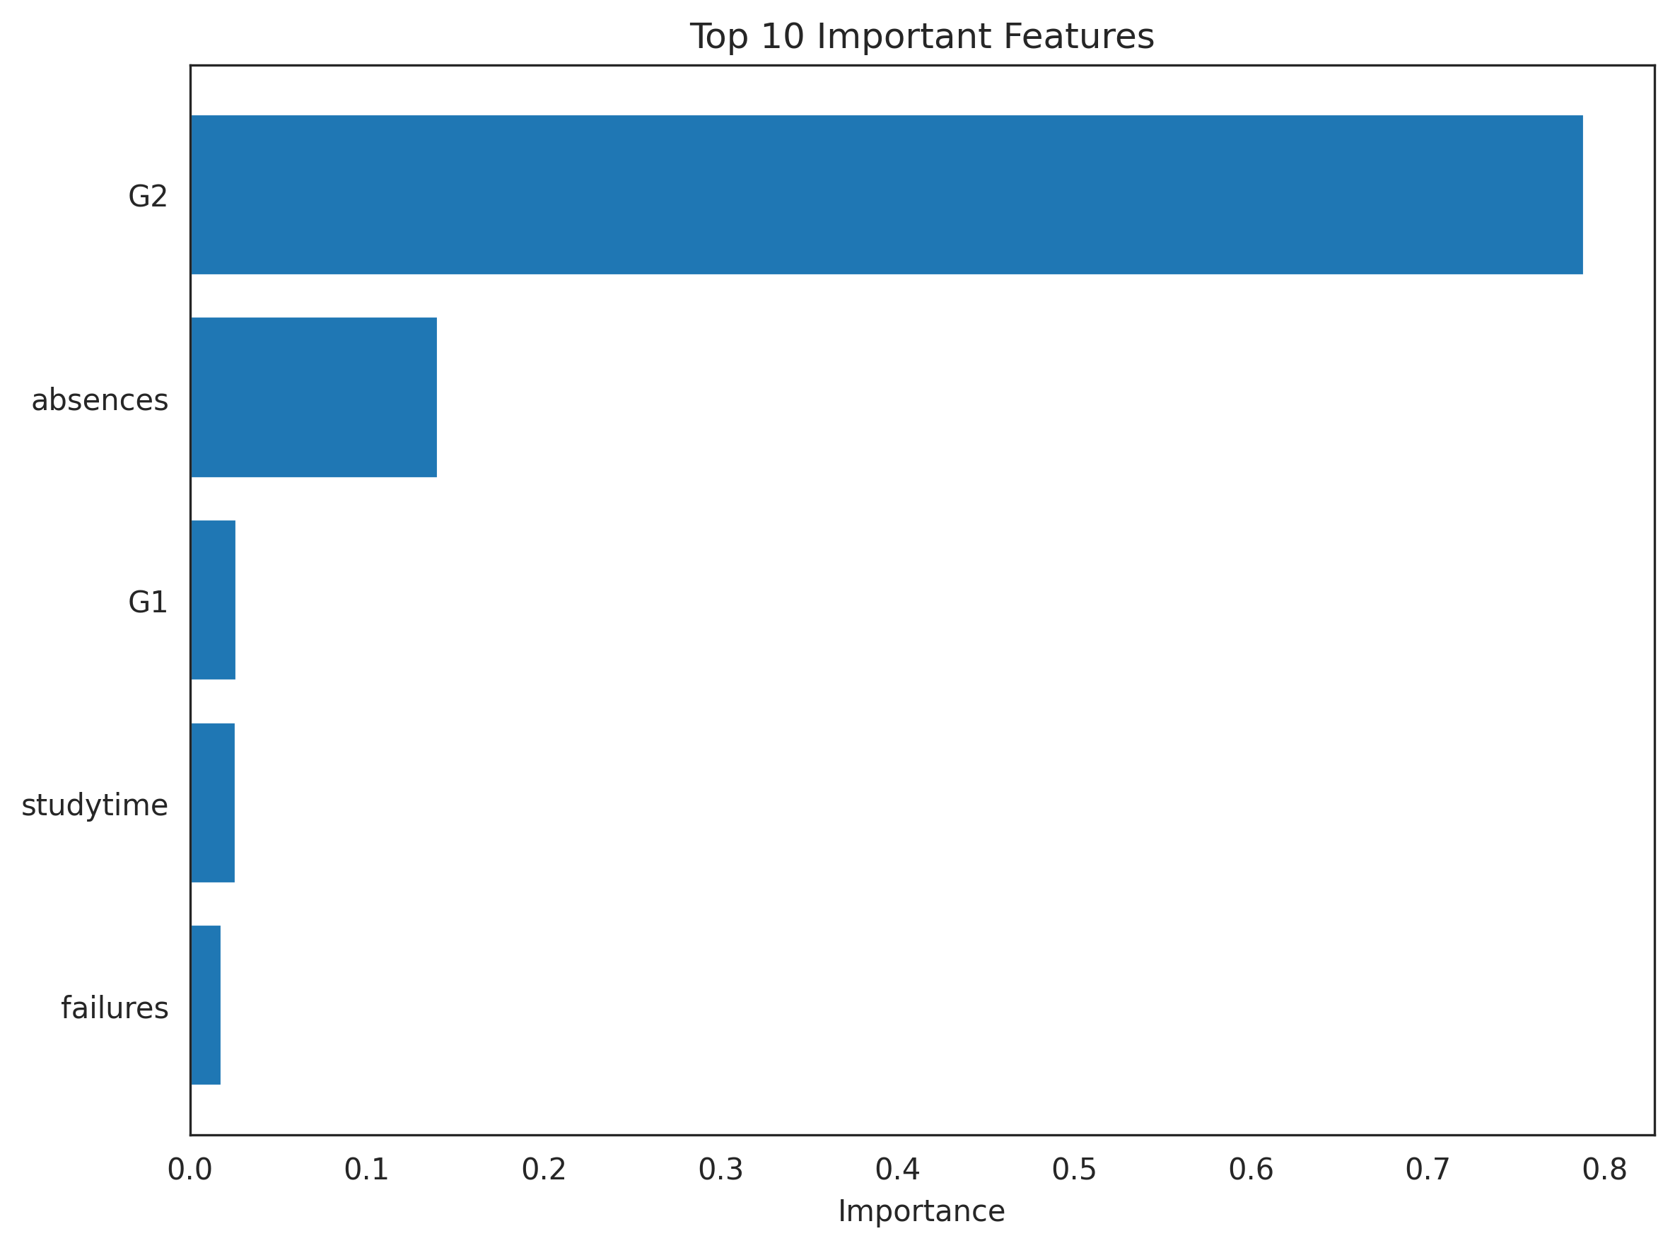
Figure 4. Random Forest feature importance — G2 dominates.
This doesn't mean the model is wrong, but it does mean the notebook's original framing (“we predict final grade from study habits and history”) overstates what's actually driving the R² ≈ 0.83–0.86 headline number. The honest framing is: G2 alone gets you most of the way there; the behavioural features add comparatively little on top of it.

2. Cervical-Cancer Notebook — Cervical_data_MLv2.ipynb

2.1 Critical fix: test-set leakage via a mutated shared model object
This was the most serious bug in either notebook. grid_rf.best_estimator_ is the same Python object stored in models["Random Forest"], which every later cell — ROC/PR curves, the confusion matrix, the calibration curve, permutation importance, and the SHAP biomarker analysis — treats as “the Random Forest trained on X_train, evaluated on the held-out X_test.”
The “Mean ROC ± 95% CI” cell called .fit() on that exact same object, in place, inside a manual 5-fold loop drawn from the full dataset (X, y) — not X_train. Because that manual split is independent of the earlier 80/20 hold-out split, its training folds necessarily contain rows that belong to X_test. After that cell ran, the “held-out” Random Forest used by every subsequent cell had, in fact, already seen a large fraction of its own test set during training — with no error or warning anywhere.
The fix uses sklearn's clone() to give that diagnostic loop its own disposable copy of the pipeline instead of touching the shared one. To make the impact concrete rather than take it on faith, a new cell measures exactly how much leakage the original code caused, using your own data and CV splits:
Held-out test set size : 12 samples
Test-set rows leaking into each of the 5 training folds (pre-fix): [9, 11, 9, 10, 9]
On average 9.6 of the 12 held-out test samples (80%) were being used to TRAIN the “held-out” Random Forest model before the fix.
In other words: 4 times out of 5, the model being scored as “unseen-data performance” had already trained on roughly 80% of the samples it was being evaluated against — which would inflate every downstream metric and biomarker ranking derived from it. After the fix, that model is never refit by this section, so every evaluation on X_test from this point on is a genuine hold-out test.
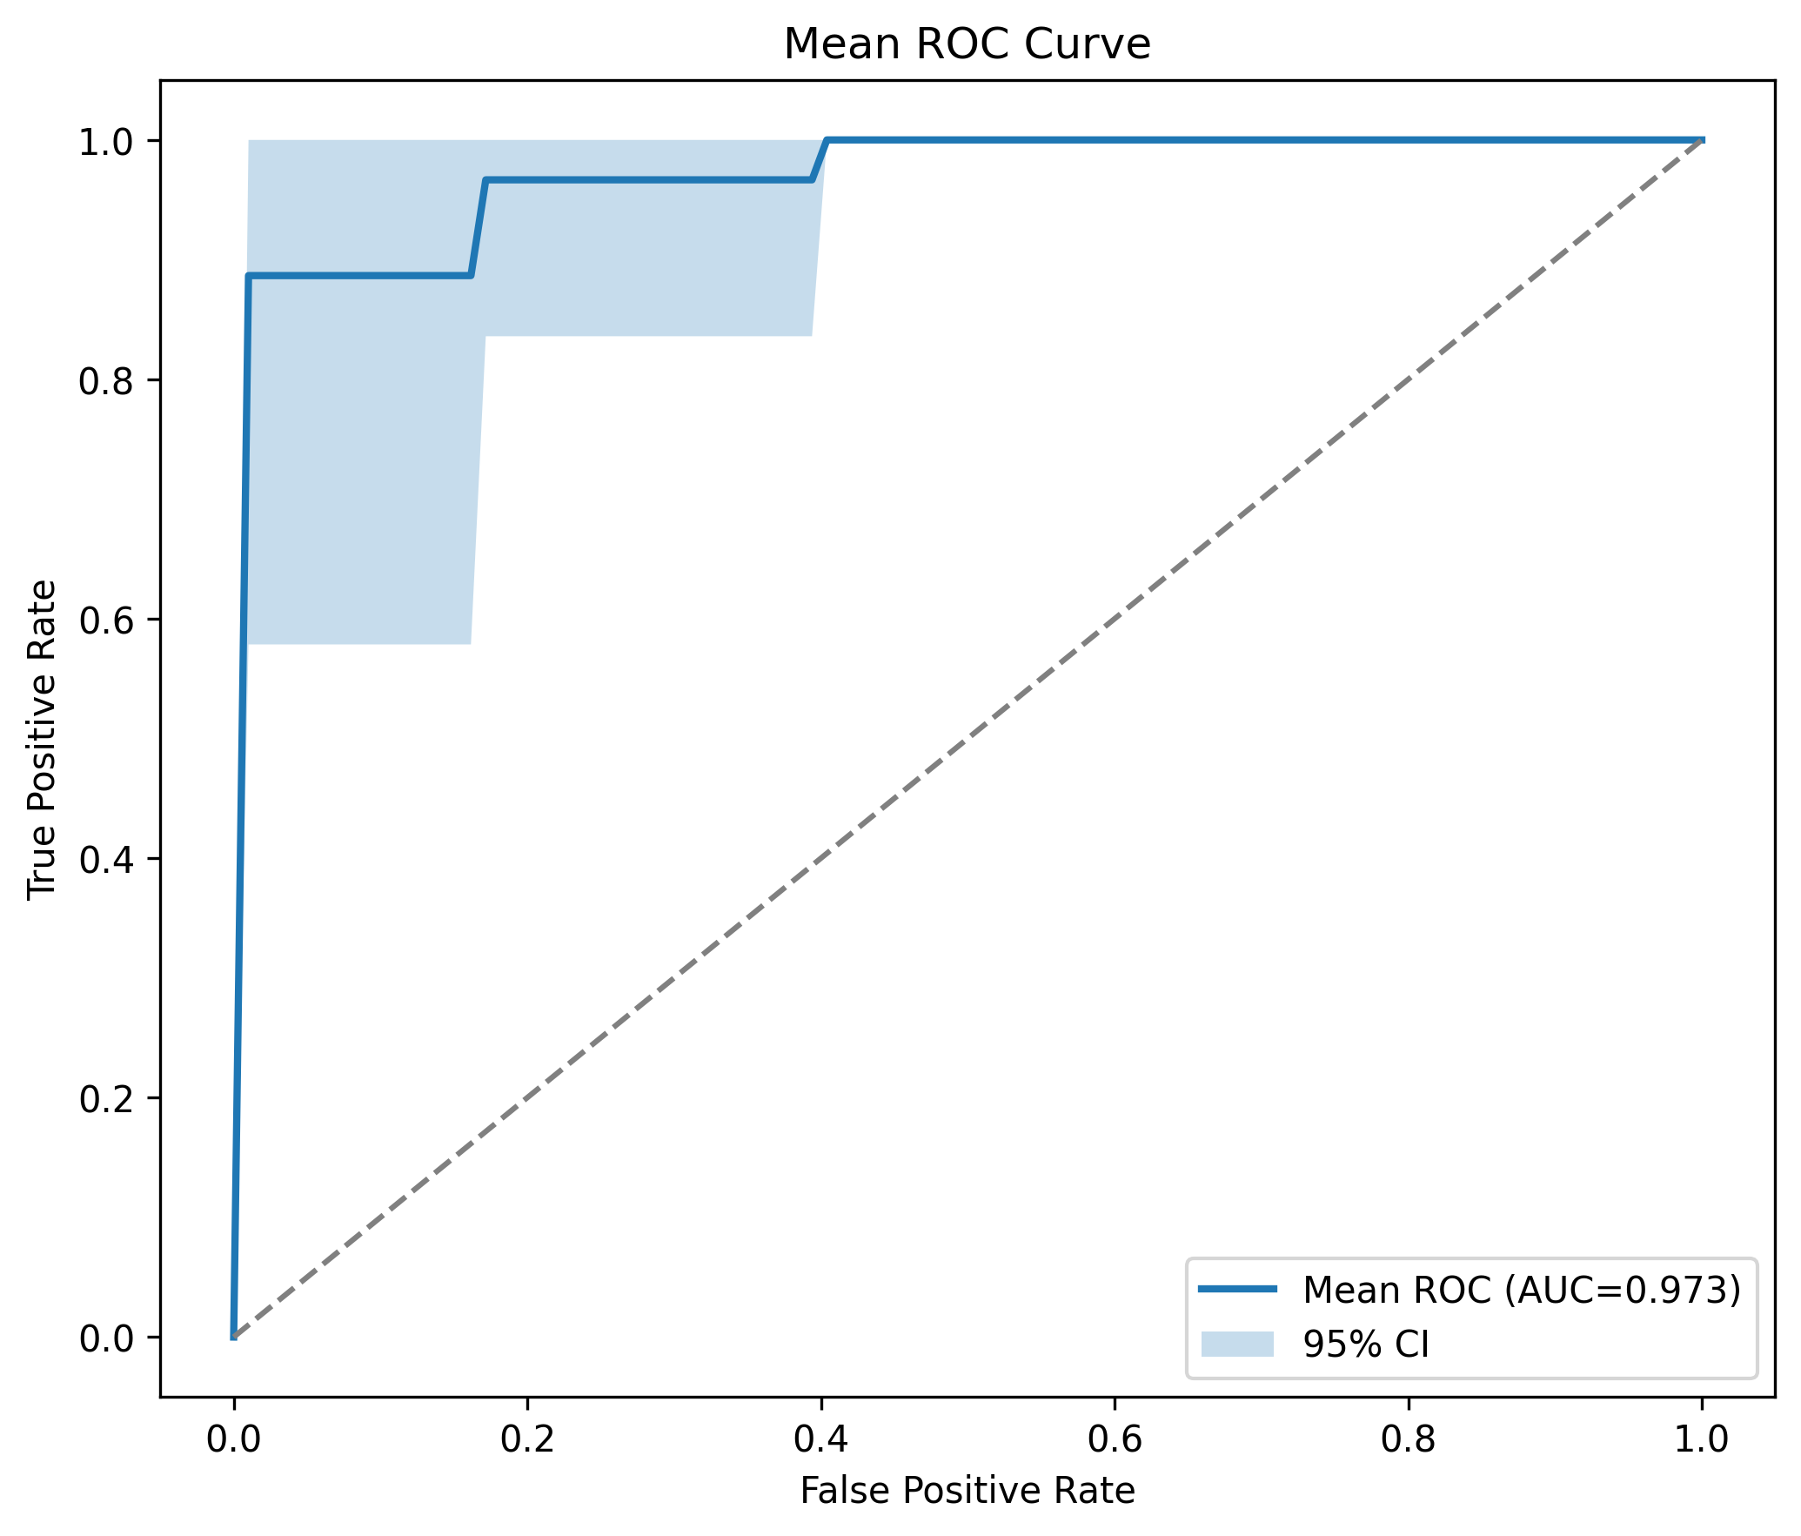
Figure 5. Mean ROC curve with 95% CI, now computed with disposable clones — the shared Random Forest model used everywhere else in the notebook is no longer touched by this diagnostic.

2.2 Nested cross-validation was picking hyperparameters by cherry-picking a fold
For every model, the original code did the equivalent of: run 25 outer folds, each with its own inner GridSearchCV, then take whichever of the 25 outer-fold GridSearchCV objects happened to report the single highest inner validation score, and use that fold's best_estimator_ — fit on only that fold's ~80% training slice — as “the” final model for everything downstream.
That is a form of selection bias: the fold is chosen using a score that was itself used to select it, and the winning estimator was never fit on the full training data available. The nested cross_validate() call is kept exactly as-is (it's the right way to get an unbiased performance estimate — the mean ± std reported per model). For the final model used in later cells, each model now instead runs GridSearchCV once more on the complete dataset, which is the standard, unbiased way to pick hyperparameters for deployment.

2.3 “Highly variable microRNAs” were ranked on the wrong scale
The top-20-most-variable-microRNA selection ranked features by the variance of raw expression values. In expression data, raw-scale variance is dominated almost entirely by mean expression level — highly-expressed microRNAs mechanically have larger absolute variance regardless of biological signal, while modestly-expressed but informative microRNAs get pushed out of the “top 20” purely as a scale artefact. This is why tools like Seurat rank “highly variable features” on log/normalised data, not raw counts. Every downstream figure in that section already plotted the log-transformed data, so ranking on log-variance instead of raw variance makes the selection consistent with what's actually shown.

2.4 Two fragile, undocumented dependencies removed
The DeLong-test cell imported delong_roc_test from a module called rocauc_comparison, which doesn't exist anywhere in this project — on a fresh clone, or for anyone else opening this notebook, that cell would fail immediately with ModuleNotFoundError. The McNemar-test cell depended on statsmodels, which isn't otherwise used or listed as a requirement anywhere in the project.
Both are now implemented inline: the DeLong test uses the standard fast-DeLong algorithm (rank/placement statistics), self-checked against sklearn's own roc_auc_score on your data before use; McNemar's test is the same continuity-corrected statistic statsmodels would have computed, in three lines via scipy. The notebook no longer depends on either external package.

2.5 Ten pairwise significance tests, zero correction for multiple comparisons
With 5 models there are 10 pairwise comparisons. Running that many hypothesis tests without correction inflates the chance of at least one false positive well past 5%. Benjamini-Hochberg FDR correction (implemented inline, no dependency needed) is now applied to the Wilcoxon, McNemar and DeLong comparison tables, alongside the raw p-values. This is not just a formality — in the verification run it changed at least one comparison's conclusion:
Model 1 | Model 2 | Raw p | BH-adjusted p | Significant (q<0.05)
KNN | Logistic Regression | 0.0078 | 0.0469 | True
KNN | SVM | 0.0391 | 0.1172 | False
KNN | Random Forest | 0.0586 | 0.1172 | False

(Wilcoxon signed-rank test on nested-CV ROC AUC scores, sandbox verification run. Two comparisons that would look “borderline significant” on raw p-values alone are clearly not once corrected for testing 10 hypotheses at once.)
Separately, it's worth being explicit that the Wilcoxon test itself is applied to repeated-CV fold scores that are not fully independent (a known, hard-to-avoid property of repeated-CV significance testing — Dietterich, 1998; Bouckaert, 2003). The notebook now says this explicitly rather than implying the p-values are exact.

2.6 A note on which importance measure to trust
Random Forest's built-in feature_importances_ (mean decrease in impurity) is known to be biased toward high-cardinality features and can mislead when predictors are correlated (Strobl et al., 2007) — both apply here, with ~715 correlated microRNA features. Permutation importance and SHAP are both more reliable precisely because they correct for this. The notebook already combined all three into a consensus ranking; a note now explains why that combination matters rather than relying on RF importance alone.

2.7 Reproducibility: optional XGBoost / SHAP imports
The notebook imported xgboost and shap unconditionally at the very top, before any EDA or output — meaning the entire notebook would fail on cell 1 for anyone without those two (separately installed) packages, including a fresh clone of this repo or a colleague's machine. Both are now imported defensively; if either is missing, the notebook prints a clear one-line warning and skips just that model or that analysis section, rather than crashing before showing anything at all. On your own machine, where both are already installed, nothing changes.
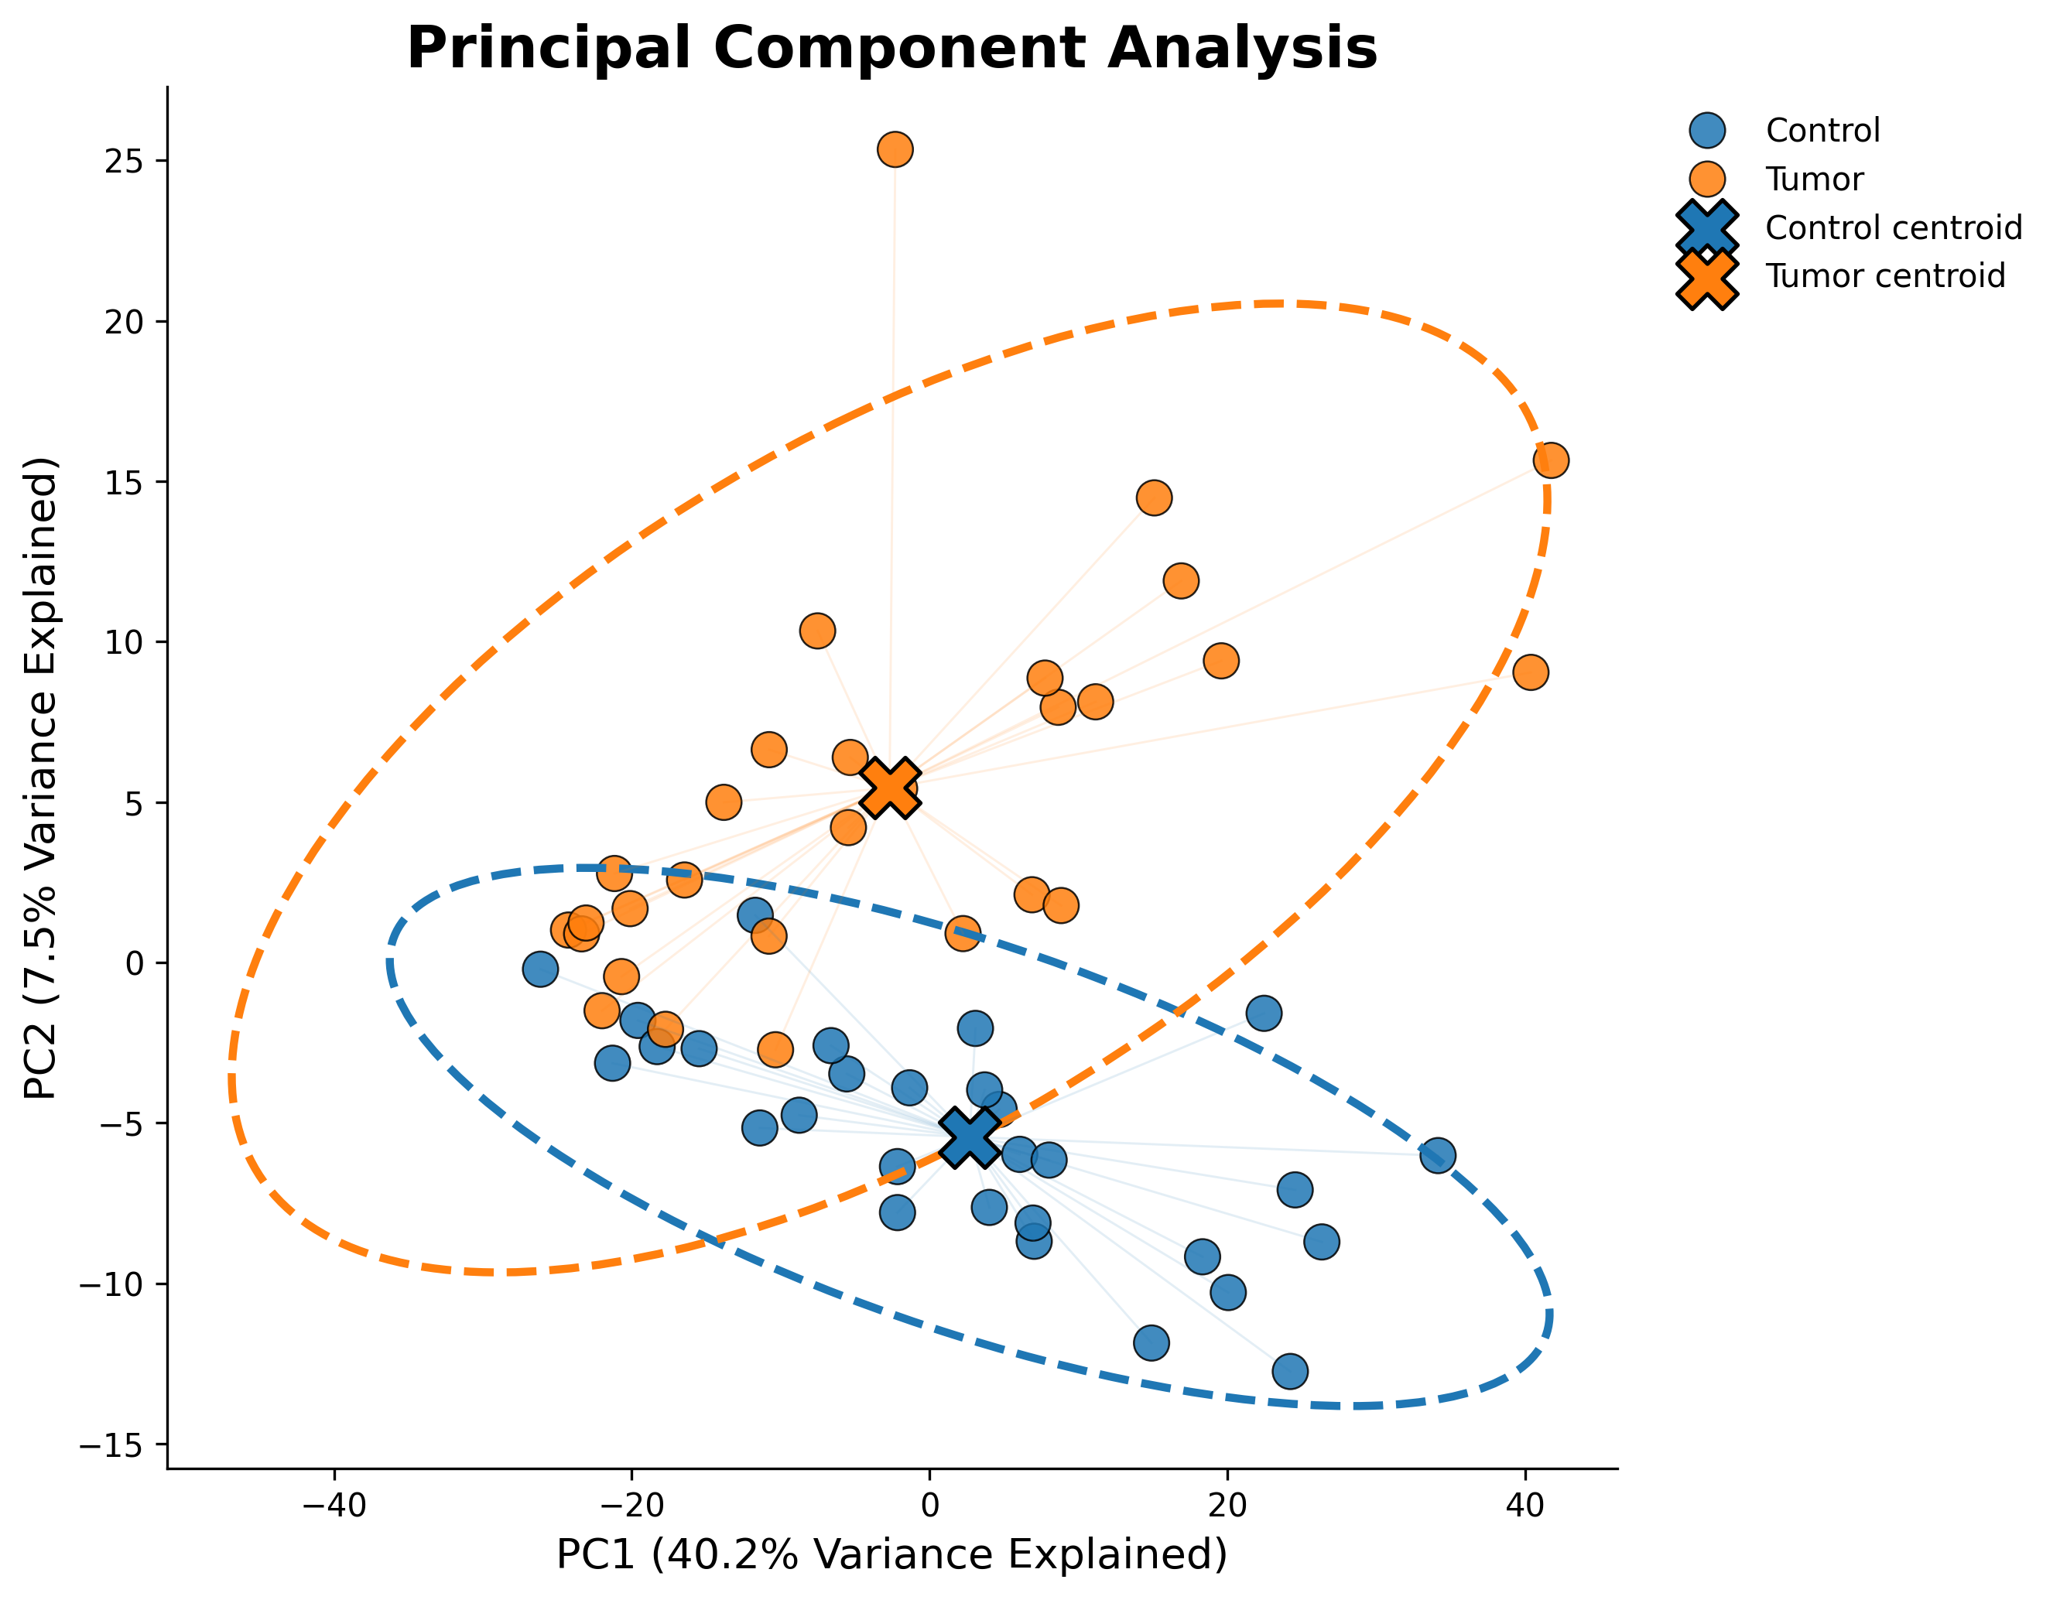
Figure 6. PCA scatter with 95% confidence ellipses and group centroids — one of two final figures kept from what was previously four successive, overwriting draft versions of the same plot (see §2.8).

2.8 Cleanup: a PCA figure that was built four times over
One cell built the PCA scatter plot four times in a row, each version an incremental tweak on the last — with the first two both saving to the same filename, so the plain first draft was silently overwritten and never actually visible in the saved file. It also defined two different confidence-ellipse helper functions, only the second of which was ever used. This is now two clean, deliberate figures, each saved once under its own name.

3. What's verified here vs. what to re-run locally
Everything in §1 and §2 was verified by actually re-running the fixed code against your real data in this session — not just read and reasoned about. Concretely:
Fully executed and verified here: all EDA and preprocessing figures in both notebooks; the student-grade Linear Regression, Decision Tree and Random Forest models and the new cross-validation and leakage-ablation analyses; the cervical-cancer KNN, Logistic Regression, SVM and Random Forest nested cross-validation, ROC/PR/confusion-matrix/calibration/learning/validation curves, the critical leakage fix and its quantitative evidence above, Random Forest and permutation importance, and the Wilcoxon/McNemar/DeLong comparisons with FDR correction.
Fixed but not executed here: every XGBoost cell in both notebooks, and the SHAP biomarker section in the cervical notebook. This cloud sandbox has no access to the package registries needed to install xgboost or shap (your own machine already has both — that's how the original outputs were produced). The code is correct and ready to run; running each notebook once end-to-end on your machine will refresh the XGBoost-inclusive comparison figures/tables and the SHAP summary plot with the fixes in place.
One consequence worth flagging directly: the multi-model comparison figures delivered alongside this report (e.g. the student-grade “Comparison of Regression Models” grid, and the cervical notebook's combined ROC/PR/confusion-matrix figures) reflect 3–4 models rather than the full 4–5, purely because XGBoost couldn't run here. Your local re-run will include it — I deliberately did not overwrite your existing XGBoost-inclusive figures with reduced versions produced in this sandbox.
For the hyperparameter grids specifically: the cervical notebook's full nested-CV grid search (particularly Random Forest's 24-combination grid × 25 outer folds) is compute-heavy — expect it to take a while even on a full machine, longer than the shrunk grid used for this sandbox's fast verification pass (whose numbers appear in §2.5's table and are illustrative, not final).

Both fixed notebooks, all newly-generated figures and tables, and this report have been saved back into your ML_Python project folder.

