Ex6 Mini Project: Algorithmic trading.
Aim of project: to build a p4pi set up that parses trade data to either send a buy or sell signal. This decision is based on the information from the current packets, compared to the previous packet. If the current packet indicates a price lower than the previous packet a buy will be sent. If it indicates higher a sell will be sent. If there is no change the packet will be dropped.
The price data will be stored in a custom header made from the python script price_data:

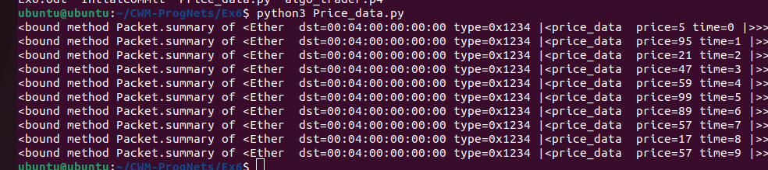
This is the output of the script, creating 10 packets with price data a random in between 0-99, with an associated time variable

