Exercise 1:

Wireshark packet capture exercise:

When connected to the raspberry pi, no packets are captured. This is because we aren’t sending information to and from the raspberry pi.

When connected to the network interface of the lab machine connected to the departmental network, the are lots of packets captured.
When filtering for HTTP traffic (webpages) there is initaly no traffic. In order to display traffic, it was necessary to load a webpage on the lab machine. Here I loaded google.com
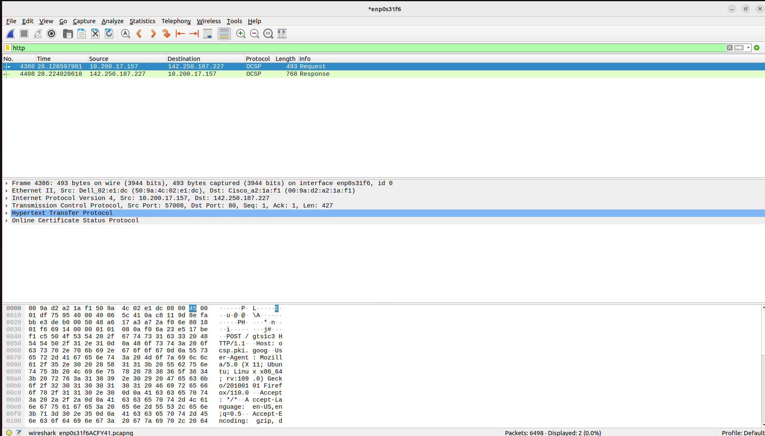

Packets Captured from the Raspberry Pi:
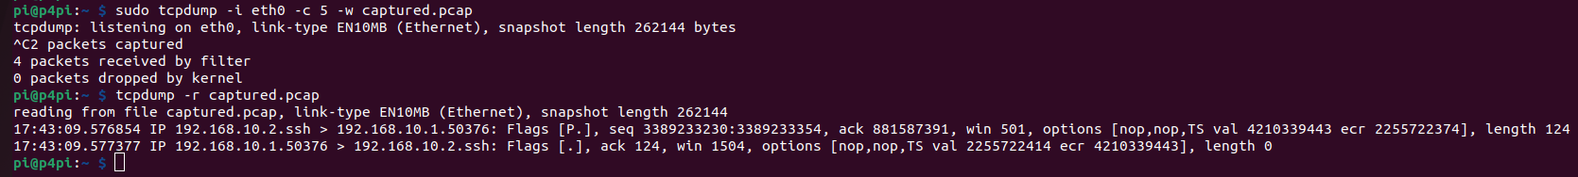
Python packet sending:

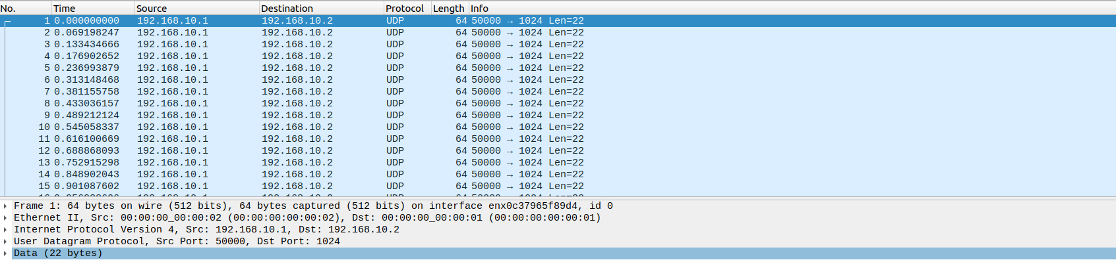
The packet size is 22 bytes of data with the total packet being 64 bytes.
The protocol is UDP.
A filter to ensure only packets we sent is: ip.addr == 192.0.2.1

After editing the python script, the received data packets are shown below. They are 512B in length and TCP as required.
