Ex2:
Ping tests:
- Lab machine to raspberry pi, 10 times, interval 0.2:
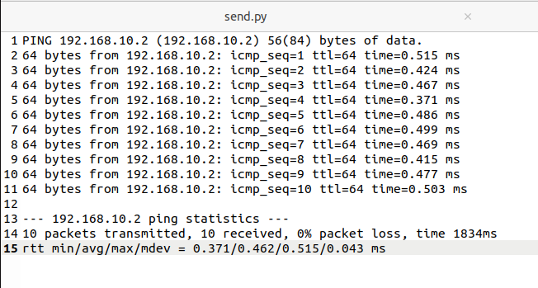
- Raspberry pi to lab machine, 10 times interval 0.2:
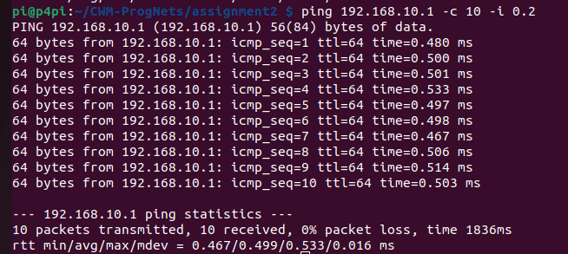
- Raspberry pit to lab machine, 100 times interval 0.001:
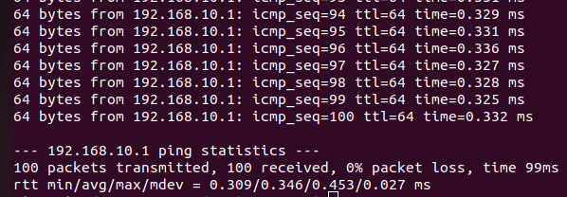
Comparison between the preceding two tests: the second test has a lower average ping time, lower mean and lower max. It has a higher standard deviation but this isn’t as significant of a difference.

- Ping Raspberry Pi to lab machine, 10000, flood.
