Co-Tonomous Lorry Crane: AI Chatbot for Operator Assistance

Reuben Farrel Wibowo
Nanyang Technological University
School of Computing and Data Science

Prof Yang Yaowen
Assoc Prof Tiong Lee Kong, Robert
Nanyang Technological University
School of Civil and Environmental Engineering

Assoc Prof Li King Ho, Holden
Dr Tan Yan Hao
Nanyang Technological University
School of Mechanical and Aerospace Engineering

Abstract - Lorry crane operations demand precision and adherence to safety protocols, yet accidents involving cranes remain prevalent in Singapore. This project presents a multimodal AI chatbot designed to assist lorry crane operators by transforming traditional manual-based learning into an interactive and accessible experience. Leveraging advancements in Computer Vision, Natural Language Processing (NLP), and Speech Recognition, the system aims to improve safety understanding and operational readiness.

The proposed system integrates multiple technologies: OpenCV and Paddle-OCR for detecting and correcting text orientation in scanned documents; Whisper for multilingual speech-to-text conversion; and Google’s Gemini for interpreting visual and textual data. Additionally, Stable Diffusion is employed to generate visual representations from user prompts, enhancing engagement and comprehension.

A RESTful API built using Flask allows users to upload images, receive deskewed outputs, and access extracted data such as timestamps or coordinates. Despite its utility, limitations include reliance on cloud APIs (raising privacy and latency concerns) and suboptimal image generation performance on CPU-based systems.

Initial results show the system processes multimodal input within one minute, making it feasible for real-world applications. Future enhancements aim to integrate real-time sensor feedback and multilingual support tailored for non-native operators. This novel chatbot framework introduces a scalable and interactive approach to safety education in the construction and logistics industries.

Keywords – Computer Vision, Visual Language Model, Chatbot, Artificial Intelligence

1 Introduction
Lorry cranes, a combination of a mobile truck and moving lifting arms, play a crucial role in various industries, including construction, logistics, and infrastructure development. These versatile machines lift and transport heavy loads from one place to another. However, operating lorry cranes requires precision, skill, and a strong understanding of safety protocols. In Singapore, the Ministry of Manpower mandates that crane operators complete relevant courses at accredited training institutions to ensure safe practices [17] [18].

Despite the availability of safety courses, crane-related accidents have increased in recent years. In 2022, the number of dangerous incidents involving cranes nearly quadrupled to 15 cases, contributing to six of the 46 workplace fatalities recorded that year [29][4]. These statistics highlight the need for a system that enhances the safety, comprehension, and accessibility of lorry crane manuals, especially for operators with diverse backgrounds.

One of the emerging ways to educate people about construction safety is an artificial intelligence chatbot. The concept of chatbot involves simulating human-like conversations through text or voice, operated by breakthroughs in Natural Language Processing (NLP) and Computer Vision. The development of chatbots started from ELIZA, a pioneering program created by Joseph Weizenbaum in 1966. ELIZA could engage in basic conversations by reflecting user inputs as questions, demonstrating the potential for automated communication [14]. Since then, chatbots have evolved rapidly, adapting to the growing demands of education, communication, and technology. Recent advancements, such as ChatGPT, have demonstrated capabilities to generate text, answer questions, code, and create diverse content based on extensive datasets [28].

Until these days, a specialized construction safety chatbot does not exist, as it needs to consider several things like different types of transport and tools, how accurately the chatbot can perform calculations, and the limited language skills that the operator. This paper will discuss how to leverage basic chatbot abilities with image generation and multilingual support. Given these features and interactive learning from a chatbot, learning the lorry crane manual can be more effective than just reading a PDF.

2 Literature review
2.1 LORRY CRANE MANUALS AND SAFETY STANDARDS
Understanding the knowledge of a lorry crane operator is required to design an effective chatbot. The key standards used to provide comprehensive insights into the safety, installation, and operational parameters are ISO 15442:2012 and ISO 21308-5:2014 [21].

The safety specifications for loader cranes installed on vehicle chassis or static foundations are described in ISO 15442:2012. The standard specifies design requirements, identifies potentially dangerous situations, and offers recommendations for control systems [10]. To guarantee that cranes are structurally sound under both dynamic and static loads, the document also places a strong emphasis on risk assessments, stress analyses, and test procedures [10]. To maintain balance and avoid overload, this standard emphasizes that operators need to pay extra attention to crane inclination, rated capacity calculations, and dynamic effects [10].

In addition, ISO 21308-5:2014 concentrates on the dimensional data exchange and interoperability between truck chassis suppliers and crane manufacturers [11]. Accurate communication of mass distribution, specifications, installation limitations, and physical is crucial according to this standard [11]. Standardized BEP (Bodywork Exchange Parameters) coding lowers risks during installation and operation [11].

2.2 COMPUTER VISION AND OPTICAL CHARACTER RECOGNITION
Optical Character Recognition (OCR) is a fundamental task in the field of computer vision and machine learning that involves converting images of text into machine-readable and searchable digital text. Traditionally, the interpretation of text from visual inputs like photographs or scanned documents was performed manually by humans [6]. However, advancements in machine learning have significantly automated this process. OCR is one of the earliest and most well-researched applications where machine learning techniques have been employed to mimic human visual understanding of text-based content.

The growing reliance on digitization, especially in data-intensive environments, has emphasized the importance of OCR technology. One major driver is the need to digitize historical or printed documents that were never stored in a digital format. Manual transcription of such documents is labour-intensive and time-consuming, especially when the documents contain structured formats like tables. Moreover, images of documents consume more storage compared to their digital text equivalents, making OCR a storage-efficient solution as well [6].

A typical OCR system relies on a neural network model trained on thousands of examples of individual characters. The training process enables the model to learn subtle distinctions between similar-looking characters, such as '1' and '7'. Only after reaching a satisfactory level of accuracy is the model deployed to process real-world text images. This ensures that the recognized characters are as faithful to the originals as possible [9].

The general OCR pipeline comprises two major stages: object detection and text recognition [9]. In the first stage, the system identifies regions in the image that likely contain textual elements such as characters, words, or lines. This detection process is tailored based on the document type. In the second stage, the detected text regions are passed to the OCR engine for transcription. At this point, the input to the OCR model consists solely of image regions that contain text, enabling the engine to focus purely on character recognition [9].

2.3 LARGE LANGUAGE MODEL (LLM)
Large Language Models (LLMs) are built upon transformer architectures and trained through a multi-stage process involving pre-training, fine-tuning, and alignment, enabling them to perform a stupendous range of natural language tasks. According to Naveed et al., large language models are initially trained through self-supervised learning on extensive text datasets, where they develop the ability to either anticipate the next word or complete sentences by identifying missing words [19]. This stage helps the model develop a general understanding of language. Training objectives include autoregressive, masked language, and unified objectives combining multiple strategies. LLMs typically adopt decoder-only, encoder-decoder, or mixture-of-experts architectures depending on their intended use [23].

Once pre-trained, these models undergo fine-tuning to adapt to specific tasks. Fine-tuning can be standard (using task-specific data), instruction-tuning (using natural language instructions and I/O pairs), or alignment-tuning (ensuring responses align with human values) [15]. Alignment often involves Reinforcement Learning with Human Feedback (RLHF), where a reward model ranks outputs based on human preferences, and the base model is optimized accordingly [24]. Moreover, training such models demands distributed computing, leveraging techniques like data, tensor, pipeline, and model parallelism. Efficient use of resources is further enhanced by optimization techniques like quantization, pruning, and parameter-efficient tuning. Tokenization, positional encoding, attention mechanisms, and activation functions are critical components that support the model’s learning capabilities. Finally, the trained model is utilized via prompting strategies—zero-shot, few-shot, or chain-of-thought—to generalize across unseen tasks [20][25]. This robust and scalable training pipeline underpins the emergence of LLMs as powerful tools in AI research and applications.

3 METHODOLOGY
3.1 Environment and Setup
The system was developed using Python 3.11. Image preprocessing and Optical Character Recognition (OCR) were performed using a combination of OpenCV, Paddle-OCR, and the EAST (Efficient and Accurate Scene Text Detector) deep learning model. The EAST model was loaded from a pre-trained frozen graph file (frozen_east_text_detection.pb), and executed using OpenCV’s DNN module.

To support image-based language understanding, we integrated Google’s Gemini 2.0, which enables multimodal (image + text) input to extract structured information from the processed document. The processed images were temporarily stored in local directories (uploads/ and processed/) for intermediate handling. All experiments were conducted on a Windows 11 with an Intel i7 processor, 16GB RAM, and no dedicated GPU, although the framework is CPU-compatible for broader accessibility.

To ensure consistent results, image resolution was standardized to 640×800 for detection and 640×640 for Gemini model inference. The application was tested using a variety of scanned documents and photos containing textual information such as addresses, coordinates, and timestamps, typical of logistics and invoice-related use cases.

3.2 DATA PRE-PROCESSING
To ensure that textual information from lorry crane safety documents, signboards, or operation panels is accurately extracted and interpreted by the chatbot, a robust preprocessing pipeline was implemented. The preprocessing aims to mitigate issues such as image skew, noise, lighting variation, and misorientation.

3.2.1 Text Region Detection using EAST
The Efficient and Accurate Scene Text (EAST) detector model is utilized to locate text in images. It is powered by a Fully-Convolutional Neural Network with 4 progressively coarser spatial resolutions: f1 to f4 [5]. After that, the results of each resolution will be combined, becoming an average of finer details (shallow layers) and semantics detection (deeper layers) [5]. By this framework, the EAST model can detect the distances from a pixel to the top, bottom, left, and right of a rotated rectangle bounding the text [5].
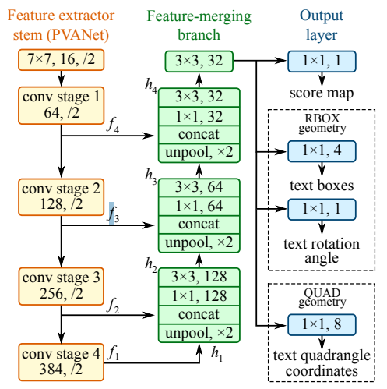
Figure 1. EAST Model Layers and Structure Design (Figure 3 of Zhou et al.).

Having this model creates higher accuracy as it prioritizes the text region when the image must find the orientation of tilted images. The model takes the uploaded image, resized to a fixed input size (640×800), then generates scores and geometry data to detect text regions. Detected boxes are filtered using non-maximum suppression (NMS) with a confidence threshold (0.5 and a threshold (0.4 to avoid inaccurate text-box detection.


Figure 2. Text Regions Detected from the EAST Model (left) and Combined Region with padding (right).

3.2.2 Image Orientation Detection and Deskew
To correct text orientation (which may vary due to camera angles or operator handling), a hybrid deskewing method is applied:
- Contour-based skew angle estimation: Morphological operations and contour analysis are used to estimate the skew angle of the text. If the contour-based method detects significant skew (typically ≥10°), the image is rotated accordingly using a robust matrix transformation.
- Paddle-OCR Orientation Classifier: If the image is already upright (e.g., 0°, 90°, 180°), the Paddle-OCR orientation classifier is used to determine the correct top-down alignment. Paddle-OCR only classifies into four classes, including 0, 90, 180, and 270. This framework is built over the combination of feature extraction by Convolutional Neural Network (CNNs) and sequence labelling by bidirectional Long Short-Term Memory (BiLSTM) in Recurrent Neural Network (RNNs)[1] [7].

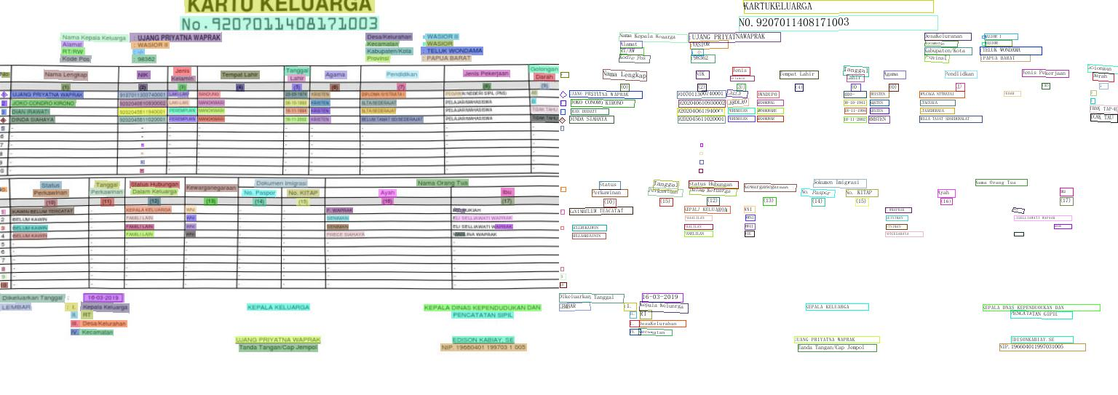
Figure 3. Paddle-OCR text detection result.


Figure 4. Paddle-OCR pre-processing result. Left is the original, center is the rotated image, and right is when the parameter “unwarping” is on.
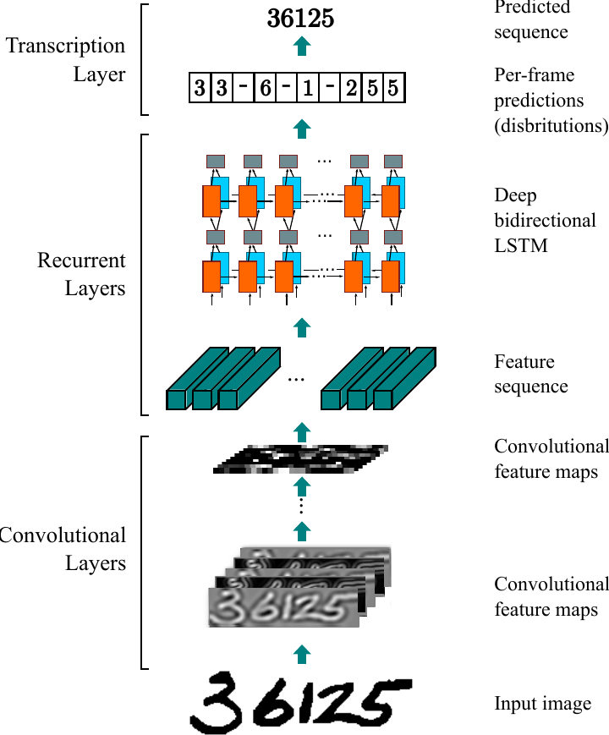
Figure 5. Convolutional Recurrent Neural Network Structure Design (Figure 5 of Andre et al.) [1].

3.3 MODELS
3.3.1 Visual Language Model
In terms of reading images and explaining PDFs, Google’s Gemini comes in handy. Gemini is built on top of large language models (LLMs). It is capable of understanding and generating content across text, images, audio, and uploaded documents. At its core, Gemini combines a pretrained language model with external sources like Google Search and various extensions to enrich its responses — a technique known as retrieval-augmented generation (RAG) [22][27].

RAG consists of a three-step framework, including indexing, retrieval, and generation. Indexing starts by extracting external documents, PDFs, and research papers into vector representations using an embedded model. The next phase is retrieval, where the user’s input or query is also transformed into vectors. The system performs a semantic similarity search and retrieves the top-k most relevant parts. Finally, the model combines context and prompt parts to generate answers in the generation phase [26].
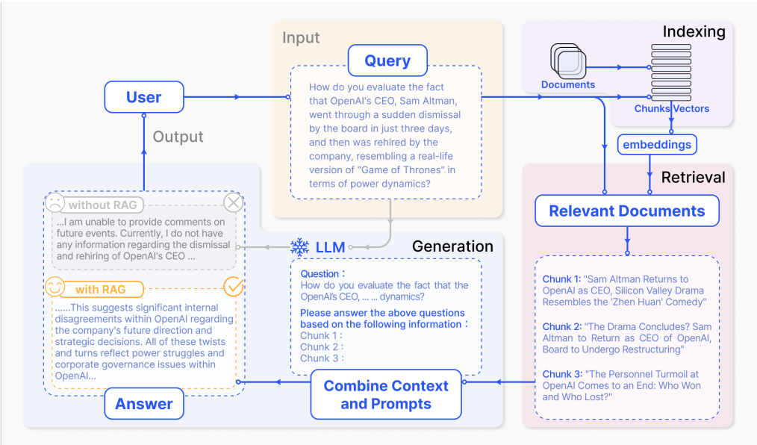
Figure 6. Retrieval-Augmented Generation Work Flow (Figure 2 of Gao et al.) [26].
3.3.1.1 Comparison of Visual Language Models
In terms of text detection, comparisons were made between Google’s Gemini-2.0-Flash, OpenAI, and Qwen2. OpenAI is a paid subscription with model GPT 4.1, while the other models are used with a free account.
Table 1: Runtime Comparison between models for 400 images
Model | Average Runtime (sec)
Gemini-2.0-Flash | 3.1481034755706787
OpenAI | 4.347527921199799
Qwen2 | 10.445920382901323

As stated in the table, Gemini-2.0-Flash has the most efficient runtime. Another thing to note is also the model Qwen2 that is used here needs to be adjusted in the language needed in the picture using Paddle-OCR Document Text Processing Module, as if the language in the input and the model parameter are not clicked, the runtime increases twice. Despite the runtime, Qwen2 is the only model that can be downloaded and called locally, while Gemini and OpenAI need to use an API Key, and the data will be stored in their training.

OpenAI is more of a conversational model, while Gemini is made to focus on multimodal data processing and generation. The table below shows how ChatGPT and Gemini answer different types of exams. The assessment focuses on token generation speed, response latency, and overall cost-effectiveness, offering insights into how well the models perform and adapt across multiple languages. Overall, they both have similar scores, with Gemini having slightly higher accuracy than ChatGPT. Therefore, Gemini 2.0 Flash is used because of its accuracy, efficiency, and free version availability [2].

Table 2: General performance on industry-standard exam [2]
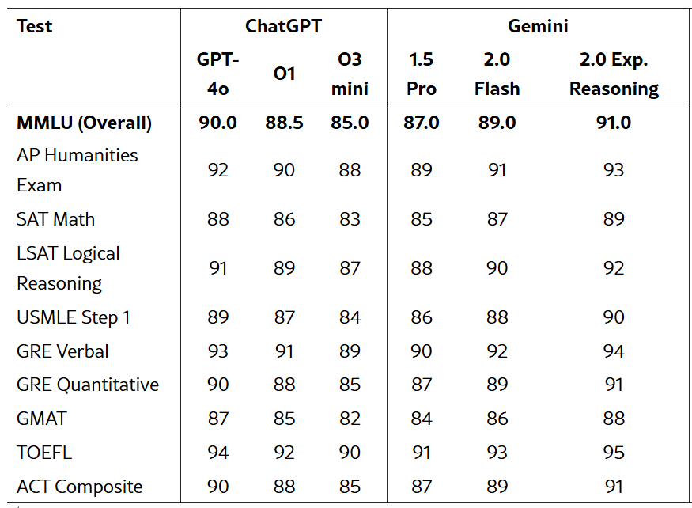

3.3.2 Speech Recognition to text
To enable voice recognition, this project uses OpenAI’s Whisper, a sequence-to-sequence transformer model trained on 680,000 hours of multilingual and multitask audio data from the internet. The transformer consists of an encoder that takes in log-Mel spectrograms of the audio and a decoder that outputs transcriptions and translations. Whisper is the first model to combine transcription, translation, voice activity detection, timestamp prediction, and language identification [3].

3.3.3 Image Generation
This project uses Flux’s Stable Diffusion to generate an image from a text prompt. Flux firstly encodes text description to a sequence of text embeddings by using the T5 encoder, then combines with image embeddings [8]. During image generation, FLUX performs multi-step sampling. In each step, the model updates the image representation, guided by both the image context and the relevant text tokens [8]. This iterative process culminates in a high-fidelity image that matches the given textual input [8]. Flux will create a layout map, then eventually render the fine-grained details along the way.

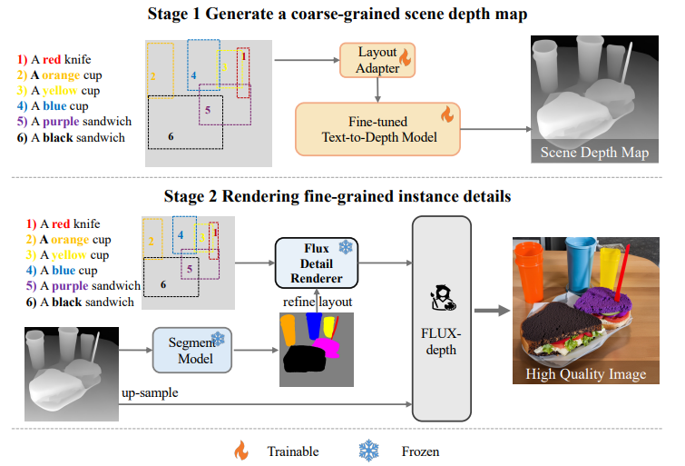
Figure 7. Flux Work Flow (Figure 2 of Zhou et al.) [8].

3.4 IMPLEMENTATION
To enable seamless and user-friendly interaction with the image preprocessing and information extraction system, a RESTful API was developed using the Flask framework. The backend server handles image uploads, processes the input using a pipeline involving the EAST text detection model and Paddle-OCR’s orientation classifier, and returns both the enhanced image and extracted semantic data. Upon receiving a POST request with an image file, the server saves the image locally, performs text region detection via OpenCV’s EAST model, and constructs a combined bounding box around the detected areas. The deskewed image is then recomposed from the array with the original layout.

Subsequently, the pre-processed image is passed to Google’s Gemini Vision API (Gemini 2.0 Flash). The system prompt used here is
“You are an expert assistant for lorry crane operators. Provide accurate, practical, and safety-focused guidance related to lorry crane usage, safety checks, load limits, regulations, daily inspections, maintenance, signaling, and best practices. Respond in a helpful and professional tone.”

Throughout this process, detailed timing breakdowns are shown to evaluate system performance. With the API structure, this program can be developed to connect with lorry crane controller applications. This project also handles different types of inputs by combining Gemini, Stable Diffusion, and Whisper.
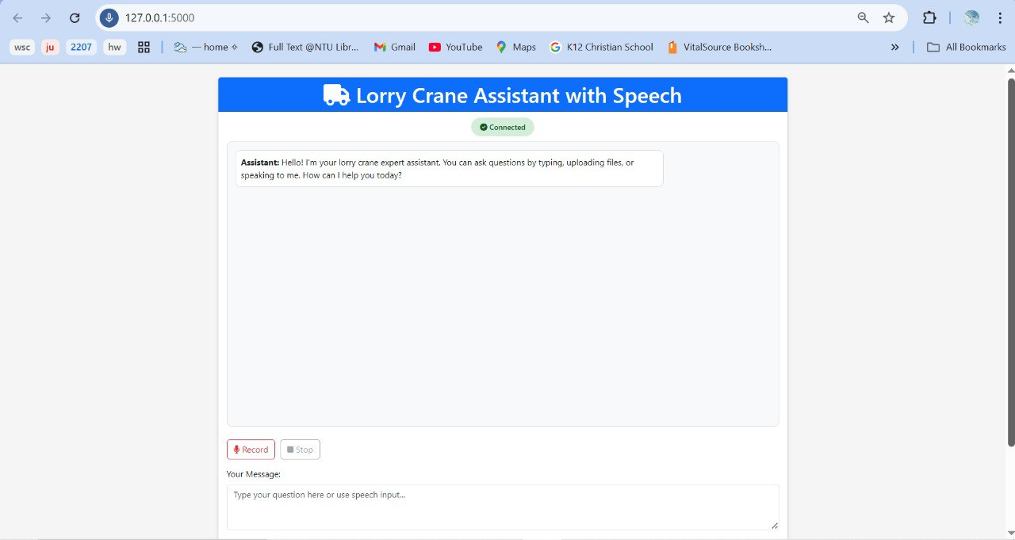
Figure 8. UI/UX using Flask, HTML, CSS, and Bootstrap. Consists of a chat screen, a type-box, a record for audio, upload files, images, and audio.

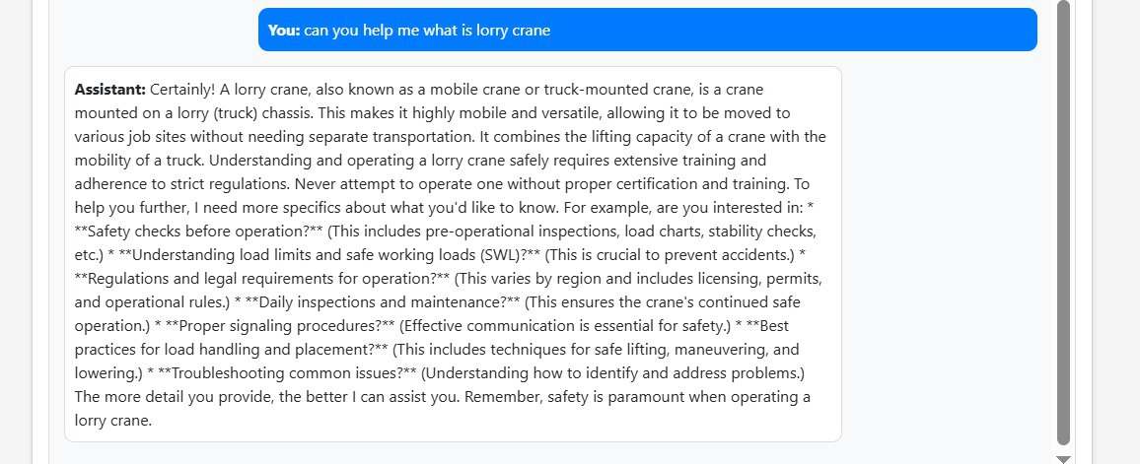
Figure 9. Example of Text Response

3.5 Data Flow

The flowchart illustrates a multimodal system that processes user input through image, audio, PDF, or text. If image generation is toggled, it generates a full image using text and image embeddings. Image input is pre-processed, checked for rotation, and passed to OCR and Gemini VLM for text extraction. Audio is transcribed using Whisper, while PDFs are read with PyMuPDF. All inputs are converted to text prompts, embedded, and processed via NLP to generate a response, which is then displayed in a Flask UI.
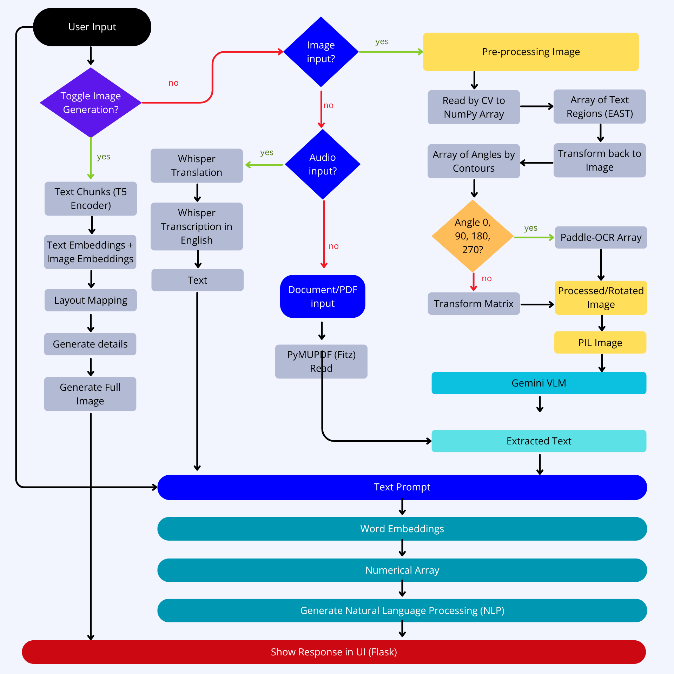
Figure 10. Multimodal Chatbot Flowchart.

4 RESULT
Table 3: Runtime Performance for All Steps

Task | Model | Average Runtime (sec)
Preprocessing | Paddle-OCR | 0.0024
Preprocessing | Contours | 1.0279
Audio Processing | Whisper | 5.2849
Image-to-text | Gemini 2.0 Flash | 3.1481034755706787
Image Generation | Stable Diffusion | 45.2392

Overall, the whole process in the GPU needs almost 1 minute on average from reading the prompt and inputs until sending the response back to the interface. The most time-consuming task is image generation.

5 LIMITATIONS
One of the primary limitations of the system is its dependence on the Gemini API, which requires the use of an API key. This raises potential concerns around data privacy, as submitted prompts could become part of the model's future training data, especially in advanced versions. Moreover, the API comes with token usage limits, which may restrict prolonged or high-volume interactions in real-time environments.

Another challenge lies in the performance of the image generation process. Using Stable Diffusion on a CPU-based system results in high latency, with image generation often taking around one minute. When using low-resource environments, loading and processing large models can take more than ten minutes, which is not practical for time-sensitive industrial use. Additionally, most visual language models cannot operate efficiently on CPUs, significantly impacting the system's responsiveness.

The current user interface, though functional, still requires improvements in usability and visual feedback. Enhancements in UI/UX design could make the system more intuitive, especially for users with limited technical experience. Importantly, the prototype does not yet integrate with real-world sensors or control systems of lorry cranes. This limits the assistant’s ability to deliver context-aware safety feedback based on actual operational parameters. Such integration is a critical avenue for future development to enable proactive and intelligent decision-making support in real-time.

6 Conclusion
The integration of speech, vision, and text understanding into a single AI assistant offers an innovative and practical tool for lorry crane operators. By facilitating multimodal inputs, the chatbot enables efficient access to safety guidelines and context-specific advice. Preliminary testing confirms its usefulness in real-world scenarios. Future work will focus on real-time deployment, expanded language support, and integrating live sensor data from crane systems to further personalize safety insights.

Acknowledgment
I would like to thank Dr Tan Yan Hao for his endless help and guidance throughout the research process. I would also want to express my gratitude to Prof Yang Yaowen for letting me and my friends do this project.

I would like to acknowledge the funding support from Nanyang Technological University – URECA Undergraduate Research Programme for this research project.

References
[1] A. G. Hochuli et al., “A comprehensive comparison of end-to-end approaches for handwritten digit string recognition,” Expert Systems with Applications, vol. 165, p. 114196, Nov. 2020. doi:10.1016/j.eswa.2020.114196

[2] A. Rahman et al., "Comparative Analysis Based on DeepSeek, ChatGPT, and Google Gemini: Features, Techniques, Performance, Future Prospects," arXiv preprint arXiv:2503.04783, Feb. 2025. [Online]. Available: https://arxiv.org/abs/2503.04783

[3] A. Radford, J. W. Kim, T. Xu, G. Brockman, C. McLeavey, and I. Sutskever, “Robust Speech Recognition via Large-Scale Weak Supervision,” OpenAI, 2022. [Online]. Available: https://github.com/openai/whisper

[4] A. Tam, “More workplace deaths and close shaves in 2022; surge in cases of work-related health conditions: MOM,” CNA, Apr. 4, 2023. [Online]. Available: https://www.channelnewsasia.com/singapore/workplace-fatalities-2022-rise-occupational-diseases-3395566

[5] C. Zhou et al., “EAST: An efficient and accurate scene text detector,” in Proc. IEEE Conf. Computer Vis. Pattern Recognition. (CVPR), Jul. 2017, pp. 2642–2651. doi:10.1109/cvpr.2017.283

[6] D. Fleischhacker, R. Kern, and W. Göderle, “Enhancing OCR in historical documents with complex layouts through machine learning,” Int. J. Digit. Libr., vol. 26, no. 1, Feb. 2025. doi:10.1007/s00799-025-00413-z

[7] DhanushKumar, “PADDLEOCR,” Medium. [Online]. Available: https://medium.com/@danushidk507/paddleocr-439a8d92fb1a (accessed Jun. 27, 2025).

[8] D. Zhou, J. Xie, Z. Yang, and Y. Yang, “3DIS-FLUX: Simple and Efficient Multi-Instance Generation with DiT Rendering,” arXiv preprint arXiv:2501.05131, Jan. 2025. [Online]. Available: https://arxiv.org/abs/2501.05131

[9] H. Wang, C. Pan, X. Guo, C. Ji, and K. Deng, “From object detection to text detection and recognition: A brief evolution history of optical character recognition,” WIREs Comput. Stat., vol. 13, no. 5, Jan. 2021. doi:10.1002/wics 1547

[10] ISO 15442:2012, ISO, Jun. 2012. [Online]. Available: https://www.iso.org/standard/57221.html

[11] ISO 21308-5:2014, ISO, 2011. [Online]. Available: https://www.iso.org/standard/37813.html

[12] J. Chung and T. Delteil, “A computationally efficient pipeline approach to full page offline handwritten text recognition,” in Proc. Int. Conf. Doc. Anal. Recognit. Workshops (ICDARW), Sep. 2019, pp. 35–40. doi:10.1109/icdarw.2019.40078

[13] J. Martínek, L. Lenc, and P. Král, “Building an efficient OCR system for historical documents with little training data,” Neural Comput. Appl., vol. 32, no. 23, pp. 17209–17227, May 2020. doi:10.1007/s00521-020-04910-x

[14] J. Weizenbaum, “Eliza—a computer program for the study of natural language communication between man and machine,” Commun. ACM, vol. 9, no. 1, pp. 36–45, 1966. doi:10.1145/365153.365168

[15] K. Chen, M. Seuret, J. Hennebert, and R. Ingold, “Convolutional Neural Networks for page segmentation of Historical Document Images,” in Proc. 14th IAPR Int. Conf. Doc. Anal. Recognit. (ICDAR), Nov. 2017, pp. 965–970. doi:10.1109/icdar.2017.161

[16] M. Mihić, “Classification of construction hazards for a universal hazard identification methodology,” J. Civ. Eng. Manag., vol. 26, no. 2, pp. 147–159, 2020. doi:10.3846/jcem 2020.11932

[17] Ministry of Manpower, Workplace Safety and Health (Operation of Cranes), 2011. [Online]. Available: https://sso.agc.gov.sg/SL/WSHA2006-S515-2011

[18] Ministry of Manpower, Workplace Safety and Health Report 2022, pp. 26–27, 2002. [Online]. Available: https://www.mom.gov.sg/-/media/mom/documents/safety-health/reports-stats/wsh-national-statistics/wsh-national-stats-2022.pdf

[19] N. Naveed et al., "A comprehensive overview of large language models," arXiv preprint arXiv:2307.06435, 2023.

[20] R. Wang, R. Wang, Y. Shen, C. Wu, Q. Zhou, and R. Chandra, "Evaluation of LLMs for Mathematical Problem Solving," arXiv preprint arXiv:2506.00309, May 2025. [Online]. Available: https://arxiv.org/abs/2506.00309

[21] S. Almaskati, S. Kermanshachi, A. Pamidimukkala, K. Loganathan, and Z. Yin, “A review on Construction Safety: Hazards, mitigation strategies, and impacted sectors,” Buildings, vol. 14, no. 2, p. 526, 2024. doi:10.3390/buildings14020526

[22] “What is Gemini and how does it work,” Gemini. [Online]. Available: https://gemini.google/overview/?hl=en (accessed Jun. 27, 2025).

[23] X. Liu et al., “Understanding LLMs: A comprehensive overview from training to inference,” Jan. 2024. doi:10.2139/ssrn.4706201

[24] X. Zhang et al., "FRAME: Boosting LLMs with A Four-Quadrant Multi-Stage Pretraining Strategy," arXiv preprint arXiv:2502.05551v4, May 2025.

[25] Y. F. Tan, T. Connie, M. K. Goh, and A. B. Teoh, “A pipeline approach to context-aware handwritten text recognition,” Appl. Sci., vol. 12, no. 4, p. 1870, Feb. 2022. doi:10.3390/app12041870

[26] Y. Gao et al., “Retrieval-Augmented Generation for Large Language Models: A Survey,” arXiv preprint arXiv:2312.10997v5, Mar. 2024. [Online]. Available: https://arxiv.org/abs/2312.10997

[27] “Gemini Team et al.,” Gemini: A Family of Highly Capable Multimodal Models, 2023. [Online]. Available: arXiv. Accessed Jun. 2025.

[28] “OPENAI’S CHATGPT AND THE PROSPECT OF LIMITLESS INFORMATION: A Conversation with ChatGPT,” J. Int. Aff., vol. 75, no. 1, pp. 379–386, 2022. [Online]. Available: https://www.jstor.org/stable/27203141

[29] Wong, “New $4m tech grant for construction firms to address spike in Crane-related workplace accidents,” The Straits Times, Nov. 25, 2024. [Online]. Available: https://www.straitstimes.com/singapore/new-4m-tech-grant-for-construction-firms-to-address-spike-in-crane-related-workplace-accidents

APPENDIX
GitHub Repository Link: https://github.com/reubennf/VLMChatbot.git

