**PRODUCT TRACKER**

A Blockchain based marketplace to track product ownership and details

Submitted By

Reuben Prasad

Project ID: CED-B4-G16

**CONTENTS**

1. Abstract

2. Modules

3. dApp Workflow Diagram

4. Smart Contract Process Flow Diagram

**ABSTRACT**

* This Project enables buying and selling of products on a blockchain based marketplace.
* A manufacturer can list products for sale – the product details like id, name, date of purchase, warranty etc. are stored in the blockchain.
* Buyers can see the details of the listed products and purchase them using Ether.
* When a product is purchased, the ownership of the product is transferred to the buyer.
* The buyer can then choose to re-sell his product, and the remaining warranty period can easily be verified by other buyers.
* The application uses React framework for the front-end and the backend is a solidity smart contract.

**dApp Workflow Diagram**

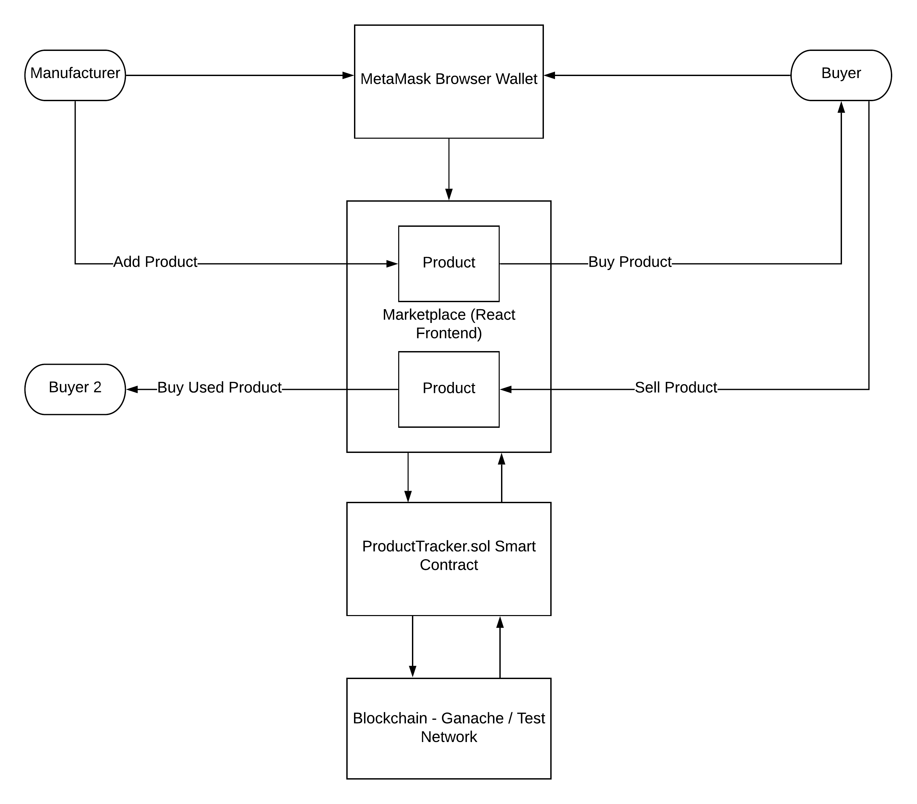

**Smart Contract Process Flow Diagram**

