

**Laboratory Report**

**Course ID: CPS 2390**

**Lab 1: A Simple LC-3 Program**

**Student: Reuben Hernandez**

**Instructor: Dr. Jing-Chiou Liou**

**Date: 10/10/2017**

**Description**

**This section describes the objective of the lab based on your understanding from the actual lab. work.**

1. **The first part: Load data from memory location x3100 and store into to a Register.**
2. **The second part: Determine if the data from memory location x3100 is odd or even. If odd store x0001 into memory location x3101 or if even store x0000 into memory location x3101.**
3. **The third part: Count the 1’s of the data in memory location x3100 and store the sum of 1’s into memory location x3102.**

**Procedure and Notes**

1. **This section is an itemized list of notes you took by following the lab procedure.**
2. **It should cover any data/information that you are asked to note or observe at that procedure.**
3. **You can list any problems you encountered during the lab. Try to discuss why it occurred and how to get it right for the correct response, if you did.**

* **Numbers that are odd end with a 1 in binary, numbers that are even end in a 0 in binary**
* **How do I create a loop in LC-3?**
* **How to calculate the offsets correctly.**
* **To go up using branch, subtract a number from the PC value**
* **To go down using branch, add a number to the PC value**
* **Masking can be used to determine the value of a bit in a certain location**
* **Use shifting to count how many 1’s are in the 16-bit number.**
* **How can I implement a nest branch.**
* **Flowchart attached on the back.**

**Results and Reports**

**This section is for you to discuss your final results and/or report from your conclusion. If there are any files prepared as the results of the lab, make sure they are accessible electronically.**

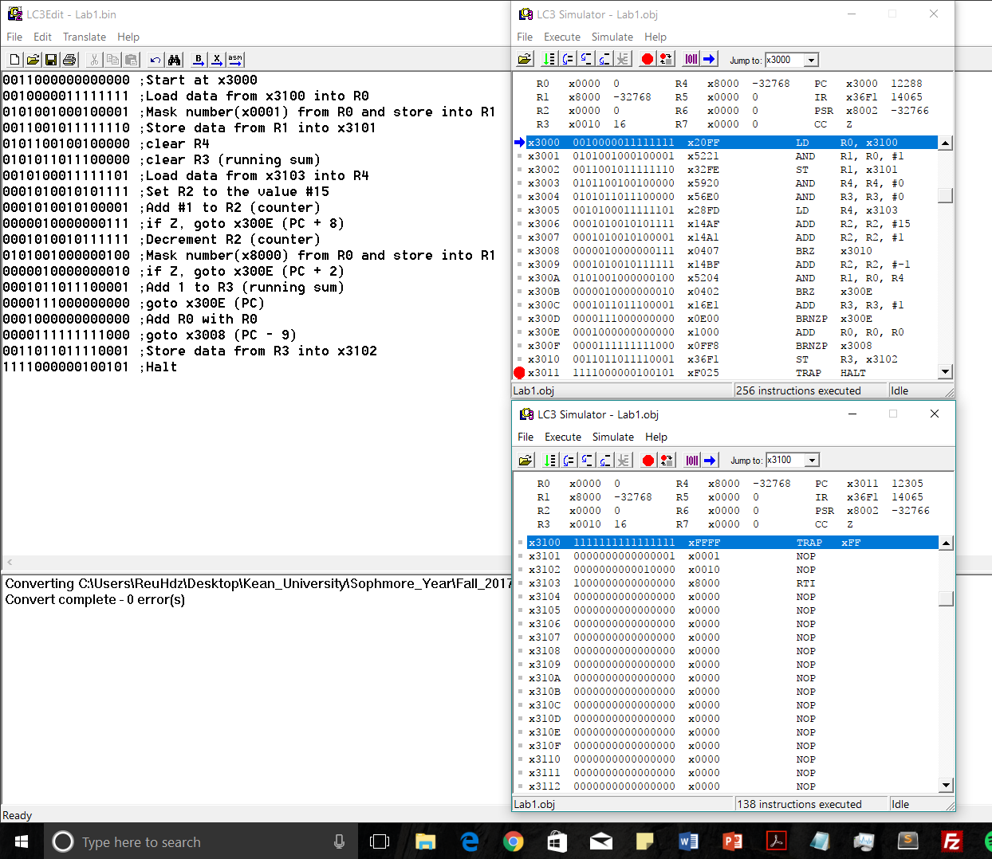

**Final result: Data from memory location x3100 was masked to determine if it was odd or even. In this case mem[x3100] = xFFFF, this program will store the value of LSB of mem[x3100] into mem[x3101]. Then using left bit shifts, each time the program encounters a 1, R3 (running sum) is incremented. This process continues till R2 (counter) is equal to 0. The value of R3 (number of 1’s) is then stored into mem[x3102] .**

**mem[x3100] = xFFFF  
mem[x3101] = x0001  
mem[x3102] =x0010**

**Reference and Acknowledgement**

**With or without encountering any difficulty, if you surfed the Internet to find some hints or to learn new information and/or technology to help you conducting the lab, you should include the information sources, such as the URLs, citations, or books.**

**If you received assistance from anyone (e.g. working together with some friend for the lab), you should acknowledge people’s contribution.**

1. Patt, Yale N., and Sanjay J. Patel. *Introduction to Computing Systems: from Bits and Gates to C and Beyond*. McGraw-Hill Higher Education, 2004.