

**Laboratory Report**

**Course ID: CPS 2390**

**Lab 2: Problem Solving with the LC-3**

**Student: Reuben Hernandez**

**Instructor: Dr. Jing-Chiou Liou**

**Date:10/19/17**

**Description**

1. **First part: Perform a left shift/rotate on the value in memory location x3100. The number of bits to be shifted/rotated is found in memory location x3101.**
2. **Second part: With the left shift, replace the LSB with a #0 as the number is shifted to the left. With the left rotate, as the number is shifted to the left add the MSB back into the LSB.**
3. **Third part: Store the values of left shift/rotate into memory location x31002.**

**Procedure and Notes**

* **Left shift happens when a number is added to itself.**
* **The value in mem[x3101] will be used as a counter to keep track of how many times left shift/rotate will be used on a number.**
* **Masking can be used to determine the MSB value to be used later.**
* **Grab the masking value from a memory location.**
* **For rotate, mask MSB then left shift by 1 bit and add the MSB to the LSB.**
* **Encountered some issues with my initial flowchart for rotate, but I fixed by doing the step over in the LC-3 simulate to track what my instructions where doing.**
* ***Flowcharts for rotate/shift attached on the back.***

**Results and Reports**

**Left Rotate: 5 bits**

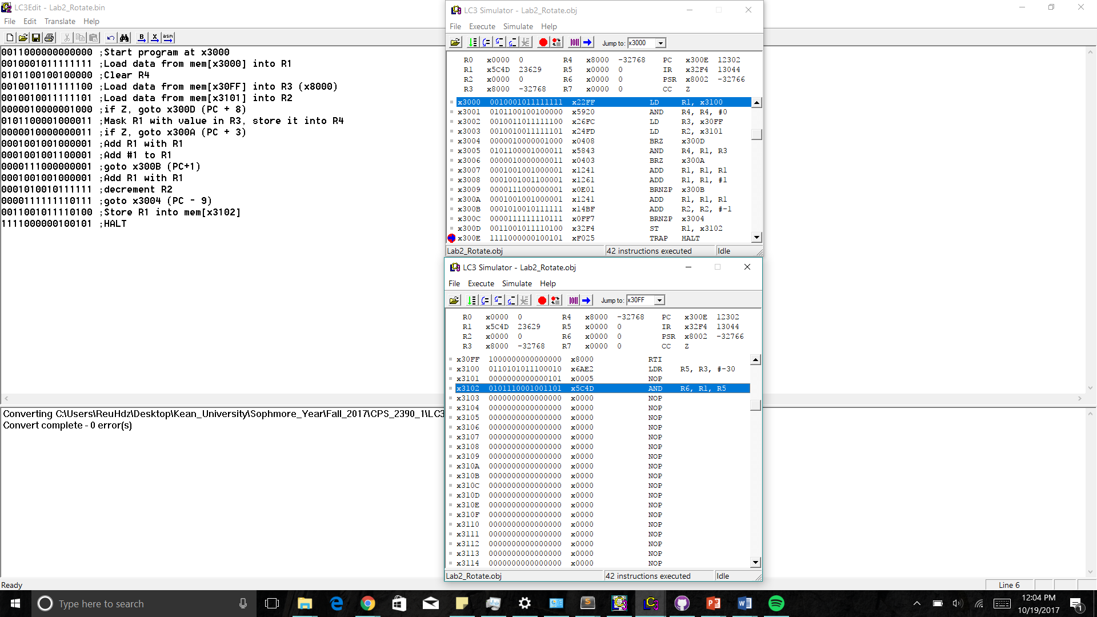

1. **Memory location data x3100 is loaded to R1, memory location x3101 data is loaded into R2.**
2. **R3 contains the value to mask R1.**
3. **Then it loops n times (n = value in R2). Inside the loop there is another loop that checks the MSB of R1. If the MSB = 1 then add R1 to R1 and then add #1 to R1, else just add R1 to R1.**
4. **The results of the left rotate are stored back into memory location x3102.  
   Results: mem[x3100] = x6AE2, mem[x3101] = x0005, mem[x3102] = x5C4D**

**Left Shift: 4 bits**

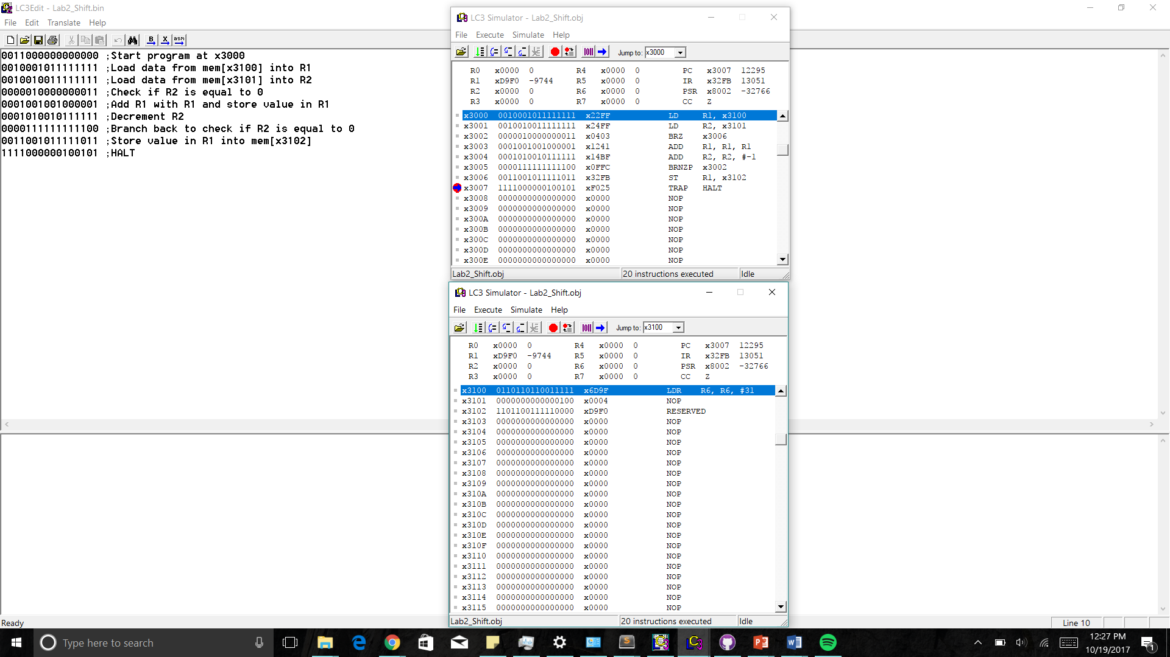

1. **Data from memory location x3100 to R1 and data from memory location x3101 into R2.**
2. **A loop checks if R2 = 0. If R2 ≠ 0 then add R1 to R1 and decrement R2.**
3. **The results of the left shift are stored into memory location x3102**

**Results: [x3100] = x6D9F, mem[x3101] = x0004, mem[x3102] = xD9F0**

**Reference and Acknowledgement**

1. Patt, Yale N., and Sanjay J. Patel. *Introduction to Computing Systems: from Bits and Gates to C and Beyond*. McGraw-Hill Higher Education, 2004.
2. PowerPoint slides from lecture.