

**Laboratory Report**

**Course ID: CPS 2390**

**Lab 4: Cryptography**

**Student: Reuben Hernandez**

**Instructor: Dr. Jing-Chiou Liou**

**Date: 11/30/17**

**Description**

**Take a string from memory then encrypt it by toggling bits [3:0] of each character and then adding a key to that character. The encrypted string will be stored into memory. Then the program will decrypt the encrypted string and store into memory**

**Procedure and Notes**

1. **How to take input from users?**
2. **How does toggling work?**
3. **How to store user input into memory?**
4. **How to encrypt each character then decrypt it.**
5. **Use LDR and STR to go through memory to load and store.**
6. **Flowchart on the back**

**Results and Reports**

**Pt. 1 – Get String**

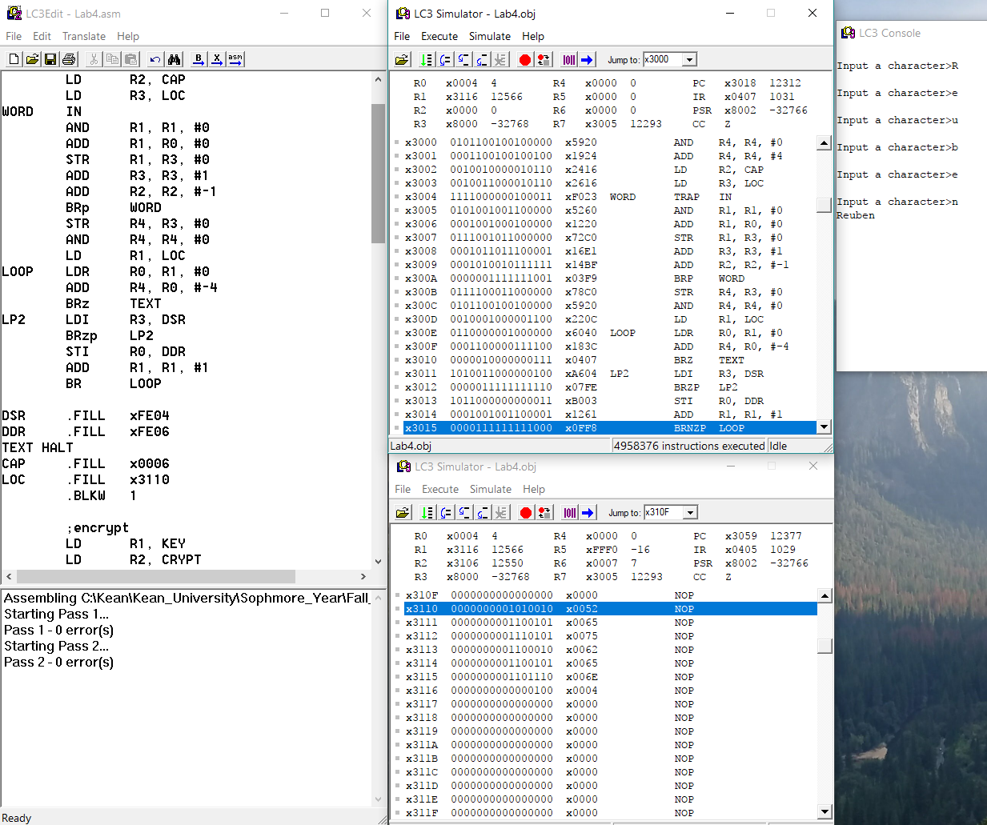

1. **This part of the program takes user input and stores into memory starting at mem[x3110]**
2. **“Reuben” is the text entered by the user.**

**Pt. 2 – Encrypt String**

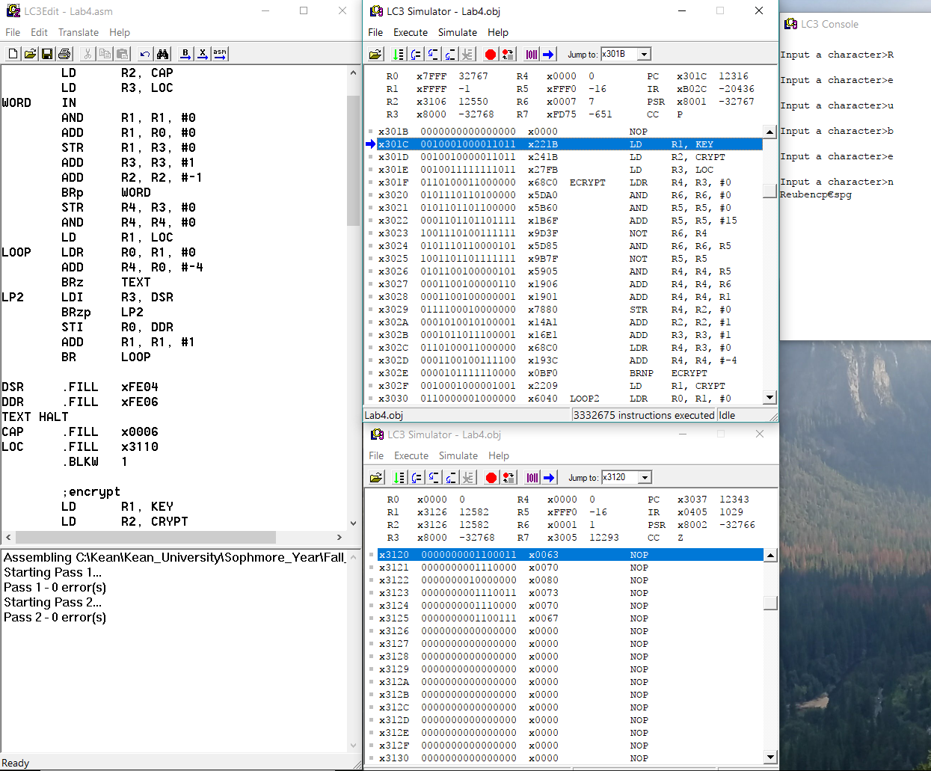

1. **This program takes the string from memory and toggles bits [3:0] for each character then it adds the key to the character. In this case the key is #6**
2. **After the whole string is encrypted it is stored back into memory starting at mem[x3120]**
3. **The console shows the string encrypted.**

**Pt. 3 – Decrypt String**

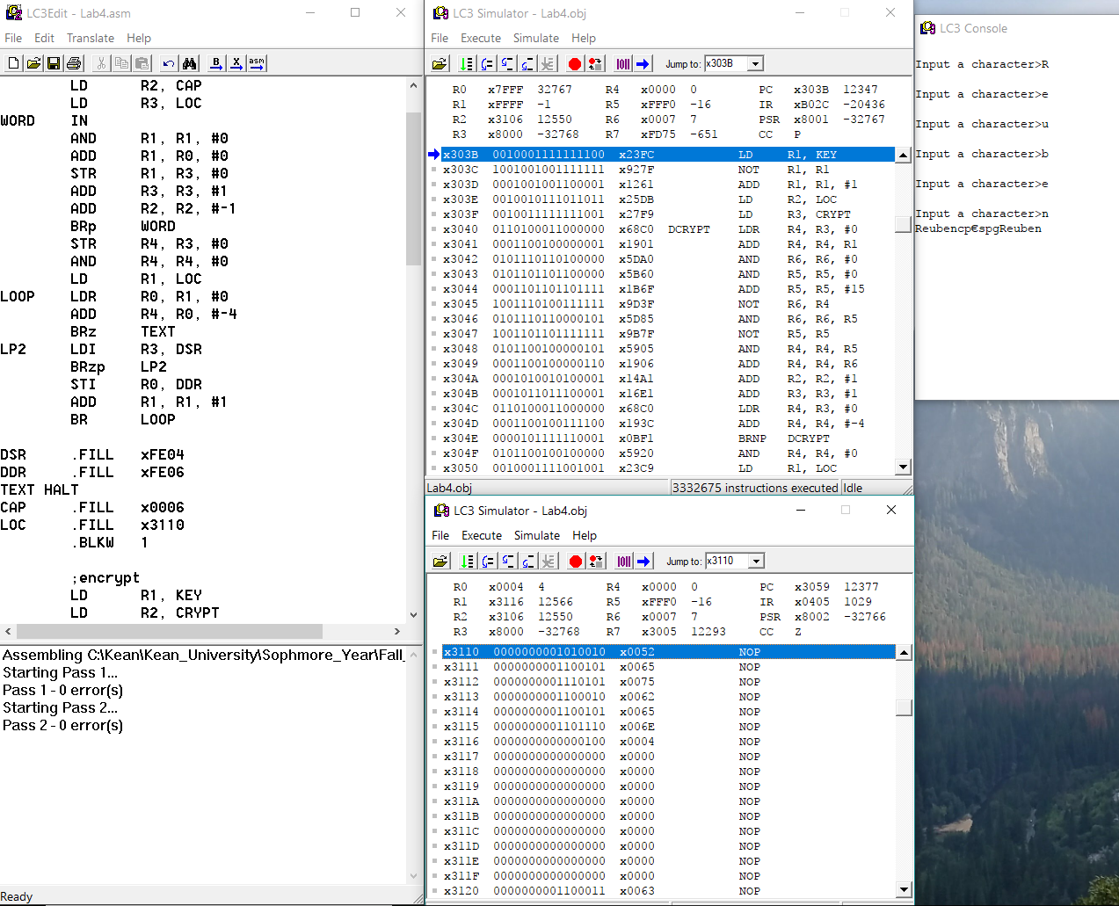

1. **Finally, this part of the programs takes the encrypted string from memory and subtracts the key (#6) and then toggles bits [3:0].**
2. **This will revert the encrypted string back into the original.**
3. **The second “Reuben” in the console is the decrypted text.**

**Reference and Acknowledgement**

1. Patt, Yale N., and Sanjay J. Patel. *Introduction to Computing Systems: from Bits and Gates to C and Beyond*. McGraw-Hill Higher Education, 2004.
2. PowerPoint slides from lecture.