

**Laboratory Report**

**Course ID: CPS 2390**

**Lab 5: Input and output with the LC-3**

**Student: Reuben Hernandez**

**Instructor: Dr. Jing-Chiou Liou**

**Date: 12/14/17**

**Description**

**This program will prompt the user to enter digits from the keyboard to guess the answer (#6). After 9 guesses then the program will terminate. Any type of character that is not a digit will result in a “Invalid input” error.**

**Procedure and Notes**

1. **How to print out whole strings onto the terminal.**
2. **How to convert ASCII code from keyboard into binary values.**
3. **How to determine what an invalid input is.**
4. **How to determine if a value is too small or too big.**
5. **How to print data from a register.**

**Results and Reports**

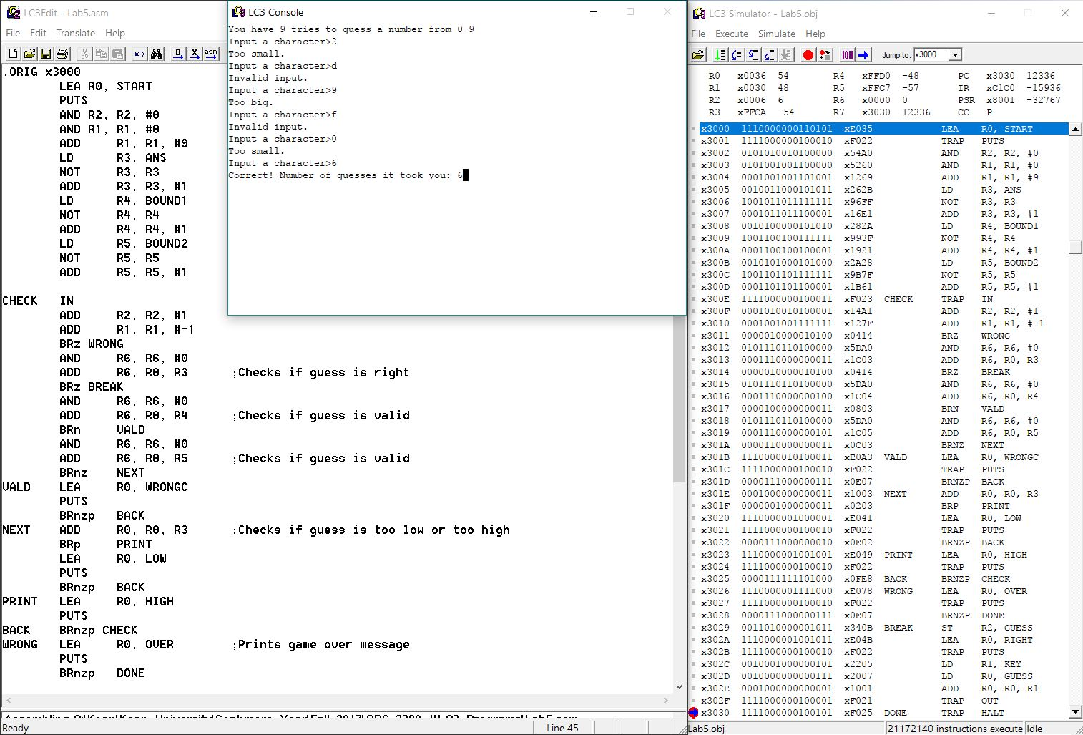

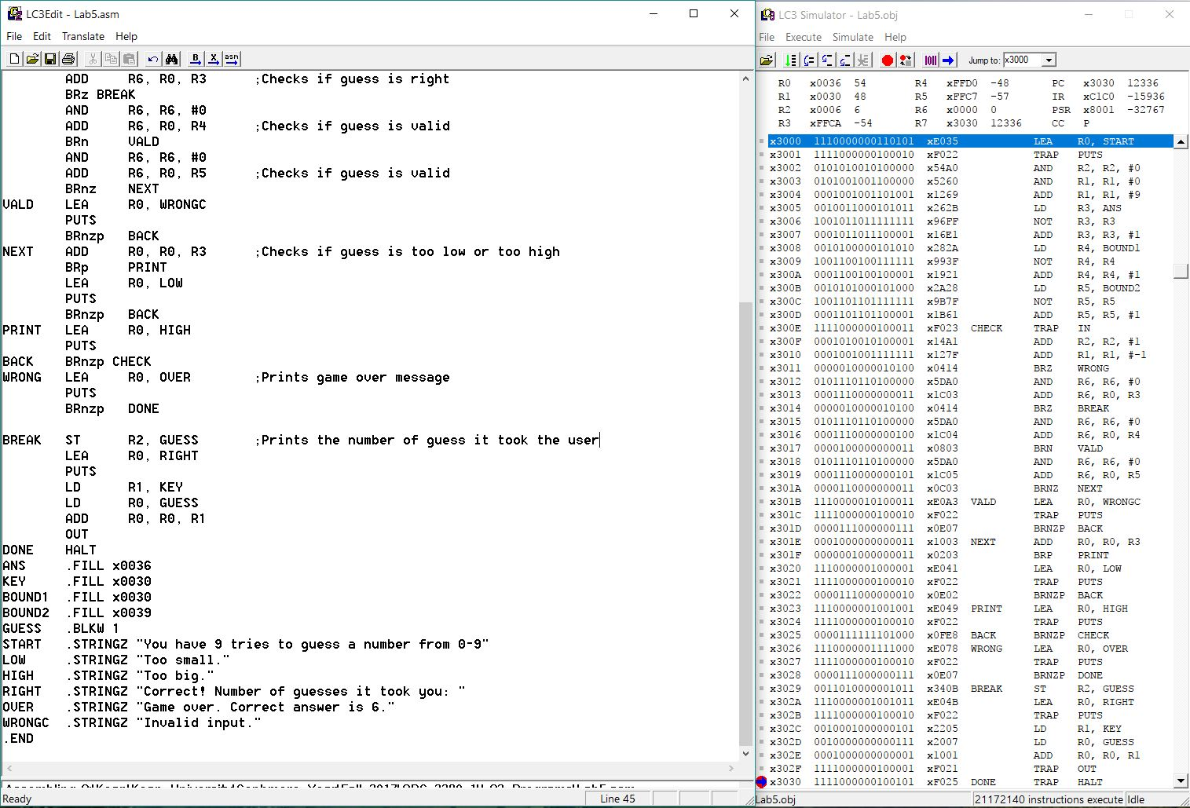

1. First it prompts the user to enter a number between 0 – 9. The program subtracts x0030 from the input to convert it from ascii code.
2. Then it checks if guess is right, if it is it’ll print the “correct” message. If not, it’ll check if the input is invalid (input < x0030 or input > x0039), if so it’ll print out the “invalid” message. Finally, it checks if the guess is too high (input > 6) or too low (input < 9).
3. If user runs out of guesses then the program will print out the “game over” message.

**Reference and Acknowledgement**

1. Patt, Yale N., and Sanjay J. Patel. *Introduction to Computing Systems: from Bits and Gates to C and Beyond*. McGraw-Hill Higher Education, 2004.
2. PowerPoint slides from lecture.