

Laboratory Report

Course ID: CPS 2390
Lab 3: machine/assembly code programs

Student: Reuben Hernandez

Instructor: Dr. Jing-Chiou Liou

Date: 11/16/17
Description
This lab asks to create an assembly code program that will multiply and divide two integers.
Procedure and Notes
- How to implement multiply and divided only using the ADD, NOT instructions?
- You can multiply by adding the first number n times. N = the second number.
- How to get a negative answer when multiplying a negative number and a positive number?
- How to get a positive answer when multiplying two negative numbers?
- Division can be performed by subtracting the dividend by the divisor.

Results and Reports
Multiply
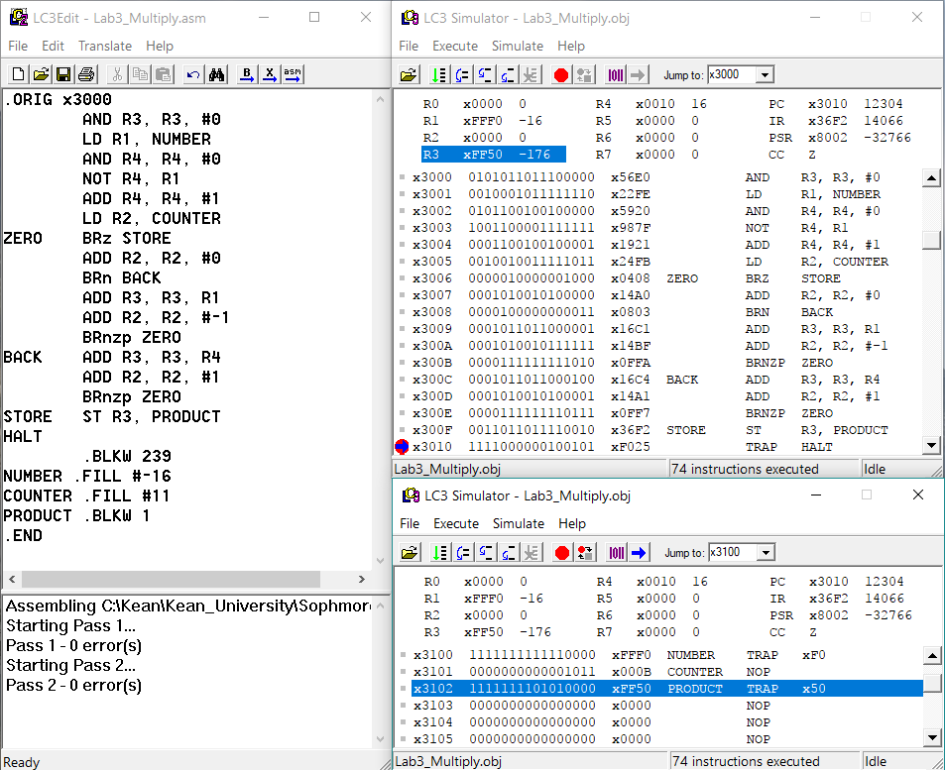
- This program loads data from mem[x3100] to R1 and mem[x3101] to R2(counter)
- R4 will contain the 2’s compliment of R1. R3 will hold the result.
- The product checks if the counter if 0 if it is then it will return 0. If not then it will check if the counter is negative.
- If negative then add R3 with R4 and increment the counter; if not then add R3 with R1 and decrement the counter.
- Finally it will store the result back into mem[x3102]
- In this case: -16x11 = -176, the programs stores -176 into memory.
Cases it will work under: If both integers are positive. | If one integer is negative and one integer is positive. | If both integers are negative. | If one integer is zero.
Divide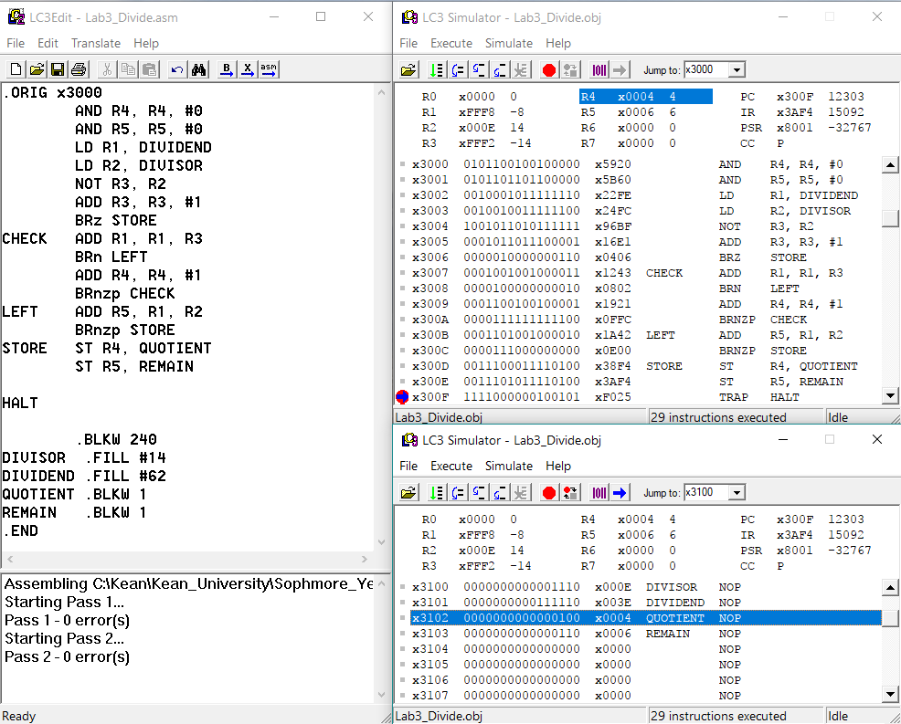
- Clears R4 (Quotient) and R5 (Remainder). Loads dividend from memory into R1 and divisor from memory into R2. R3 will contain the 2’s compliment of R2
- It checks if R3 is zero. If yes then it will store 0 back into memory. If not then it will add R1 with R3 and check if the result is negative.
- If the result is negative then it will add R1 with R2 and store into R5 (the remainder).
- If the result is not negative then it will add #1 to R4 (the quotient).
- Once the program is done with the division, it stores the quotient into mem[x3102] and the remainder into mem[x3103].
- In this case: 64/14 = 4 Remainder 6. R4 = 4 and R5 = 6.
Cases it will work under: Both numbers have to be positive | Dividend > divisor
Reference and Acknowledgement
- Patt, Yale N., and Sanjay J. Patel. Introduction to Computing Systems: from Bits and Gates to C and Beyond. McGraw-Hill Higher Education, 2004.
- PowerPoint slides from lecture.

