La Palma Earthquakes
Steve Purves
Rowan Cockett
2026-09-29
Abstract
In September 2021, a significant jump in seismic activity on the island of La Palma (Canary Islands, Spain) signaled the start of a volcanic crisis that still continues at the time of writing. Earthquake data is continually collected and published by the Instituto Geográphico Nacional (IGN). …

1 Introduction
_{Source: Article Notebook}
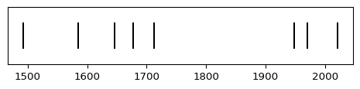
Figure 1: Timeline of recent earthquakes on La Palma
_{Source: Article Notebook}
_{Source: Article Notebook}
Based on data up to and including 1971, eruptions on La Palma happen every 79.8 years on average.
Studies of the magma systems feeding the volcano, such as Marrero et al. (2019), have proposed that there are two main magma reservoirs feeding the Cumbre Vieja volcano; one in the mantle (30-40km depth) which charges and in turn feeds a shallower crustal reservoir (10-20km depth).
Eight eruptions have been recorded since the late 1400s (Figure 1).
Data and methods are discussed in Section 2.
Let $x$ denote the number of eruptions in a year. Then, $x$ can be modeled by a Poisson distribution
$$p(x)=\frac{e^{−λ}λ^{x}}{x!} (1)$$
where $λ$ is the rate of eruptions per year. Using Equation 1, the probability of an eruption in the next $t$ years can be calculated.
Table 1: Recent historic eruptions on La Palma
Name | Year
Current | 2021
Teneguía | 1971
Nambroque | 1949
El Charco | 1712
Volcán San Antonio | 1677
Volcán San Martin | 1646
Tajuya near El Paso | 1585
Montaña Quemada | 1492

Table 1 summarises the eruptions recorded since the colonization of the islands by Europeans in the late 1400s.
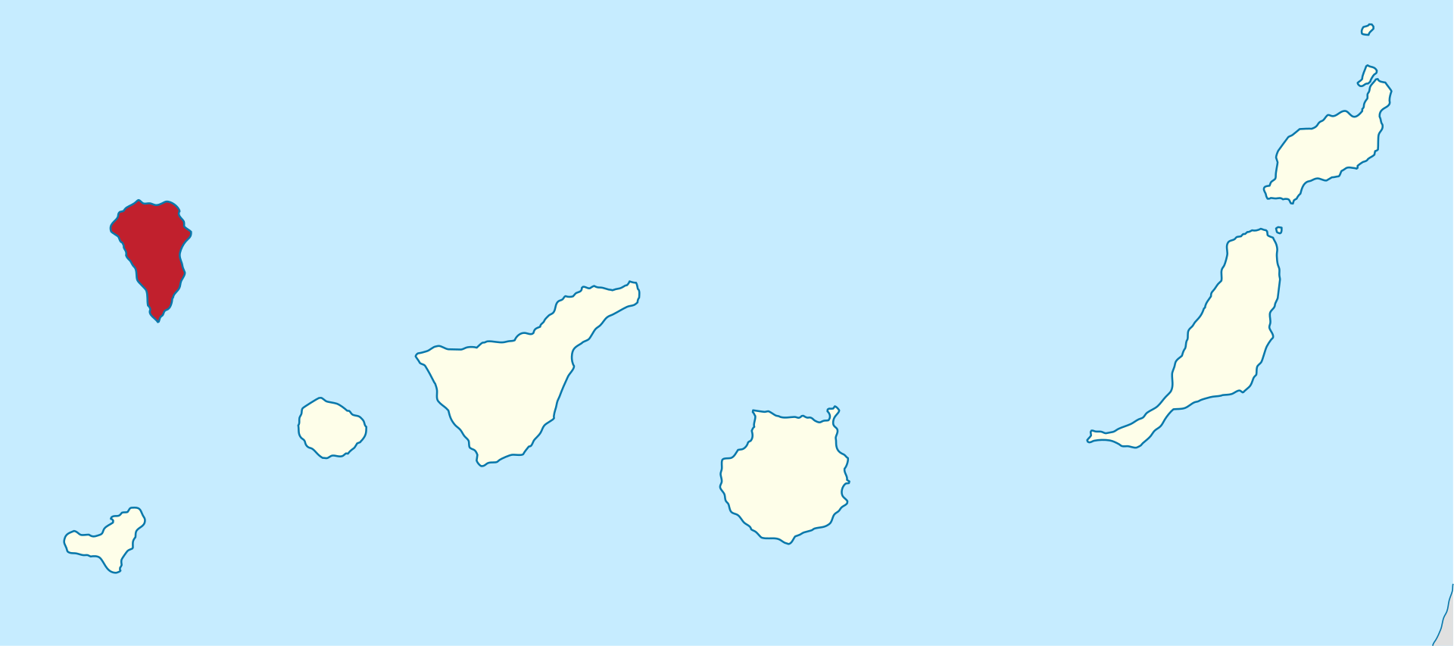
Figure 2: Map of La Palma
La Palma is one of the west most islands in the Volcanic Archipelago of the Canary Islands (Figure 2).
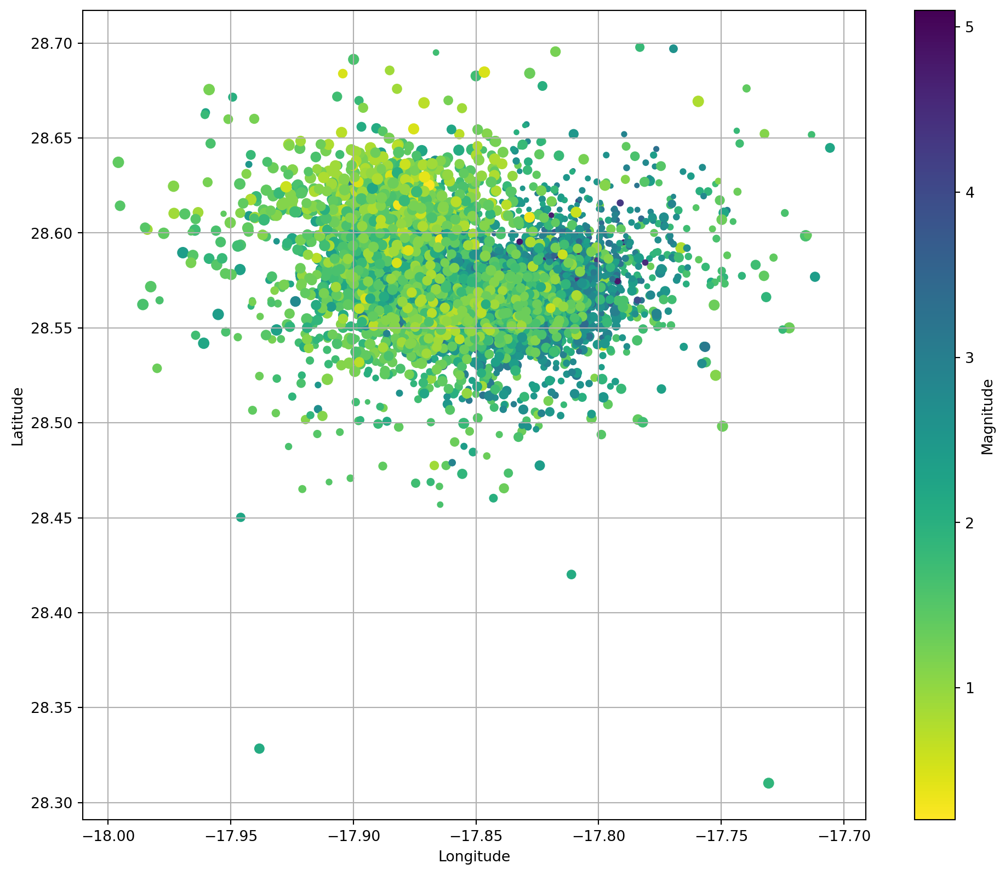
Figure 3: Locations of earthquakes on La Palma since 2017.
_{Source: Article Notebook}
Figure 3 shows the location of recent Earthquakes on La Palma.

2 Data & Methods

3 Conclusion

References
_{Source: Article Notebook}
Marrero, José, Alicia García, Manuel Berrocoso, Ángeles Llinares, Antonio Rodríguez-Losada, and R. Ortiz. 2019. “Strategies for the Development of Volcanic Hazard Maps in Monogenetic Volcanic Fields: The Example of La Palma (Canary Islands).” Journal of Applied Volcanology 8 (July). https://doi.org/10.1186/s13617-019-0085-5.

