Cover memo: the signed term sheet is pictured below.
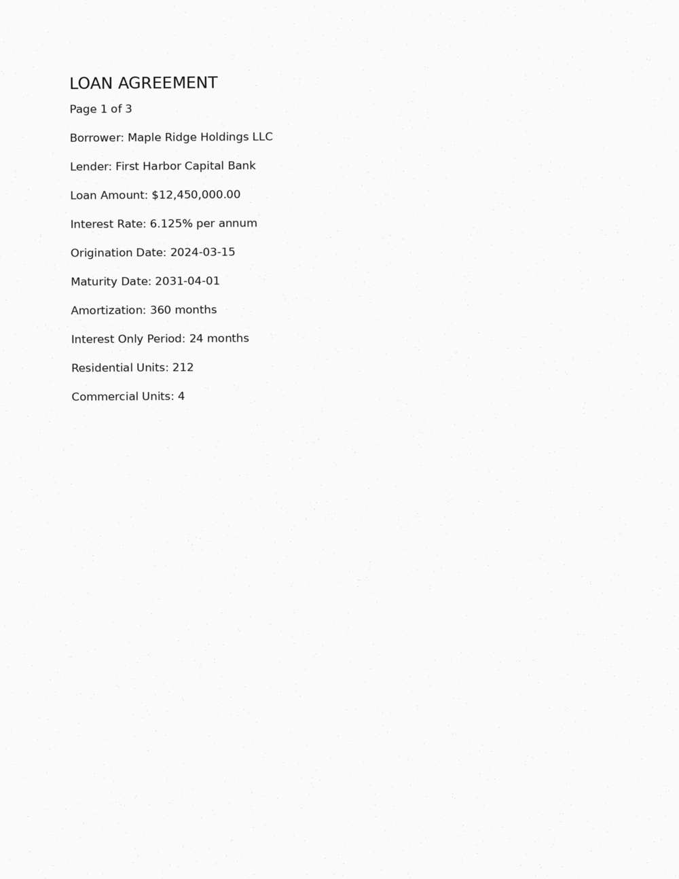
End of memo.

