 |  |  |  | 

ClockTHREE-Junior_v2

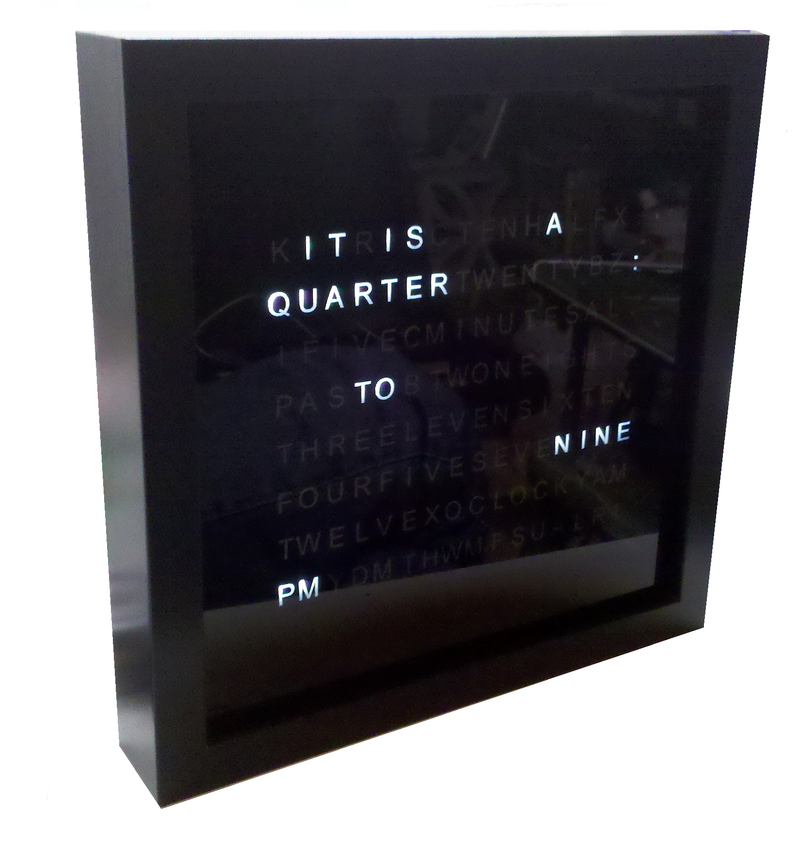
Assembly and User Guide
# C3Jr_v2

add LICENSE Information on this page :

- Creative Commons : http://creativecommons.org/licenses/
- Open Source Hardware (OSHW) : http://freedomdefined.org/OSHW
- OSHW Logo : http://oshwlogo.com/
- Open Hardware Summit : http://www.openhardwaresummit.org/
example :
This work is licensed under the Creative Commons Attribution-ShareAlike 3.0 Unported License. To view a copy of this license, visit http://creativecommons.org/licenses/by-sa/3.0/ or send a letter to Creative Commons, 444 Castro Street, Suite 900, Mountain View, California, 94041, USA.

Index
- IMPORTANT 1
- Links 2
- Introduction 3
- Bill of Materials 4
Bill of Materials 5
Bill of Materials 6
- Tips, before you start Assembly 7
- Resistors 8
- IC Sockets 9
- Capacitors 10
- Transistors 11
- Other Parts 12
- Optional Parts 13
- LED Array 14
- Smoke Test 15
- The Assembled Board 16
- Mechanical Assembly 17
Mechanical Assembly 18
Mechanical Assembly 19
- the ClockTHREE_Junior ver 2 20
- Modes & Functions 21
- Programming 22
- Personal Notes 23

 | VERSION INFORMATION
 | KIT VERSION | v2
 | SW VERSION | v0_6
 | USER GUIDE VERSION | v1_0

 | IMPORTANT | 1

 | SAFETY: Please read this MANUAL carefully before assembling the kit. It contains important information, Warning, and Cautions that must be followed to ensure safe operation and to maintain the product in a safe condition. | BEFORE YOU SOLDER the IC sockets check that every leg has come through the PCB. Trust us, you don't want to notice twenty pins in that a leg got bent.
 | USE PROPER POWER CORD: Use only the power cord and connector appropriate for the voltage and plug configuration in your country. | Be careful with the baffles, they are fragile.
 | DO NOT OPERATE IN EXPLOSIVE ATMOSPHERES: To avoid explosion, do not operate the product in an atmosphere of explosive gas.

 | Links | 2

- Wyolum : www.wyolum.com
- Support & Discussion : http://wyolum.com/forum/index.php
- WiseTime with Arduino : http://timewitharduino.blogspot.com/
- C3Jr Project Repository : http://code.google.com/p/clockthree/
- Arduino : http://arduino.cc/
- Sparkfun : http://www.sparkfun.com/products/9766
- Smoke Testing : http://en.wikipedia.org/wiki/Smoke_testing#Electronics_and_electrical_engineering

 | Introduction | 3

We are so excited for you to build this kit ! The ClockTHREE_Junior is a simpler, smaller version of our ClockTHREE RGB word clock. This is a very easy to build project, which you can likely complete over a weekend, and requires only basic electronics skills. The completed ClockTHREE_Junior, version 2 - a.k.a C3Jr_v2 - will make a fine addition to your home or office and will surely attract a lot of conversation. The C3Jr_v2 shows time using a set of words. A group of LED's located behind the face plate light up individual words to indicate time, such as “IT IS TEN MINUTES PAST FIVE IN THE EVENING”.

It features mono-color LEDs instead of RGB full color. The LED matrix is smaller at 16 columns and 8 rows, giving a total of 128 addressable LEDs. Other than that, it is similar to the C3 in terms of build instructions. The SW code is also almost the same as that for C3. On the hardware side, we use a 8 bit row driver, instead of the dual 16 bit drivers used in the C3. It is compatible with the Arduino IDE, and uses an ATMega Micro-controller. The kit is provided with the software already installed on the micro-controller.

This guide covers the procedures for assembling the C3Jr_v2 kit. Please exercise appropriate safety practice while soldering. All parts are through-hole mounted, and there are no surface mounted parts for you to solder or worry about. This is an open-source hardware+software project. For design files, source code, & support, please contact us at << info@wyolum.com >>

Before commencing assembly, please read this manual carefully and acquaint yourself with the build process.

The kit consists of the following :
- ELECTRONICS - Main Board (PCB), with set of components
- MECHANICAL - A set of Baffles, Front Face Plate, Rear Plate and fixing hardware
- Wall Wart – 5V DC output, 1A

 | Bill of Materials | 4

 | Bill of Materials | 4

 | Bill of Materials | 4

A picture of the kit contents

 | Tips, before you start Assembly | 5

- Read through and understand the entire set of instructions before you get started. We know, they always say that, but heed the advice this time. It could save you hours of rework and much consternation. We've captured all of the mistakes and blunders made in creating and building the prototypes and tried to foresee problems you may have.
- Take your time. Enjoy the build process and take a break when you feel fatigued. You will have this clock for years to come (and hand it down to your grandchildren!) so there are no worries if it takes you an extra day or week to build it.
- Leave the paper on the front cover and front frame until final assembly. This protects the parts from scratching and smudging.
- Soldering:
  - We assume that this is NOT your first soldering project. If it is, we'd suggest getting a cheap learn-to-solder kit to get started. If this is your first project in a while, here is a quick refresher on soldering. The main thing is to double and triple check that the part is in the correct place with the correct orientation (if applicable). While de-soldering is possible, it is troublesome and time consuming and risky. Make it a goal that you will not have to de-solder in the course of making this clock.
  - After each step, evaluate the solder joints from the front and back of the board. On the back, the solder should be shiny and make a volcano shape, as opposed to a dome shape. On the front, you should see that the solder came all the way trough the board. If it doesn't look good, try re-heating the joint until the plated-through-hole sucks up the solder.
  - Check that the solder does not cause a short to neighboring parts.
  - If you do make a mistake, don't panic. Use a solder sucker to remove the solder and pull the piece gingerly while applying heat. If you damage a trace in the process of de-soldering, send a picture of the damaged area and we will help you make the most of the situation. It may be possible to "blue wire" around the damage.

 | Resistors | 6
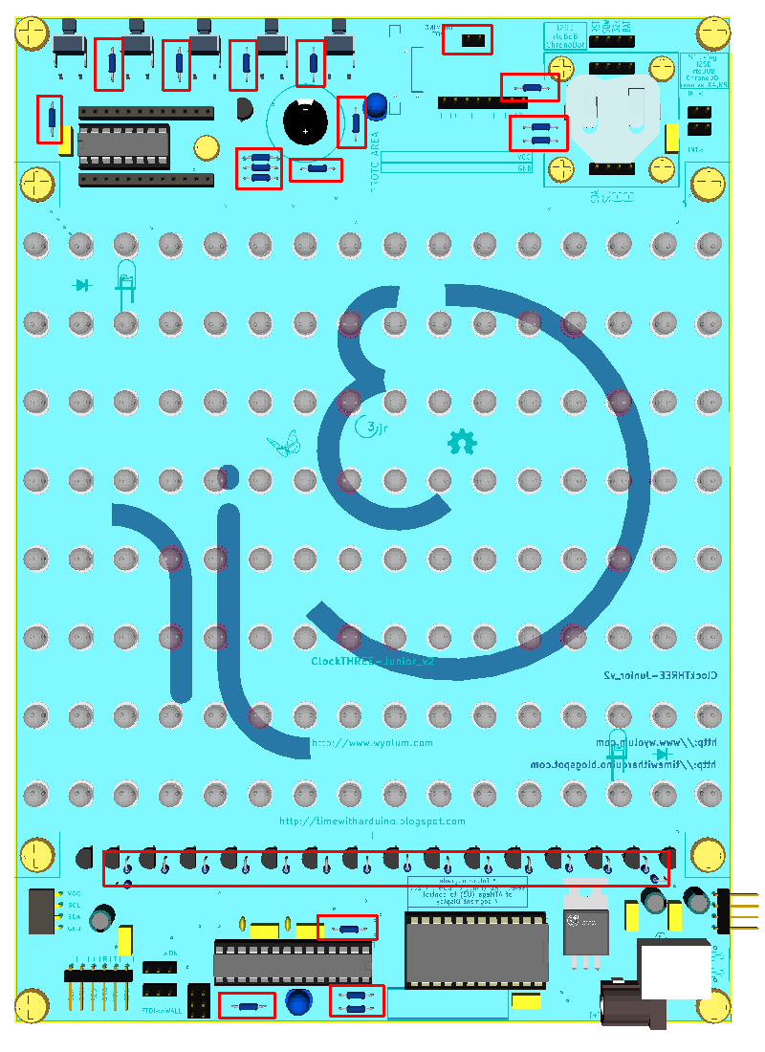 | RESISTORS  Start by soldering the resistors. The polarity (orientation) does not matter.  PARTS  R1 to R16 : 100 Ohm [brown-black-brown]  R17, R18, R19, R22, R23, R31, R36, R37, R38 : 10k [brown-black-orange]  R20, R21 : 4k7 [yellow-violet-red]  R24, R25, R26 : 1k [brown-black-red]  R30 : 100 Ohm  R32 : 2 pin female socket for LDR (light dependent resistor – it's use may be supported in future software release)  R33, R35 : 680 Ohm [blue-grey-brown]  NOTE  R26 : only if DBG LED is used.  R31: only if R32 [LDR] is used.  R36, R37, R38 : only if DS3231 (SMD) is mounted on-board. Not needed if using Chronodot or I2SD.

 | IC Sockets | 7
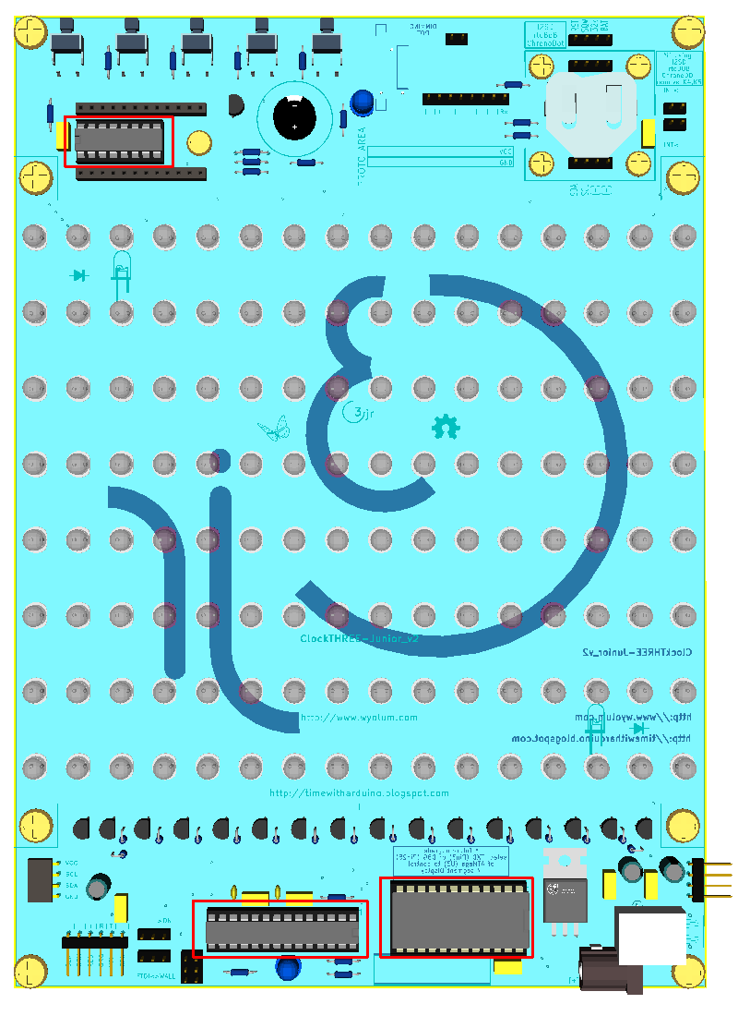 | IC SOCKETS  The sockets are polarized - so make sure to align them correctly with the legend marking on the board. (If you happen to solder one of these in backwards, don't fret, just be sure to plug the IC as indicated on the board).  PARTS  U3 : 28 pin socket, 0.3" width - for ATMega processor  U4 : 24 pin socket, 0.6" width - for Column Driver 74HC154  U5 : 16 pin socket, 0.3" width - for row driver STP8DP05  NOTE  Install the IC's in their sockets when you are ready to test the board. See instructions later in this guide.

 | Capacitors | 8
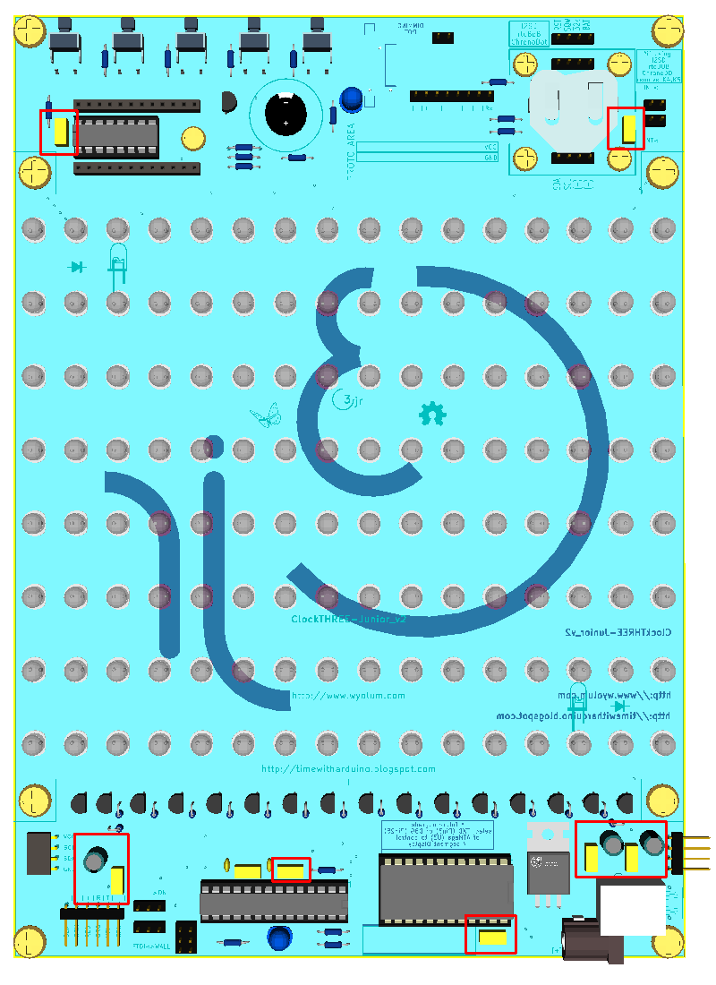 | CAPACITORS  There is one polarized capacitor (C8), and all the others are non-polarized.  PARTS  C3, C4, C5, C6, C7, C9, C10 : 100nF decoupling/filtering capacitors  C1, C2, C8 : 100uF Electrolytic capacitor (polarized)  NOTES  C11, C12 : Only required if X1 is a Crystal. Not required if X1 is a 3 pin resonator. By default, the kit is supplied with the 3 pin resonator.

 | Transistors | 9
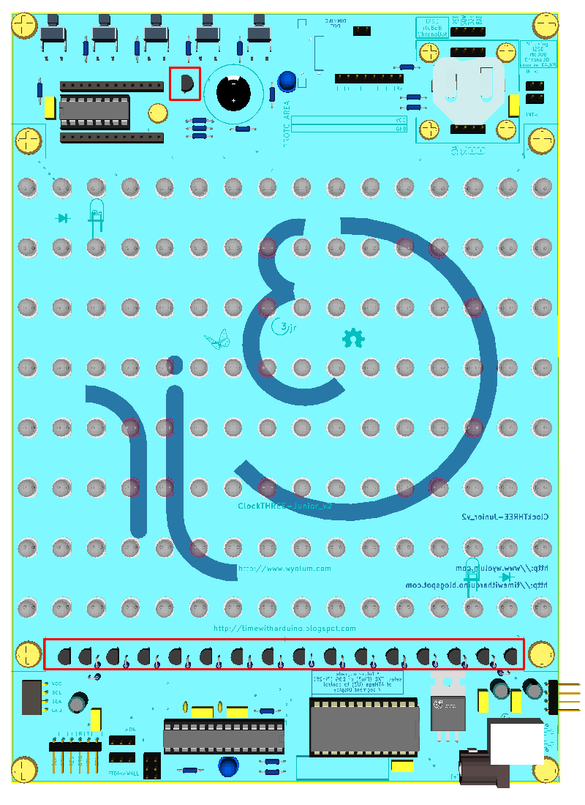 | TRANSISTORS  With transistors, orientation matters. The silk screen indicates the correct orientation. We find that using the middle hole is easier than using the offset hole.  PARTS  Q1-Q16 : 2N5401 [near 100 Ohm resistors]  Q17 : 2N5401 [near Speaker]

 | Other Parts | 10
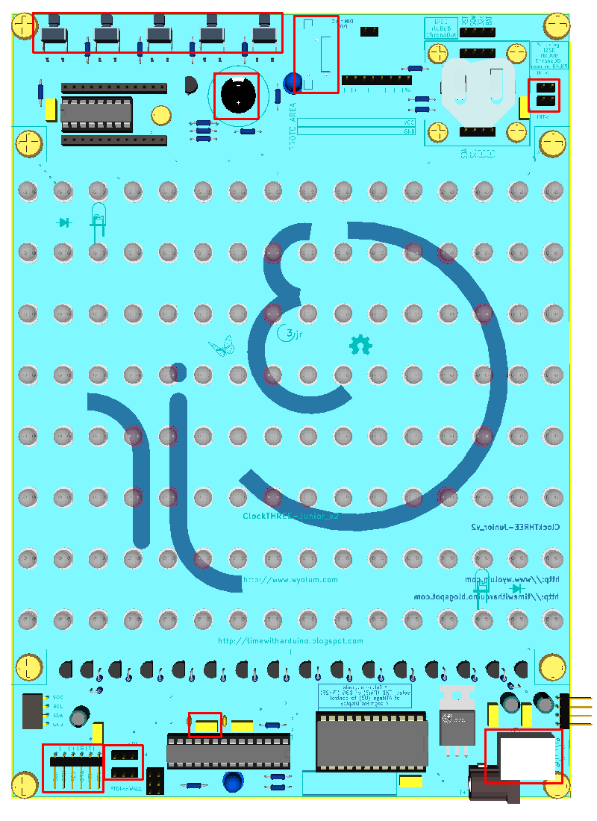 | OTHER PARTS  Finish off by adding in all the other remaining parts.  PARTS  J2 : The USB-B type Power Input socket.  K1, K2 : 3 pin male header pins for Power SEL (Wall Wart/FTDI) and LED ARRAY (Enable/Disable). Both of these also require a shorting link. [as shown below]  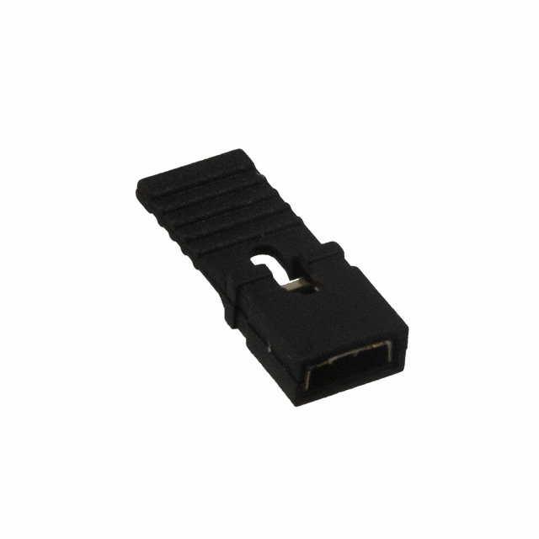  K4, K5 : 2 pin male header pins for RTC INT or EXT. When using INT RTC, both of these require a shorting link. When using EXT RTC, remove the shorting links.  P7 : 6 pin, right angle, male header pins for FTDI connector  SP1 : Speaker / Buzzer  SW12, SW22, SW32, SW42, SW52 : push button switches (on solder side)  X1 : 16MHz resonator (3 pins, not polarized)  R34 : 2k Thumb wheel Dimming Potentiometer (Pot). On Solder Side. It allows manual control of LED array brightness.

 | Optional Parts | 11
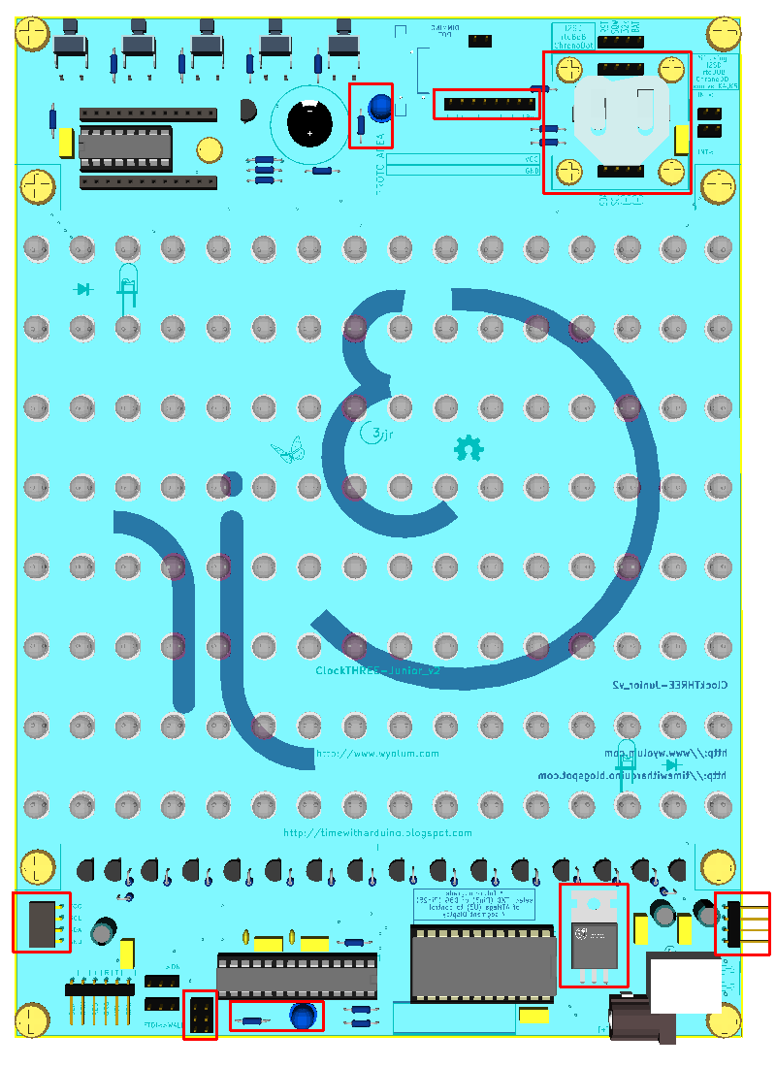 | OPTIONAL & UN-USED PARTS  The board includes several parts that are either optional, planned for future use, or just included in case they're needed.  PARTS  U6 : DS3231 RTC IC. This SMD chip is mounted on solder side of the board. It may be pre-installed in some cases. If you plan to use either I2SD or the ChronoDot, U6 may be disabled by removing jumpers on K4 and K5.  BT1 : CR2036 Battery socket and coin Battery. Used only if U6 is installed on-board.  CD1, CD2 CD3 : 4 pin female header sockets. Use if you plan to install either I2SD or ChronoDot. BT1 has to be removed.  D258 + R25 : Debug LED and Resistor – this one is optional, based on personal preference. Some like it installed, some don't.  D260 + R26 : PWR LED and Resistor - this one is also optional, based on personal preference. Some like it installed, some don't.  P1 : 8 way male header to allow fixing the 7 segment, 4 digit LED display from Sparkfun (see Links). This feature is not yet supported in software.  U2 : 7805 – fix shorting link between VI and VO if input is 5V. If input is more than 8V, fix 7805 voltage regulator.  P13 : ISP – For programming the processor.  P41, P42 : C3SB Connectors – Marked as STACK-L and STACK-R, we call this the C3SB (ClockTHREE serial Bus). Allows us to cascade several C3Jr boards).

 | LED Array | 12
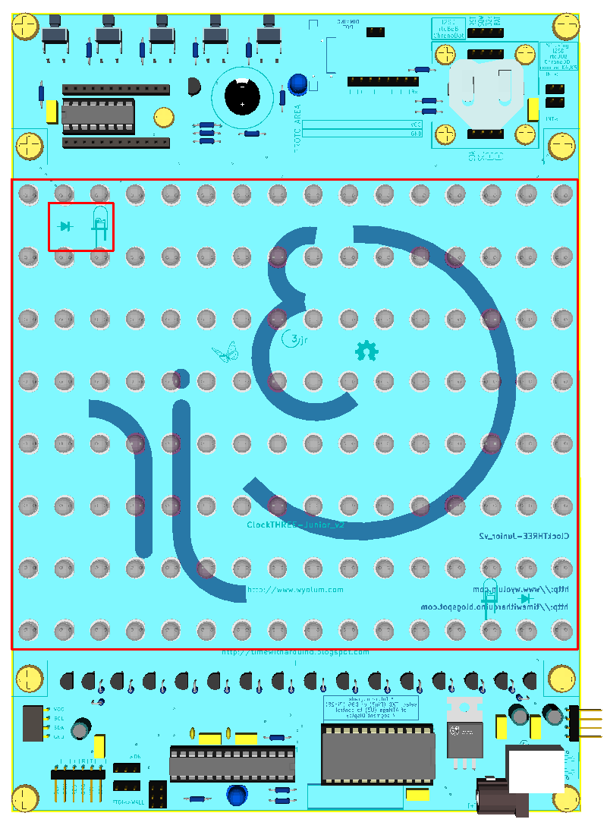 | LED ARRAY  Install the rest of the LED's for the array. The short lead (Cathode) of the LED always goes toward the label (D1 to D128).  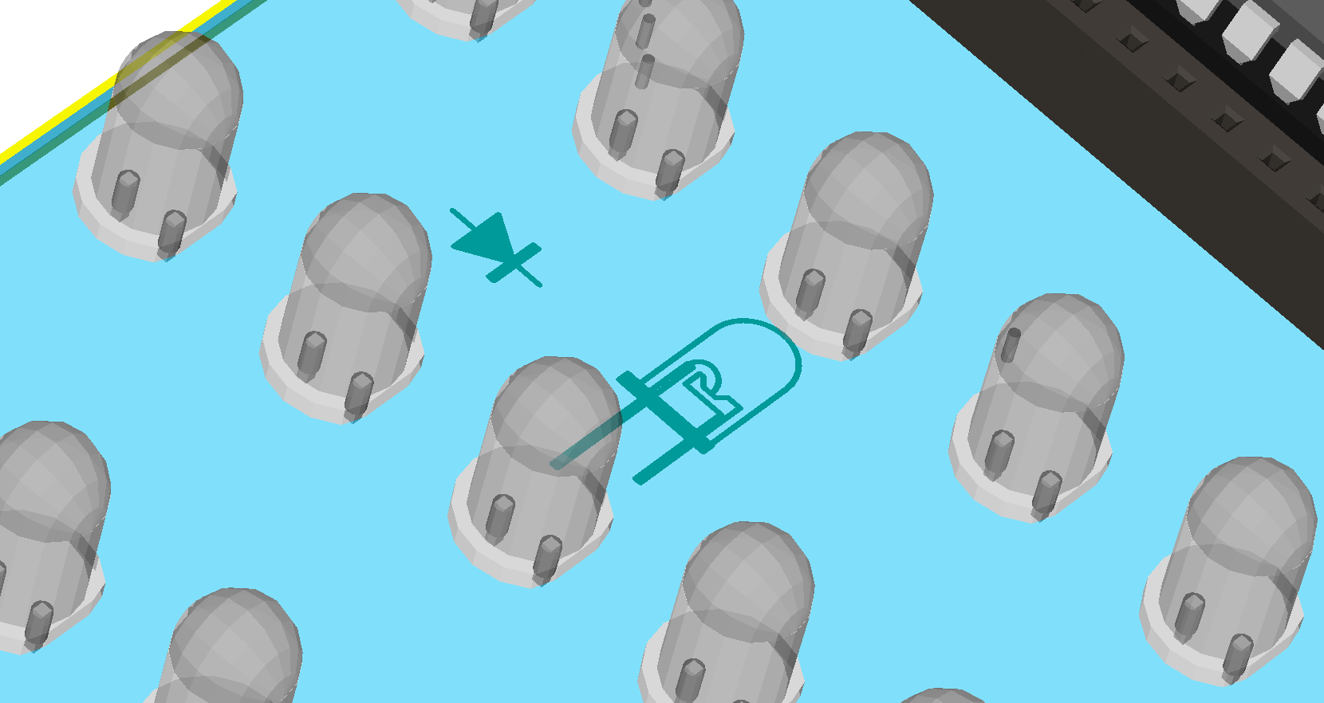  This can go very smoothly and quickly. We've found the fastest way to install the field of LEDs is in two steps : even numbered rows and odd numbered rows. This allows ample space for soldering iron and gets the job done in short order.  PARTS  D1 to D128 : 5mm White LED's  NOTE  It may be advisable to mount the first few LED's (D1 to D6) and test the C3Jr_v2 before filling up the array. See instructions later in this guide << SMOKE TEST>> for details.  After the Smoke Test, finish the rest of the LED array.

 | Smoke Test | 13
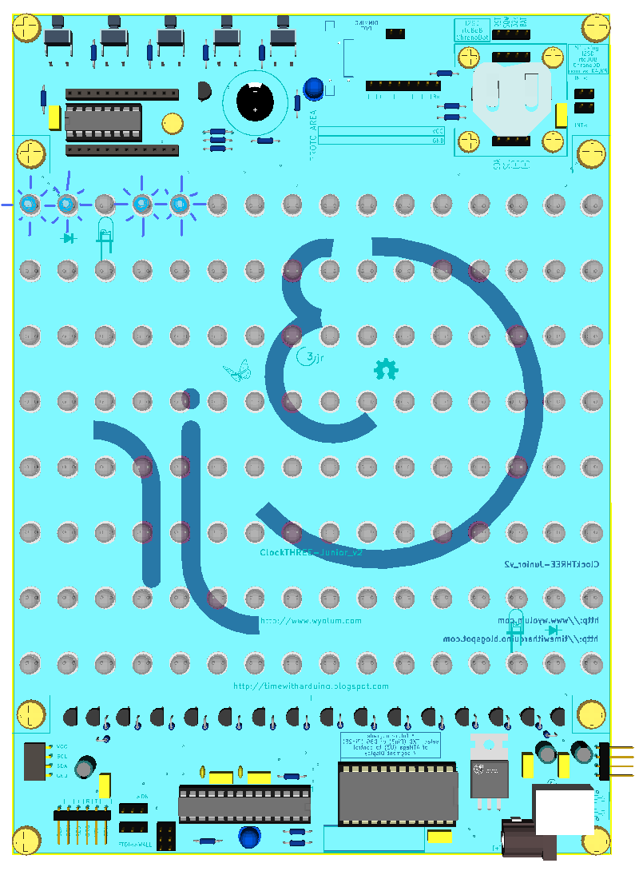 | Smoke Test  Before installing all of the LED's, it is advisable to confirm if the board is functioning correctly.  If already not done, install all the IC's (U3, U4, U5). Make sure you plug them in the correct orientation.  Ensure LED_ENABLE [K2] has a jumper connected to the ON location.  Ensure PWR_SEL [K1] has a jumper connected to the WALL location.  Plug in the Wall Wart to utility power, and connect its plug to the C3Jr_v2.  TAKE A DEEP BREATH  Switch on the Power. In a couple of seconds, LED's D1, D2, D4 and D5 should light up (IT_IS_). If they do, smile, and give yourself a pat on the back. It's time to go ahead and solder the rest of the LED's.  If the LED's don't light up, it's time to shoot a mail to << info@wyolum.com >> before soldering the rest of the LED array.

 | The Assembled Board | 14

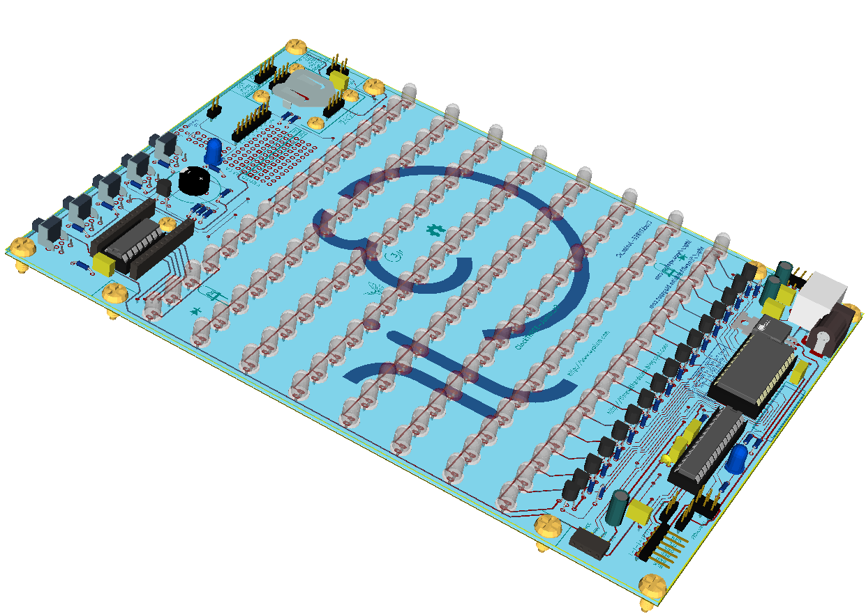 | 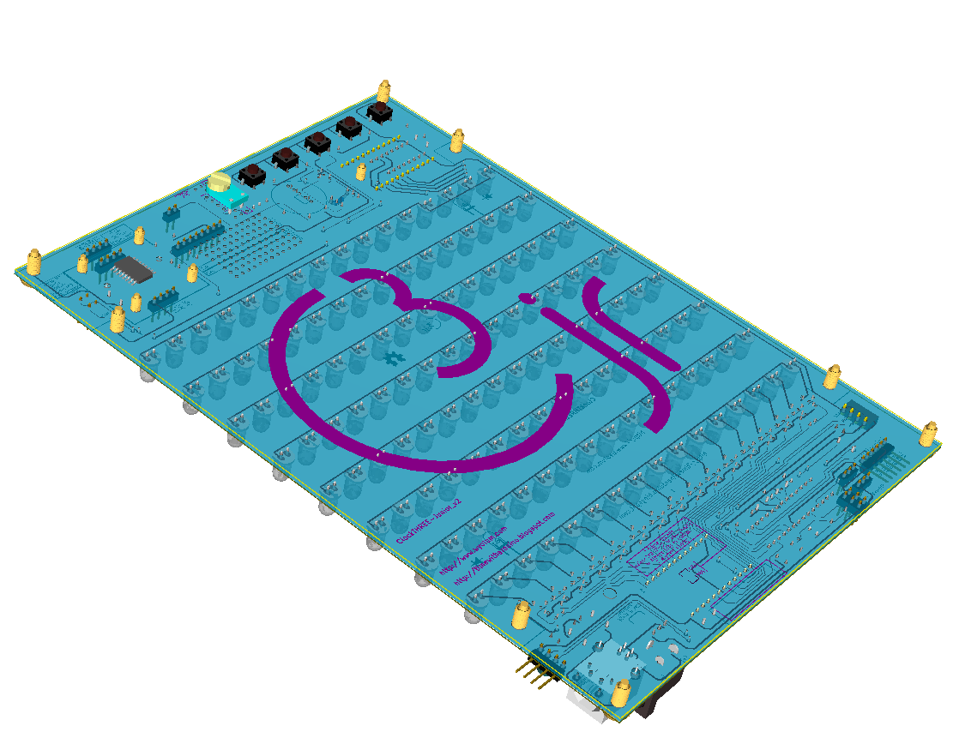  Here's how the board will look after all parts are populated.

 | Mechanical Assembly | 15
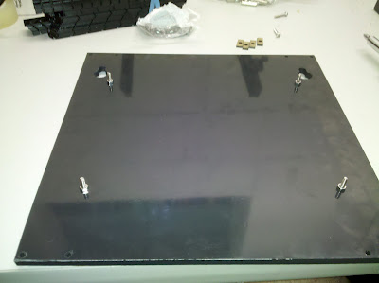 | Step 1. Start by inserting the four long screws into the four holes near the center of the backplate. Secure each with a small nut as shown.  Step 2. Insert four short screws into the four corners of the backplate. Secure each with 20mm standoff.

 | Mechanical Assembly | 15
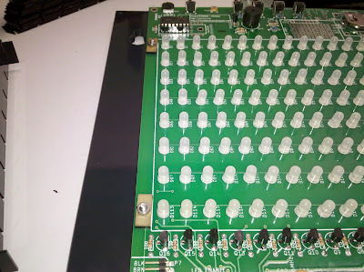 | Step 3. Slide the completed PCB on to the extended screws with the buttons near the the two keyholes in the top of the backplate. Then place the four small baffle locator's on the screw and secure with four small nuts.

 | Mechanical Assembly | 15
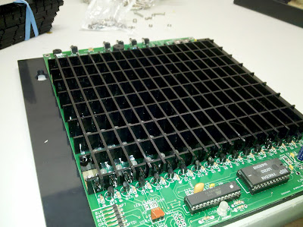 | Step 4. Interlock the baffle grid into place with the angled edge against the PCB. This provides a little extra space for the components. We found it simplest to start with the top and bottom horizontal pieces and slide all the vertical pieces into place. Then, place a flat surface, such as a book, on top of the baffles and flip the whole assembly over and lift of the backplate and PCB leaving the baffle grid. Now the remaining horizontal pieces can be set into place. Finally set the pcb and backplate on upside down on the baffle grid and flip the entire assembly back over. If you find an easier way, please let us know.  Double check that the baffles are not caught up on the locator's in the four corners.  Step 5. Place a 7"x6" sheet of velum on top of the baffles. and install the faceplate, securing it with the remaining four hex screws.

 | the ClockTHREE_Junior ver 2 | 16
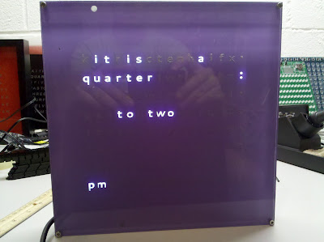 | Finally: Your clock is complete. Plug it in using either the wall wart , or the FTDI interface. Either way, ensure that the PWR SEL jumper is in the correct position: on the right two pins for wall wart, on the left two pins for FTDI power.

 | Modes & Functions | 17

C3Jr_v2 : Modes and Functions – Buttons and Menus
BUTTONS
  - RST Reset
  - Mode Menu Modes
  - INC Increment, Up, Next
  - DEC Decrement, Down, Previous
  - ENTER Enter, Select, Accept
MODES
  - MT Mode Time
  - MC Mode Color
  - MA Mode Alarm
  - MM Mode Mode
  - MN Mode Normal

Describe each mode's function.
 | Programming | 17

- Where to get the code from
- Arduino IDE
- Variables , special Clock Functions etc
- How to Program via FTDI

 | Personal Notes | 18

