**High-Level Design: Woof Wisdom**

# Introduction

Our app will help pet owners and those who have not yet discovered man's best friend. Our goal in creating the application is to combine several services into one place, accessible, interactive, and easy to use. The user will be able to get information about the different breeds of dogs, and thus choose the ideal friend that suits his needs. The dog owners will receive a place available for consultation with veterinarians, trainers, and dogsitters, as well as be able to track the vaccinations that have been done, and those that are to be done, all with the help of notifications in the user's google calendar. Another and very effective feature is image processing of the dog's stool/vomit to get an analysis of the problem and a solution for it. All in all, this is an application designed to help us help and give the best answer to our best friend, our dog.

## Main Components

Our system will include the following main components:

1. UI - That will be used to interface between the user and the application. It will show all the information the application holds.
2. API for UI - A REST API used by the UI, and it will interface between the UI and the backend.
3. Logical Processor - Responsible for the communication with the UI (using the API, based on the UI’s requests), with the Google geolocation, and Google calendar, and with the DB that holds the information.
4. DB - The DB will save all the information of the entities saved in the system.

## Front-End and Back-End Technologies

For the Front-end technologies:

Java (for writing the app logic)

XML (for designing the app's user interface)

Android SDK (for interacting with the device's hardware and other software components).

For the Back-end technologies :

SQLite - for the database to store and retrieve data

server-side will be in JAVA to interact with the application and database and to handle business logic.

## Use Cases

The primary use cases will be:

1. 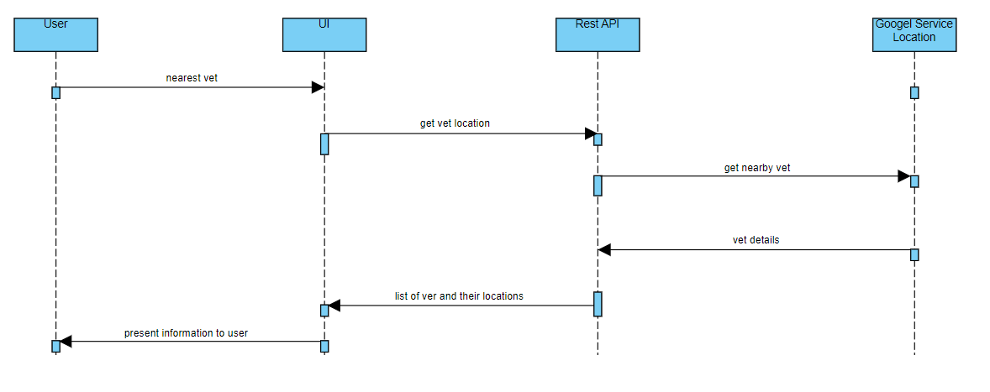Get nearest location
2. 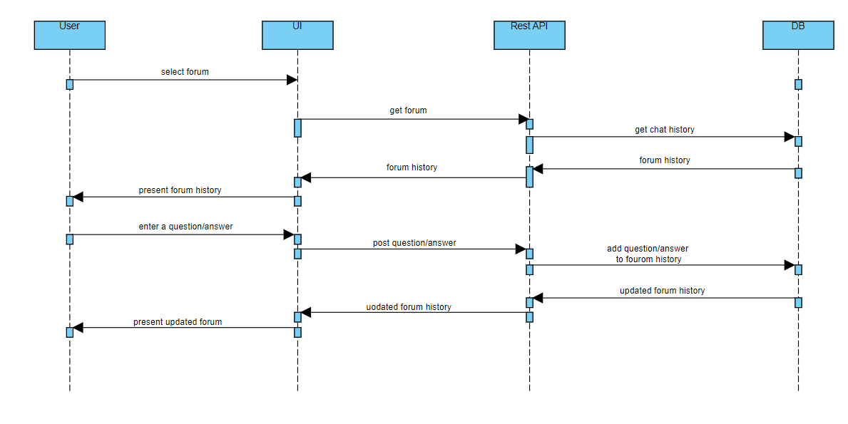Forums
3. 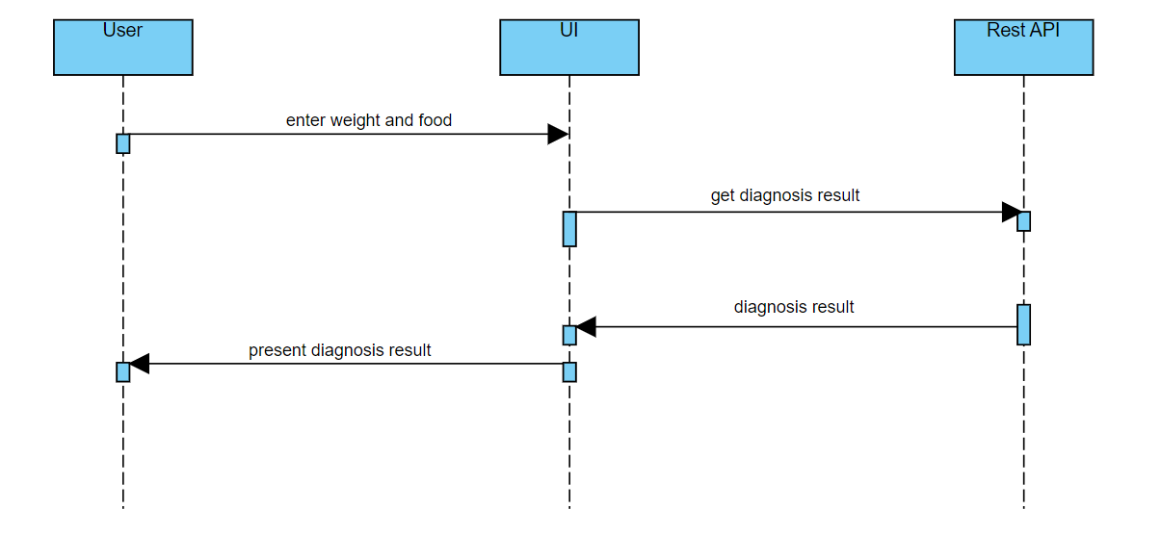Diagnosis dangerous food
4. 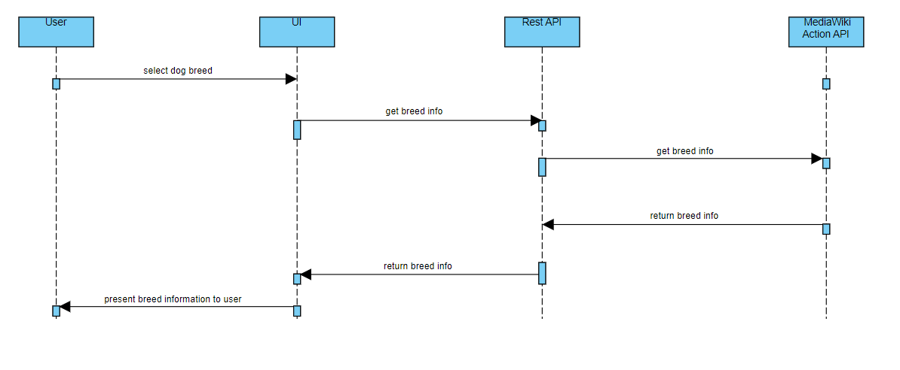Breed information
5. 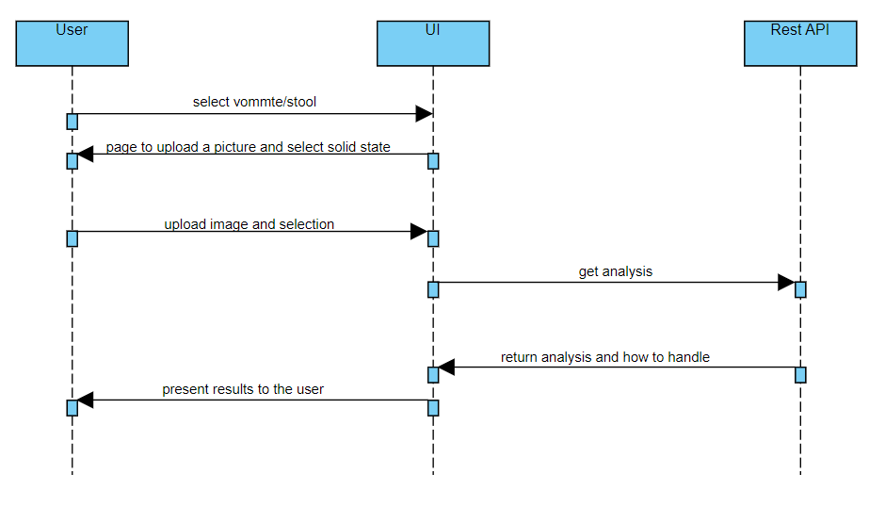Boot analysis
6. 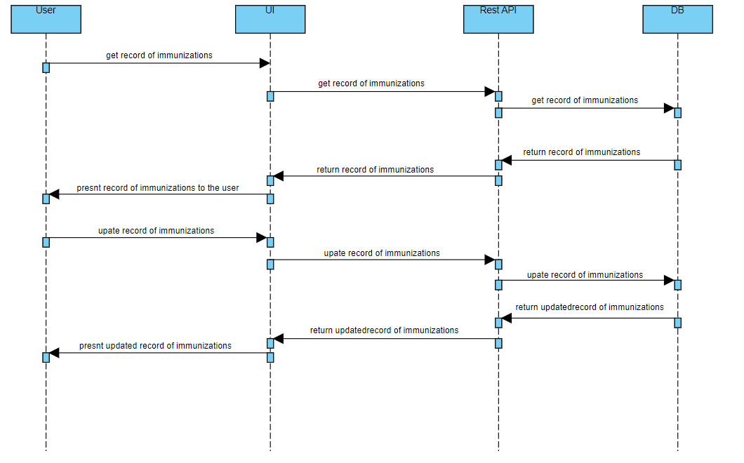Record of immunizations
7. Immunization’s reminder using google calendar

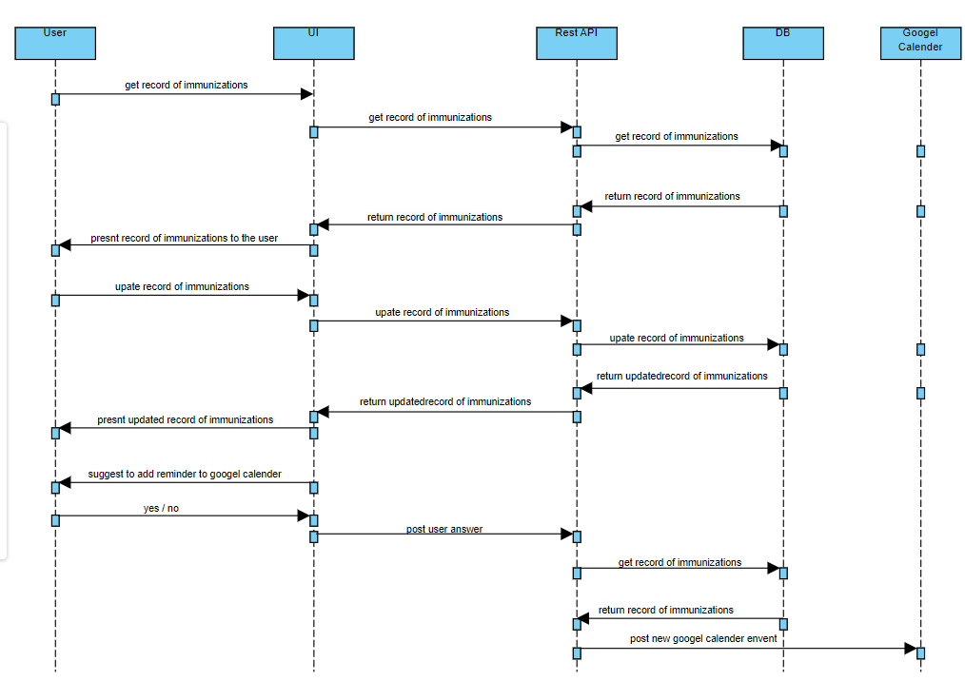https://developers.google.com/calendar/api/v3/reference/events/insert

1. Chart, box and whisker chart

   Description automatically generatedUser Login / sign in

## Mocks: How it is supposed to look



