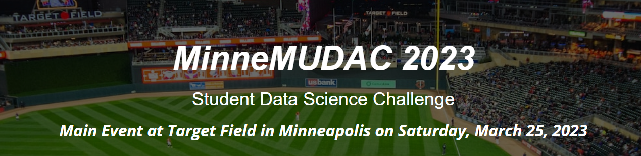

This document contains information regarding the prizes to be awarded for the MinneMUDAC 2023 Student Data Science Challenge.

**Award: Overall Winner**

* Round #1: Morning of March 25, 2023

Each team will be required to present their outcomes/findings in-person at Target Field on March 25. Student teams will give their 6-8 minute presentation to a group of judges (a judge group consists of 2-3 working professionals in analytics). Teams will give their presentation repeatedly (likely between 4 and 6 times) with the exact number depending on the number of teams participating in this year’s competition and the number of judges available.

* Round #2: Afternoon of March 25, 2023

A limited number of teams from each division (likely between 3 and 5) will advance to Round #2. The exact number of teams that advance to Round #2 depends on the score distribution from Round #1 and/or the number of teams participating in each division. The decision regarding who advances to Round #2 is made by members of the organizing committee.

In Round #2, teams will present their findings to all participants and all judges. Judge scores from Round #2 are used to determine the overall winner.

**Award: Best Prediction**

Teams will be required to submit a 2023_MLBSeason_Predictions.csv file that contains your prediction for the attendance of every home game for all MLB baseball teams. These predictions must be submitted before the start time of Round #1 judging on March 25, 2023. Details regarding the procedure for making this submission will be forthcoming.

The following metric will be used to evaluate prediction accuracy for games played in the month of April and games played for the entire season. The value of $w_{1}$ has yet to be determined, but will likely be in the range of $\frac{1}{30}≤w_{1}≤\frac{1}{10}$.

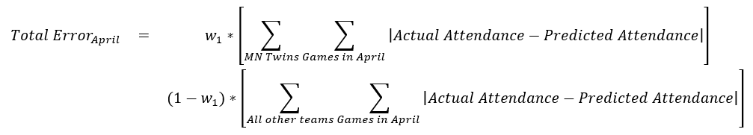

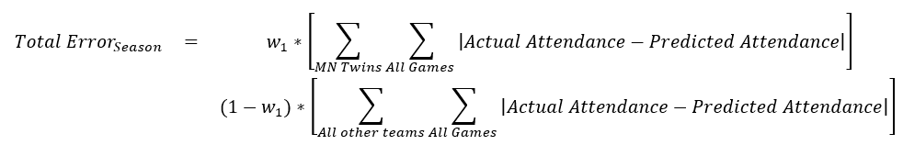

* Novice: See Bonus for Prediction Award for this division.
* Undergraduate & Graduate

**Best Prediction - April**

In early May, prediction accuracy will be computed for ${Total Error}_{April}$ for all teams. The team with the smallest value of ${Total Error}_{April}$ for each division will be given the Best Prediction - April Award.

**Best Prediction - 2023 Season**

After the conclusion of the MLB regular season, the prediction accuracy will be computed for ${Total Error}_{Season}$ for all teams. The team with the smallest value of ${Total Error}_{Season}$ within each division will be given the Best Prediction - 2023 Season Award.

Award: Bonus

**Novice**

Novice teams that wish to be considered for the Bonus Award will be required to submit a 2023_MLBSeason_Predictions.csv file that contains your prediction for the attendance of every home game for the MN Twins. These predictions must be submitted before the start time of Round #1 judging on March 25, 2023. Details regarding the procedure for making this submission will be forthcoming.

The following metric will be used to evaluate prediction accuracy for MN Twins home games played throughout the entire 2023 baseball season.



The Bonus Award for the Novice division will be awarded at the conclusion of the MLB regular season.

**Undergraduate**

The evaluation of the bonus element for the undergraduate division will be done separately from the evaluation to determine the Overall Winner.

**Graduate**

The evaluation of the bonus element for the graduate division will be done separately from the evaluation to determine the Overall Winner.