<RELEASE No.>
USER MANUAL

Revision History
Date | Version | Description | Author | Approved
Fri,03-May-2012 | V3.0 | The third Release | Amy
www.enclaveIT.com

Table of contents

1. QUICK START 4
1.1 How to use this manual 4
1.2 Term and abbreviation 4
2. INTRODUCTION AND OVERVIEW 5
3. INSTALLATION GUIDE 6
4. GETTING STARTED 21
5. SYSTEM FUNCTIONAL DESCRIPTION 22

QUICK START

How to use this manual
This document includes 5 parts:
- Quick start: Typography convention, term and abbreviation.
- Introduction and overview.
- Installation guide.
- Getting started.
- System functional description.

Term and abbreviation
Terms and abbreviations of this software:
- CIS: Comparing image software.
- OpenCv: Open Source Computer Vision Library.
- JavaCv: Java Computer Vision Library.
- PCA: Principal Component Analysis.

INTRODUCTION AND OVERVIEW

- This software will detect the face in an image, recognize that face then list all faces which are closest with original face and user can see information of those faces.
- Software help user has priority can edit, add or delete information from database easily and quickly.
- It can recognize frontal-face, left-face, right-face skip brightness and darkness.
- It also can connect to mobile to receive image then recognize person on that image. Result will sent to mobile and you can see information about the person in that image.
- Programming language of software is Java.
- Use DB2 to create database.
- Besides, software uses some supporting libraries such as: OpenCV, JavaCV to help process image easily and quickly.

INSTALLATION GUIDE

FACE RECOGNITION

===========================

* You have to copy "Release1" folder into where installed operating system.

* The network is available

* The components of this application:

- jdk1.6 or more

- OpenCV

- JavaCV

* Operating supporting: Linux (Fedora).

I. Install jdk1.6 or more you can download jdk1.7 at http://jdk7.java.net

II. Install application

1. Open terminal

2. # cd where/path/of/Release1/CIS_SProjectR1/

3. # chmod 777 install.sh //set execute mode for install.sh file

4. # chmod 777 run.sh //set execute mode for run.sh file

5. # ./install.sh

If you don't have permission to install, you can run this command #su

III. Run application

1. Open terminal

2. # cd where/path/of/Release1/CIS_SProjectR1/

3. # .run.sh

The other way to run this application

Double click on run.sh -> choose "Run" or "Run in terminal"

You must be sure the "run.h" file have mode is 777.

# chmod 777 run.sh
1. Install DB2 on Linux
- Download package db2exc_975_LNX_x86.tar.gz.
- Open terminal and login to root, cd to directory contain that package.
- Execute command:
# ./ db2setup
- And DB2 setup wizard will appear.

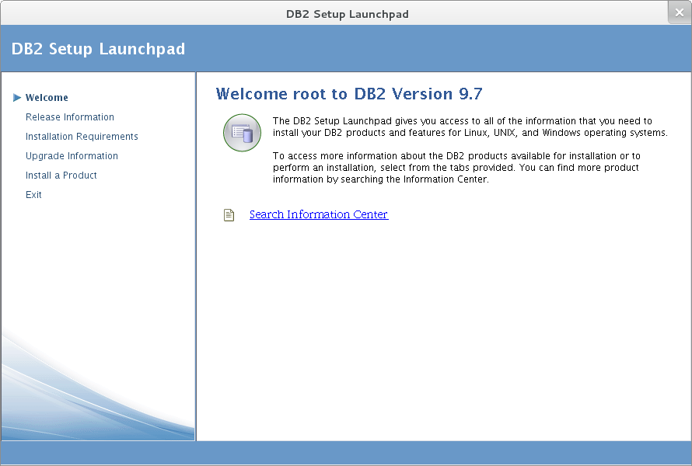

- Choose tab Install a Product.

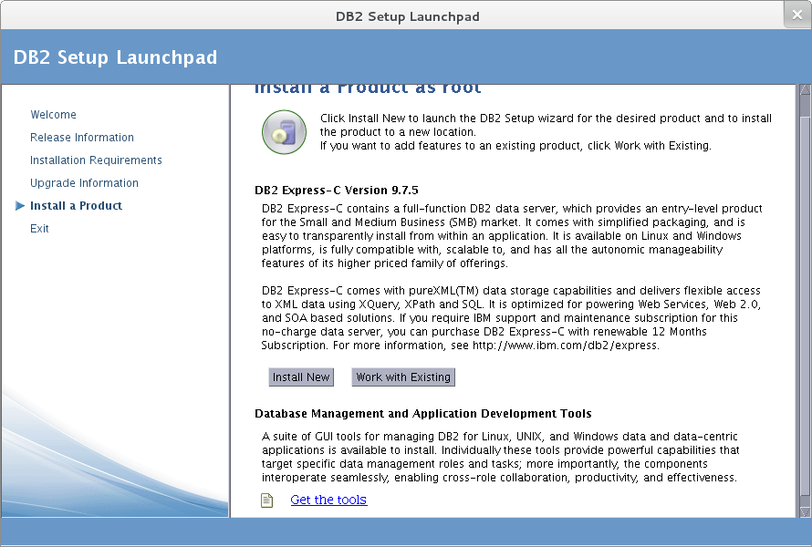

- Choose Install new and follow every step in wizard to install DB2.

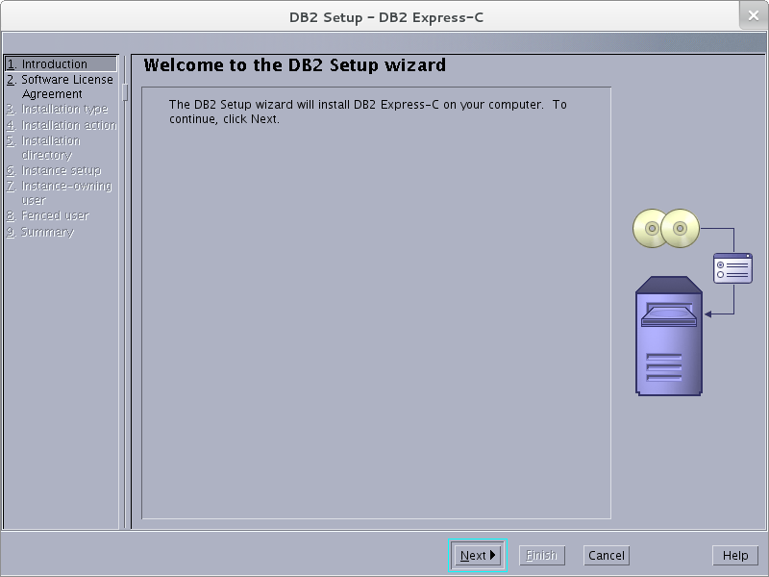

2. Using DB2:
- To start DB2: open terminal and login at user has name “db2inst1”
# su db2inst1
# Password:
# db2start
# db2cc ( open Control Center ).
- To stop DB2:
# db2stop

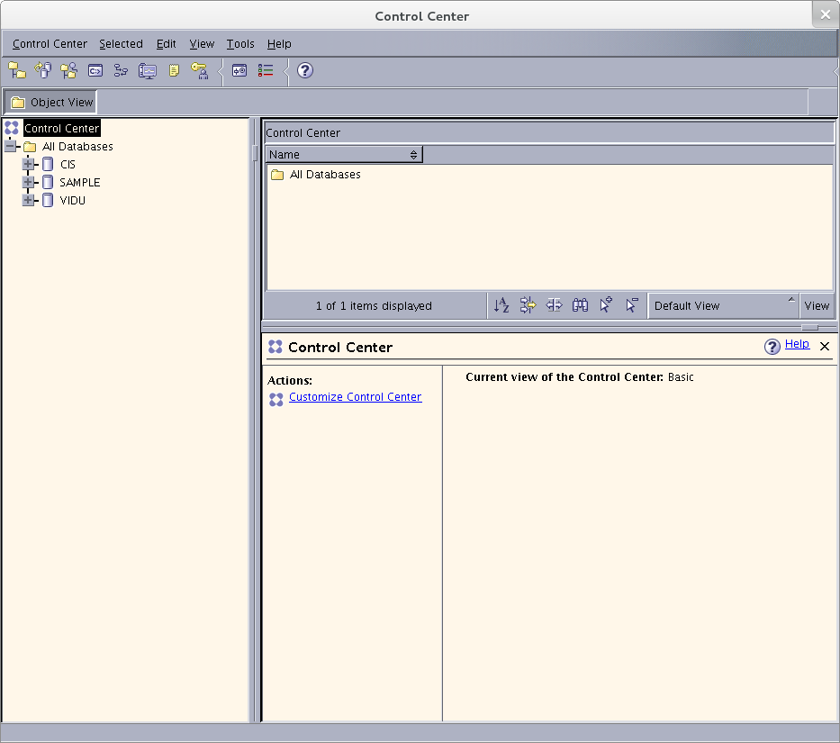

3. Backup database in DB2:
- Before backup database open terminal and execute command:
# su dasusr1
# Password:
# db2admin start
- If you want backup database, right click on that database and choose Backup.

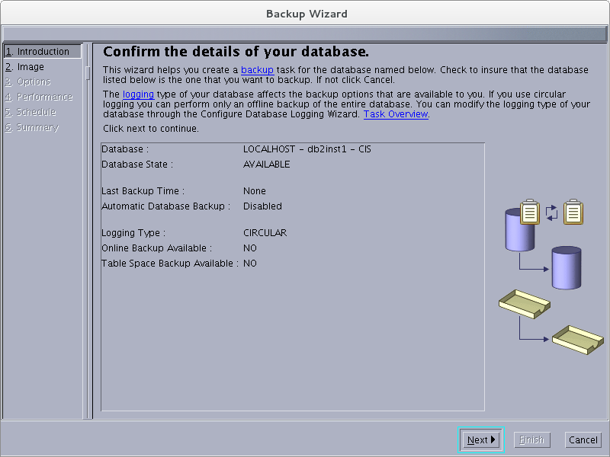

- Follow every step in wizard to backup database.
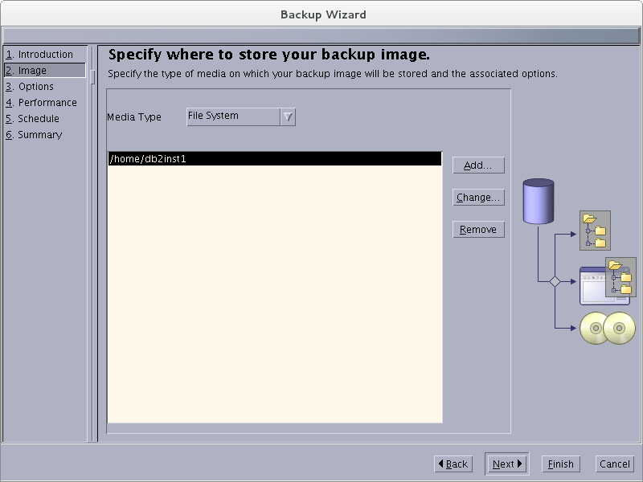

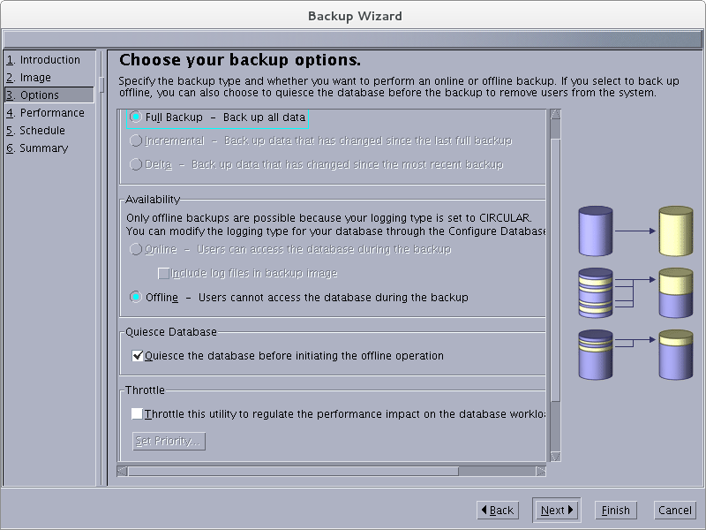

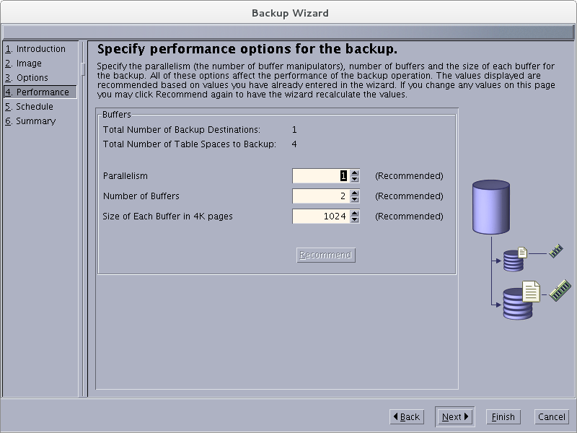

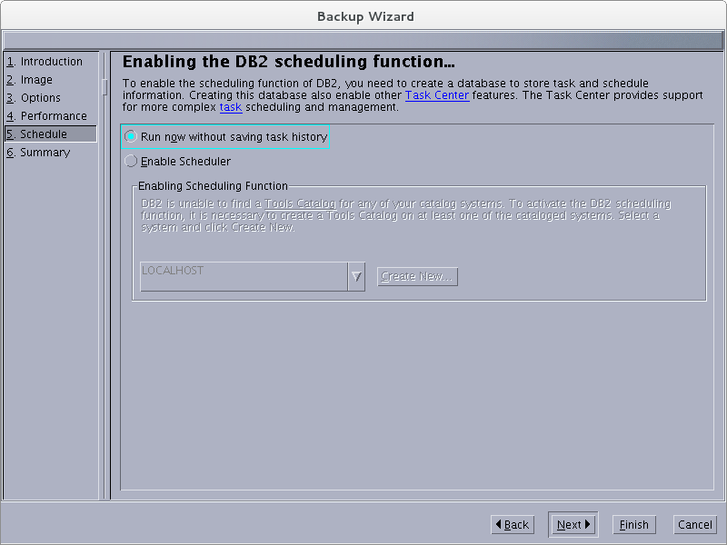

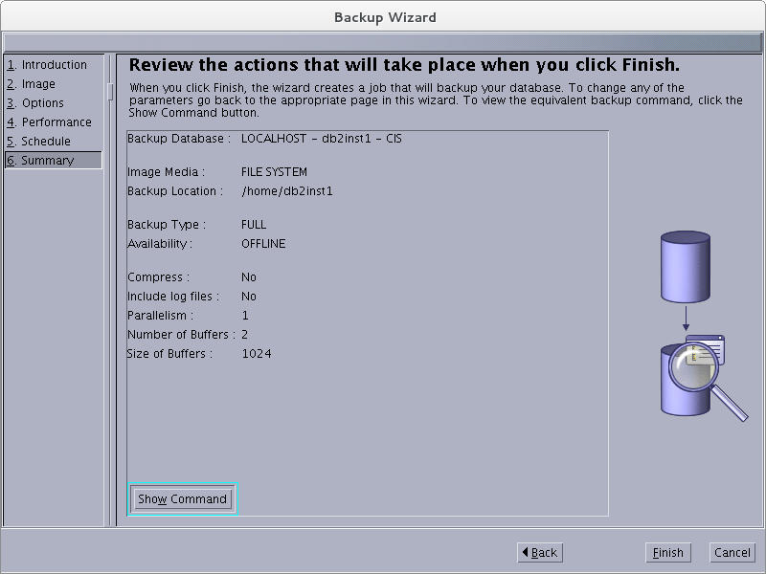

4. Restore database in DB2
- Create a new database. Right click on it and choose restore database.
- Restore data wizard will appear.
- Follow every step in wizard.

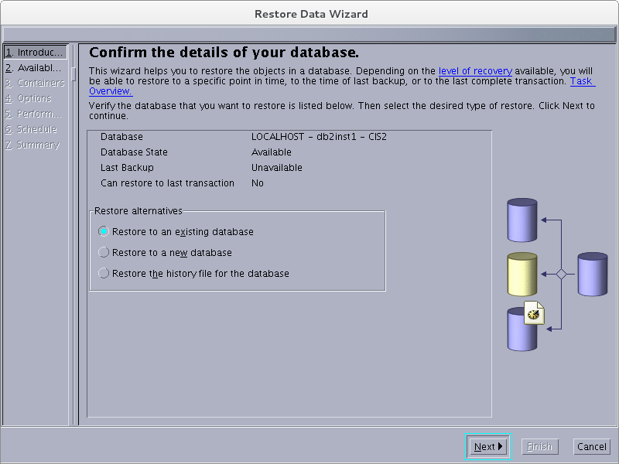

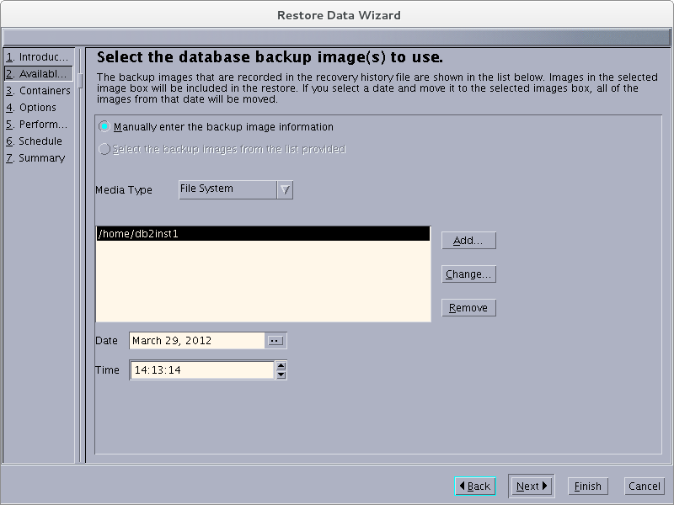

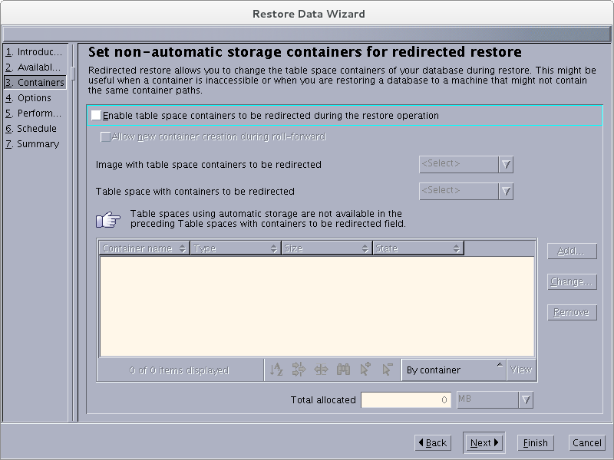

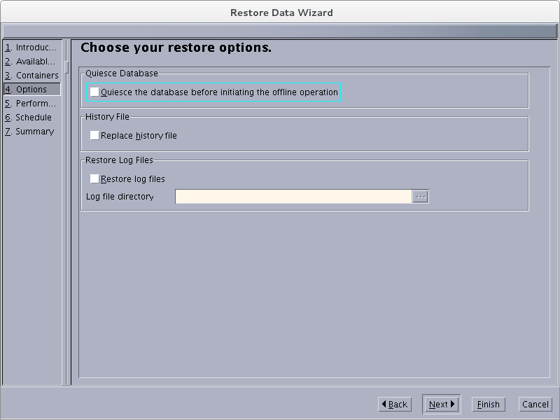

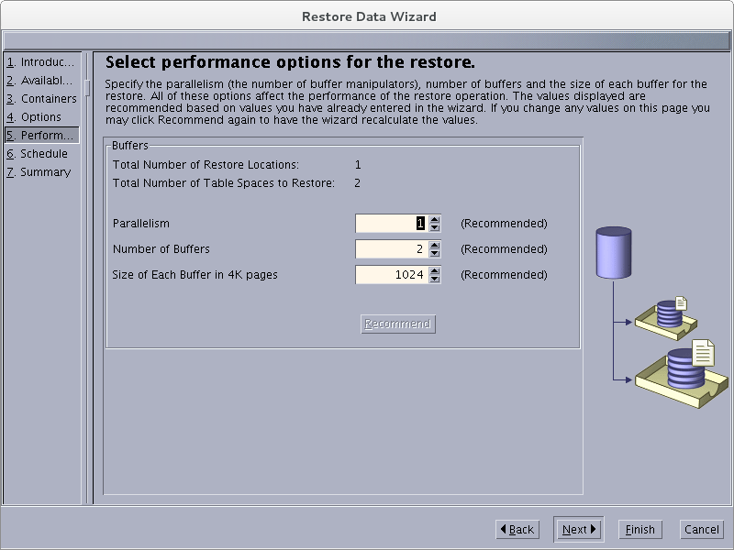

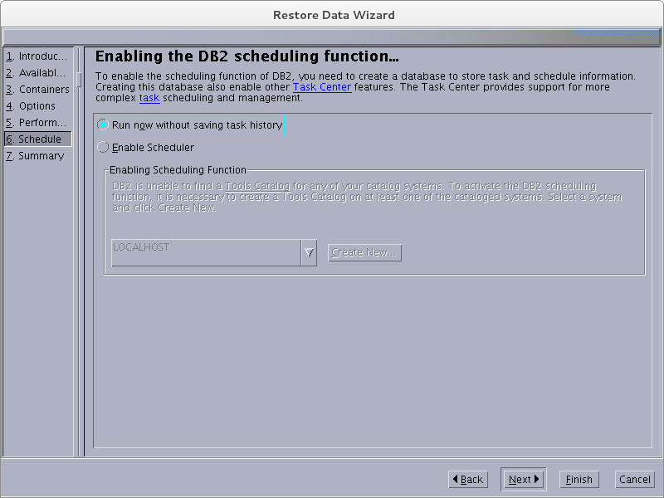

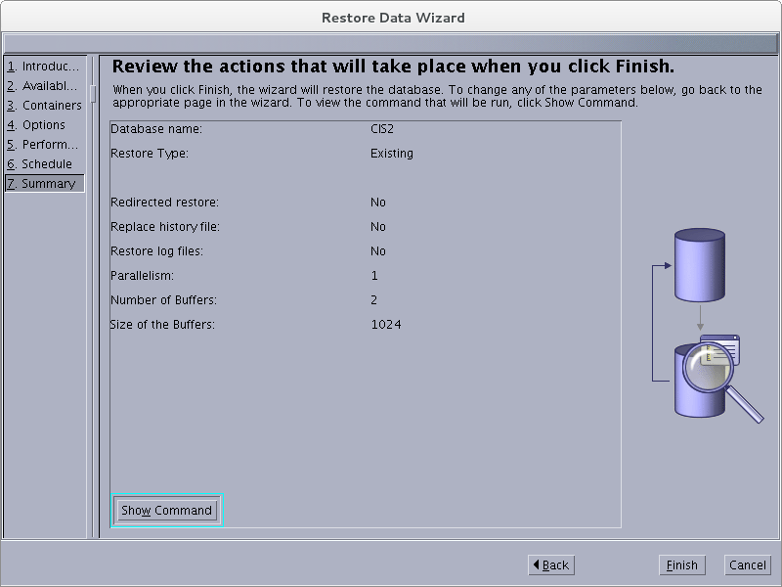
5. Install Android
- Preparing your development computer and install required software
  - If you don't have Eclipse download it at http://www.eclipse.org/downloads/ then install it (we use Eclipse Indigo (3.7.2) Packages).
  - Screen welcome of Eclipse:
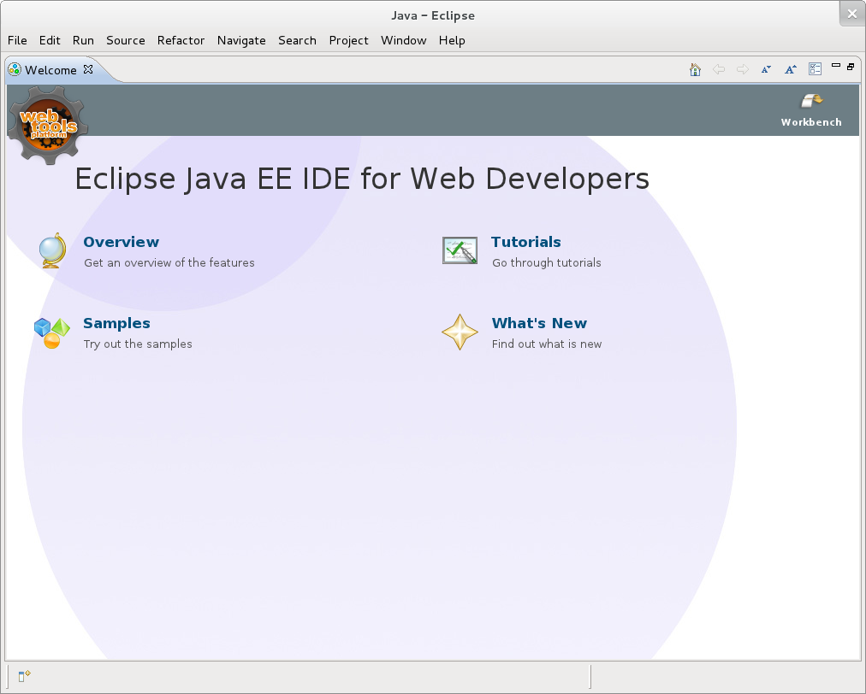

- Install Android SDK
- From main screen of Eclipse, choose Window -> Android SDK Manager and choose the item need to install by check on it.
- Click “Install packages” to install.

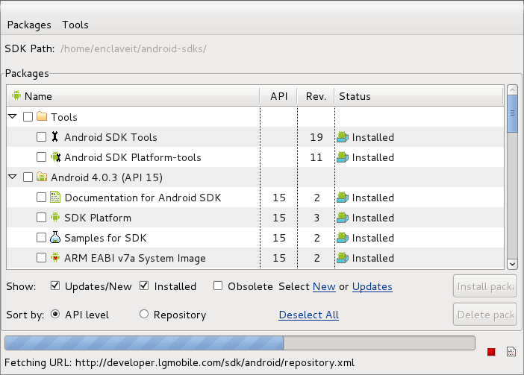
- Install ADT plugin for Eclipse
- From main screen of Eclipse choose Help -> Install New Software...
- Follow these steps in the pictures to plugin ADT: Click Select all -> Next
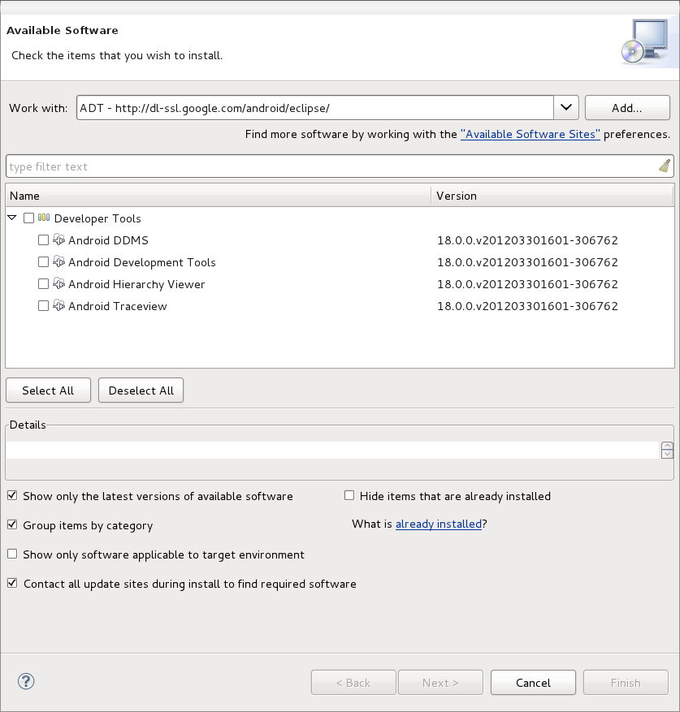
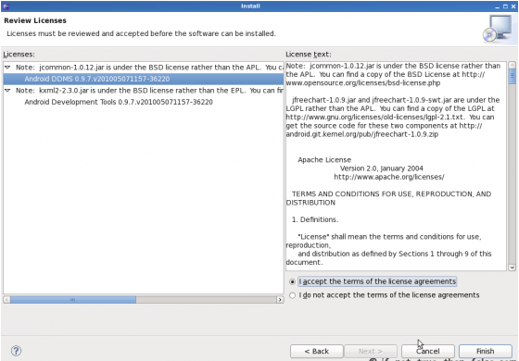

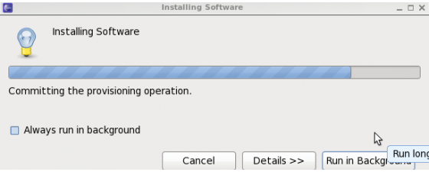

- After install it, use can run an Android project and this is Android emulator.

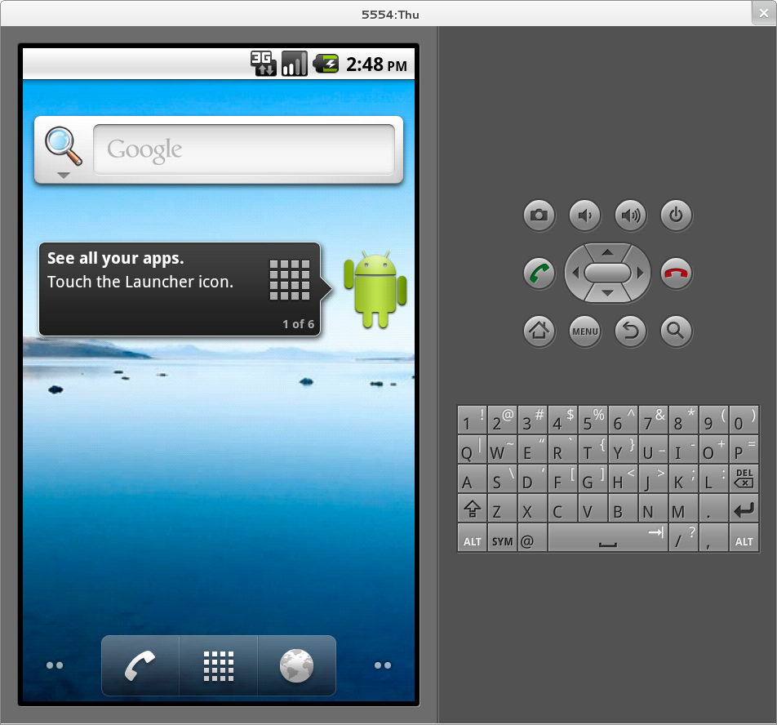

GETTING STARTED

Software help recognize a person easily and quickly. Firstly, detect a face in an image then compare that face with the faces in database. If the face of that person exists in data folder, software will list all of faces which are closest with original face. So we can find the face we want to see and information of person in image. User who has priority can operate on database such as: update, delete, insert information or image into database. Besides, it can connect to mobile to receive image to recognize then send result to mobile. So this software can help user recognize face easily, quickly and flexibly.

SYSTEM FUNCTIONAL DESCRIPTION

This software has functions such as:
- Detect face on an image or a list of images to recognize.
- Connect to database DB2 to get information about that face.
- Interface is very easy and friendly with user.
- Manage database.
- Connect to mobile to help recognize face flexibly.

