III Semester B.Tech., (CSE)
Data Analytics – CSS 2103
Internal Assessment 4 - Mini Project Report
School of Computer Engineering
Manipal Institute of Technology, MAHE

Data-Driven Insights into Titanic Passenger Survival: EDA, Hypothesis Testing, and Predictive Modeling
Name: Reva Bhojwani
Roll No: 2
Registration No: 240905011
Section: CSE-B
Branch: Computer Science Engineering

Abstract
The 1912 Titanic accident is still one of the most researched maritime disasters. This project explores the Titanic passenger dataset to understand the factors that influenced survival through analysis and modeling, it identifies trends showing that women, children, and first-class passengers had higher chances of survival. Logistic regression was used to predict survival outcomes with accuracy.

1. Introduction
The Titanic’s sinking in 1912 stands as one of the most tragic maritime disasters in history, claiming over 1,500 lives during its voyage after colliding with an iceberg. This study examines the Titanic dataset to identify the factors that influenced passenger survival through data preprocessing, exploratory data analysis (EDA), hypothesis testing, and predictive modeling.

2. Objectives
- To preprocess and clean the Titanic dataset for analysis.
- To perform exploratory data analysis (EDA) and identify patterns affecting survival.
- To apply hypothesis testing techniques to draw statistical inferences.
- To build and evaluate a predictive model to estimate passenger survival.
- To gain practical experience applying analytical methods and visualization tools to real-world data.

3. Problem Statement
The primary goal of this project is to determine whether gender, age, passenger class, and fare had a statistically significant impact on survival, and to predict survival outcomes using logistic regression modeling.
4. Literature Review / Background Study
Many studies on the Titanic dataset have shown that factors like gender and passenger class had a big effect on survival. Researchers have also found that cleaning and preprocessing the data helps improve model accuracy.
- Titanic Survival Prediction with Machine Learning:
Ahmed et al. (2019) analyzed several algorithms, including logistic regression and random forests, and found that random forest models produced the most reliable results.
- Socio-Economic Factors and Survival:
Ranganathan and Scarpino (2016) examined how social and economic variables affected survival chances. They reported that gender and passenger class were the most influential factors, with females and first-class travelers showing higher survival rates. Their findings revealed clear inequalities in survival outcomes based on social standing.
- Handling Missing Data in the Titanic Dataset:
Schafer and Graham (2002) explored various methods to deal with missing values, such as mean, median, and multiple imputation techniques. Their work provides guidance on maintaining data completeness and reliability, particularly for columns like Age and Cabin that contain missing entries in the Titanic dataset.
- Feature Engineering for Improved Model Accuracy:
Heaton (2017) demonstrated that engineered features like family size and passenger title enhanced prediction accuracy.

5. Methodology
5.1 Data Collection
The dataset used in this project was obtained from the Kaggle Titanic: Machine Learning from Disaster competition.
It contains 891 records and 12 attributes, describing demographic and ticket-related information about passengers aboard the RMS Titanic.

The key variables include:
- Survived – Survival status (0 = No, 1 = Yes)
- Pclass – Passenger class (1st, 2nd, or 3rd)
- Name, Sex, Age – Personal details
- SibSp, Parch – Family relationships aboard
- Ticket, Fare, Cabin, Embarked – Travel and boarding details
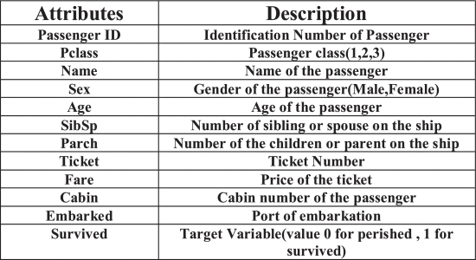
Table 1: Attributes and their Description
5.2 Tools and Technologies Used
Language used- Python (Jupyter notebook)
- pandas : Data loading, preprocessing, and cleaning
- NumPy: Numerical computations
- Matplotlib & Seaborn: Data visualization (EDA)
- SciPy: Statistical hypothesis testing
- Scikit-learn (sklearn): Machine learning and logistic regression modeling

6. Implementation / Experimentation
Data Preprocessing:
- Handled missing values (Age: median, Embarked: mode, Cabin: dropped).
- Encoded categorical variables.
- Dropped irrelevant columns.
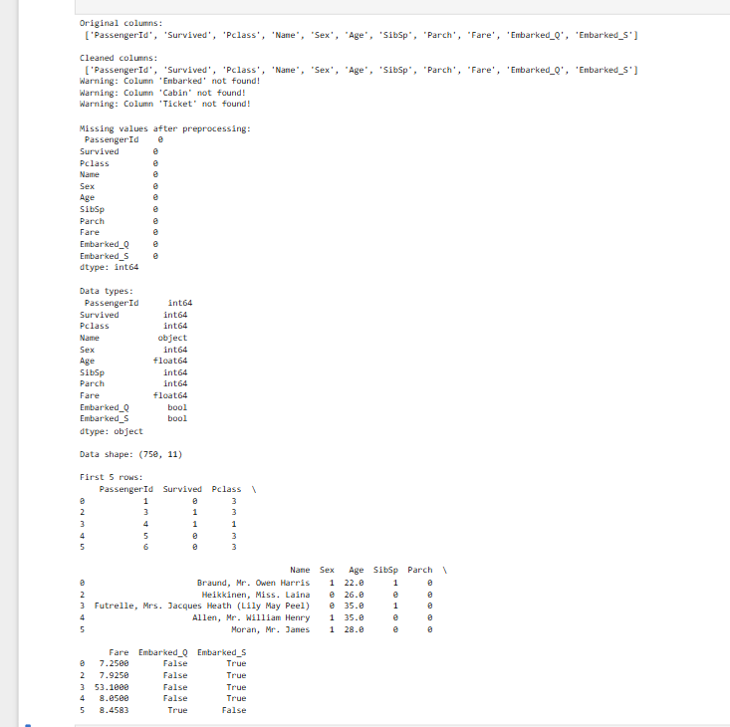
Exploratory Data Analysis (EDA):
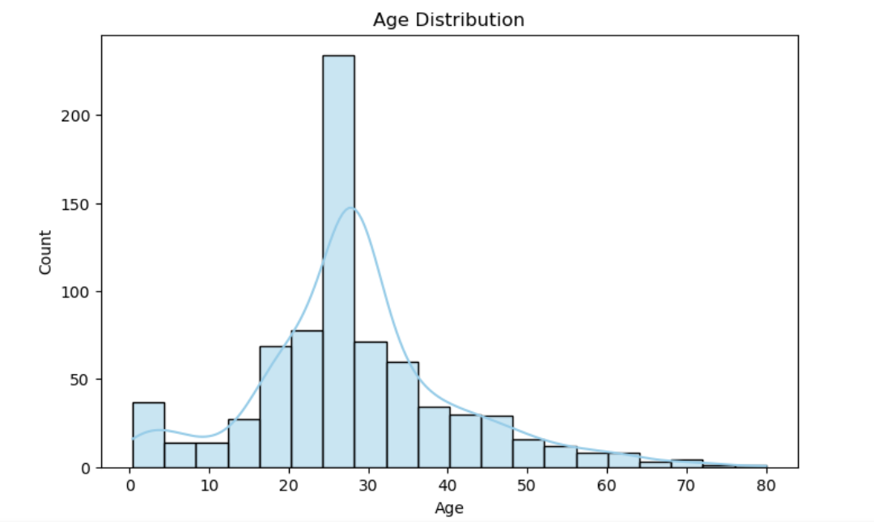
Figure 1: Age distribution of passengers.
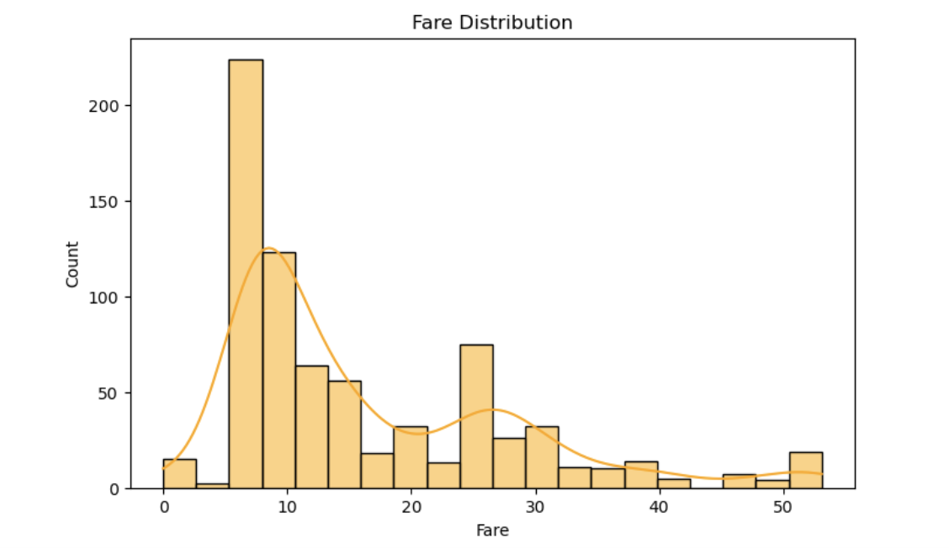
Figure 2: Fare distribution histogram.
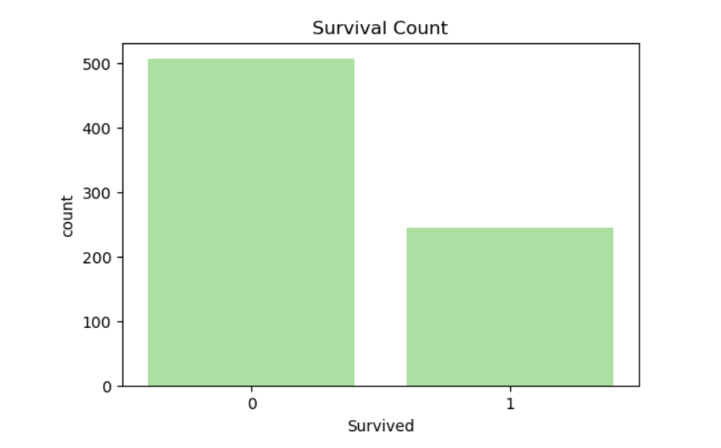
Figure 3: Survival count by gender.

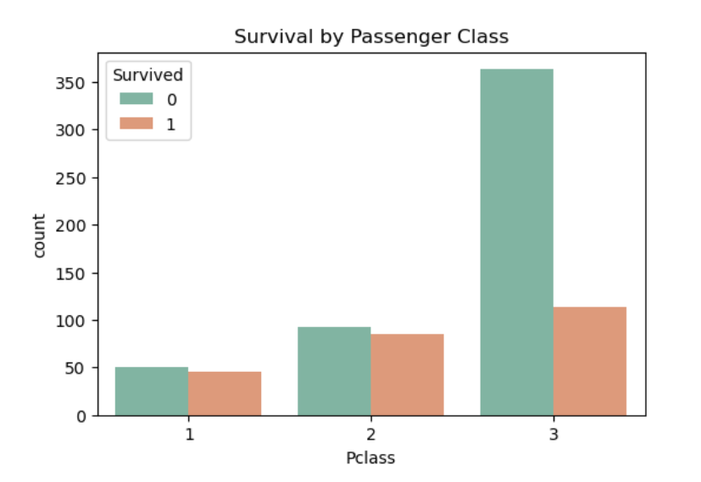
Figure 4: Survival count by class.
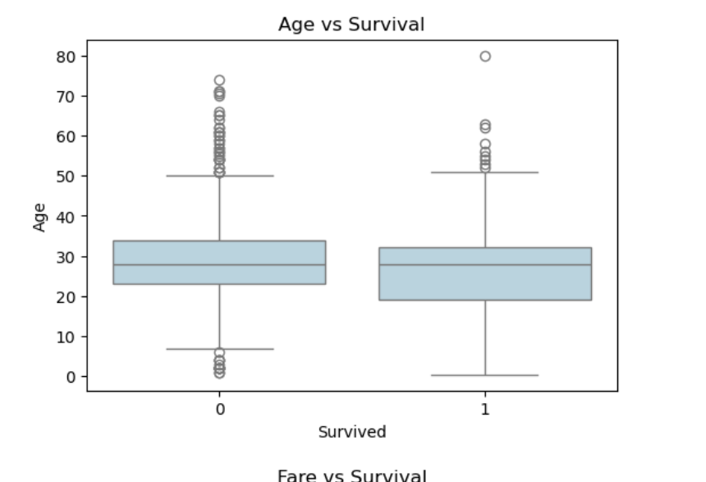
Figure 5: Age vs Survival (boxplot)
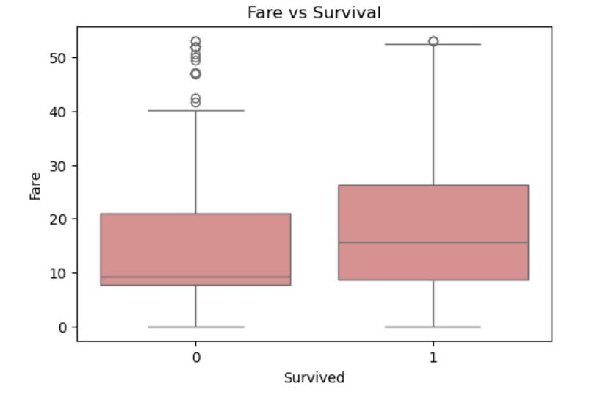
Figure 6: Fare vs Survival (boxplot)
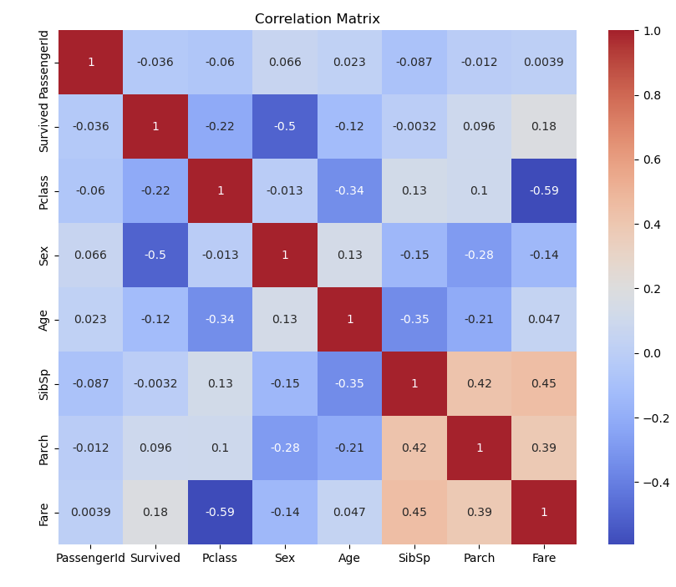
Figure 7: Correlation heatmap of numerical features.

7. Results and Discussion
7.1 Exploratory Data Analysis (EDA)
The exploratory data analysis revealed several key insights into the demographic and socioeconomic factors that influenced passenger survival on the Titanic.
- Figure 1: Age Distribution
The age distribution shows that most passengers were between 20 and 40 years old. There were fewer older passengers and only a small number of children on board.
- Figure 2: Fare Distribution
The fare distribution was highly skewed, with most passengers paying low fares. A few first-class passengers paid much higher fares.
- Figure 3: Survival Count by Gender
A strong gender-based difference in survival was observed - female passengers had a much higher survival rate than male passengers.
- Figure 4: Survival by Class
The survival count by class indicated that first-class passengers had the highest survival rate, while third-class passengers had the lowest.
- Figure 5: Age vs Survival (Boxplot)
The boxplot showed that younger passengers, especially children, had better survival probabilities, while middle-aged and elderly passengers had lower survival rates.
- Figure 6: Fare vs Survival (Boxplot)
Passengers who paid higher fares were more likely to survive.
- Figure 7: Correlation Heatmap of numerical features.
The correlation matrix revealed that Pclass had a negative correlation with survival (-0.35), confirming that lower-class passengers had reduced survival chances. Sex (encoded as 1 for female, 0 for male) showed a strong positive correlation with survival, emphasizing the gender effect.
Overall, the EDA highlights clear social and demographic disparities in survival outcomes — gender, class, and fare played significant roles, while age had a moderate effect.

7.2 Hypothesis Testing
To verify whether demographic factors significantly affected survival, Chi-Square tests were conducted between Gender and Survival and between Passenger Class and Survival.

Table 2: Hypothesis test results (One-sample t-test, Two-sample t-test, Chi-square test)
Interpretation:
Both gender and passenger class have a statistically significant relationship with survival. Female and higher-class passengers were much more likely to survive. The extremely low p-values (< 0.05) confirm that these factors were not due to random chance.

To further test the predictive capability of the identified variables, a Logistic Regression model was applied using Age, Sex, Pclass, and Fare as predictors of survival.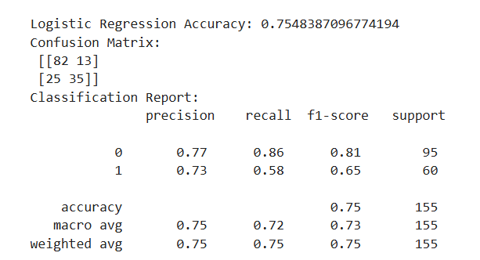
Table 3: Logistic Regression performance metrics (Accuracy, Precision, Recall, F1-Score)
The model achieved an accuracy of 75.4%, indicating reasonably strong predictive performance. The confusion matrix shows that the model correctly classified most non-survivors and a majority of survivors.
Interpretation:
The logistic regression model identified the main factors affecting survival, with gender and passenger class being the most important. It predicted non-survivors more accurately than survivors but still gave good overall results that matched the statistical findings.

7.3 Key Insights
The analysis of the Titanic dataset revealed several important insights about the factors that influenced passenger survival:
- Gender had the strongest impact on survival.
- The passenger class played a major role.
- Fare and wealth were linked to survival.
- Age showed a moderate effect.
- The logistic regression model confirmed these patterns.
- Gender had a strong positive effect on survival probability.
- Pclass had a strong negative effect, meaning survival chances decreased with lower class.
- Fare contributed positively, while Age had a mild negative impact.

8. Conclusion and Future Work
This project analyzed the Titanic dataset to identify the main factors that influenced passenger survival. Through data preprocessing, visualization, hypothesis testing, and logistic regression modeling, several clear patterns were found. Gender and passenger class were the most significant predictors of survival, while fare and age also showed smaller effects. These findings are consistent with historical records, confirming that gender and class significantly affected survival.
Future Work:
In the future, this project can be improved by trying other machine learning models, like Decision Trees or Random Forest, to get better accuracy.

9. References
1. Kaggle Titanic Dataset – https://www.kaggle.com/competitions/titanic/data
2. Karman Singh, Renuka Nagpal, Rajni Sehgal - Exploratory Data Analysis and Machine Learning on Titanic Disaster Dataset
3. Ahmed, M., Mahmood, A., & Afzal, S. (2019). "Comparative Analysis of Machine Learning Algorithms for Titanic Survival Prediction." International Journal of Advanced Computer Science and Applications
4. Breiman, L. (2001). "Random Forests." Machine Learning
5. Freund, Y., & Schapire, R. E. (1997). "A decision-theoretic generalization of on-line learning and an application to boosting." Journal of Computer and System Sciences
6. Heaton, J. (2017). "An empirical analysis of feature engineering for predictive modeling." Proceedings of the 14th International Conference on Machine Learning and Data Mining in Pattern Recognition
7. Ranganathan, A., & Scarpino, S. V. (2016). "The Role of Socio-Economic Factors in Titanic Survival Rates." Social Science Research Network, Retrieved from https://ssrn.com/abstract=2874942.
8. Kumar, A., et al. (2021). “Predictive Analysis of Titanic Survival Data.” Elsevier Journal of Data Science.

