HW6: Tide Plotting

Rachael Valdez

10/3/2017

Tide plotting will be conducted through downloading several months worth of tide height data through NOAA tide stations. The function NOAAfunction was designed to acces data from the NOAA website and request 1 months worth of data at a time.

We will request data from Monterey, Ca (station 9413450) for the month of January, April and October 2016. Only one month of data can be requested at a time. We will re-use the plotting code to make the plots for each month listed.

## Loading required package: bitops

First we will plot January 2016 tide data and list some of the returned data:

jan = NOAAfunction(station = 9413450, startDate = 20160101, endDate = 20160131)

## Contacting server...  
## Data returned...

## Returned Data: January 2016

## stationId datum TimeUTC TideHT Flag.Inferred Flag.Flat.Tol  
## 1 9413450 MLLW 2016-01-01 00:00:00 1.064 0 0  
## 2 9413450 MLLW 2016-01-01 00:06:00 1.054 0 0  
## 3 9413450 MLLW 2016-01-01 00:12:00 1.041 0 0  
## 4 9413450 MLLW 2016-01-01 00:18:00 1.031 0 0  
## 5 9413450 MLLW 2016-01-01 00:24:00 1.014 0 0  
## 6 9413450 MLLW 2016-01-01 00:30:00 0.996 0 0  
## Flag.Rate.Tol Flag.Temp.Tol  
## 1 0 0  
## 2 0 0  
## 3 0 0  
## 4 0 0  
## 5 0 0  
## 6 0 0

## Plot 1

ptjan(df)

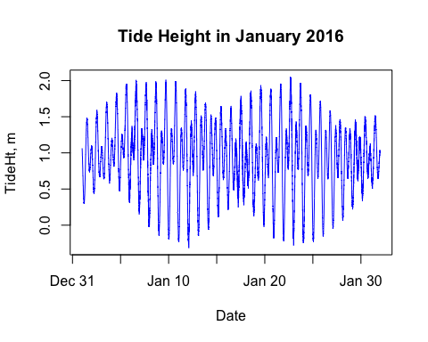

The following months will repeat the same function call to NOAAfunction. We will need to add new date ranges for April:

apr = NOAAfunction(station = 9413450, startDate = 20160401, endDate = 20160430)

## Contacting server...  
## Data returned...

## Returned Data: April 2016

## stationId datum TimeUTC TideHT Flag.Inferred Flag.Flat.Tol  
## 1 9413450 MLLW 2016-04-01 00:00:00 0.849 0 0  
## 2 9413450 MLLW 2016-04-01 00:06:00 0.881 0 0  
## 3 9413450 MLLW 2016-04-01 00:12:00 0.902 0 0  
## 4 9413450 MLLW 2016-04-01 00:18:00 0.903 0 0  
## 5 9413450 MLLW 2016-04-01 00:24:00 0.917 0 0  
## 6 9413450 MLLW 2016-04-01 00:30:00 0.914 0 0  
## Flag.Rate.Tol Flag.Temp.Tol  
## 1 0 0  
## 2 0 0  
## 3 0 0  
## 4 0 0  
## 5 0 0  
## 6 0 0

## Plot 2

ptapr(df)

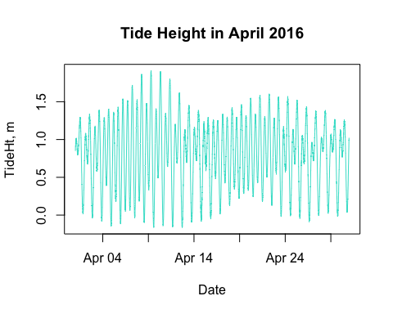

And for October:

oct = NOAAfunction(station = 9413450, startDate = 20161001, endDate = 20161031)

## Contacting server...  
## Data returned...

## Returned Data: October 2016

## stationId datum TimeUTC TideHT Flag.Inferred Flag.Flat.Tol  
## 1 9413450 MLLW 2016-10-01 00:00:00 0.330 0 0  
## 2 9413450 MLLW 2016-10-01 00:06:00 0.338 0 0  
## 3 9413450 MLLW 2016-10-01 00:12:00 0.340 0 0  
## 4 9413450 MLLW 2016-10-01 00:18:00 0.330 0 0  
## 5 9413450 MLLW 2016-10-01 00:24:00 0.360 0 0  
## 6 9413450 MLLW 2016-10-01 00:30:00 0.358 0 0  
## Flag.Rate.Tol Flag.Temp.Tol  
## 1 0 0  
## 2 0 0  
## 3 0 0  
## 4 0 0  
## 5 0 0  
## 6 0 0

## Plot 3

ptoct(df)

